Willaston Village Green

The first record of the village green in Willaston was on the ‘Estate Map’ of 1774:

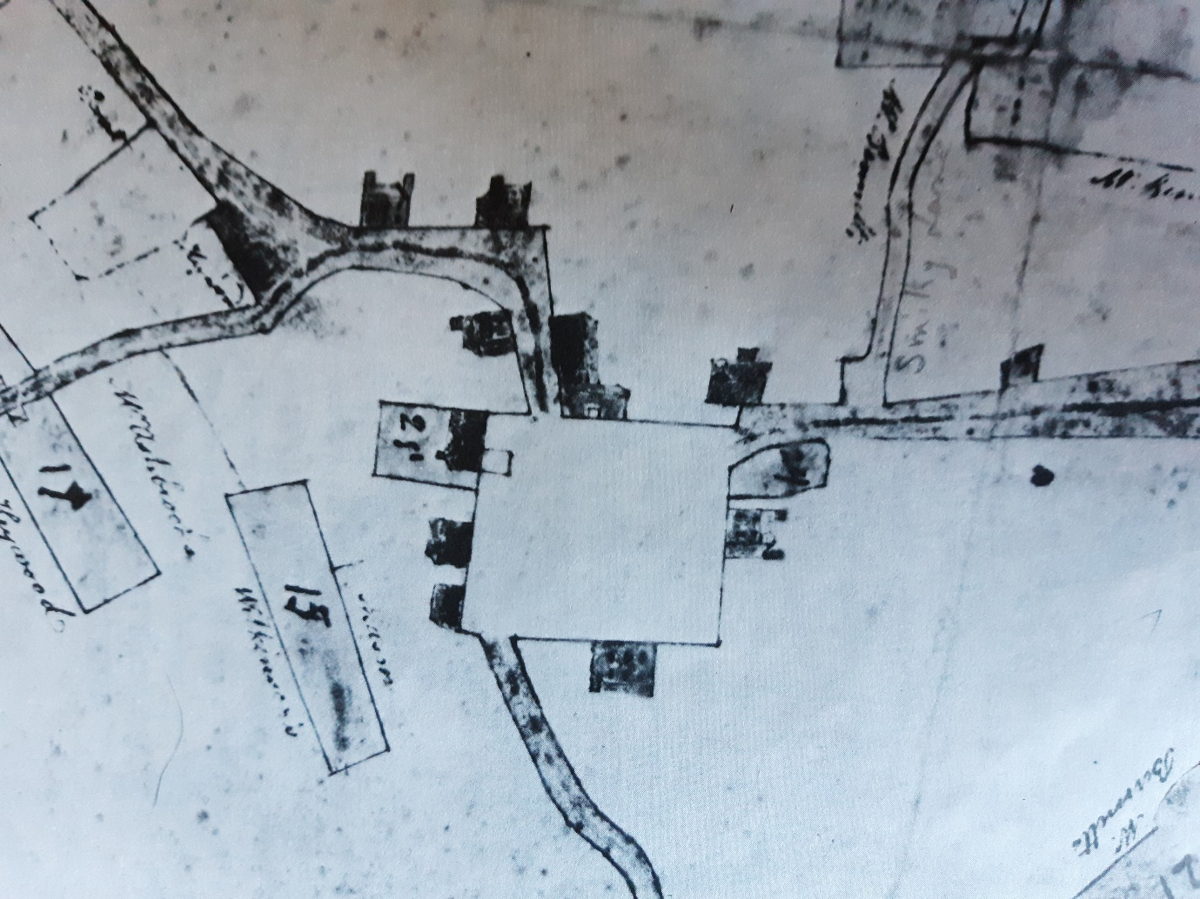

At this time, the Green was much larger, extending to what is now the car park next to Pollards Inn.

Willaston is unusual amongst Cheshire villages in that the green was until recently, rectangular in shape. It is not clear what feature that led to this layout but an enclosure associated with the nearby Roman road or an enclosing ditch of an early homestead or manor house have both been suggested.

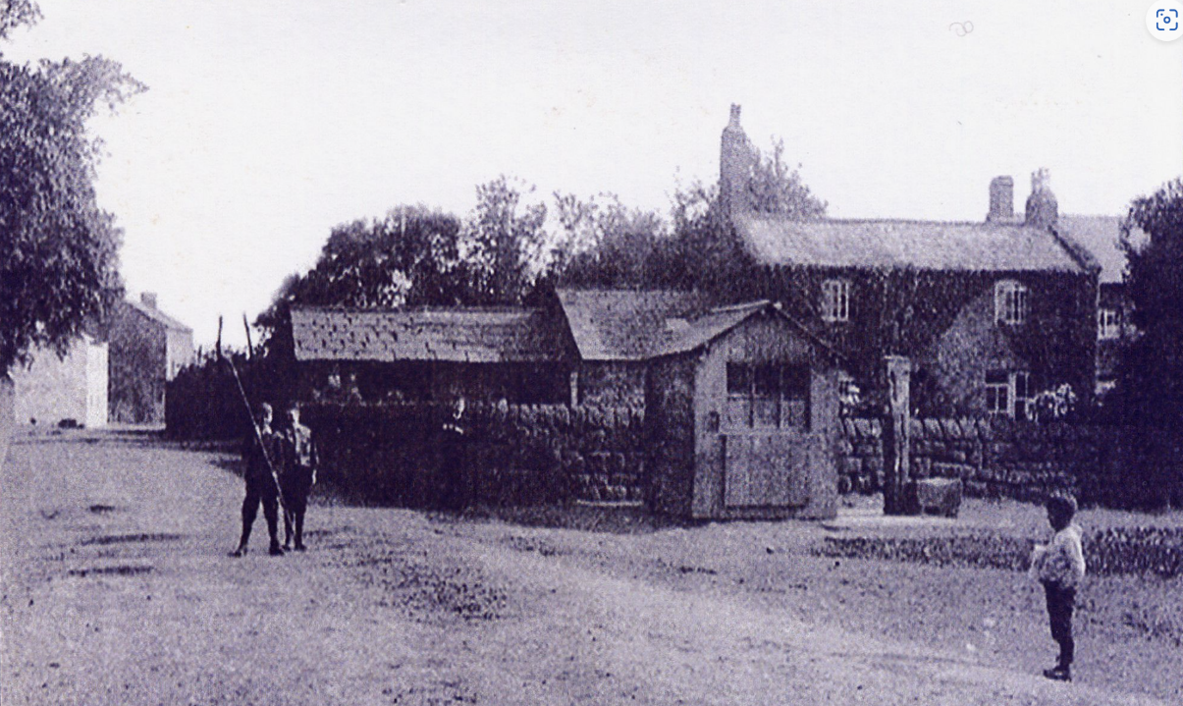

Pump on the green – date unknown
This was covered over in 1940

The first village school was built on the green in 1859, opposite the Red Lion Hotel. It consisted of one room. It was extended in 1877.

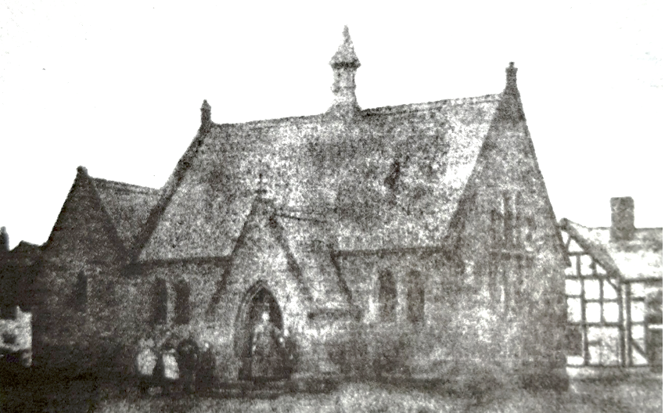

The school on the Green c1870 when it still had a single classroom. The Red Lion is on the right. (Photo: Willaston’s Heritage by E.C. Bryan)

George Cecil Barnes attended the school between 1912 and 1918 and remembered: ‘The school was surrounded by the green. The green itself was not in the form of a green in those days but was laid out with a hard surface and was used as the school playground … we used to play rounders, marbles, hopscotch, skipping, Maypole dancing, drill, hand-ball, jacks, kick-the-can, hide-and-seek and many other youthful recreation and pastimes.’
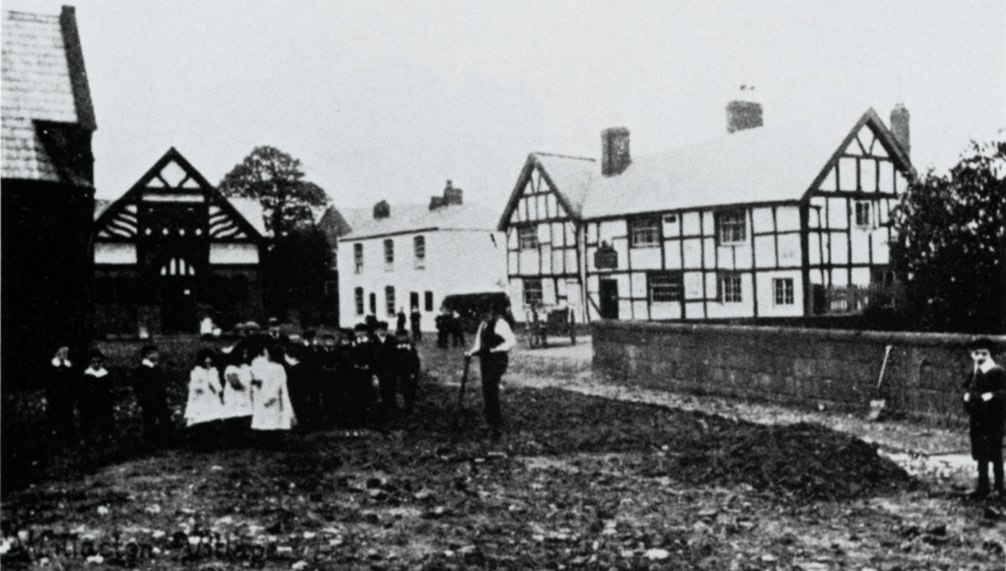
Photo from Pictures of the Past. Collection No Three of old photographs of Bromborough, Burton, Eastham, Heswall, Neston, Ness Mine, Parkgate and Willaston by Derek and Marian Young

School on the green in 1931. Note the post box on the side of the school.
Photo from press cutting, paper unknown.

In 1930, the school was put up for sale, for £200 for building purposes by Church Wardens and sold to the Parish Council. A letter was sent to the Vicar of Willaston from the Wirral Society Committee stating that in their opinion, everything should be done to preserve the open space and that a certain number of residents in Willaston had already guaranteed donations in the event of a fund being raised to buy the site. The Vicar agreed and also suggested that the Society write to the Birkenhead Brewery Company who owned the Red Lion site, asking them to subscribe to the fund and the Society received a donation. This campaign was successful and after the school was demolished, the site was cleared and the area of the green was laid out to grass funded by Alderman Merritt.

Sale agreement to Willaston Parish Council

The custody of the green was transferred to Neston Urban District Council in 1933. The Urban District Council fenced it with white posts and chains in return for land taken to widen the road and make a footpath. The chains stopped cows going onto the green – the area was known as ‘cow muck city’.

On 6th May 1935 on part of the former school site the copper beech tree was planted by Charles W Wright Esq to commemorate the Silver Jubilee of King George V.

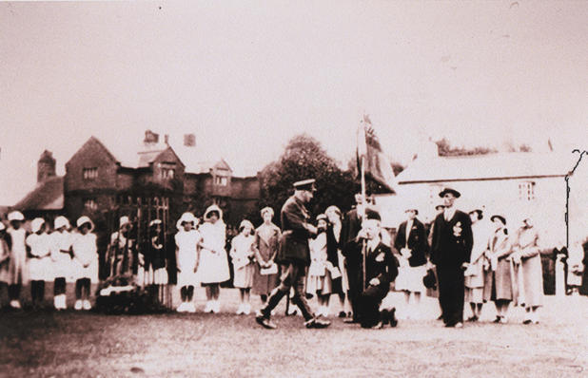

Photo from Willaston of Yesteryear by Bob Prince

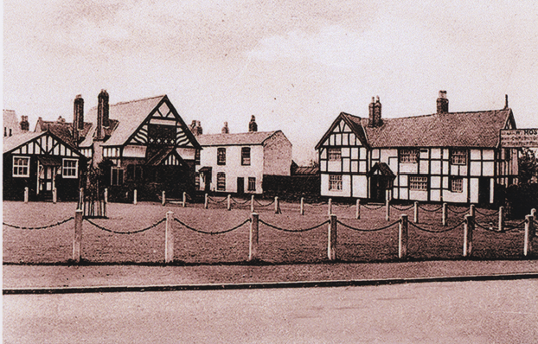
Willaston Village Green in about 1935, with the newly planted copper beech tree (photo from Bob Prince)
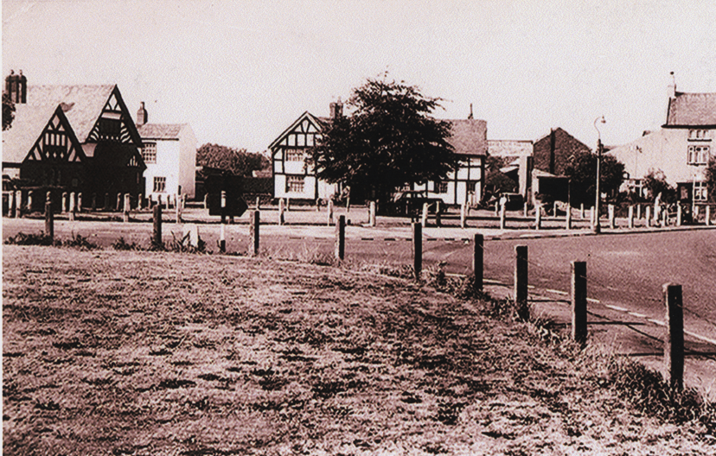
The village green about 1940 (photo from Bob Prince)

In the 1960s, the first Christmas lights were put on the tree.

In 1967 the annual Carols on the Green gathering began. This tradition was started by the former Hadlow Green WI. This tradition has continued by Willastonhey WI when Hadlow Green WI ceased.

In the 1960’s through to the early 1990’s, the Royal Rock Beagles would gather on the green on Boxing Day. People would gather on the green and either walk with the hounds or join a fancy dress football match on the Recreation Ground.

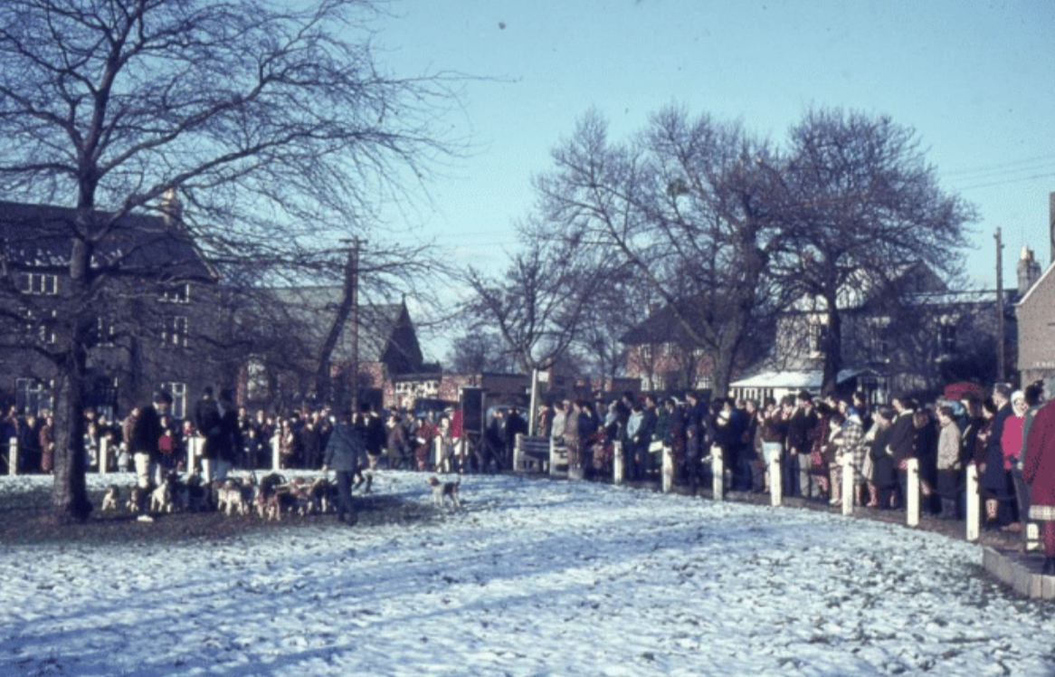

1968 Boxing Day Hunt (Photo: Janet Leece)

The crocuses were planted under the tree in the early 1970s.

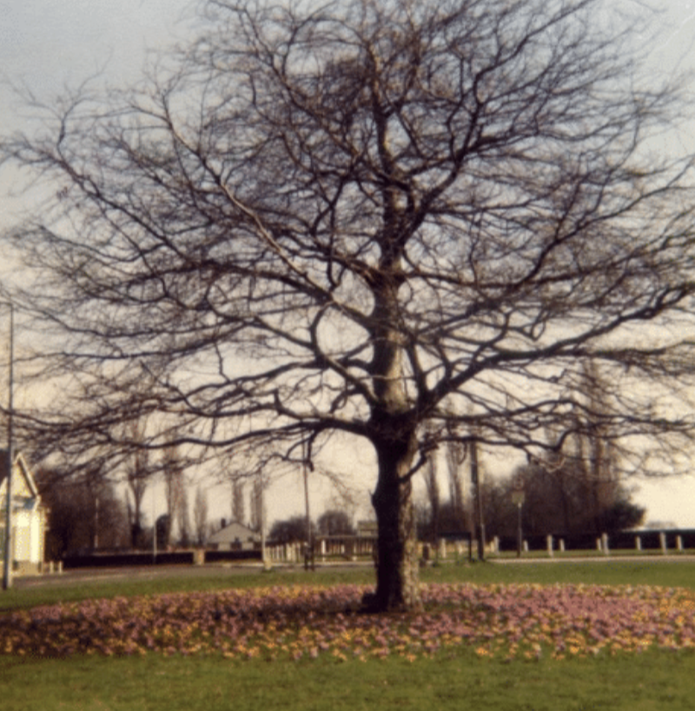

The green in the early 1970s. Photo: Eileen Macdonald
This photo was subsequently used for the Millennium wall hanging.

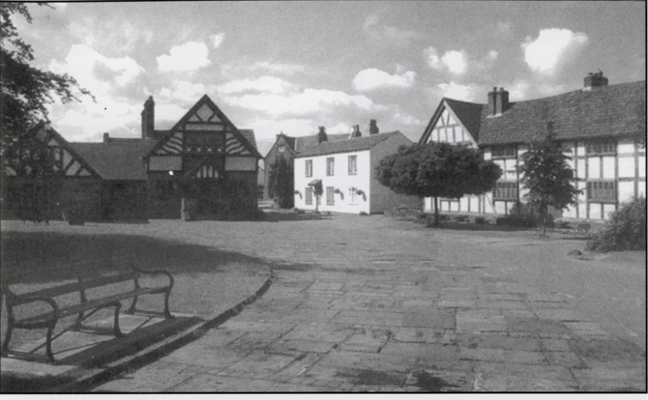

Paving on the green (and no cars!)
Photo from Willaston – Centre of Wirral by Bob Prince

In 1974, the area around the green was paved. The paving was laid with dividers. Although these now form parking spaces, they were intended to be rays of the sun radiating out from the tree on the village green.

At that time 130 residents at a meeting of the Willaston Residents’ and Countryside Society unanimously voted that they did not think that the area should be used for car parking. An article in the Parish News in 1975 said: ‘The Council were informed at the time and have since made several efforts to discourage cars parking on the Green. We would ask for full co-operation in this matter and then perhaps it will be possible to use the open space as a meeting place for pedestrians to stop and have a chat without the distraction of the motor car and so restore the village green to its original purpose.’

On 29th September 1982, the green was registered as common land.

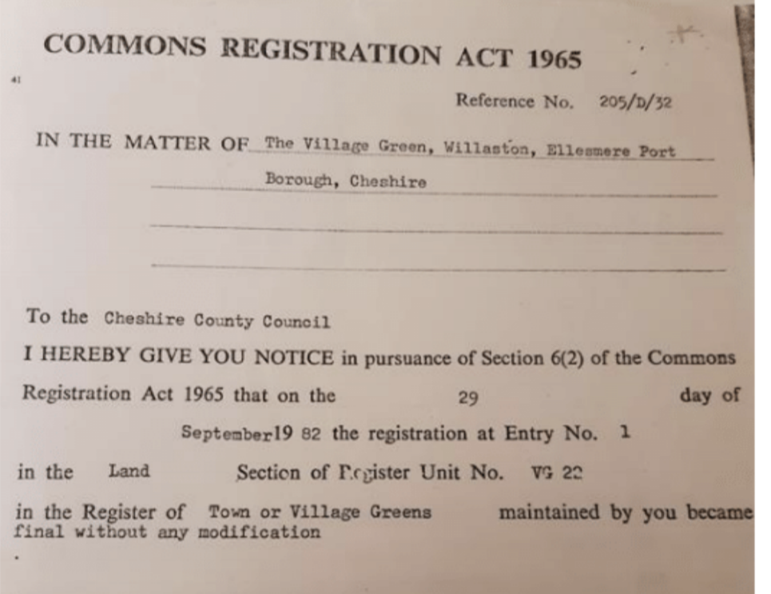

From 1992, when the hunt ceased, the Mersey Morris Men began performing on the green on Boxing Day and this is now a tradition for many local people.

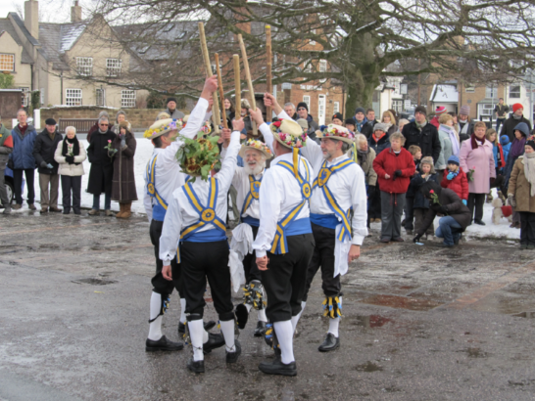

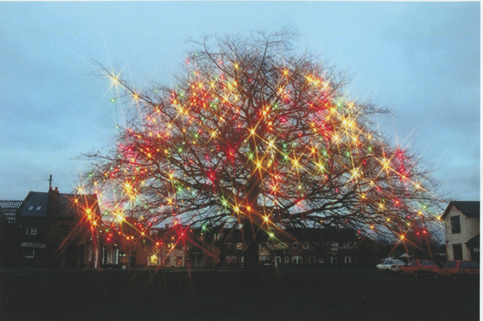

Lights on the green 2001
Photo from Willaston in Photographs by Bob Prince
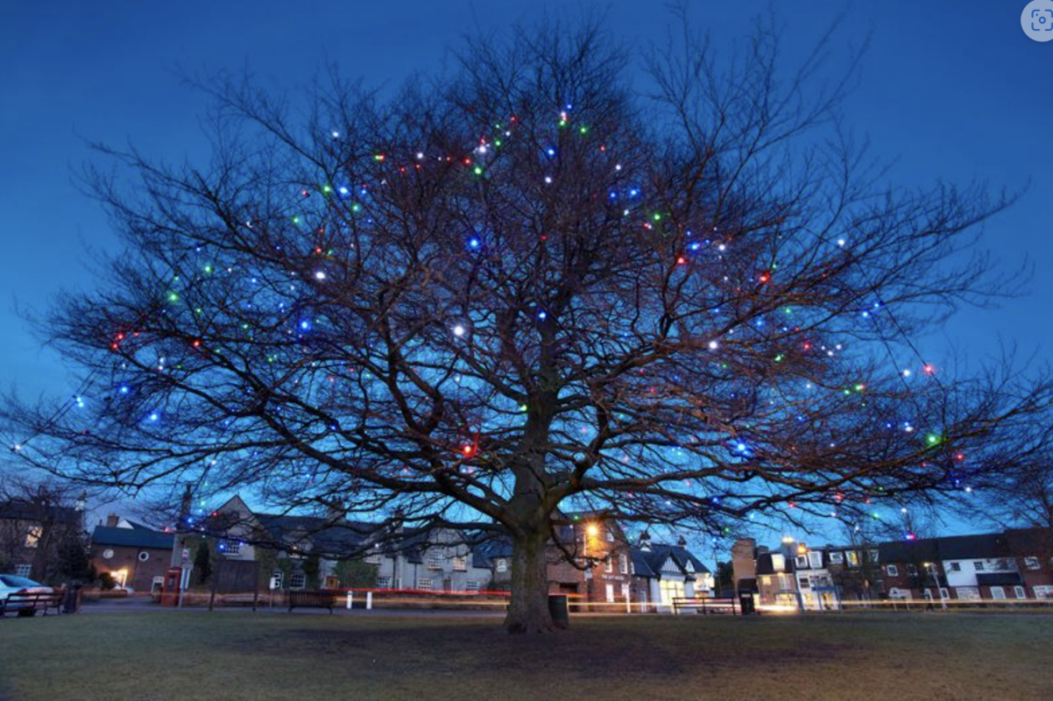
Lights on the green in 2011

On 5th December 2014, Willaston and South Wirral Rotary Club organised the first switch-on event for the Christmas lights. This is a popular event, especially loved by children who love to see Father Christmas arrive.
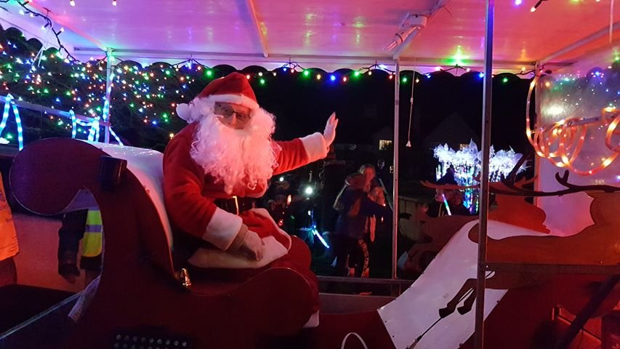
Santa at the Christmas Light Switch On 2021
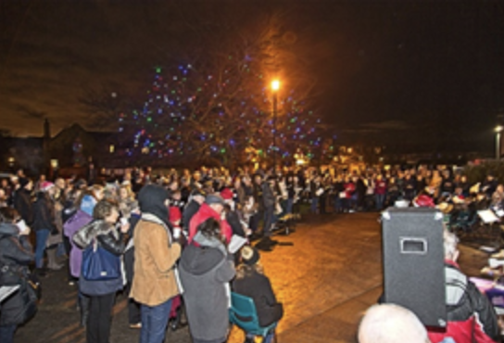

50th Anniversary of the Carols on the Green in 2017 (Photo: Martin Eves)

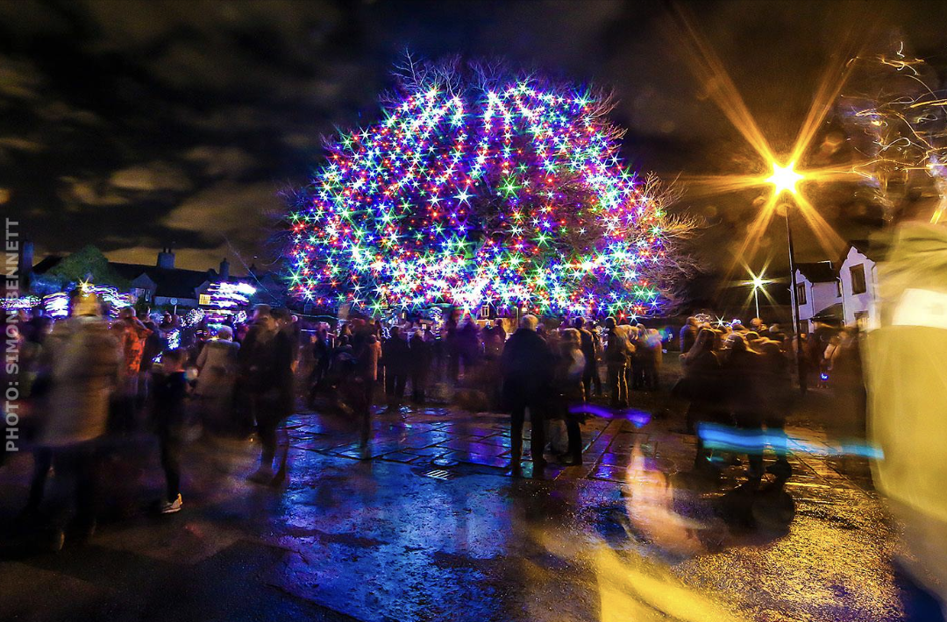

Christmas lights switch on 2018, when new lights had been bought for the tree
(Photo: Simon Bennett)

Little Green

The millstone on the little green was installed in 1996. The stone is from Willaston Mill and originally ground wheat into flour, and oats and beans into cattle food. The design of the millstone sign was by Dennis Williams, a local village artist following a competition for the best design. The sandstone plinth was worked by John Sanderson, a local stonemason and the name Willaston is carved on a slab of York stone by Alan Roberts.

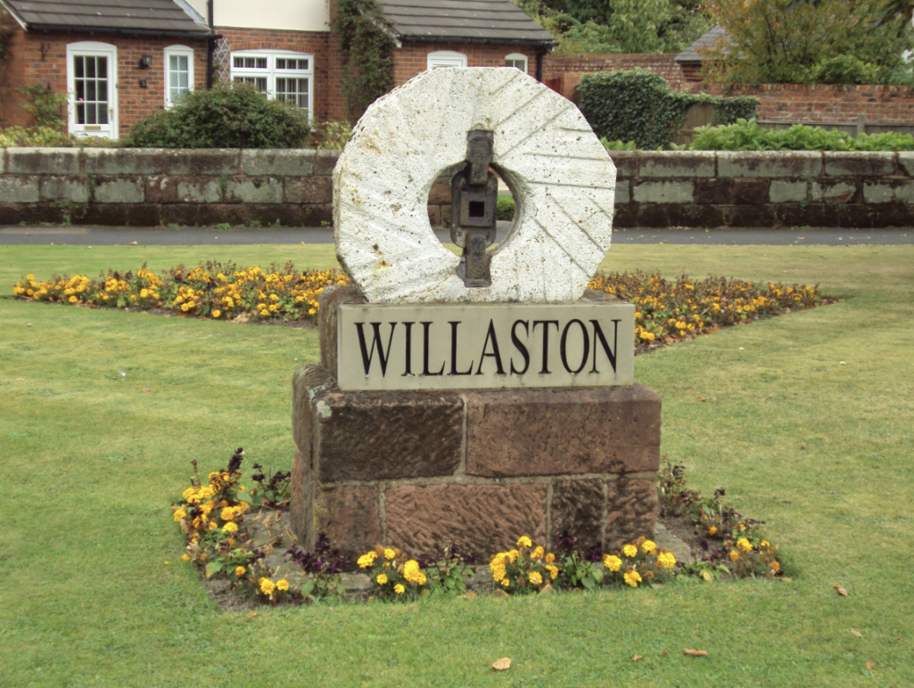

Millstone on the little green September 2009

Two time capsules are buried below the structure, one provided by Willaston Residents’ and Countryside Society and one by Willaston C of E School. The capsule also contains a scroll of 250 signatures of Willaston residents in 1996.

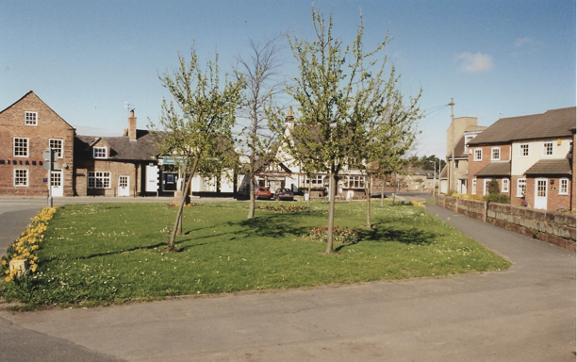

This photograph of the Little Green was taken by Bob Prince in the late 1990s.

Updated Febuary 2024

