The Red Lion

The Red Lion was probably a single private house originally but for a period in the eighteenth century, it was occupied as two cottages. It is a timber framed building, originally filled with wattle and daub, later replaced with bricks. It is divisible into three units, the oldest probably being the section nearest to Neston Road, followed by the centre section and finally the gabled part to the South. It is thought that all parts were built in quick succession.

In the front of the building is a terracotta house plate with the initials and date J.B. M.B. 1631. The initials probably refer to John and Marie Bennett. Marie married John on 16th December 1608 in Shotwick Church, aged only 12 years. However, the date of 1631 does not seem early enough for the construction of the earliest part of the building and may be the year that the gabled wing was added.

At the beginning of the nineteenth century, the two dwellings were joined together to become a licenced premise. The Quarter Sessions records show that in September 1822, a licence was either granted or renewed for the Red Lion at Willaston, the tenant being Samuel Davies.

On 24th October 1868, Major John Bennett sold some of his property in Willaston, including the Red Lion, at public auction at the Queen Hotel in Chester.

Lot 7 was described as ‘A well established Public house at Willaston known as the Red Lion.’ The tenant was J. Maylor and the property included ¼ acre garden, ¼ acre croft and Wall Croft Meadow containing 2 acres, 2 roods, 22 perches. The reserve of £990 was not reached.

This photo is thought to be taken in the early 1900’s
(Photo from: Willaston’s Heritage by E.C. Bryan)

There was a bowling green and stabling at the rear of the building.

The last licensee was Joseph Moss, who lived there from 1902. In 1928, it ceased to be a public house but Mr Moss continued to live there and after his death, his widow remained there until 1962.

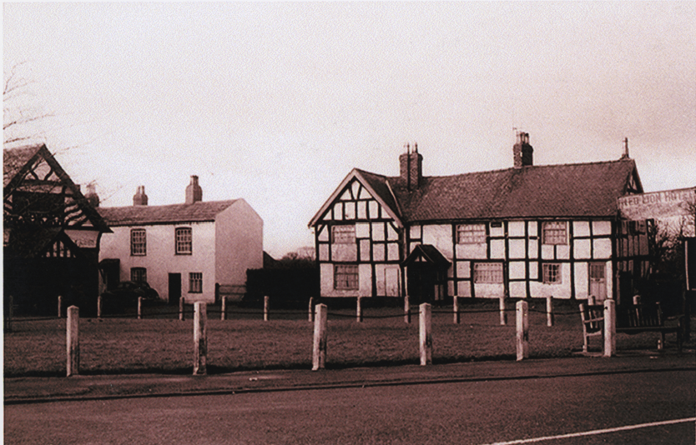
The Red Lion about 1940

The building became derelict as this photo from the Liverpool Daily Post on Friday June 30th 1967 shows.

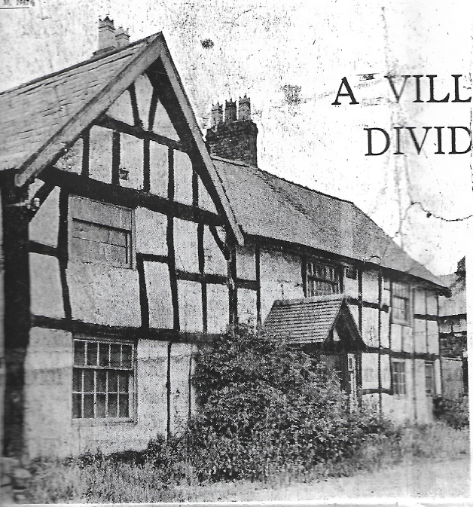

After Mrs Moss left the pub, Birkenhead Brewery wanted to pull the building down and replace it with modern licensed premises in 1962 but planning permission was refused. As a result, Cheshire County Council’s Amenities Sub Committee proposed to make a building preservation order and the building was listed on 27th December 1962 as Grade II. The public inquiry took place in 1964. So many villagers attended the meeting to hear the planning inquiry at Neston Urban Council, it had to be moved downstairs to the large public hall. Again, it was refused.

The 1969 Willaston Village Plan, which was not implemented, suggested that the external features of the Red Lion should be preserved but it should be rebuilt internally, with an extension at the rear with a car parking area so it could be developed into a restaurant or steak house.

The property remained derelict until Janet and Nigel Worth bought the house in 1972. With the assistance of grants, he and his wife took on the daunting task of restoration. Mr Bill Hardman who lives in Willaston was appointed to carry out much of the work.

This was reported in The Post as follows:

… the building’s new owners Nigel and Janet Worth who have been living – or camping as Janet prefers to put it – in the house for the past few months whilst the restoration work continues about them, much of which they are doing themselves calling in expert craftsmen for the structural work.

The bought the house about two years ago after moving up from Bristol and realised at once they had a job on their hands.

To repair the timber frame, the whole building had to be taken down in stages and then rebuilt. Among the features of the house Janet and her husband have uncovered during their renovation work is an old fireplace which had been panelled in and hidden by what Janet described as a ‘hideous’ marble fireplace.

The remains of a huge open fire were also uncovered in another part of the house which could be something to do with an ancient tradition of eating ‘court cakes’ on a certain in the year, which developed from the days when the house was used for the village court.

A less pleasant discovery has been death watch beetle and the building will have to be treated in five years’ time.

The main problem in carrying out the work has been finding someone capable of doing it – together with the fact that it is has taken about five times as long as the couple expected.

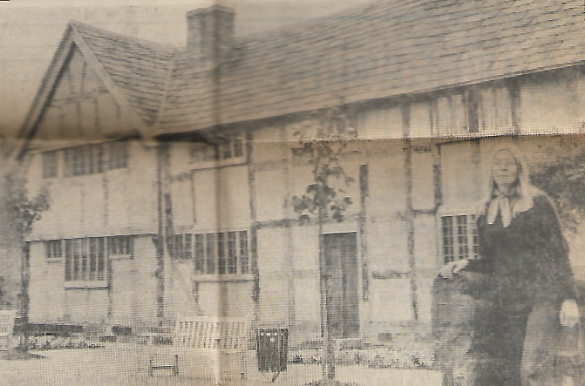
‘We have restored it in much the way we felt it had originally been used. We like to live simply’ said Janet.

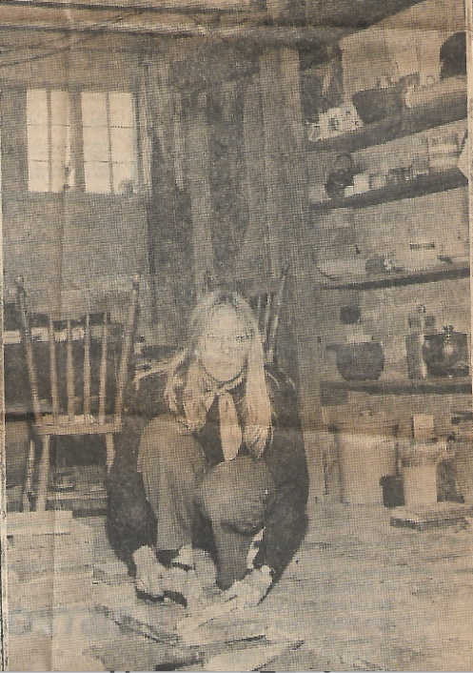

Janet Worth (photos: The Post)

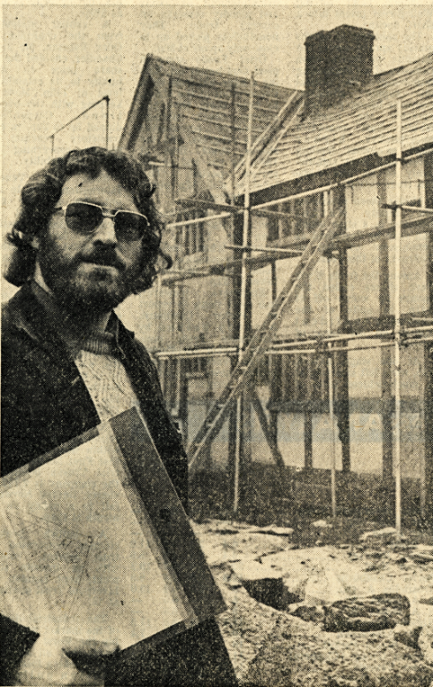

Adrian Hodgson, a joiner, did a lot of the work on the Red Lion (Photo: Liverpool Daily Post, December 1973)

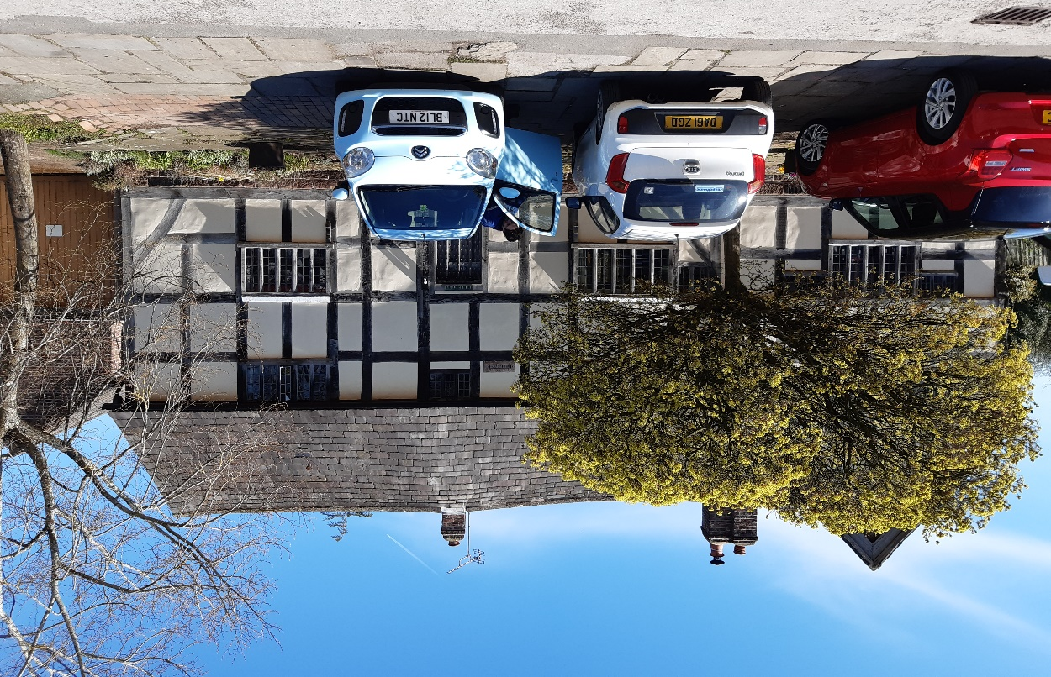
The Red Lion in 2023

Updated February 2024

