The Old Hall

Although The Old Hall has the appearance of a manor house, it is really an illusion as Willaston never had a lord of the manor and this was only one of several similar houses in the village.

The date 1558 is carved in the stone over the entrance of the Old Hall, along with the initials H.B, which has led to the assumption that is the date it was built. However experts have expressed the view that, on architectural grounds, it was unlikely to have been built before 1600 – and the initials and date were unlikely to have been carved before the beginning of the 19th century.

The HB is likely to be Hugh Bennett but there were a number of Hugh Bennetts living in and around Willaston at that time, at least one of whom lived at The Old Hall. As well as The Old Hall, the Bennetts owned various properties in the area as well as estates in Neston, Heswall, Shotwick, Bedstone in Shropshire and on the Isle of Man.

The Old Hall is built of strawberry red brick, with three storeys and three projecting gables which form the letter ‘E’. At the time it was built, brick was just beginning to be used as a building material in Cheshire and its use, together with the adoption to the fashionable E plan, show that the Bennett who built it was a man of significant social standing.

The Old Hall contained a private chapel which was the only place of worship in the village until 1838 when the first Methodist Chapel was built. It was reputed to have a secret passage that ran to the smithy but there has been no evidence found to substantiate this.

The Old Hall also has a decorated chimney piece in the main bedroom. This contains the coat of arms of the Bennett family.

From around 1760, the Bennetts had been living mainly in Chester and the building was occupied by tenant farmers. In 1819, Ormerod described the building as ‘a moss-grown and ruinous brick building.’ The house remained with the Bennett family until 1920 and the main room on the first floor has the Bennett coat of arms.

In 1859, Major John Bennett married Caroline Tarrett of Ludford Park near Ludlow. A marriage deed said that the Old Hall Estate (then called ‘Willaston Hall Farm’), together with Corner House Farm would give an annual rent of £450 to Major John for life and after to his wife, if she should survive him (which she did). At this time, The Old Hall was occupied by William Huntington and had 164 acres of land. The estate included a ‘Lane in Intake’ and 21 fields.

Major John Bennett died in 1903 and The Old Hall was sold by Public Auction in Liverpool on 18th June 1920 for £16,500. It was described as: ‘All that valuable mixed farm, known as Old Hall Farm, Willaston’ and as ‘One of the finest in the Wirral Peninsula.’ The total area was about 168 acres and the property was let to a Mrs Allan at an annual rent of £325 – she had received notice to quit. The outbuildings included ‘a cart-shed, modern Dutch Barn, shippon for 16 cows, another for 24 cows, a 3-stall stable and a 4-stall stable with loose box, a brick granary, 3 loose boxes and a mash house.’ The particulars also stated that ‘a portion of the north-west corner of the outbuildings was let as a provision store containing a shop, office with store room over’. This was a shop known as Coll’s, which was on the small green.

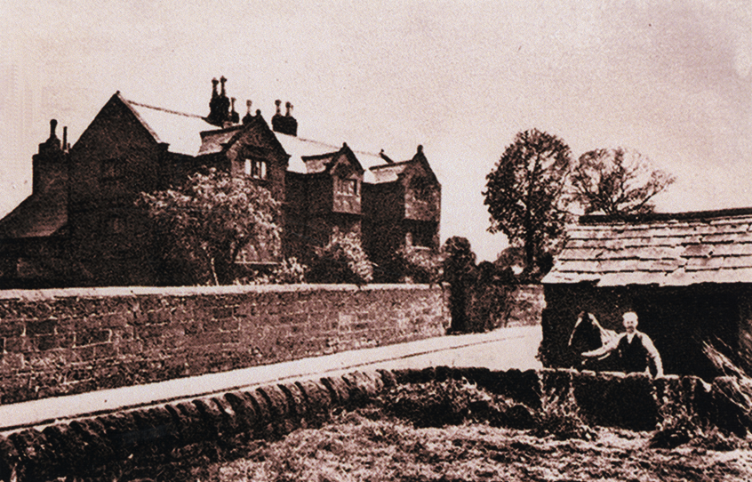

The Old Hall in 1940, with the Smithy opposite (picture from Bob Prince)
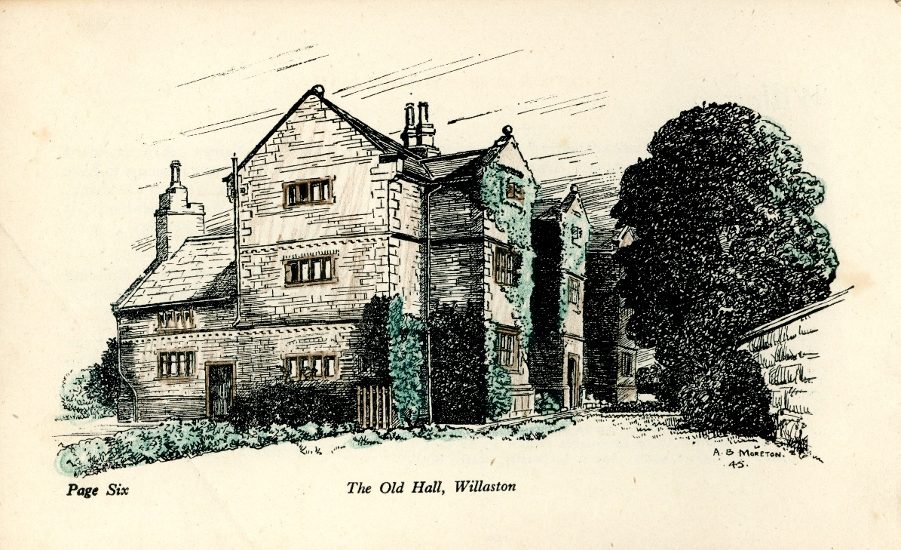

Drawing of The Old Hall in 1945, taken from All About Willaston, produced by the British Legion

The owners in 1956 were Professor and Mrs Rosalind Brooke. He was professor of medieval history at Liverpool University. When they moved there, they had to do substantial treatment for woodworm and death watch beetle.

The Old Hall was listed at Grade II* in 1962.

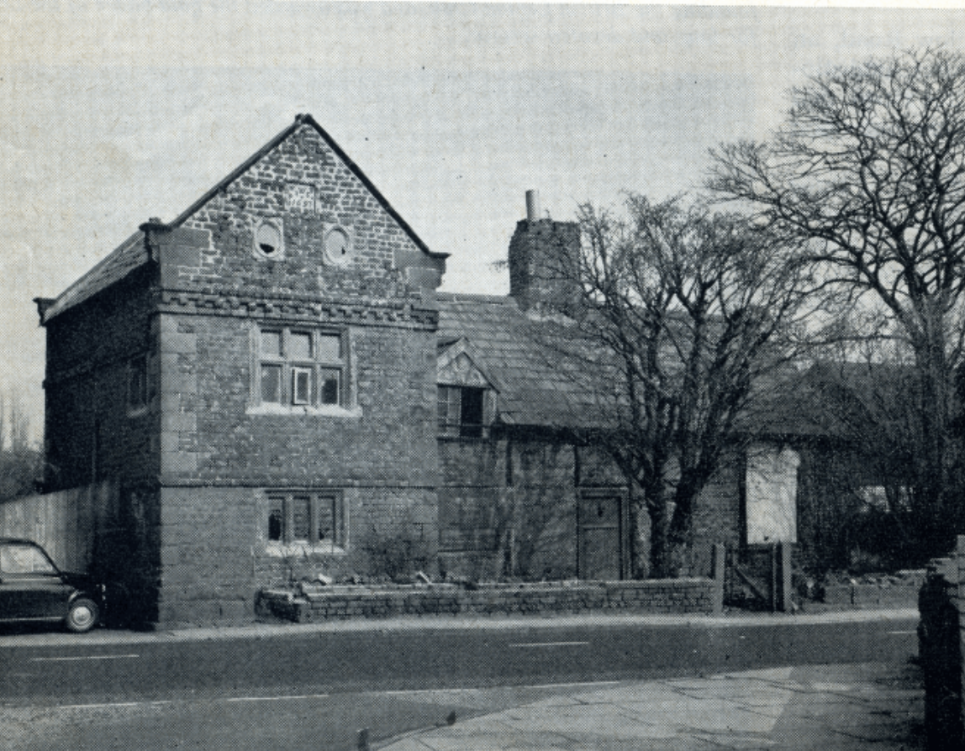

The Old Hall in 1970 (photo: Cheshire Life)

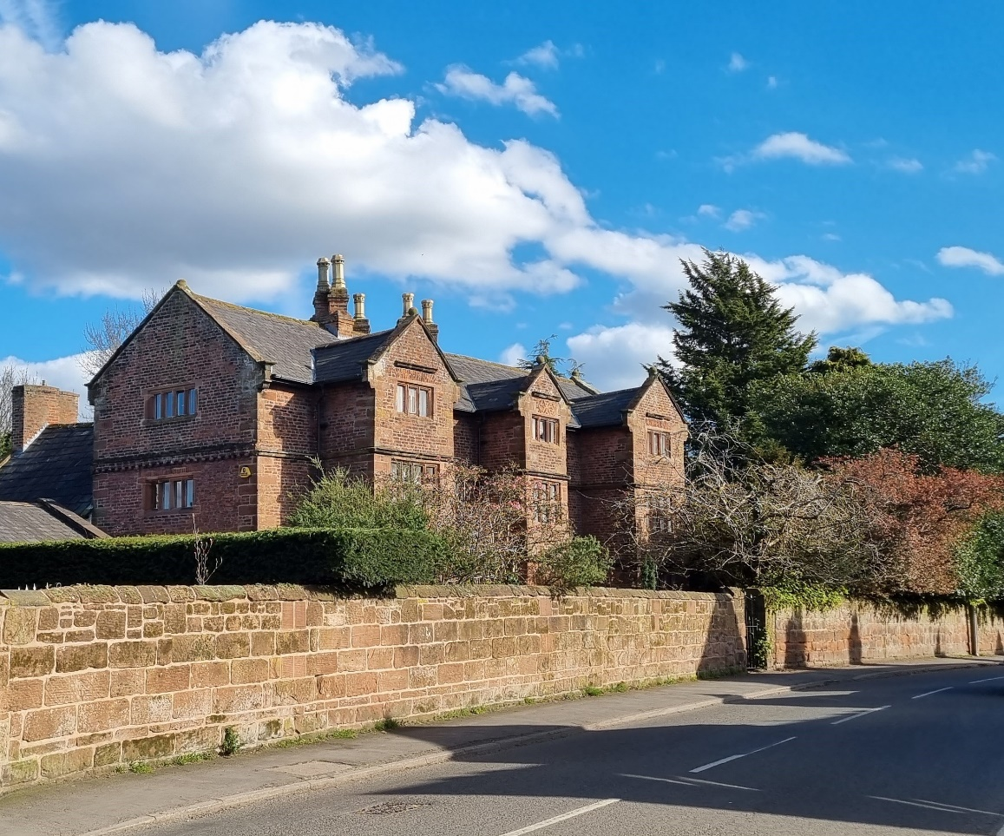

The Old Hall in 2023 (Photo: Ruth Hampshire)

Updated February 2024

