Smithy on the corner of the Village Green

On 26th September 1908, the Willaston Smithy was part of an auction at the Grosvenor Hotel, Chester. It was listed as Lot 19. The house was said to comprise a parlour, kitchen, scullery, washhouse, 3 bedrooms, 2 shoeing forges and a good garden. The tenant was Mrs Mary Millington and the rent was 9d.

It is not clear who bought the land but blacksmiths Joseph Millington and Stanley Ashton continued to work in the Smithy.

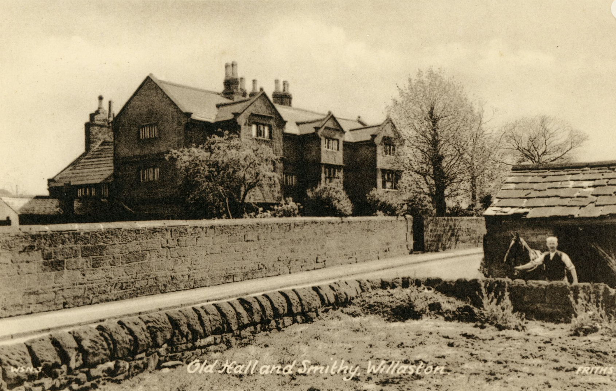

Keith Edwards remembers that Stanley Ashton was also the church verger. He always sat at the back of the church and ate sweets. He was also the grave digger for the churchyard.

After this, the Millington sisters lived in the cottage.

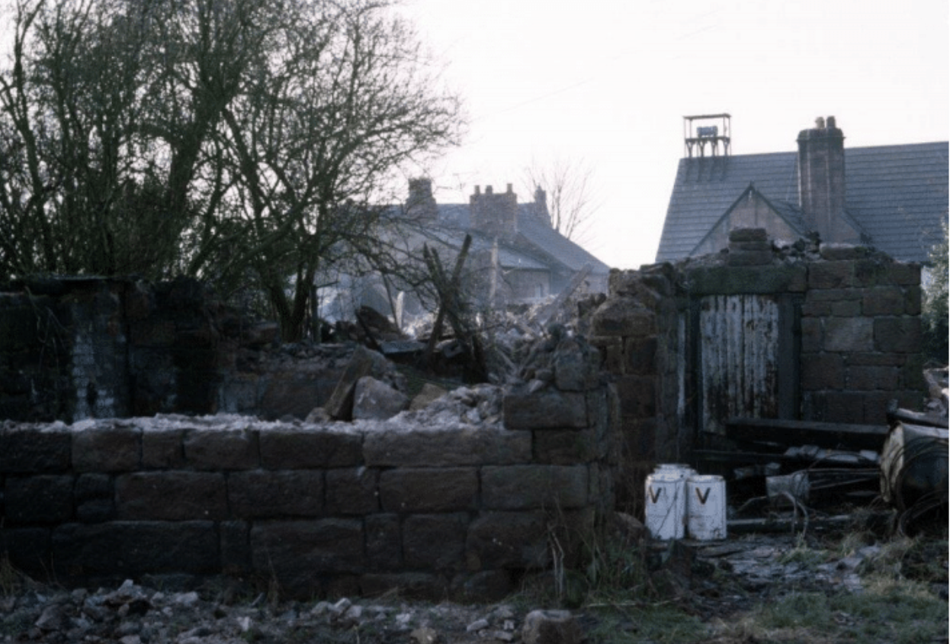
The cottage in the process of being demolished

The cottage was demolished in 1973 and is now Willaston Green Mews, which was built in 1984.

