Corner House Farm / Pollard Inn

Corner House Farm was at the south-west corner of the Green until later buildings came between the building and the Green. It was probably the ‘greate house’ occupied by Thomas Bennett which was referred to in the will of John Hey of Eastham in 1618. The date when the original structure was built is not known but it consisted of a single room on the ground floor and one above.

The oldest part of the house is built of local red sandstone, was almost square on the ground floor and three storeys high. The original hall room occupied almost all of the ground floor and contained a large inglenook fireplace.

On the floor above, the chimney piece has coloured carved decorations of flowers and other motifs below which is carved JB – AB – 1637 – TB – EB. The first two sets of initials probably refer to a John Bennett and his wife Anne and the initials TB, to their son Thomas. However, there were a lot of Bennetts in the area and it is not entirely clear that this is correct.
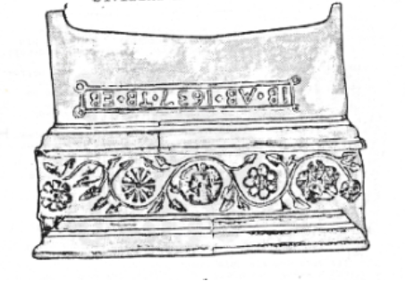

Drawing from The Bennetts of Willaston Old Hall in Wirral by E.C. Bryan

It appears that at some point between 1618, when the Bennetts inhabited the house but did not own it and 1688, they purchased the house. By 1714, they terminated their ownership and at some stage, the house was purchased by another Bennett family, who owned The Old Hall.

In 1859, Major John Bennett married Caroline Tarrett of Ludford Park near Ludlow. A marriage deed said that the Old Hall Estate (then called ‘Willaston Hall Farm’), together with Corner House Farm would give an annual rent of £450 to Major John for life and after to his wife, if she should survive him (which she did). At this time, Corner House Farm was occupied by Samuel Mealor and had 169 acres of land. The estate included 22 fields.

On 11th June 1870, Corner House Farm was put up for sale by action at the Queen Hotel in Chester. There were 17 lots of which Lot 17 consisted of ‘House, Farm Buildings, Garden etc’ containing ¾ acre, stackyard ¼ acre and ‘Big Wall Croft’ 5½ acres. The other 16 lots were fields and the total area of the 17 lots was 159 acres. The property went to the Uvedale Corbetts of Shropshire. The tenant continued to be Samuel Mealor.

The 1911 Census records record that the Pollard family were now living at Corner House Farm. At this stage, father, Joseph was already dead but the mother, Sarah, was listed as a farmer aged 49. Five male children aged between 15 and 29 all worked on the farm and the youngest child, Elsie was at school. Their other son, John was listed as an apprentice and a dentist. John served in the Middle East in WW1 and died as a prisoner of war in hospital at Mosul. His name is listed on the Willaston War Memorial.

The building was listed in 1962 as Grade II.

In 1971, the Cheshire County Council authorised a grant to repair the farm. The report noted that much of the interior had been well restored revealing a massive inglenook.

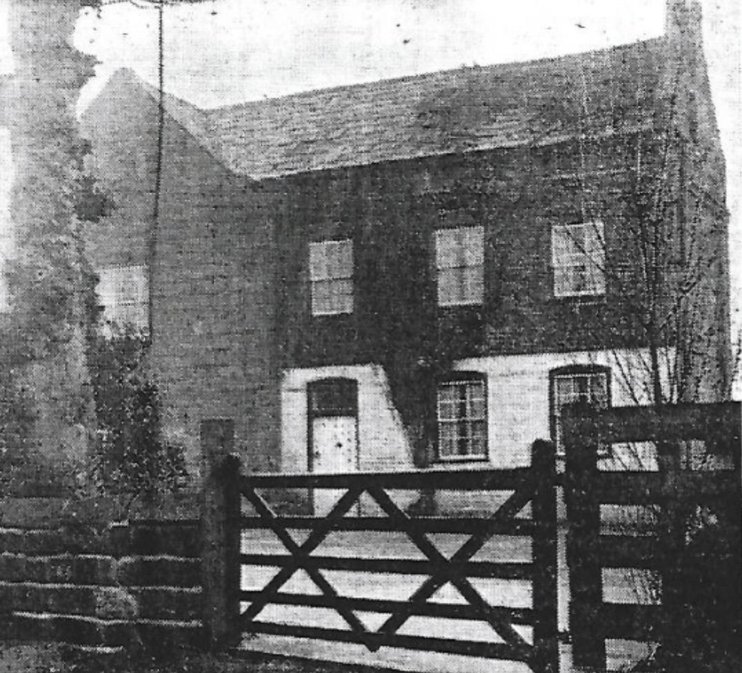

Corner House Farm in 1971 (Photo The News, Friday 17th December 1971)

In 1973 and 1974, two fires occurred at the Farm. The first gutted a 173-year-old brick and sandstone building and the second a 100-years-old brick store containing about 30 tons of Irish seed potatoes.

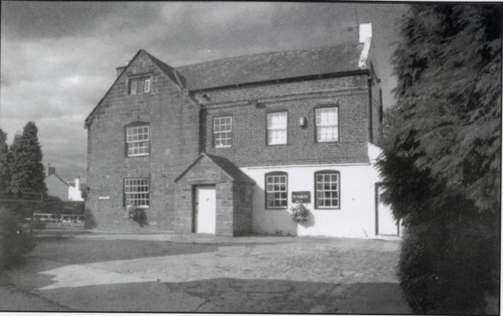

Date unknown.
Photo from Willaston – Centre of Wirral by Bob Prince

In 1983, the building was converted to a residential hotel and restaurant, named after the last farming family to own it. Sadly Jack Pollard died two years later.

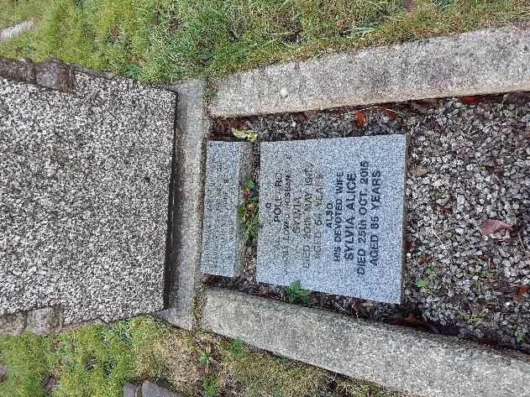

Jack Pollard’s grave in Christ Church cemetery

The Dutch chef of the new restaurant had been in service with the Duke of Westminster and gained a good reputation with dishes including roast rib of beef, dover sole, chicken a la crème. Fish courses ranged from £4.50 to £6.50 and grills from £5.40 to £7.00 for a 16oz T-bone steak. Although villagers were not initially in favour of the change, it proved to be popular.

In 1986, Pollards Inn was sold to Greenall’s Brewers.

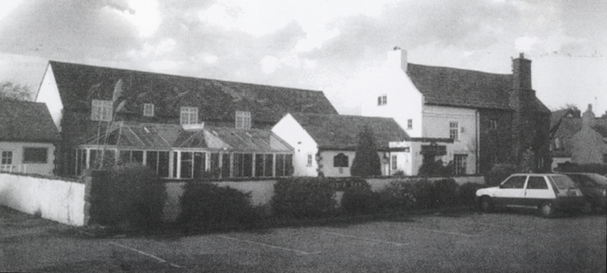

Pollards Inn, possibly 1995
Photo from Willaston – Centre of Wirral by Bob Prince

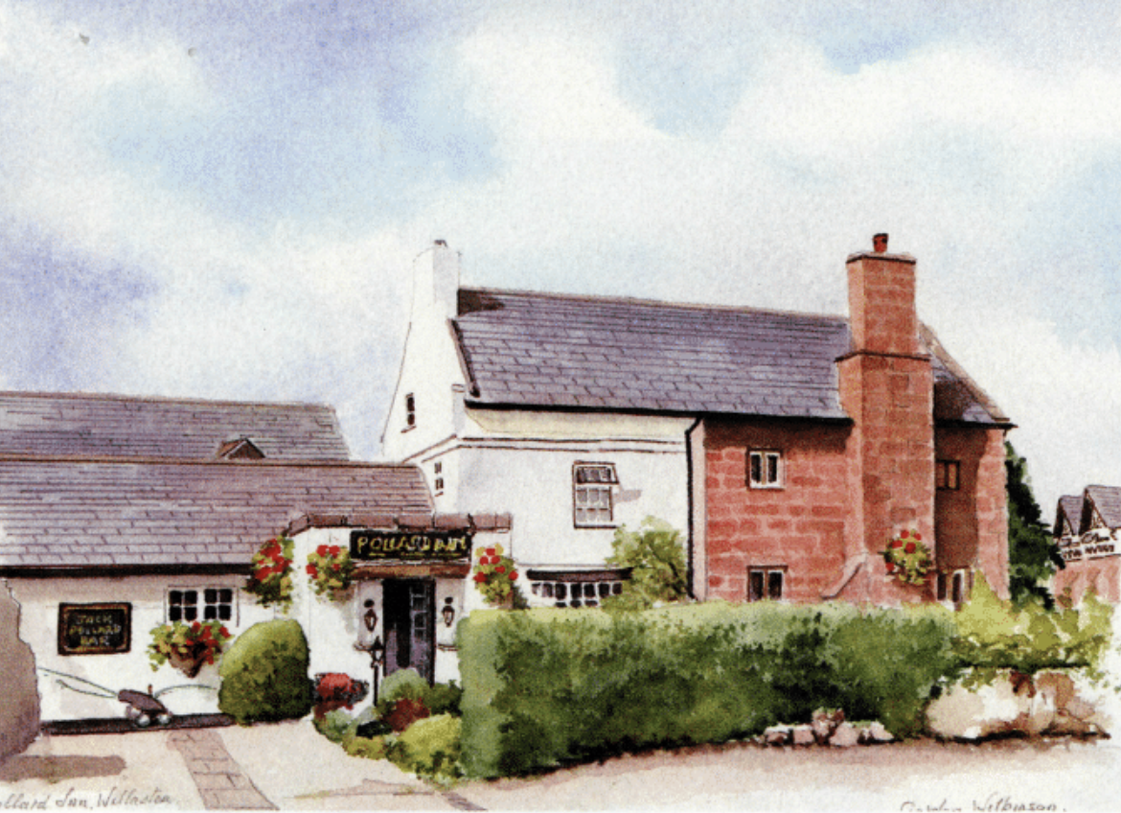
Picture of Pollard’s Inn by Gordon Wilkinson
(printed in Cheshire Life November 2006)

Updated February 2024

