Corner Stores

On 18th June 1920, the Old Hall was sold by public auction in Liverpool. Amongst the particulars, was stated that ‘a portion of the north-west corner of the outbuildings was let as a provision store containing a shop, office with store room over.’

In 1951, this store, on the corner of Hooton Road and Hadlow Road, was run by H. Coll.

Advert in Willaston Parish Magazine June 1951

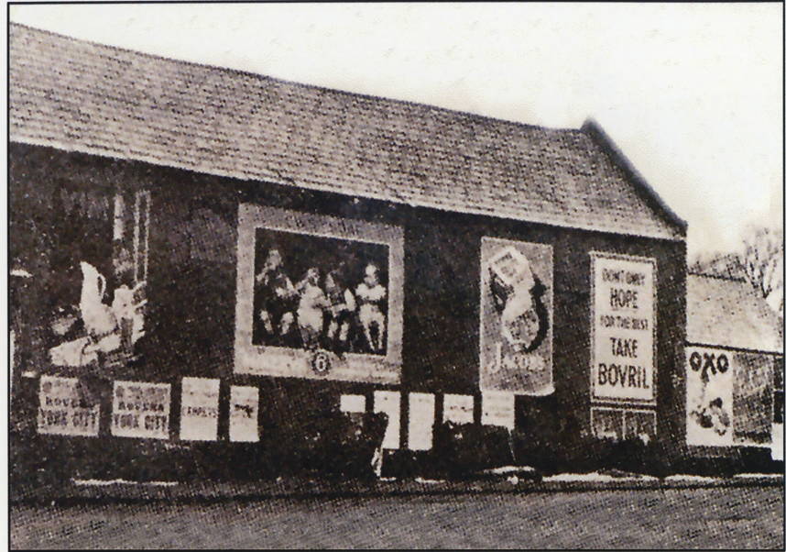

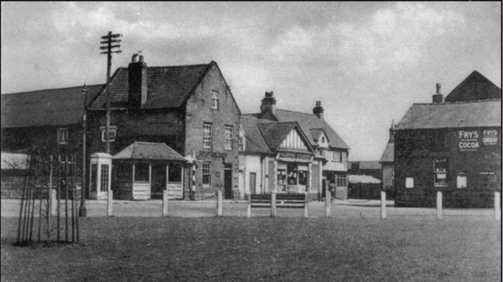

Photo from Willaston – Centre of Wirral by Bob Prince

Dates of these photos unknown

After Colls Barn was demolished, a small shop was on the area:
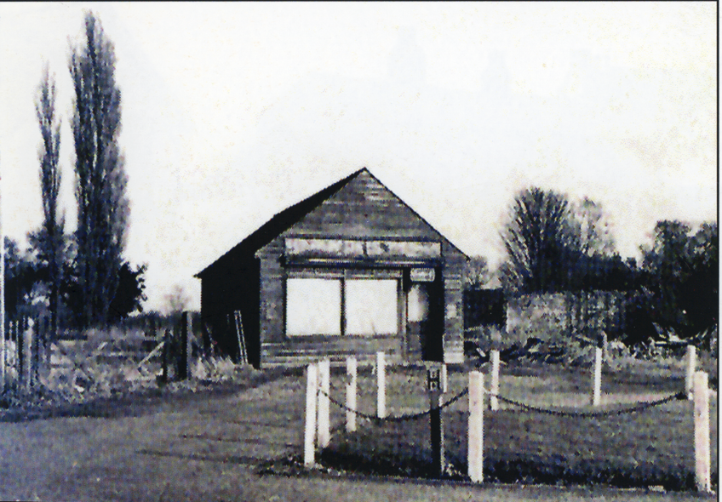

This was described by Cheshire Life in 1970 as ‘this old hut-cum-shop on derelict property – County Council land, and of no credit to them.’

Joyce Ryan remembers: ‘One night, a group of guys came out of the pub and dismantled it because it was all falling down.’

