Willaston CE School

The first village school in Willaston was built in 1859 on the Green. Initially it consisted of one room. The Chester Chronicle later reported that ‘through [Mr Duncan Graham’s] and the late Mr Christopher Bushell’s combined efforts, a dame’s seminary, which was the revered seat of learning in Willaston, was supplemented by the present national schools.’

The school was originally funded by voluntary subscription but in 1877 the ratepayers in the village voted that a voluntary rate of 6d (or less if it would meet their needs) should be levied on the rateable value of the district of Willaston Parish to meet the annual expense of maintaining the school. For several years this rate remained at 3d and was collected each year in April.

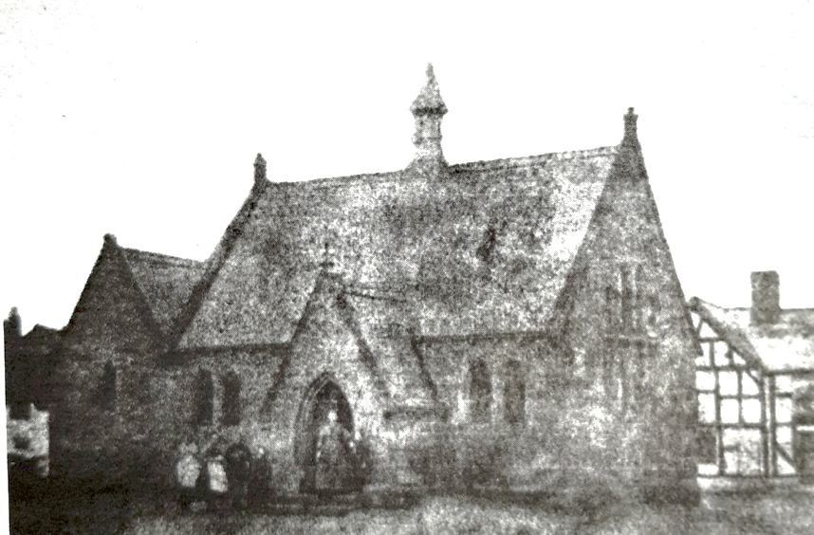

The school on the Green c1870 when it still had a single classroom. The Red Lion is on the right. (Photo: Willaston’s Heritage by E.C. Bryan)

In December 1877, the managers applied for the status of a Public Elementary School under the Education Act 1870. The children attending the school paid fees, infants 2d each week and older children 3d, with reduced rates for families. School opened at 9am and the doors were locked at 9.15am with latecomers excluded. One letter from an irate mother whose children were consistently late or absent is reproduced in full in the log book, with annotations by the headmaster:
‘I have no money for yow (you) their father as (has) not been working and he not (is not) working today and do you realy (really) think I am made off (of) money.’

Two further rooms were opened in December 1877. At this time the headmaster was Mr Read and he had 95 children in his school. A bell turret and bell were added but nearby residents complained of the noisy bell.
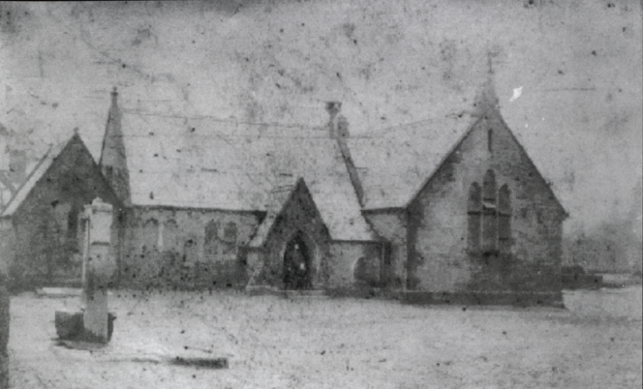

School with the village pump in front (date unknown)
Photo from Willaston – Centre of Wirral by Bob Prince

In 1882, Thomas Bostock became the headmaster and the average attendance was 140.

The school accounts for 1984 show that the total annual salary bill was £192 1s 8d, cleaning and caretaking, £13 12d 0d and heating about £5.

The infants in 1895 with their teacher, Miss Cottrell

In 1898, Mr Fell became the teacher. He had a reputation for being very strict. The numbers of pupils increased until there were 165 children in school. Several girls became pupil teachers at a salary of £5 a year. Their indentures were signed by the headmaster and their parents and after three or four years’ apprenticeship, some of them took the Queen’s Scholarship examination and entered college to be trained as teachers.

In 1895, the school closed for 7 weeks owing to an epidemic of measles and whooping cough and in 1898 it was closed for scarlet fever.

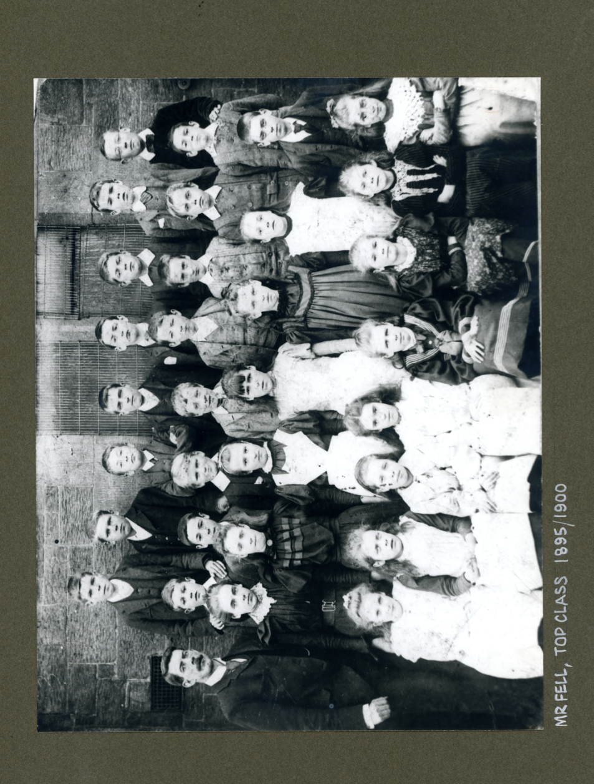
In 1901, under the new Education Act, Foundation Managers were appointed. A house was built in Smithy Lane and Mr Fell, who had lived in lodgings until then, moved into the house after he got married. The staff at that time consisted of the Headmaster, two assistants and two pupil teachers.

In 1905, as there was no playground, the Inspectors proposed that they should close the land adjacent to the school. This was resisted by local villagers who took down the fencing. Minutes of the school Managers’ Meetings show that there was a prolonged feud between the two teachers about who should supervise the infants during playtime and the Managers had to make peace.

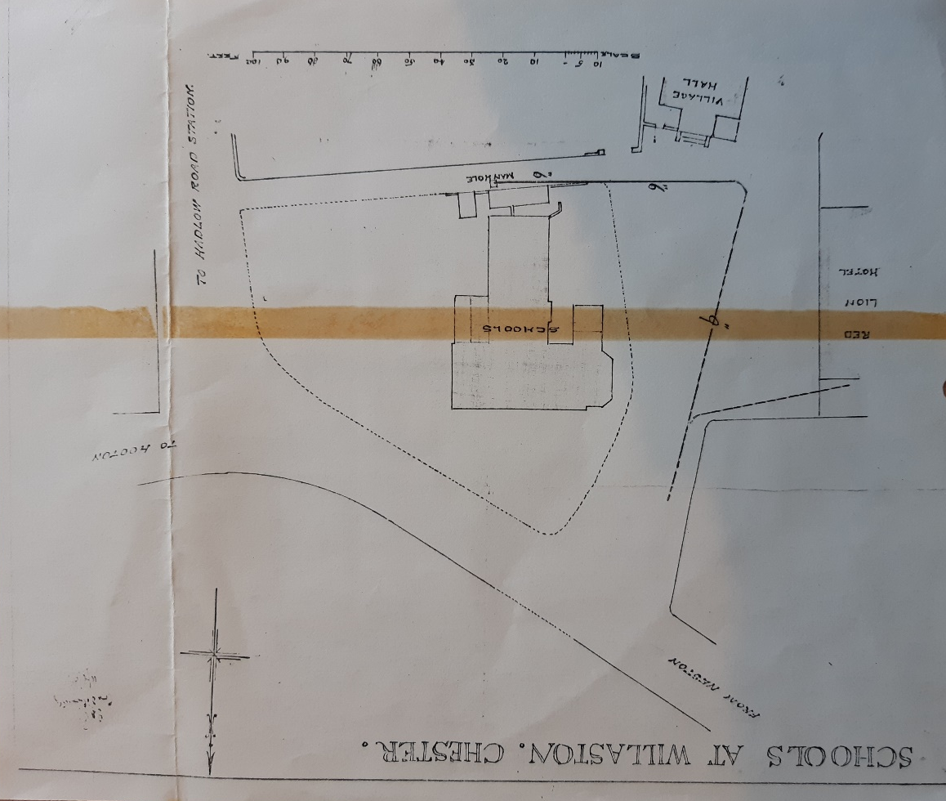

Copy of a plan of the new school drawn up in 1908

In 1911, the Education Authorities reported their opinion that the school was built on an unsuitable site, the play-grounds should be enclosed and that the position of the sanitary arrangements was distinctly wrong. The managers considered the report but concluded that they were unable to remedy these defects but did move the infants to the Village Institute. In consequence, the Board of Education condemned the school and decided to build a Council School on a site on Hadlow Road. However, the First World War intervened.

George Cecil Barnes remembered:
I attended the school between 1912 and 1918… The school was surrounded by the Green. It was not in the form a green in those days but was laid out with a hard surface and was used as the school playground… we used to play rounders, marbles, hopscotch, skipping, Maypole dancing, drill, hand-ball, jacks, kick the can, hide-and-seek and many other youthful recreation and pastimes…’

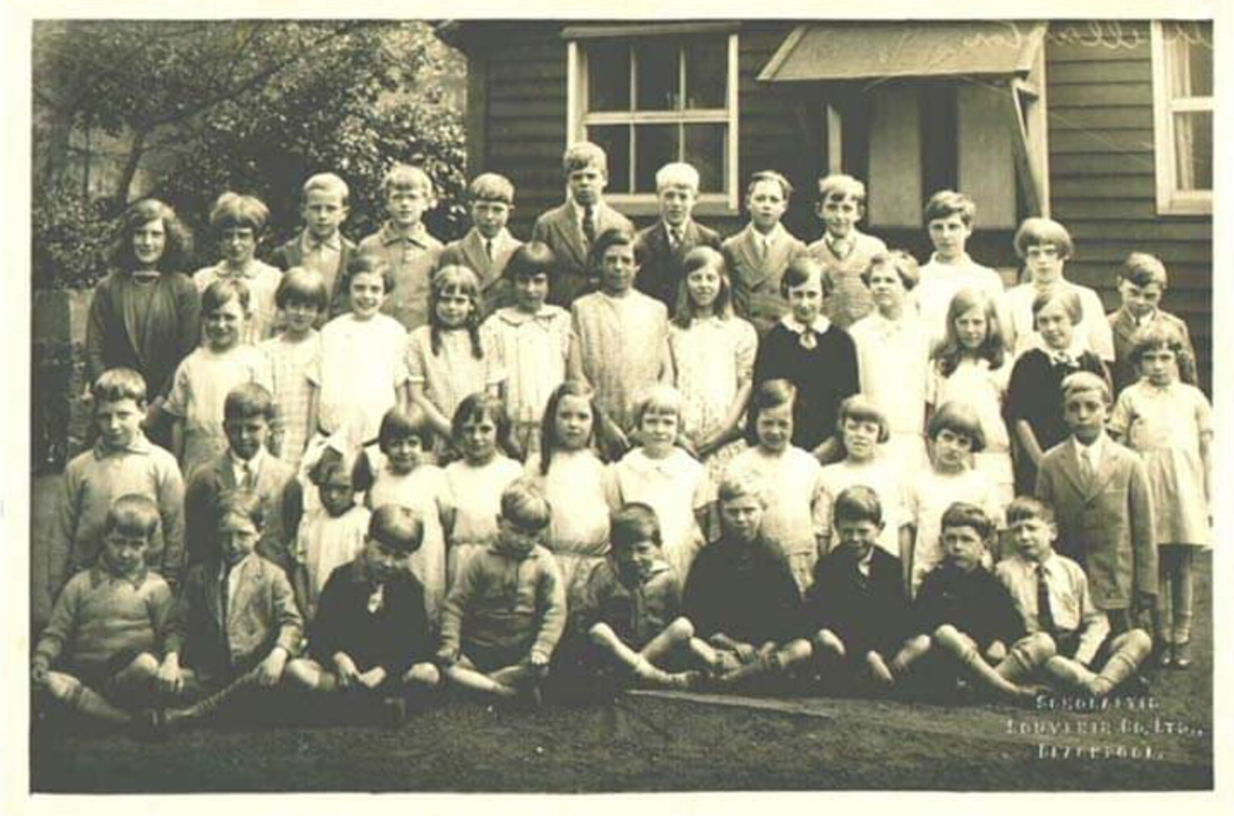
School children in 1926 (Photo: Richard Moss)

In 1926, the Education Authorities re-opened the issue of the unsuitability of the school.

A letter from H. Todd of Willaston Grange in 1926 said the following in response to their report:

I was asked to comment on the defects which [are in the report].

As regards the position of the school, it is not admitted for a moment that it stands in an unsuitable position. It is true that it stands on open ground which there are great difficulties in the way of fencing in, owing to certain copyhold rights vested in various person, but there is a kerb and channel running round the boundary of the playground and this prevents vehicles crossing and, in fact, no-one can recollect there ever having been an accident to a child when using the existing playground.

The suggestion that the playground is unsafe because cattle can go across it is too ridiculous for serious consideration. It so happened that when I met the Inspector at the school… he was standing in the doorway discussing matters when a few of some milking cows, on their way to the fields after milking, crossed over the corner of the playground. The Inspector at once in horror said ‘just look at those cattle crossing over the playground. We can never have the children exposed to such danger as that.’ I replied that in an agricultural village like Willaston the children were almost born and brought up with the cattle and as soon as they were old enough were only too pleased to be allowed to drive the cattle form the farmsteads to the fields and back again and there could not be slightest danger or risk to the children under the circumstances, even if a few harmless milking cattle did stray across the corner of the playground…

… the new site is far less desirable than the present one, as it will open out from an enclosed space immediately onto the main road within about 200 yards from the station, with the result that just as the children are coming down the Road to the School, they will be in danger of motorcars being driven rapidly to the station by people hurrying for their trains. It is also further away from the centre of the Village and to that extent will give most of the children further to go…’

A meeting of parishioners was called on December 14th 1926. It was unanimously resolved to offer to build a new Church of England school for 150 children on a new site. The estimated cost was approximately £5,000. At the same time, it was decided to protest against the proposed Council School. The Education Authority gave them twelve months to start the building and they had to promise to provide accommodation for up to 250 places when requested by the Board. Fundraising began with a general meeting on Friday January 13th 1928 at which villagers were asked how much they would be willing to give.

Mr Fell retired in 1929 after 40 years’ service.

In 1930, Mrs Glazebrook of the Lydiate cut the first sod of the new building and the school in Neston Road was opened on Sunday 19th October 1930, with accommodation for 160 children in four classrooms. The school was for boys and girls aged 5-15 years. The old school building on the Green was demolished.
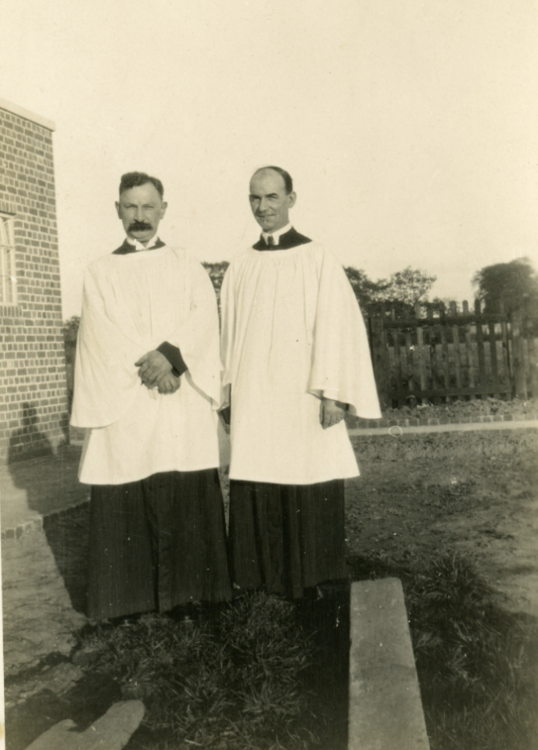

The blessing of Willaston School by the vicar and the Bishop of Birkenhead, thought to be in 1930.

Sales document for the old school site to Willaston Parish Council

Schoolchildren in 1934
Standing L-R: Daphne Lloyd, Mary Mulreay, Vera Earl, Violet ? Mr Helm (Head Teacher), Violet Griffiths, John Davies, Eric Prince, Steve Lloyd
Middle Row L-R: Jean Graham, Moyna Cottrell, Nancy Davies, Poppy Edwards, Kitty Fleet, Betty Maiden, Marjorie Flavell, Joan Pugh
Front Row L-R: ‘Spud’ Davies, Eric Higgins, Billy Mulreay, Alan Pollard, Stephen Bartley, Roger Preater, Jimmy Edwards

In 1944, a kitchen was added to the school.

Sadly, in 1945, a schoolgirl from Hooton called Heather Tongue was killed in the road outside school. The bus from Hooton drew up and stopped to let off the children, Heather ran straight across the road into a car coming in the opposite direction.

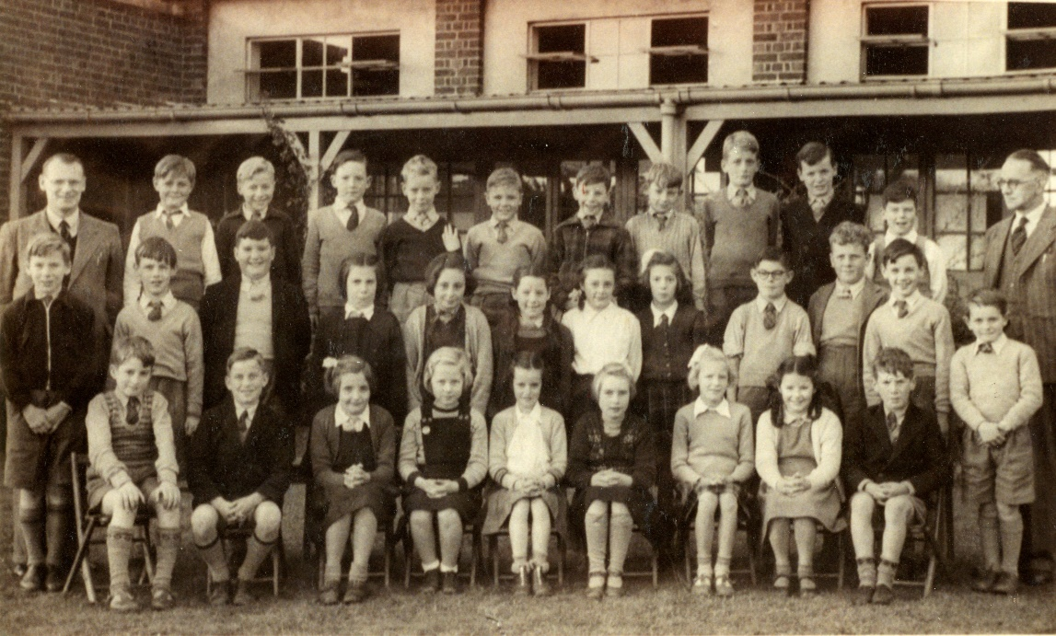
Schoolchildren in the 1950s
Pictured include Mr Haydock, Headteacher, Rich Pugh, Martin Collins, Lucille Davies, Glenda Williams, Dennis Munroe, Eleanor Flavell, Barry James, Royston Whithead, Judith Johnson, Joyce Clapperton, Eddie Jackson, Paul Taylor, Billy Stevenson and Mr Hird

Keith Edwards remembers that the school in the early 1950s consisted of one classroom with four classes in it, divided by screens. The children were often sent to work in the garden, which were much admired by villagers. Children would get on the train to Neston where the boys learnt woodwork and the girls learnt cooking and laundry.

In 1954, faced with heavy expenditure if it remained as a Church School, the managers applied for ‘Controlled’ status. This transferred the property to the County Education Authority.
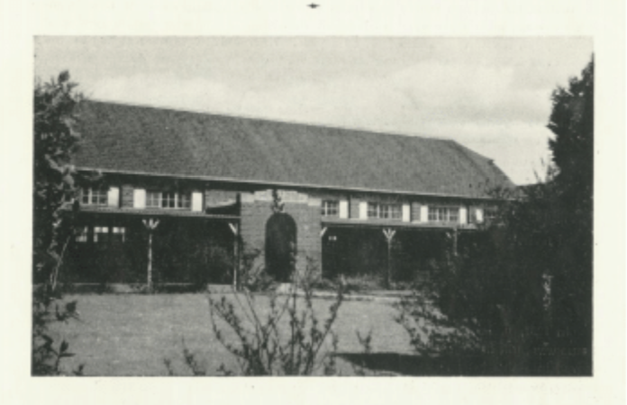

Willaston School in 1955 (Photo from Christ Church Centenary 1955)

School children in about 1958.The teacher is Miss Postance.

The following pictures are from 1969-1973 (from Chris Mcreadie)

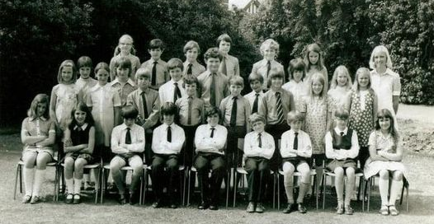

The teacher is Miss Oxley

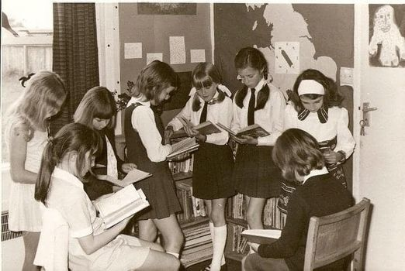

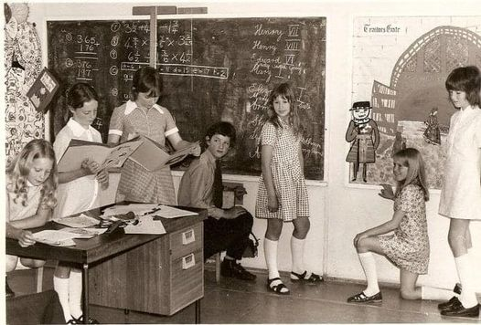

From left to right:
Theresa Newman,
Julia ?
Isobel Whitmore
David Malcolm
Lizzie Barnett
Christine Jones
Lynne Edwards

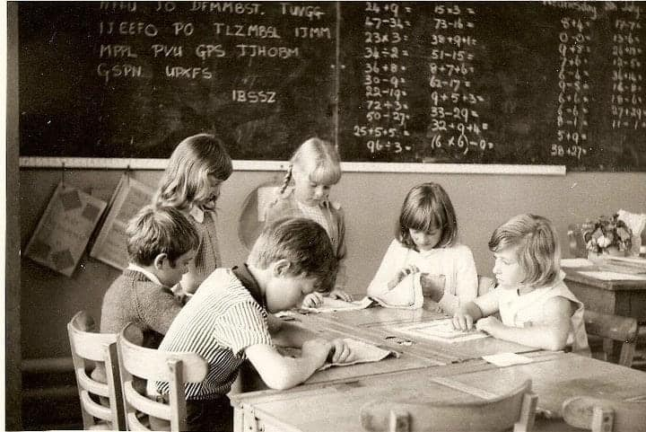
From left to right:
David Holding
Peter Ginty
Lizzie Barnett
Christine Jones
Kerry Harrison
Jane Nicholson

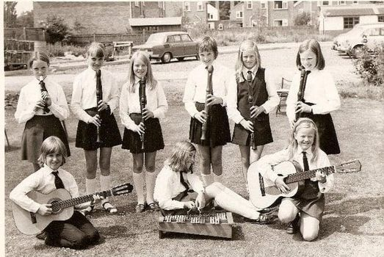

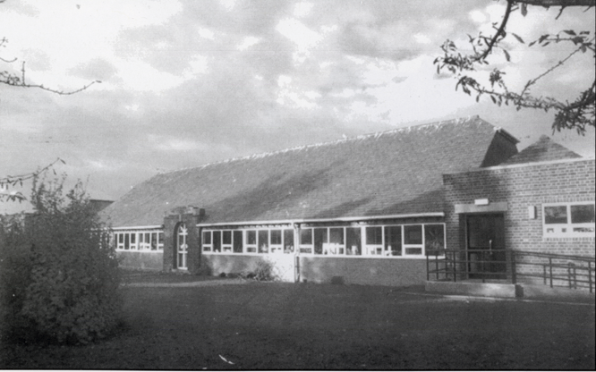

Date unknown (photo from Willaston – Centre of Wirral by Bob Prince)

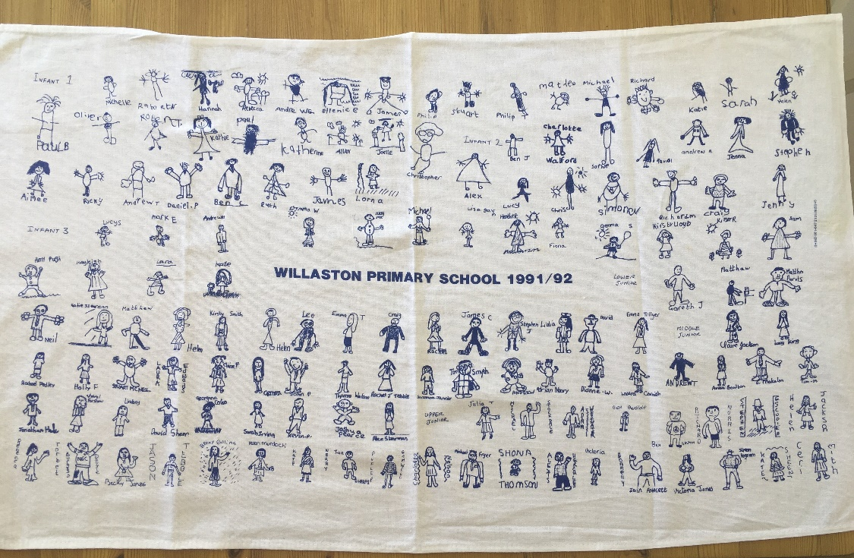

Willaston School Tea Towel 1991-92
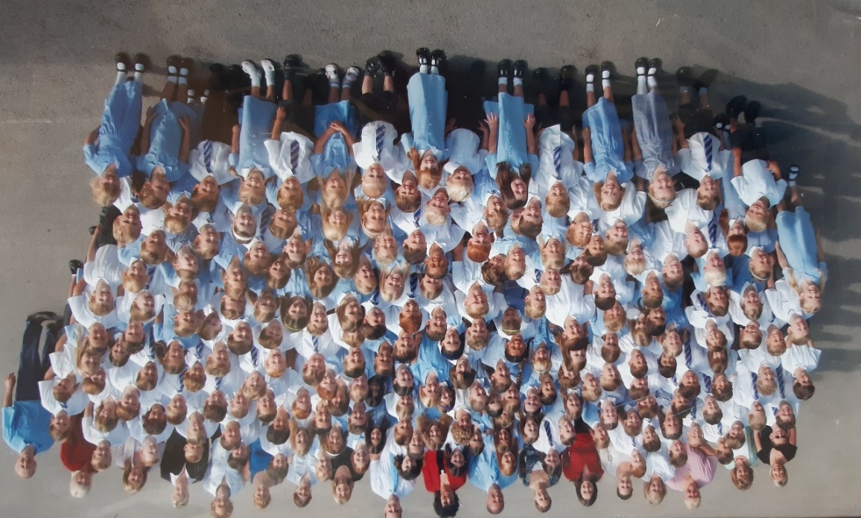
Willaston School 2006, with headteacher Mrs Drew in the centre back

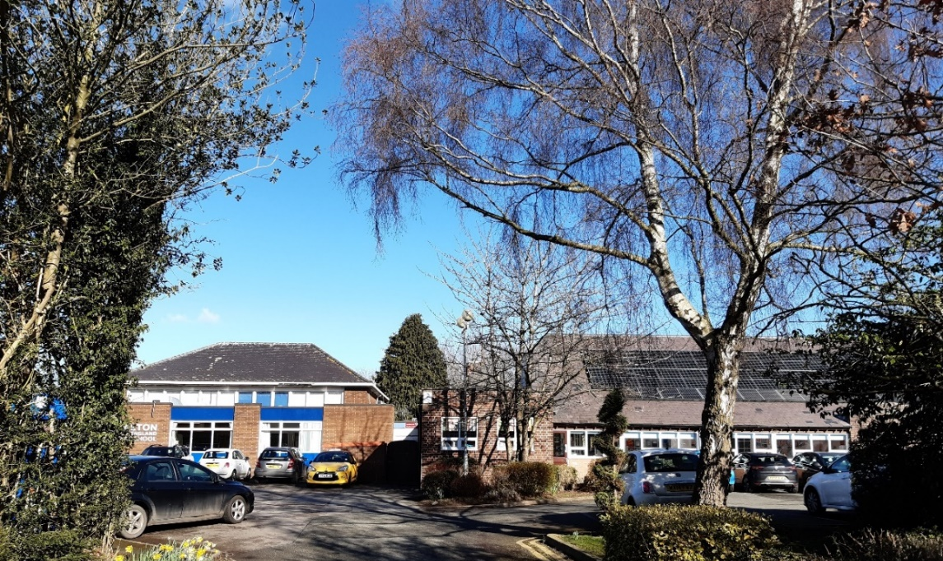
Willaston School in 2023

Updated January 2024

