Whitegates

The land, which is now the Whitegates estate was bought in 1923 by John Henry Burns who was a City of Liverpool warehouse owner. The house was built in 1935 and the architect was Hubert Thomas, who also built the YMCA building in Birkenhead and Irby Village Hall.

Mr Burns was said to be an alcoholic. Keith Edwards remembers that his mother worked there as a domestic and that there was a very smart front room. When the family went on holiday, she was not allowed to go with them as she had to continue working. In 1934 the land was left by Mr Burns to his widow and children, Gilbert Franklin Burns (of Redcroft, Willaston) and Louisa Gertrude Burns, along with Thomas Winlack Harley.

Gilbert Burns was a squadron leader who ran the air cadets across the whole Mersey area, growing it to one of the largest in the country. He received an MBE (Military Cross) in the New Year’s honours list of 1946.
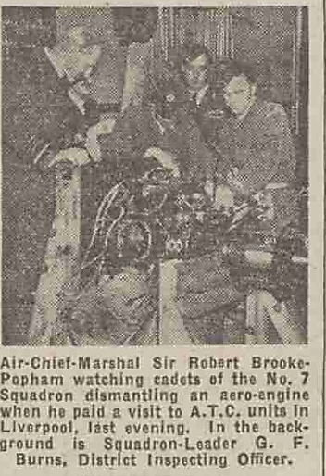
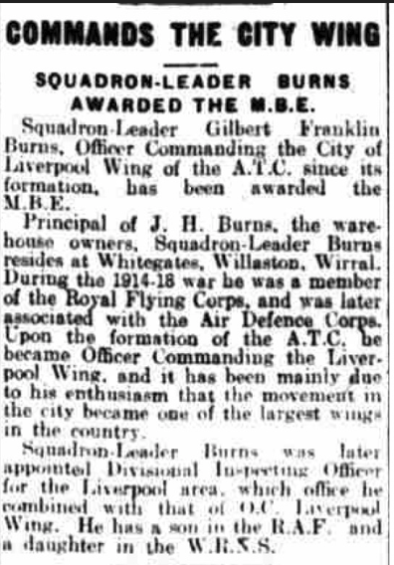

Cuttings from the Liverpool Echo, Friday 4th September 1942 and 22nd January 1946

1939 Register showing that the residents were Gilbert F Burns, Kathleen H Burns and John G V Burns.

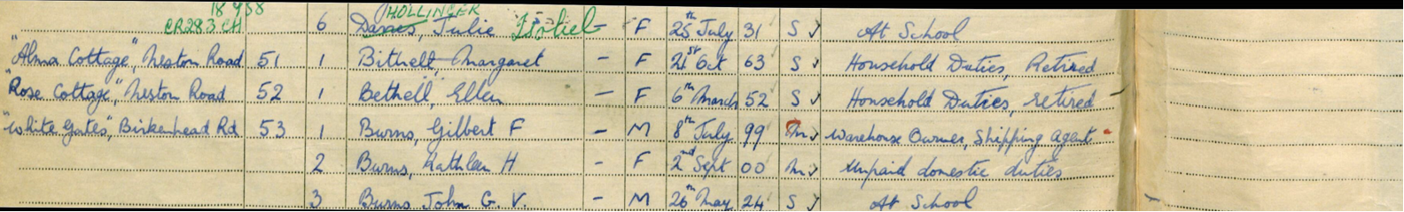

John G V Burns was active in WW2 in the Far East and became a prisoner of war.
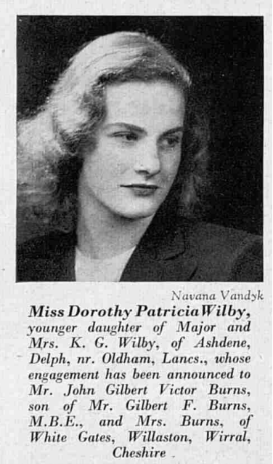

Article from The Tatler and Bystander in November 3rd 1948, announcing the marriage of John G V Burns to Dorothy Wilby. They had three children but sadly the marriage ended in divorce.

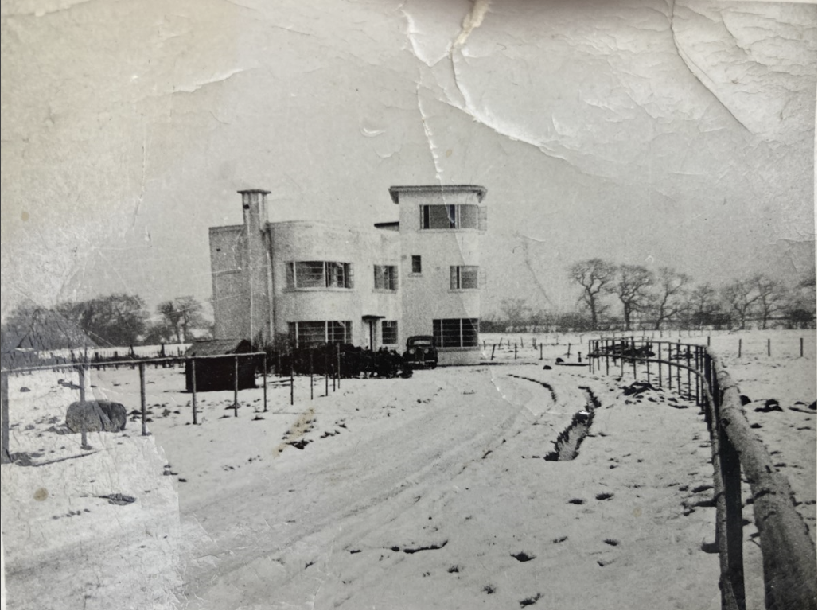

The date of this photo is unknown. However, the entrance to Whitegates is from Birkenhead Road as the estate road did not exist.

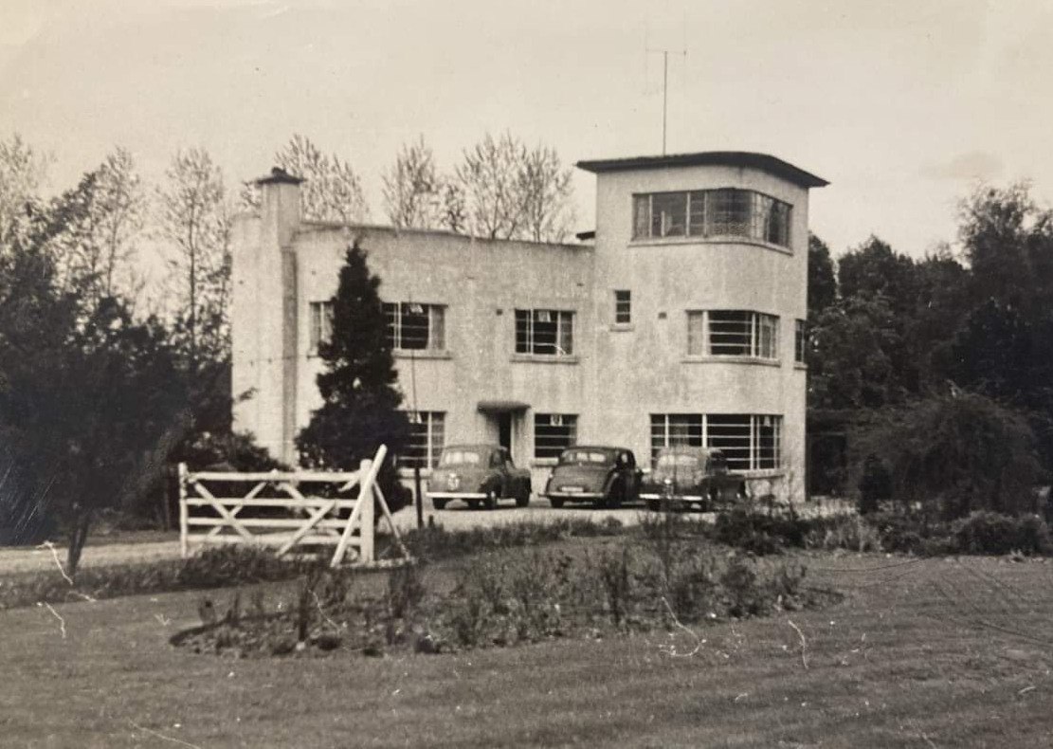

This photo shows Whitegates, probably in the early 1960s, also before the Meadow Lane/Whitegates estate was built. The ‘white gates’ appear to be a farm style gate – nothing ornate or in keeping with the art deco building. There was a nursery on the rest of the estate called Ashtons market garden.

In 1969, some land was sold to Normand Mitchell for development. This house was called The Shrubbery and included the drive onto Birkenhead Road.

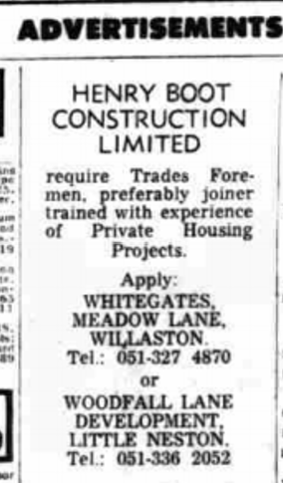

Advertisement in Liverpool Echo, September 9th 1971

In 1970, more land was sold and planning permission given for 60 detached houses, which became Whitegates Crescent. The builders were Henry Boot Construction Limited and they were based in Whitegates whilst doing the work.

In 1974, planning for three more houses was refused. This may be the reason that that are no numbers 5 or 6 on the estate.
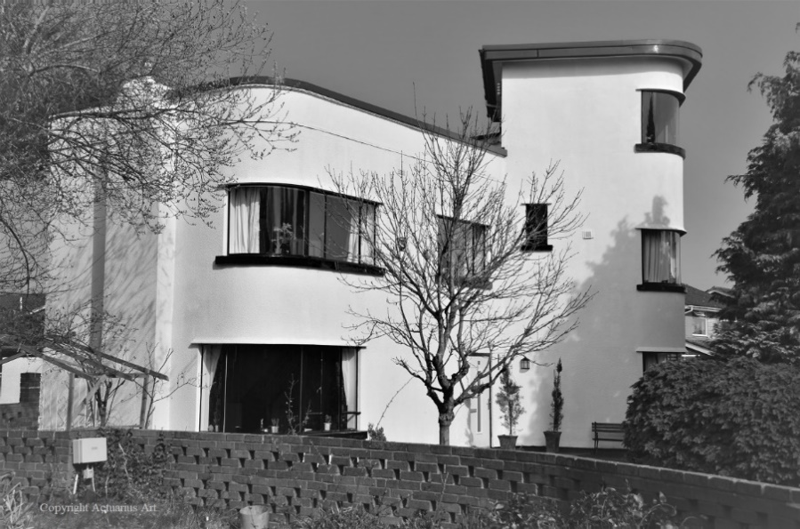

The house in 2022 (Photo: Actuarius Art)

Updated January 2024

