Wake Up Willaston and the birth of Willaston Residents’ Society

In June 1970, Alan Brack wrote along article in Cheshire Life titled Wake Up Willaston! in which he lamented the state of the village.

…Willaston has gone downhill alarmingly. Today much of the old is very old and in an advanced state of decay while most of the new no more blends with it than oil does with water. And as for ‘a happy blend of industry with agriculture and commerce’, the truth is that what industry there is has intruded without let or hindrance right into the village centre.

Willaston is living proof of the need for the Town and Country Planning Acts. If anyone doubts this, show him Hadlow Road, an unplanned, disastrous muddle of Victorian terrace houses, undistinguished modern semis, the ancient but dilapidated Ashtree Farm, odd shops, and the fine Elizabethan Willaston Hall looking out upon derelict farm buildings.

Show him also Neston Road where, in the space of two or three hundred yards the scene changes indiscriminately from expensive bungalows to modern houses, to terraced cottages to council houses; where cattle food is made in a building almost leaning on the Parish Church which is opposite a light engineering business which is almost on the village green.

And if he is still not convinced show him Elm Road where war-time built, flat-roofed, pebble-dashed houses have plumbed the depths of incongruity. It is all a far cry from ‘England as it-ought-to-be’.

There is, however, a preponderance of fine houses in the village and there are many buildings worth more than a second glance, no fewer than thirteen being listed as Grade II buildings. A typical example – in fact the example, oft quoted and oft-photographed – is the old Red Lion inn on the village green. Built in 1631 it ceased to be a licensed pub in 1928. It has been empty for a long time now and is owned by a brewery company who wanted to demolish it and build a modern pub in its place. The inevitable outcry brought about a public inquiry and ultimately a preservation order – and so a stalemate was reached. The Red Lion is still there, untouched, and becoming grimier and more derelict every day.

A similar situation obtains with the empty cottages facing the green and also with Ashtree Farm in Hadlow Road. This crook-framed cottage dates from the fifteenth century and for some years has lain empty neglected and a target for vandals – but ‘preserved’. Its windows are broken, the interior is ankle-deep in rubble and rubbish but, for all that, it still remains a building or architectural and historical importance. Happily, a young couple from Neston – Bill Hardman … and his wife Diana – have bought the place and intend to restore it and live in it. They ought to be granted the freedom of the village for their courage.

The article then describes the development of the village development plan, which was approved in January 1969 by the County Council Planning Committee.

So, how has Willaston changed as a result? The answer is: not at all. The plan is simply a long term guide-line to which anyone wanting to build anything or change anything must adhere. It is not, as some people at first seemed to think, a blue-print for an almost immediate rebuilding of the place. Consequently, there are people who feel that the plan was little more than an entertaining exercise for the planners.

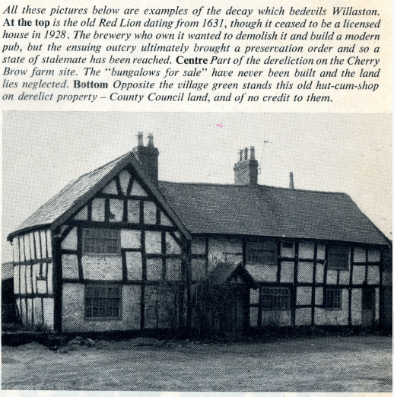
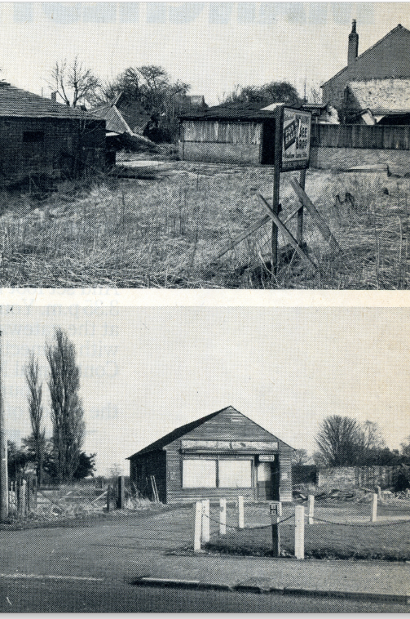

The Willaston Countryside Association – a sort of village civic society – which once boasted 250 members seems to be moribund, which is a pity for if ever such an organisation were needed it is now… Willaston needs a ginger group; an organisation aimed at promoting a pride in the place and indeed, with preserving its identify. Perhaps the residents have not noticed how it is slipping away? The Willaston Parish Council ceased to exist when the village became just another ward of Neston UDC. This is now ono Willaston railway station and there is now no Willaston telephone exchange, while letters posted in the village bear a Heswall postmark.

But all is not lost by any means. If the residents can shake off the general apathy which seems to have set in during the last five or six years then perhaps we may yet see a ‘Willaston-as-it-ought-to-be’.

This article hard a startling affect and a subsequent article by Alan Brack in Cheshire Life in October 1970 was called Willaston Wakes Up!

When we expressed our disappointment at the way the village was deteriorating and when we wagged a finger at Willastonians for doing nothing about it, it seems we lit a fuse that exploded into a fair old rumpus that attracted space in the national press, on television and on the radio and kept Willaston in the headlines of the Merseyside and Deeside papers almost every other day throughout July and August and well into September.

Within a week or too [the Hadlow Green Women’s Institute] had received permission from the owners to remove a completely derelict and collapsed corrugated -iron Dutch barn which had lain rusty and twisted for years in a field within a hundred yards of the village green.

At the end of July nearby Puddington was named for the second years running as Cheshire’s Best Kept Village. A couple of days later Willaston folk … were startled to see a large sign erected on their village green … proclaiming Willaston as WORST KEPT VILLAGE 1970!

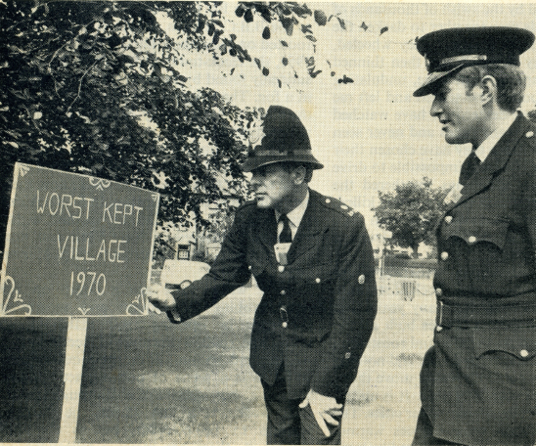

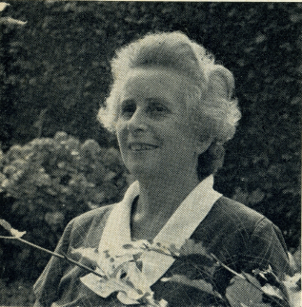
It roused into action Mrs Joan Adams, a resident for forty years … who promptly set about organising a petition. It read ‘We, the ratepayers and members of Willaston, resent the horror of our village and wonder what the Council members are doing and, if they are doing nothing and have no time to do anything, they should give way to someone who will…

Feelings began to run high and eventually Mrs Adams called an open meeting of the village … once again, not mincing her words, the notice was headed: FIRST AID FOR OUR AWFUL VILLAGE: ALL WHO WOULD LIKE TO SEE WILLASTON AS THE BEST KEPT VILLAGE WELCOME. On the night, the Church Hall was packed as it has never been packed before, with over three hundred residents crammed in.

The meeting agreed to elect a steering committee for a new society. In 1973, the Willaston Residents’ Society started, amalgamating with the Countryside Society to form the Willaston Residents’ and Countryside Society on 7th May 1974.

