The Old Bakery (Hadlow Road)

This building was originally a bakery run by Mr Hughes. Keith Edwards remembers particularly enjoying long pink iced buns bought there and Elizabeth Harker remembers that the sponges were beautiful.
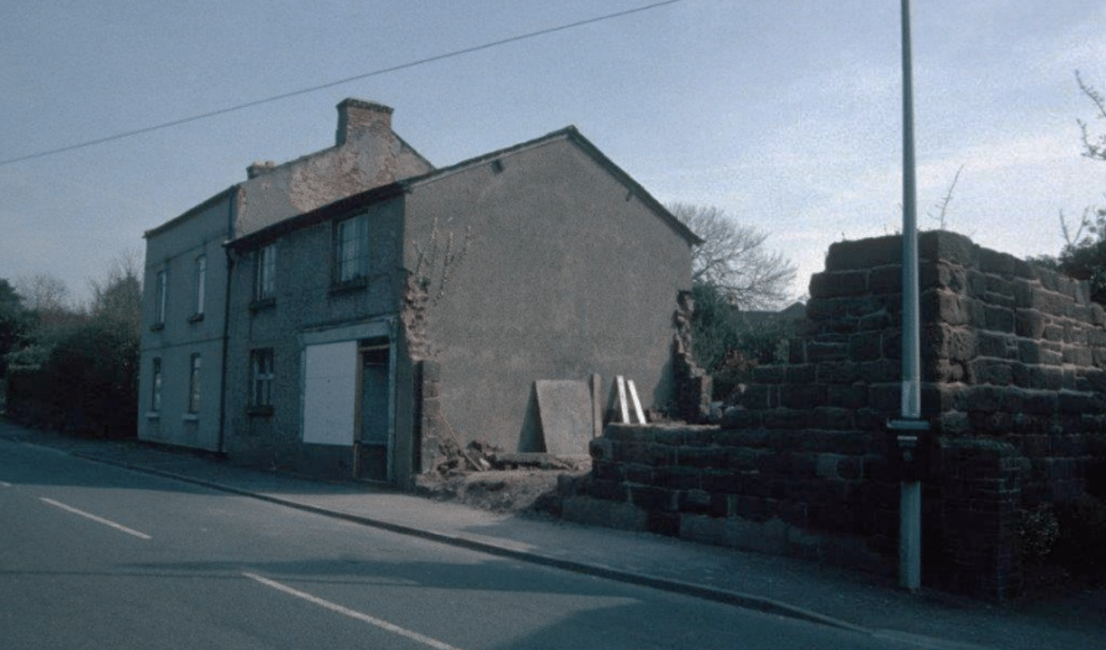
The Old Bakery in 1995, before restoration
(Photo: Jean Griffiths)

The building now houses Hunters Projects Ltd and part of it was converted into a house in 2008.

