The Nags Head

The building has a house plate in the gable which reads RV 1738. The initials probably refer to Richard Vernon and the date to the year of building, although there have been many alterations and the present building has little in common with the original.

Quarter Sessions show that in 1822, the name of the pub was the White Horse and the licensee was Thomas Lloyd. By 1834, the inn had become the Nag’s Head and the licensee was William Delamore (he had a field in the road now known as Delamore’s Acre).

There was a bowling green at the rear of the pub.
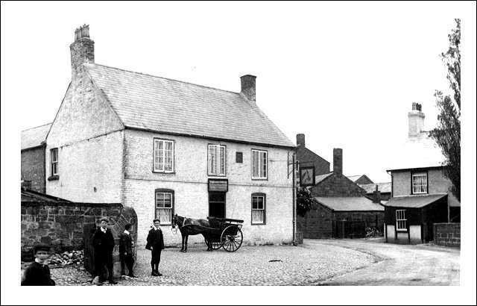
The Nag’s Head shown on a postcard sent in 1906.

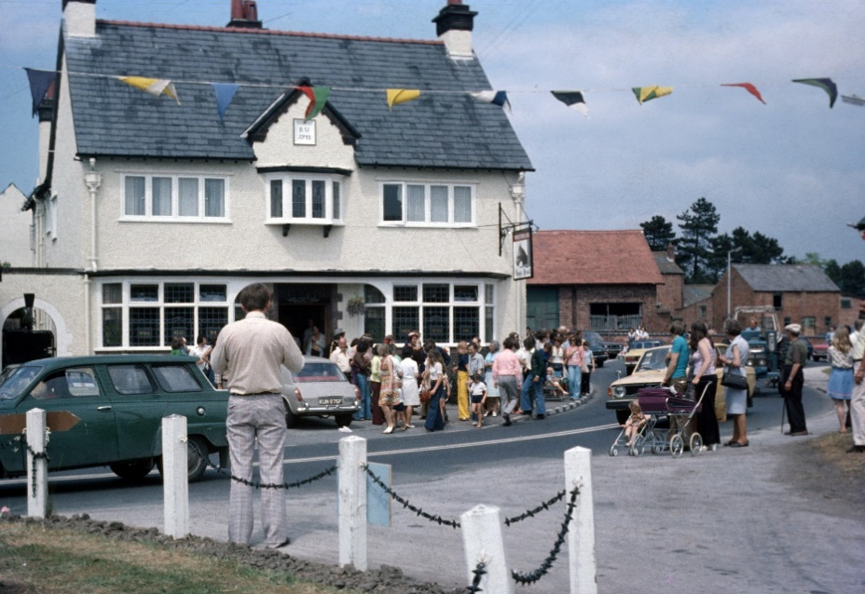

The Nag’s Head at the Heritage Festival in June 1975.
(Photo: Andy Clegg)

The Homing Bird Society met at the pub and in the 1980’s for a few years, when it was run by Colin David Thompson, the Nag’s Head was known as ‘The Song Bird’. At the time, the original painted Nag’s Head sign was lost and replaced with a new one when the name changed back in 1992.
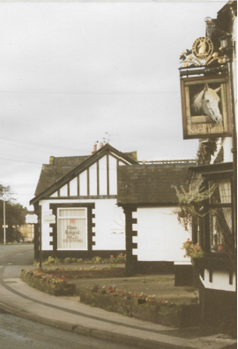
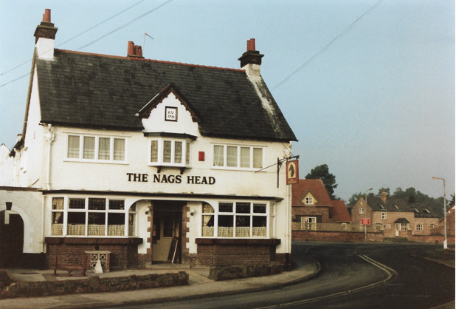

Nag’s Head in the early 1990s.

The Nag’s Head in 1996.

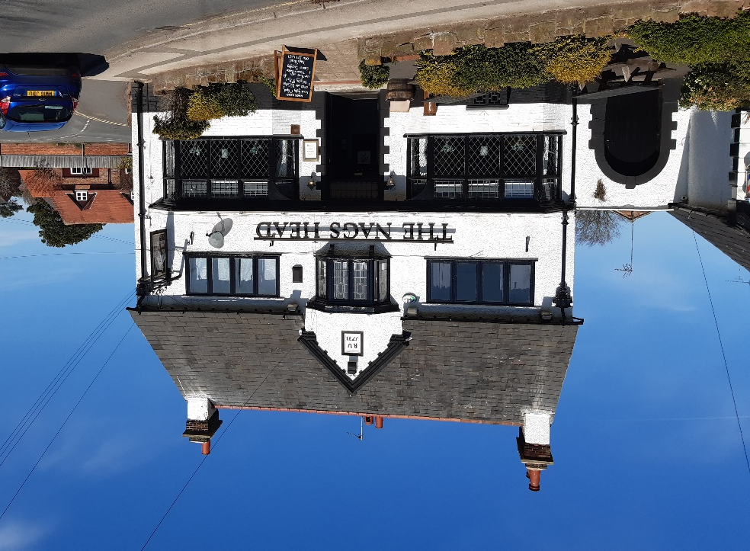

The Nag’s Head in 2023

Updated January 2024

