Silverstones – Hardware and Ironmongers

The shop was on Hadlow Road and run by Clive and Barbara Silverstone.

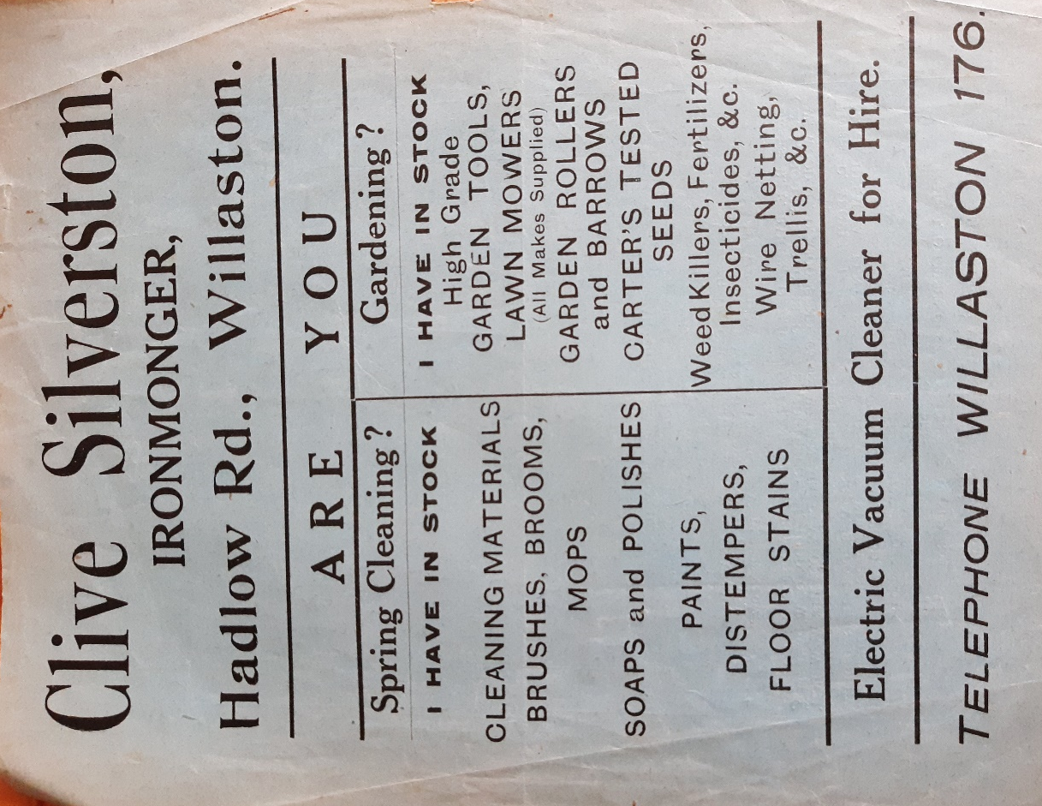

Advertisement in Willaston Parish Magazine in May 1932

Elizabeth Harker remembers working in the shop on Saturdays in the 1950s. She said ‘The work was mainly weighing nails into brown paper bags.’

Rob Pugh recalls: ‘My first fishing rod and tackle came from there.’

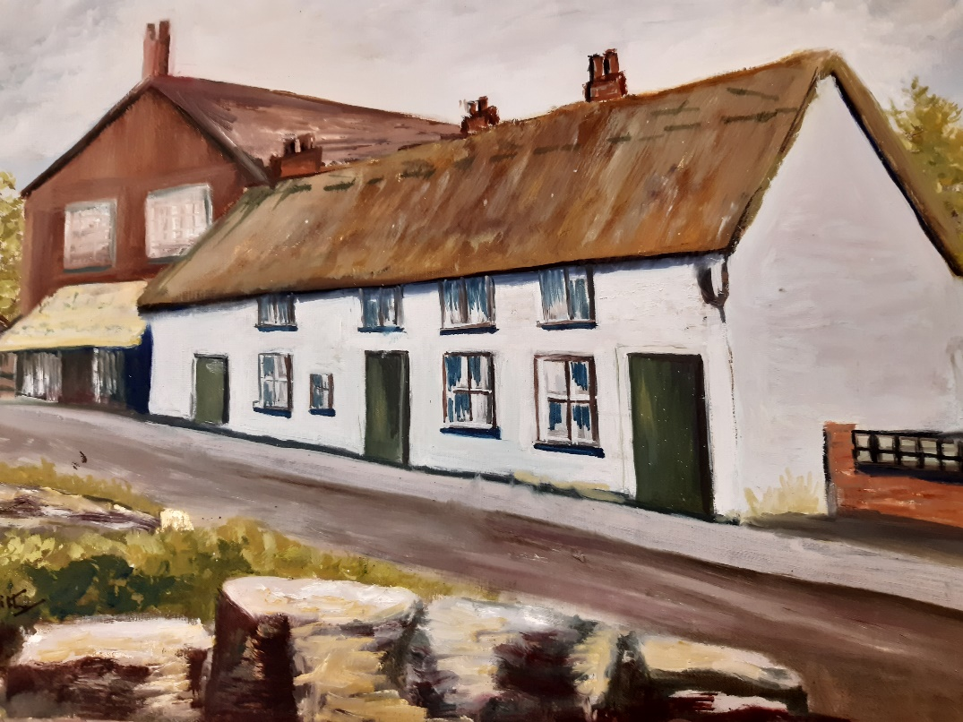

This painting, belonging to Elizabeth Harker, shows Silverstones on the left. The date is unknown but Hadlow Road appears to be untarmacked. The houses are now pulled down.

Ruth Hampshire remembers in the late 1960’s: ‘The back door had a polished brass latch and there was a distinctive smell of polish etc. when you opened the door. You could buy grates and ash pans for the fireplace and replacement gas pokers, coal scuttles etc. There would be produce outside the shop including brooms, metal buckets, garden tools etc.’

The shop later became Alexanders and they both also taught swimming at Neston Rec, teaching children when they went with the school. Their daughter Jane was an Olympic swimmer.

Then it became an off-licence, first run by Cellar Five and then by Bargain Booze.

It was converted to a house in 2012.

Updated January 2024

