Remembrance Day in Willaston

It is believed that 148 men from Willaston served in the First World War. 34 people are listed on the village War Memorial as having lost their lives and a further two died shortly after the war as a result of their service. A further nine people are listed as having died in the Second World War.

Buried in the churchyard are several graves of people that died in WW1. These are:
- Lieutenant James Lonsdale. An officer from Sandhurst who died of wounds in France on 29th October 1914. He was the first casualty from Willaston.
- Private Ralph Wright. He served for 57 days before being discharged with tuberculosis and died on 28th April 1918, aged 31 years.
- Second Lieutenant Edward Gonner. An officer who lived for a short time in Willaston, he contracted influenza and died on 2nd July 1918.
- Signaller Kenneth Smyth. He died at home on 1st November 1918, aged 18.
- Private John Dickenson. He died on 9th February 1919, aged 18 years.
- Private John Moss. He died at home, on 27th February 1919 from the effects of being gassed, aged 31 years.
- Gunner Thomas Jones. He served in Bombay and the North West Frontier and died on 26th May 1920 from malaria and the side effects of wartime service, aged 30 years.
A further 16 soldiers are mentioned on family graves.

In 1945, the booklet All About Willaston records that there was a Services Comforts Fund and a Welcome Home and War Memorial Committee. At this stage there was ‘the Memorial to the 34 men from Willaston who gave their lives in the War of 1914-19, and in the porch is the roll of men and women who have served with the Forces since 19939.’

In Willaston, veterans and the uniformed groups used to parade through the village, starting at the British Legion building (now McCarthy Stone) and finishing opposite the church for a short service and laying of the wreaths on the memorial, before moving into Christ Church.

The British Legion had a flagpole and memorial area:
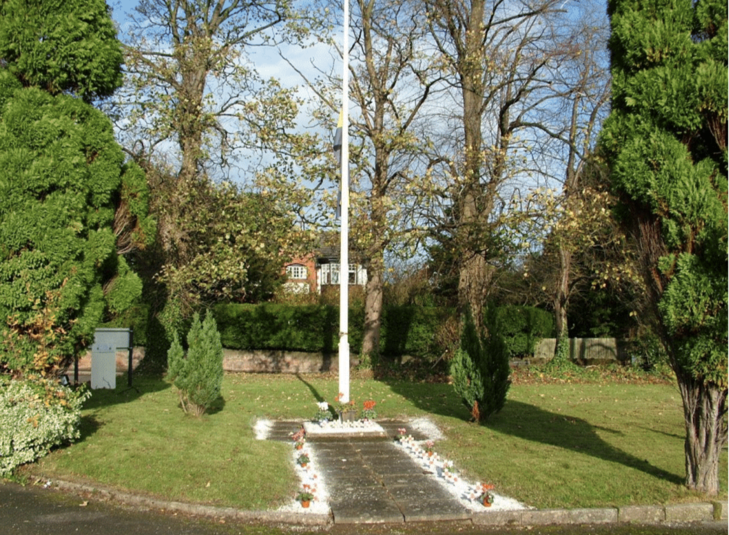

Photo: Hilary Gould
The different groups would meet at the Legion building before parading through the village:

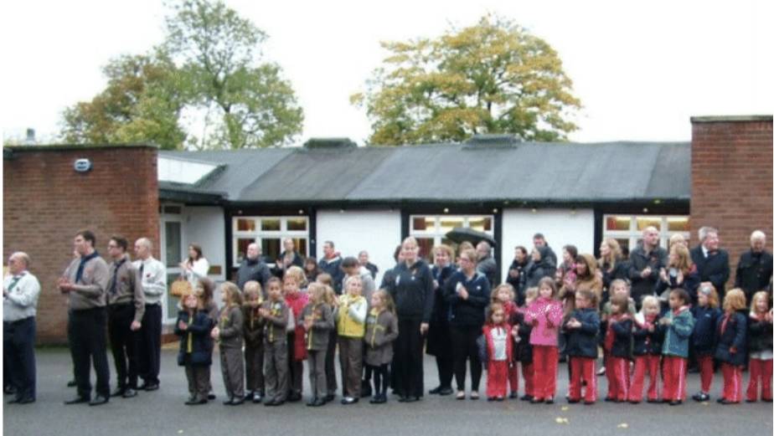

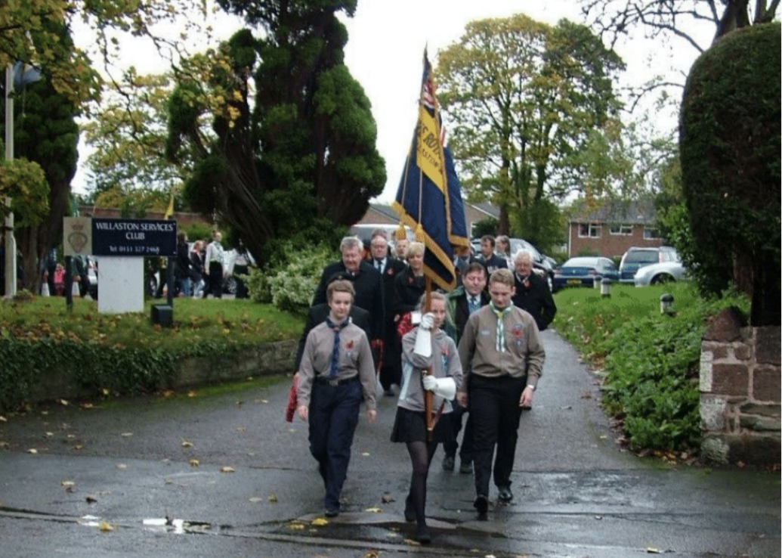

Photos: Hilary Gould

Parade in the 1980s (Photos: Peter Williams):
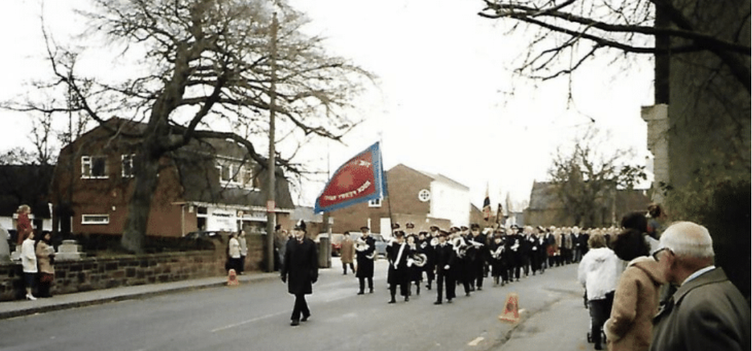

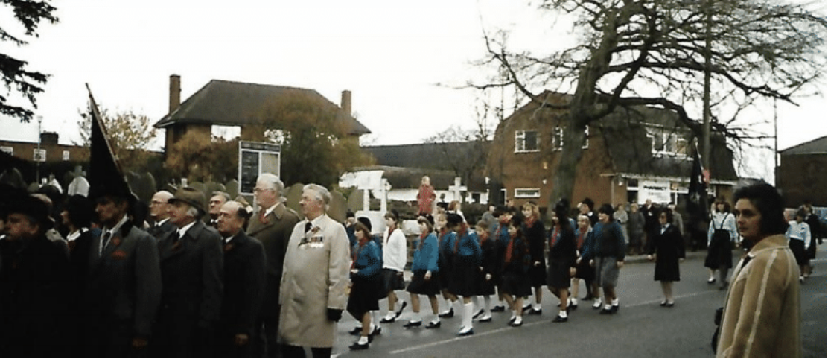

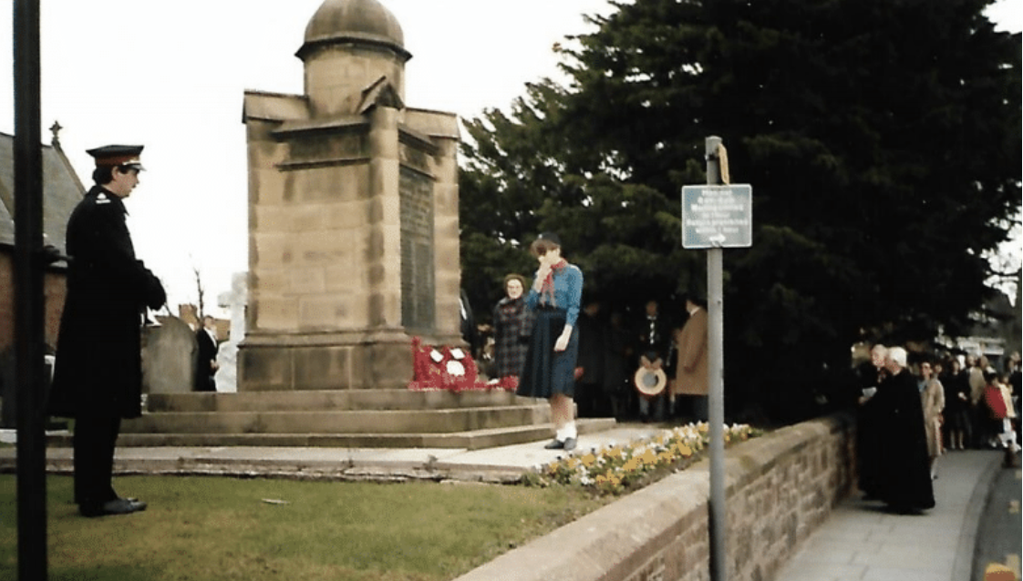

Parade in 1994:

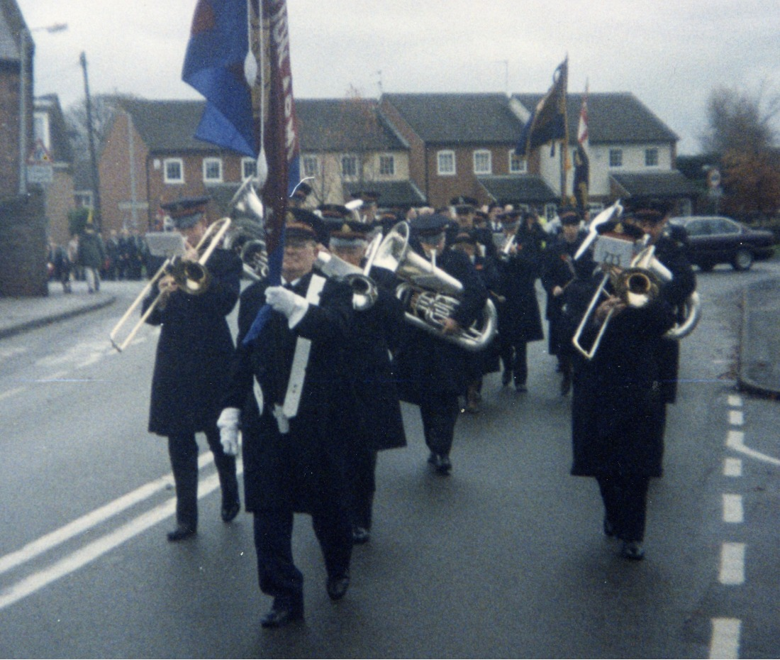

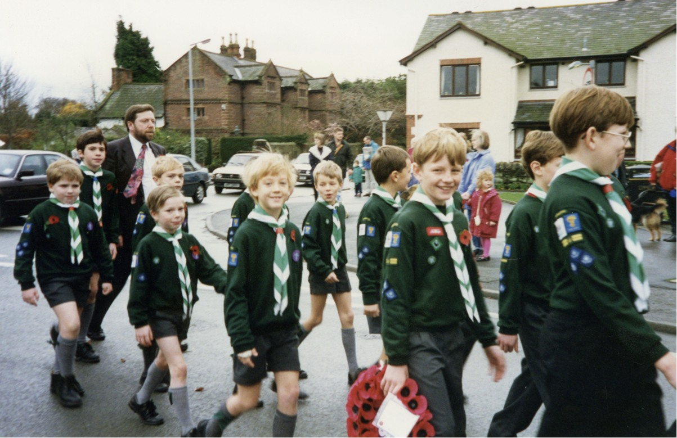

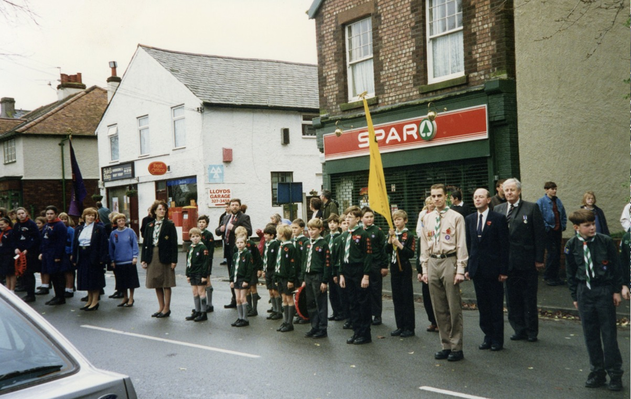

Sadly, in 2011, vandals stole the metal plaques from the memorial which recorded the names of soldiers who had died. That November, Willaston schoolchildren wrote the names of the dead and they were used for the service. The story reached the national press and a widely publicised fundraising campaign raised sufficient money to replace the plaques with greater security.
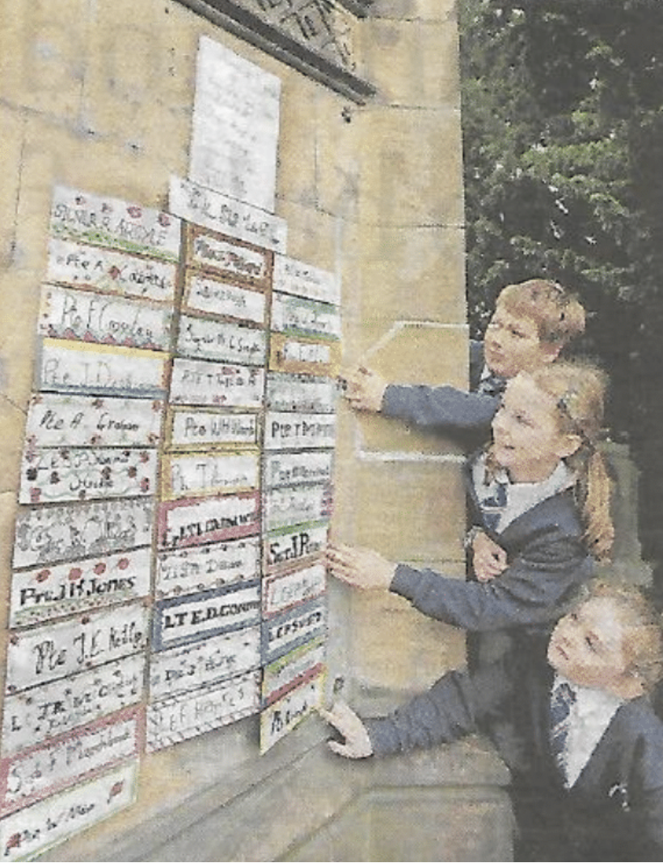

Photo: Gareth Jones
Printed in Liverpool Daily News, Friday 4th November 2011

Parade in 2014:

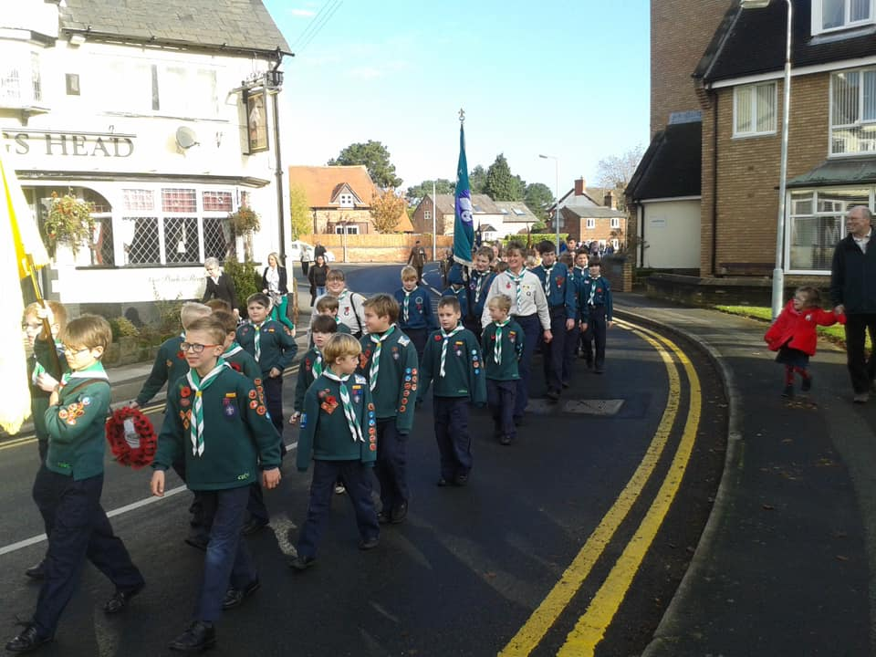

Photo: Helen O’Hare

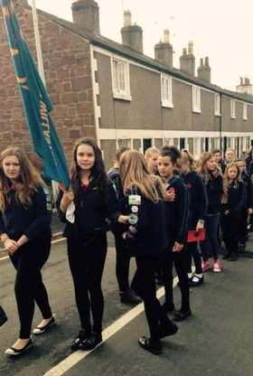
Photo: Tracy Lloyd

The Village Butcher, run by Dean Taylor always decorated his shop for the parade:
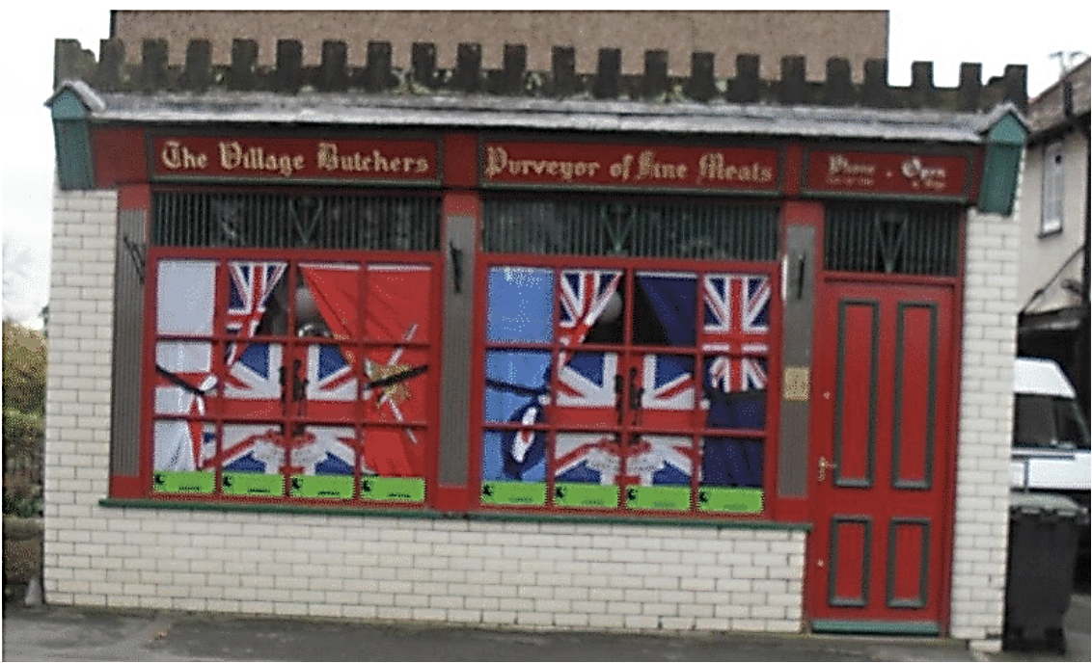

Photo: Sue Unsworth

In 2018, a special parade was held, starting at the Legion, going to Christ Church for the wreath laying and service, then going up to Hadlow Road Station for a commemorative event. This was part of a programme of events for the weekend celebrating 100 years since the end of WW1.
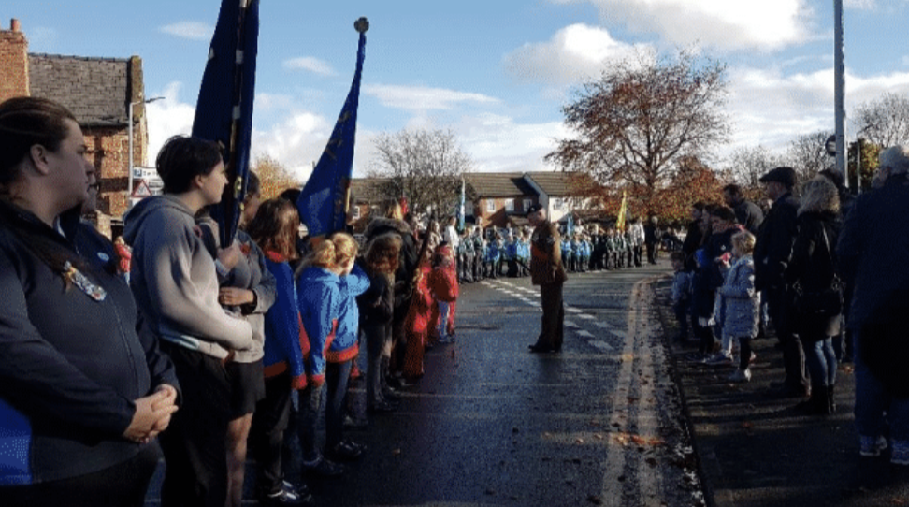

Photo: Ruth Hampshire

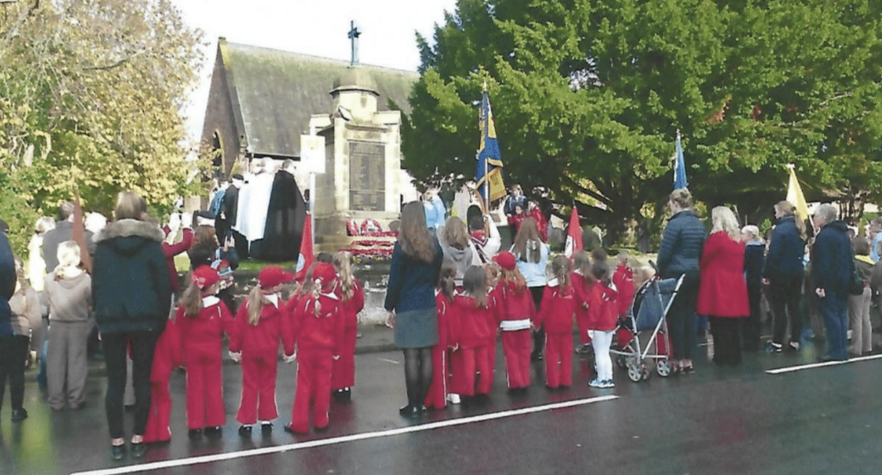

Photo: Margaret Callendar

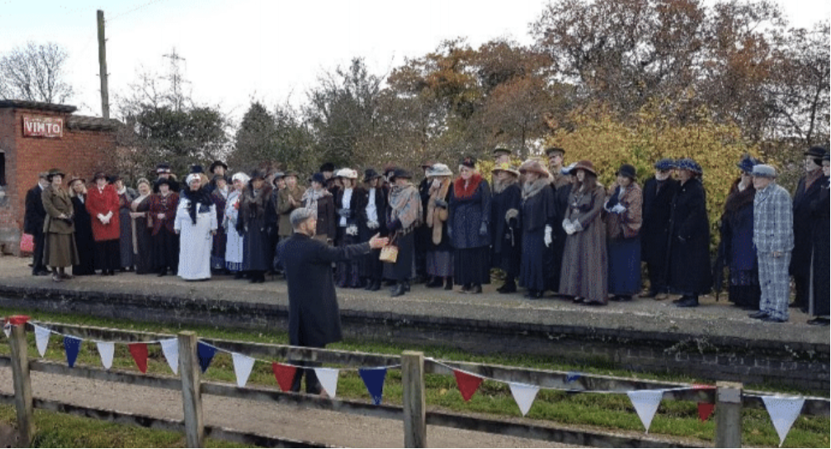
Photo: Ruth Hampshire

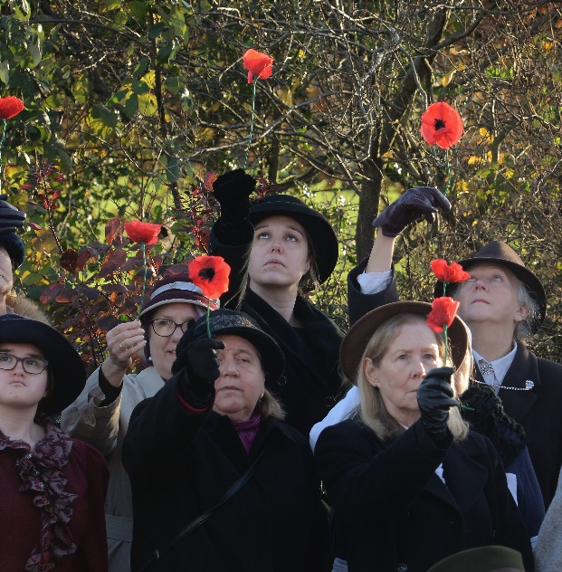

Photo: Actuarius Art

Unfortunately, the Covid 19 pandemic, followed by increased bureaucratic requirements from the Council, together with the closure of the British Legion meant that there are no longer Remembrance Day parades through the village, although special services are still held in Christ Church, including laying of the wreaths.
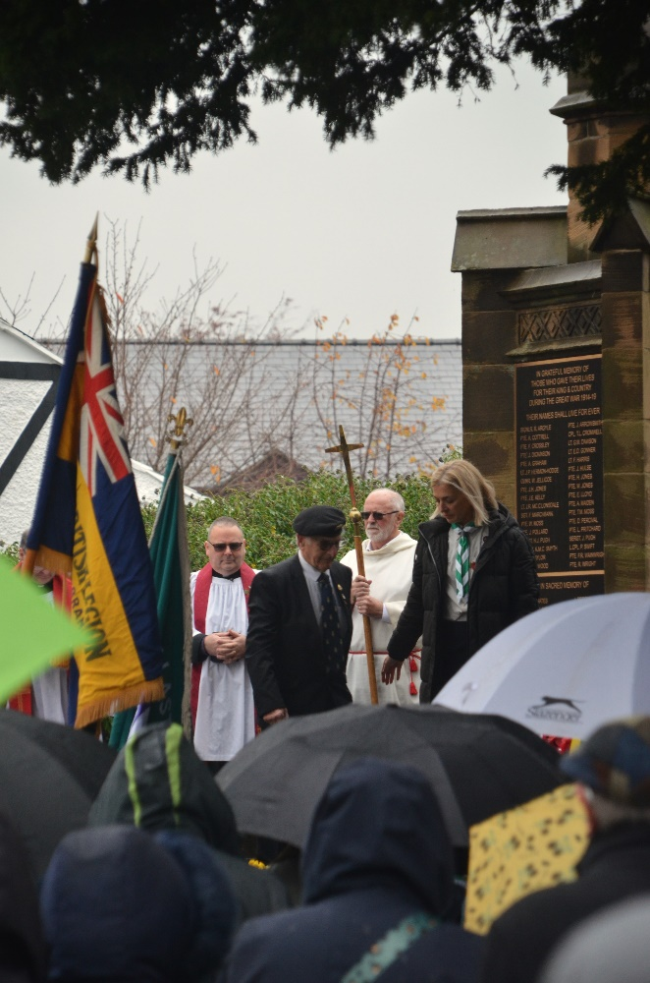
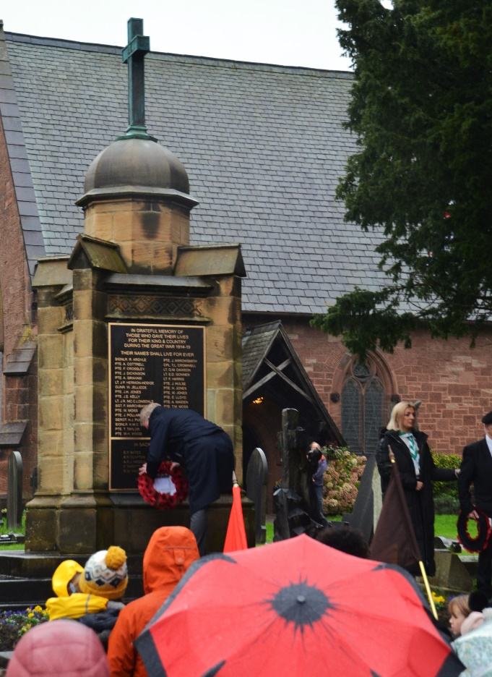
2023 (Photos: Actuarius Art)

Updated December 2023

