Willaston Detachment of the Red Cross

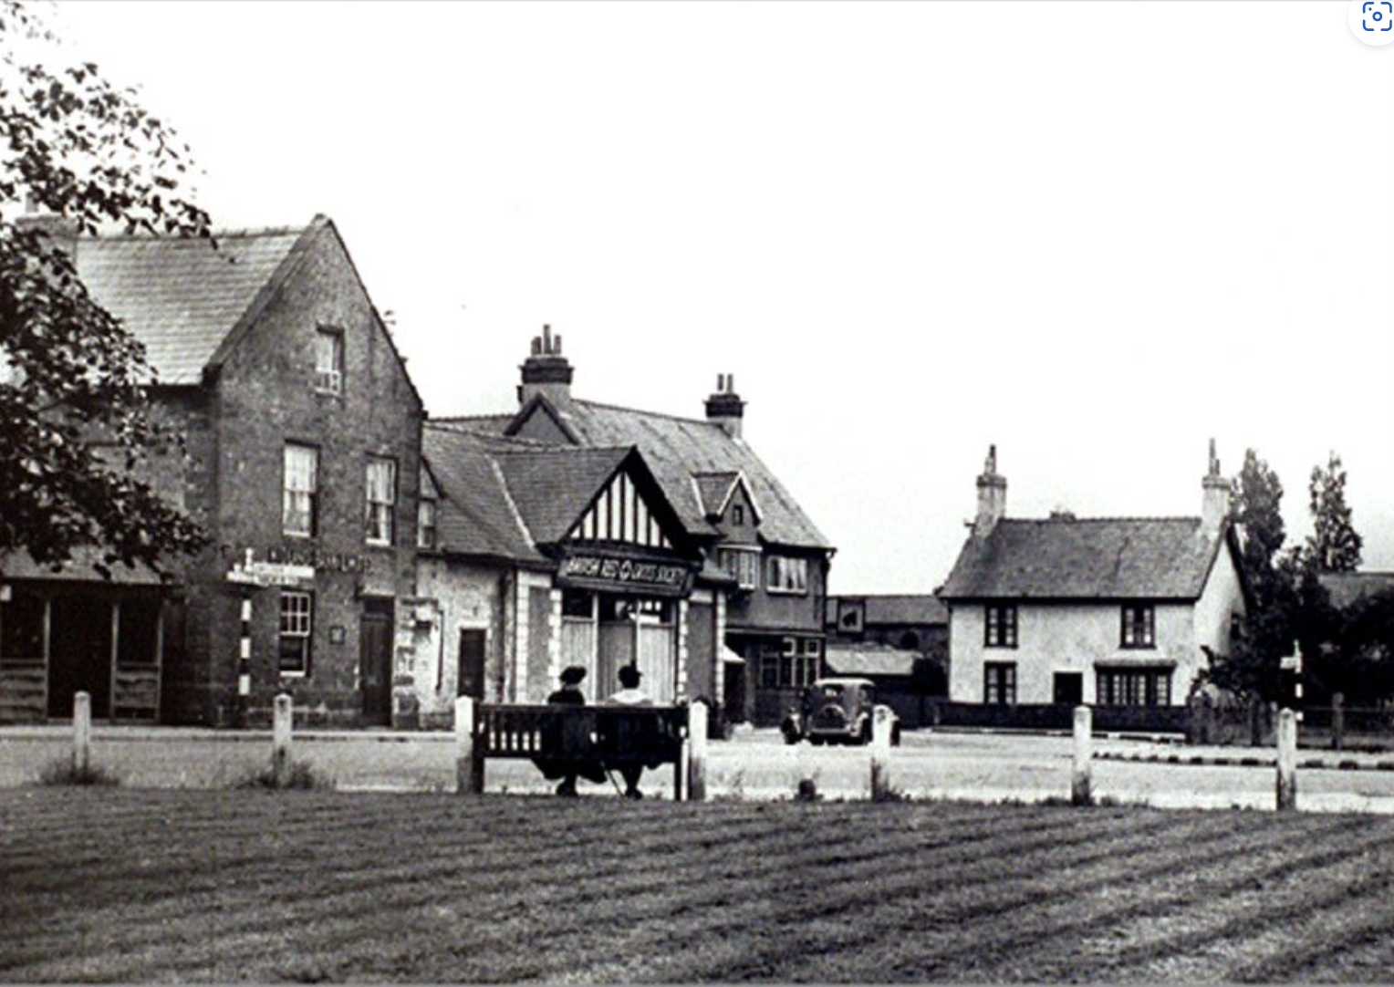
This building was a grocer’s store before 1947, owned by Mr U. Farr.

Photo from Bob Prince

The Red Cross was originally based in the Institute on the village green but then moved to its own building in 1947. It provided the base for St. John’s Ambulance (Hilda Jackson), a District Nurse (Gladys Lloyd) and the Doctor’s surgery, which occupied on half of the building on the right hand side, with a waiting room in a ‘lean-to’ at the back. The GP was Dr Scott.

In 1948, they started an Infant Welfare Clinic. They bought an infra-red lamp to give treatment and massage. Joyce Ryan remembers that the orange juice from there was delicious!

In 1949, they formed a Girls Cadet Unit.

In 1950, the detachment also took on the duty of National Hospital Service Reserve. Members volunteers to train in hospital for 80 hours a year so as to be ready in case of a national emergency.

In 1965, the building became Martins’ Bank, with the Red Cross still operating from the premises for a time. The bank was a sub-branch to Neston, open for reduced hours four days a week and Saturday mornings.

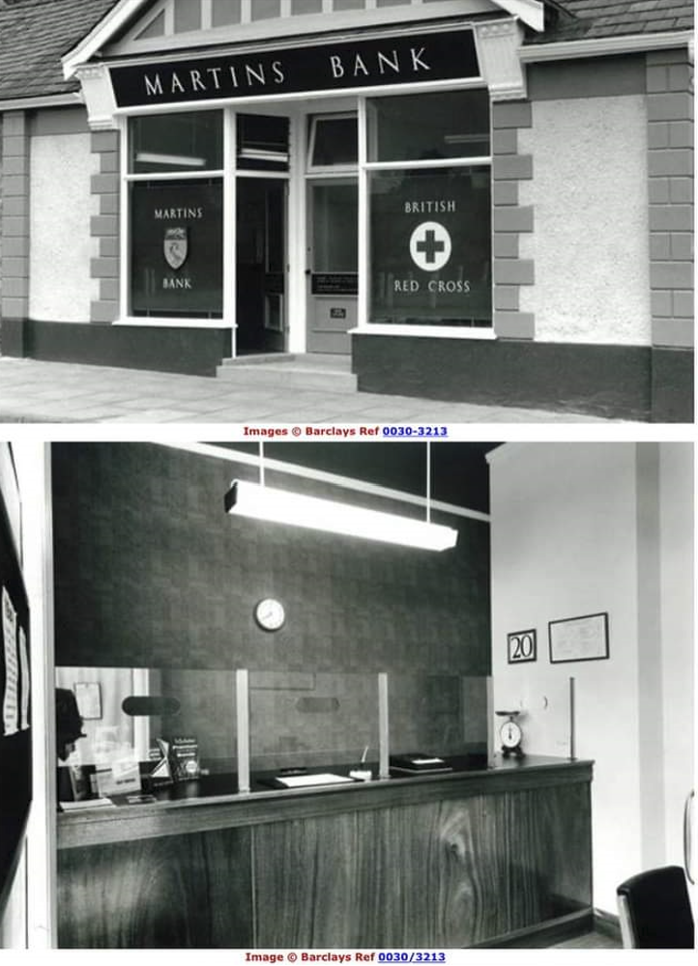

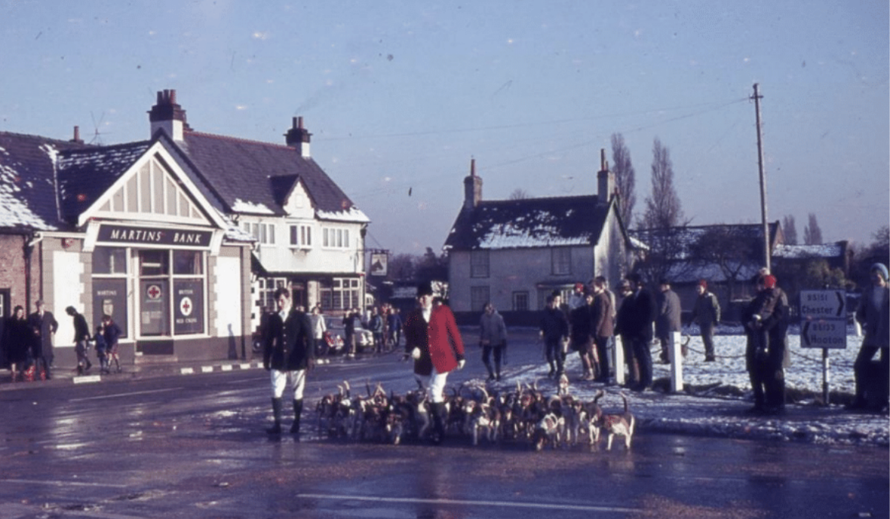
Boxing Day Hunt with Martins Bank in the background 1968
Photo: Janet Leece

In 1969, Martins Bank was acquired by Barclays.

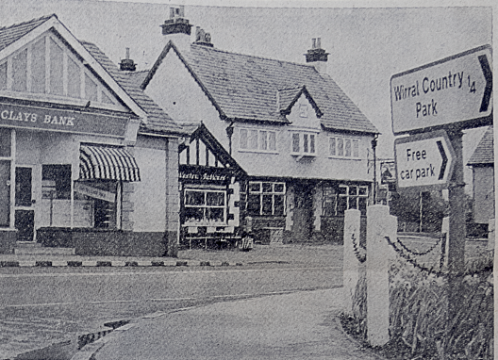
Picture from The News 1975, by which time it is Barclays Bank

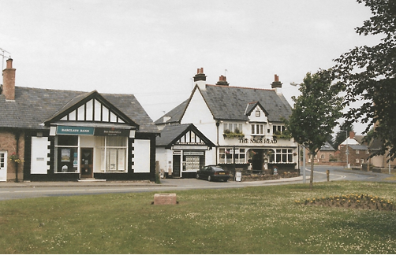

The bank was open until 2000, by which time Blain Boland Solicitors (Nicholas Thomas) occupied the right side of the building. A cake shop then operated in the left side.

The cake shop section became The Gallery in the mid-late 1990s.

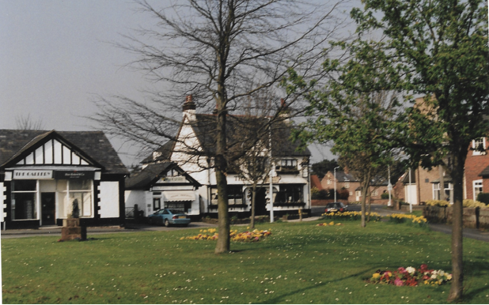

Then it became Eclipse dress shop run by Pauline Argyle.

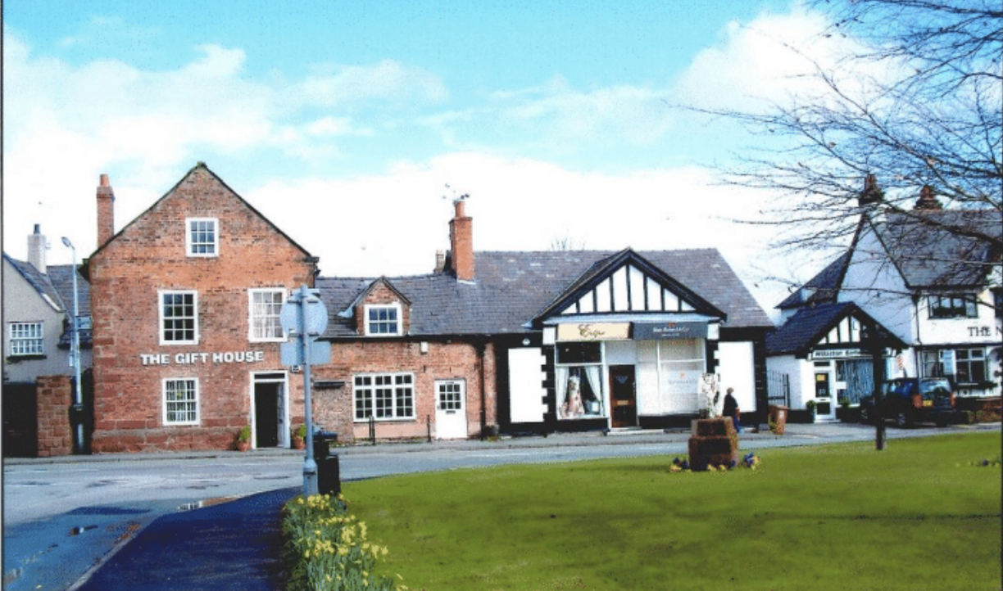
Photo: Bob Prince

When Eclipse closed, Blain Boland Solicitors acquired the whole of the building.

White Feather Home occupied the whole building from 2019.

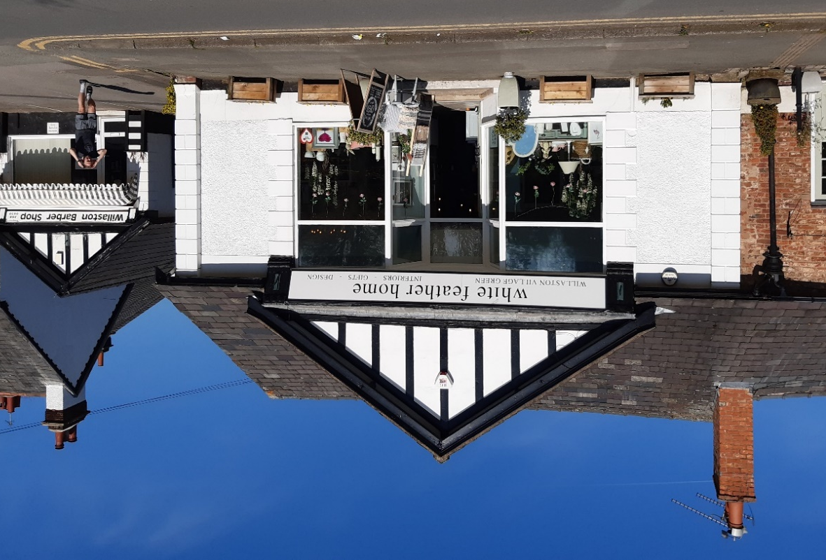

White Feather Home in 2023

Updated January 2024

