Newsagent /Classie

EA and JB Fyfe (Eileen & Brynn and Barbara & Derek)

Advert in Willaston Parish Magazine September 1975

The shop was divided into two: on the right was a bakery, known as Ada’s. She baked in premises at the rear. There is a grave for Ada Shown in the churchyard.

On the left was the Post Office. Keith Edwards remembers that his father was a postman, working from the Post Office in 1945. He lived in Eastham and rode a bike into Willaston to pick up the letters for his post round.

It later became Dillons and the Post Office moved to separate premises further down the road.

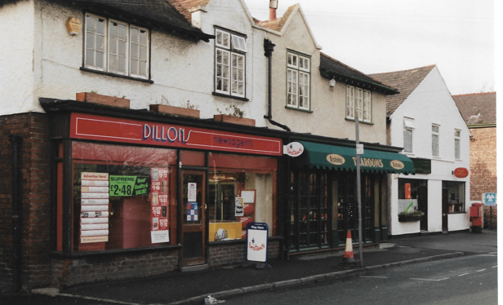

It then became Martins and McColls. From 2018, McColls included the Post Office once again.

In August 2018, the newsagents got ram raided with an attempted theft of the ATM (cash dispenser).

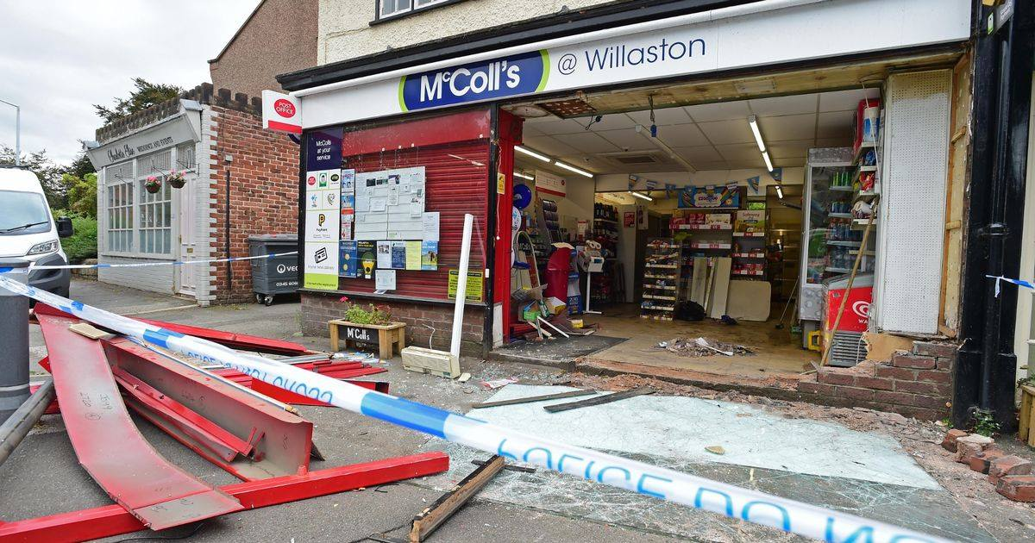

Picture from WR&CS Facebook site

In 2020, it became Classie Grooming, run by Mike Wildman.

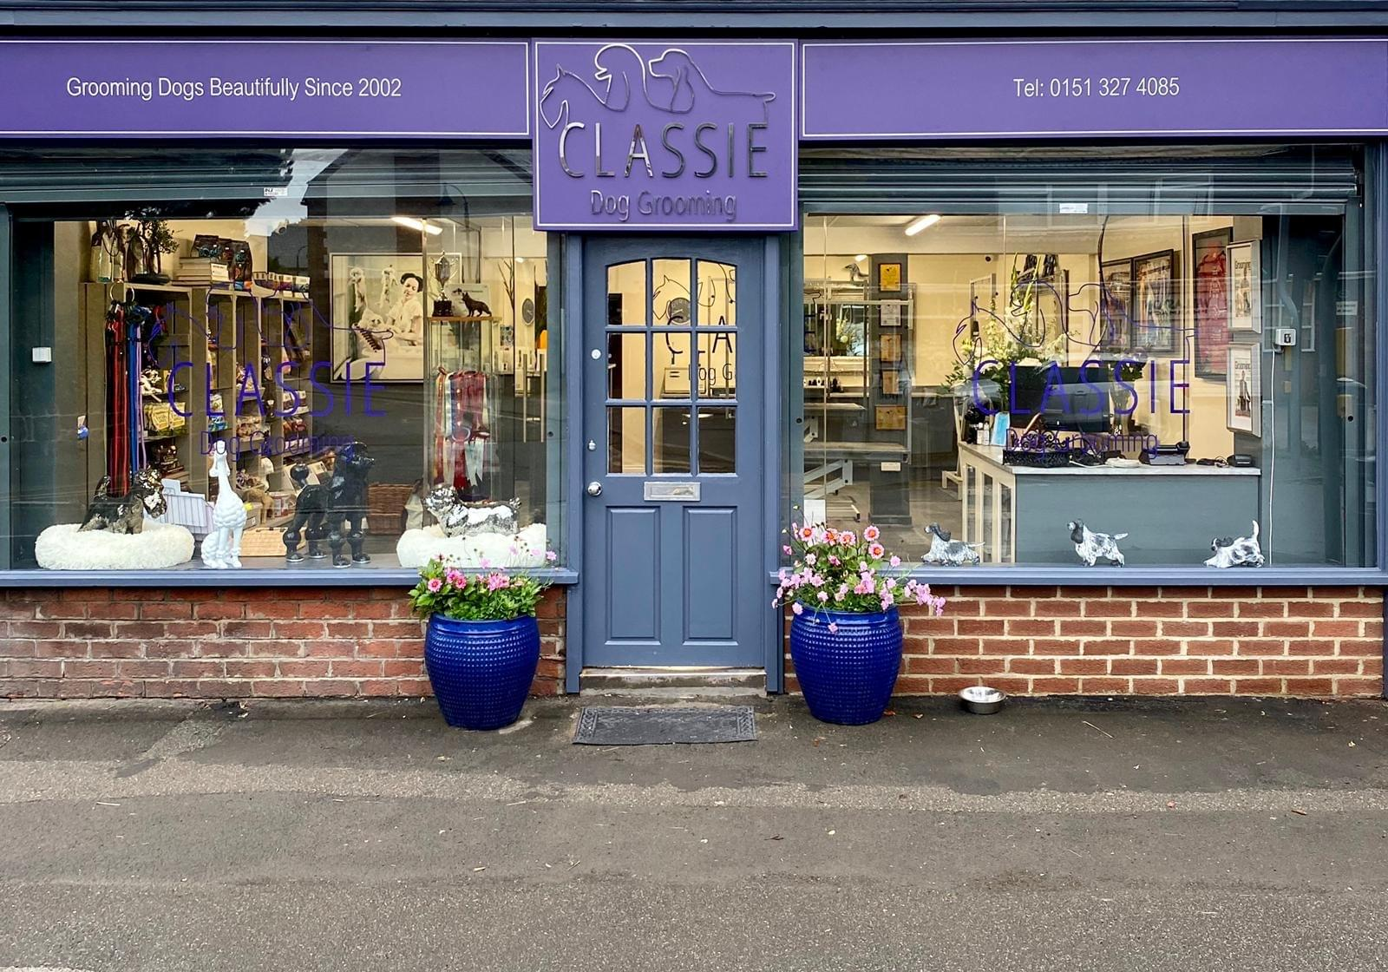

Updated January 2024

