Kaye’s, The Chemist

In 1926 L. N oeley was the local pharmacist and then Miss Lanceley was proprietor. The exact dates are unknown but she was still running the shop in 1945.

In 1948 Duncan Kaye built Pharm House and ran the chemist from there.

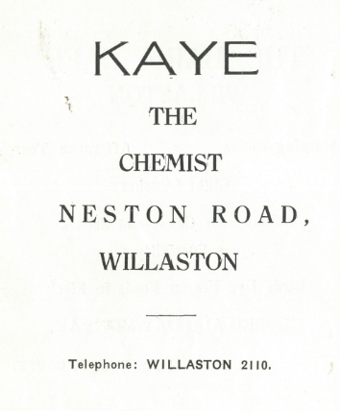
Advert in Christ Church Centenary 1955
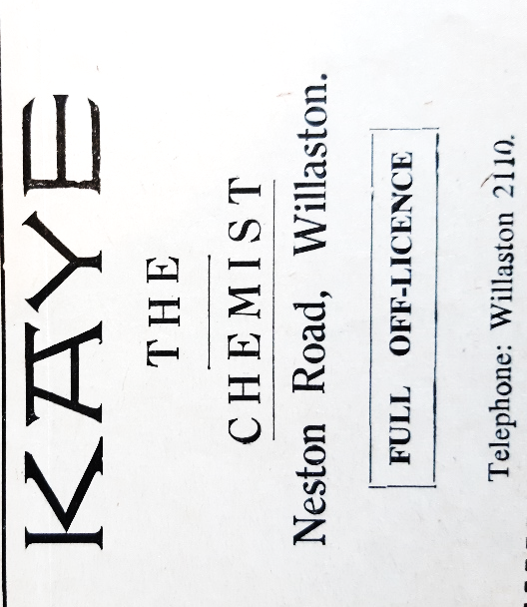

Advert in Willaston Parish News December 1962. At this time, the chemist included an off-licence.

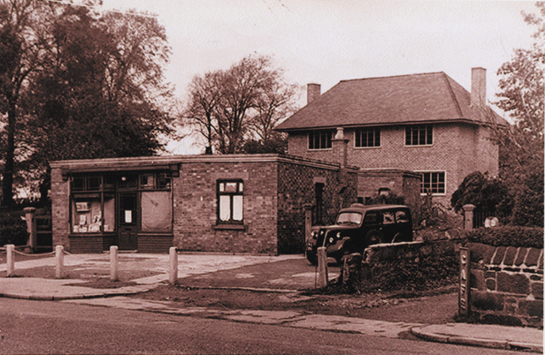

Pharmacy with Pharm House behind.
Photo from Willaston of Yesteryear by Bob Prince

Keith Edwards remembers that Mr Kaye had geese who acted as guards. One of them would walk along the path to Jacksons, just up the road. He never went onto the road.

In 1967, Malcolm Kaye took over and in 1971 built the present shop with a flat above. There was a doctor’s surgery to the right of the newly built pharmacy which then moved to the left into a purpose-built extension at the back.

Pharmacy in 1998 Photo: Bob Prince from Willaston – Centre of Wirral

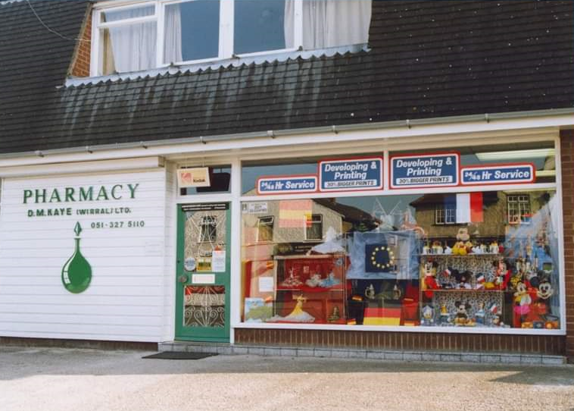
Pharmacy decorated for the Willaston European Festival in 1992.
Photograph developing and printing was once a part of the pharmacy offer
Photo: Bob Prince

Ruth Hampshire remembers: ‘Malcolm was a lovely man and Kaye’s the Chemist was central to the village. I recall numerous times when Malcolm would mix up specific preparations for various ailments (especially ‘drawing ointment’ to help with splinters). He was a good old fashioned pharmacist, so caring and knew all his customers and their families. He always supported village events and would dress the shop window for special occasions.

Rachel Epoc remembers: ‘I did work experience in the chemist when I was in 4th year (1992/93) and his feedback has stayed with me to this day and I still call on it!

The extension was later used by Willaston Physiotherapy and Sports Injury Clinic.
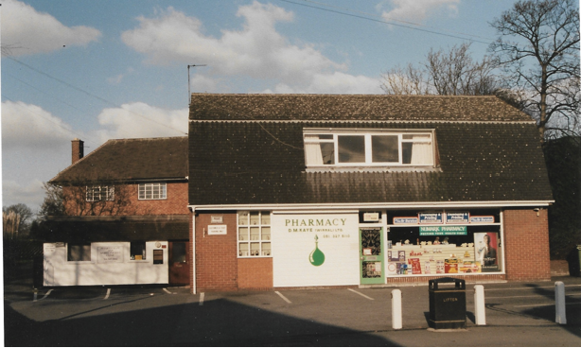

Later the extension became an estate agent.

Estate agencies using the site have been:
- Village Properties, run by Eric Murch
- Clive Watkin
- Constables (from 2021)

In 2023, ownership of the pharmacy was transferred to Knights Pharmacy.

Updated January 2024

