Willaston Physiotherapy/Horseshoe Stores

This was in Hooton Road and was originally a small alehouse known as the Plough, said to have been built in the seventeenth century. It is said that Change Lane is called this because people stopped to change horses at the Plough Inn whilst travelling between Chester and Liverpool.

It then was a bike shop in a small wooden building. The electoral roll for 1929 records John Evans, Cycle Mechanic living in the adjoining Rose Cottage.
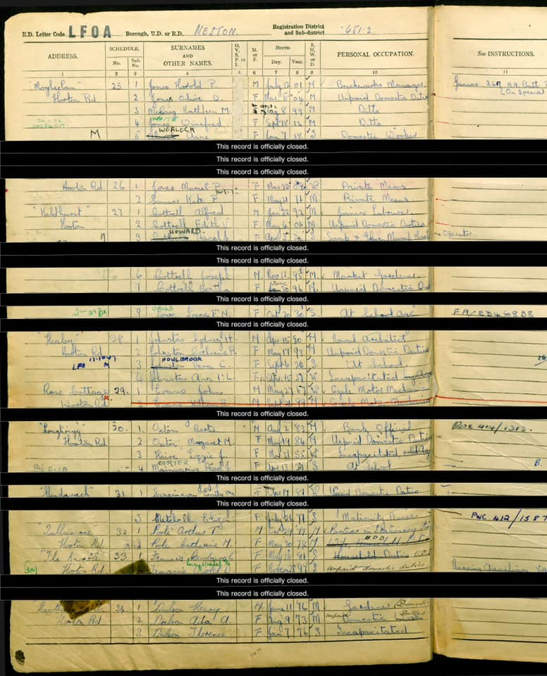

The building then became the Horseshoe Stores, providing general provisions and a diary until the early 1970s.

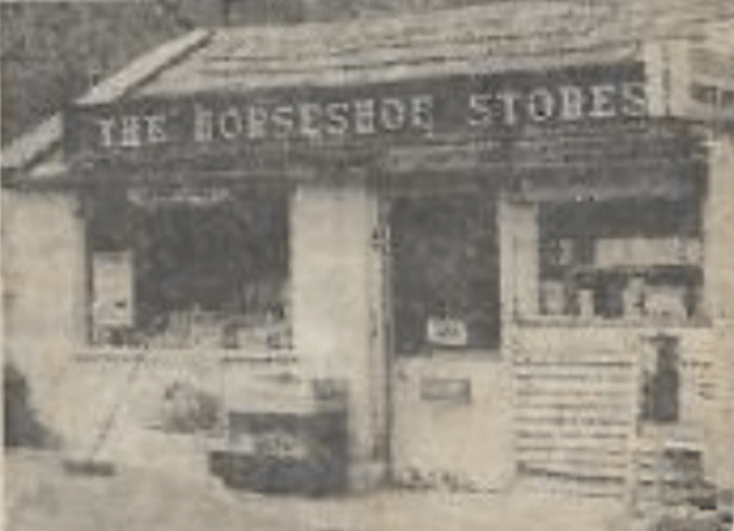

From a press cutting in 1972, paper unknown.

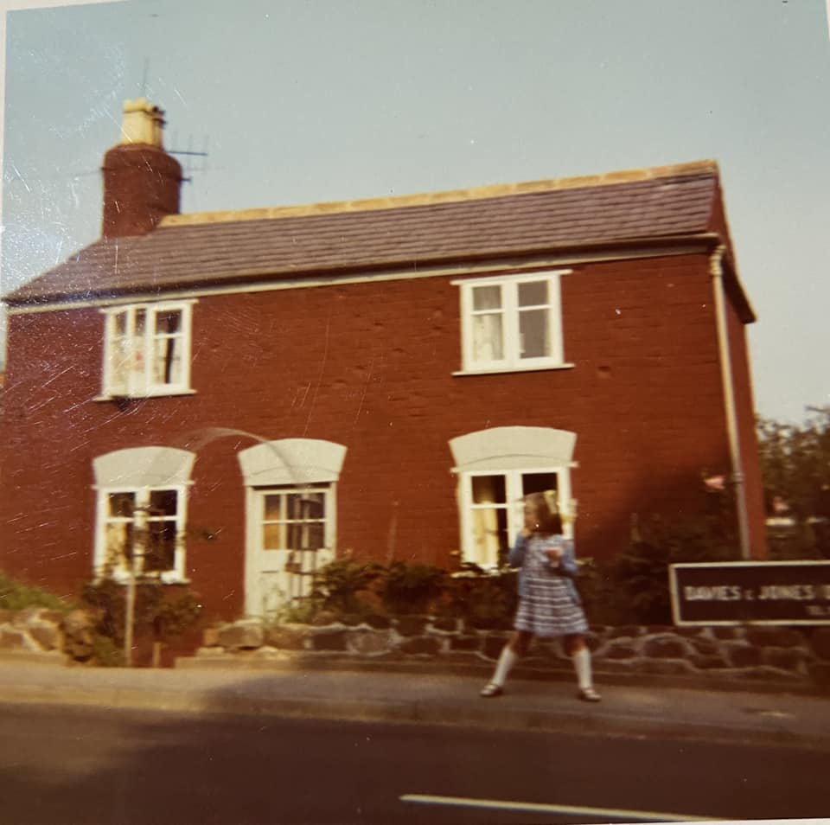

Rose Cottage, which adjoined the Horseshoe Stores and was inhabited by Larry and Carol Baker (Photo: Helen O’Hare)

The original building and Rose Cottage adjoining were then demolished and a new building with a flat above housed the larger Horseshoe Stores and Dairy. Larry and Carol Baker ran the shop, which became a ‘Happy Shopper’ and hen a ‘Spar’. The dairy had an extensive milk round serving homes in Willaston, Easton and Burton.

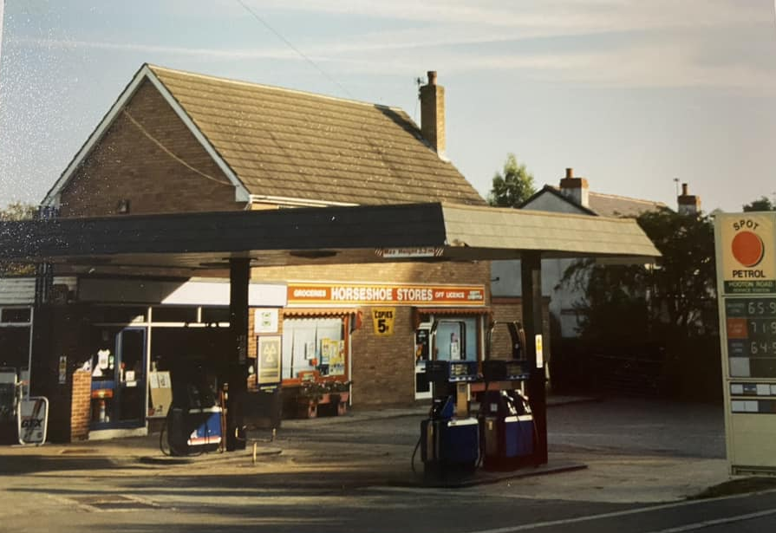

Horseshoe Stores in late 1980’s/early 1990’s
(Photo: Helen O’Hare)

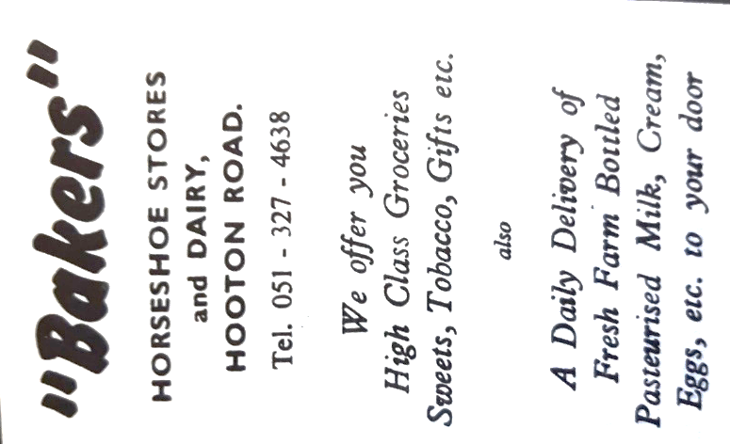

Advertisement in Christ Church Parish News September 1975

Graham Baker remembers: ‘When my Dad knocked down the old Rose Cottage/Horseshoe Stores to build the current building, we lived in a caravan on the site until the new building could be lived in. We had the shop and the milk round. I delivered milk to houses in the neighbourhood and that is how I earned my crust as a kid. My favourite destination was Craxton Wood on the Chester High Road. We would get there at about 8am and had been working for about three hours by then. The Italian chefs would make up some toasted bacon butties and a mug of tea, which kept me and my Dad going for the next five hours. My sisters worked in the shop with our Mam.’

Later it was run by Barry and Joan Waddington.

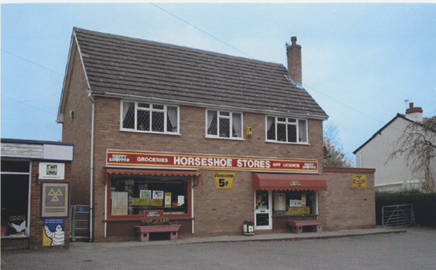

Horseshoe Stores in 2001
Picture from Willaston in Photographs by Bob Prince

In 2002, Willaston Physiotherapy and Sports Injury Clinic opened in the building.
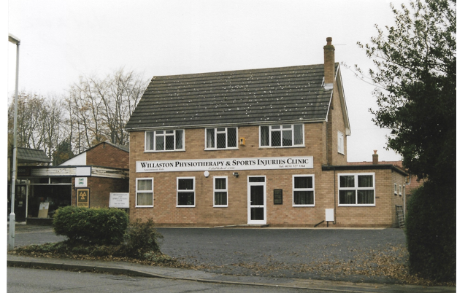

Willaston Physiotherapy in 2002 (Photo: Bob Prince)

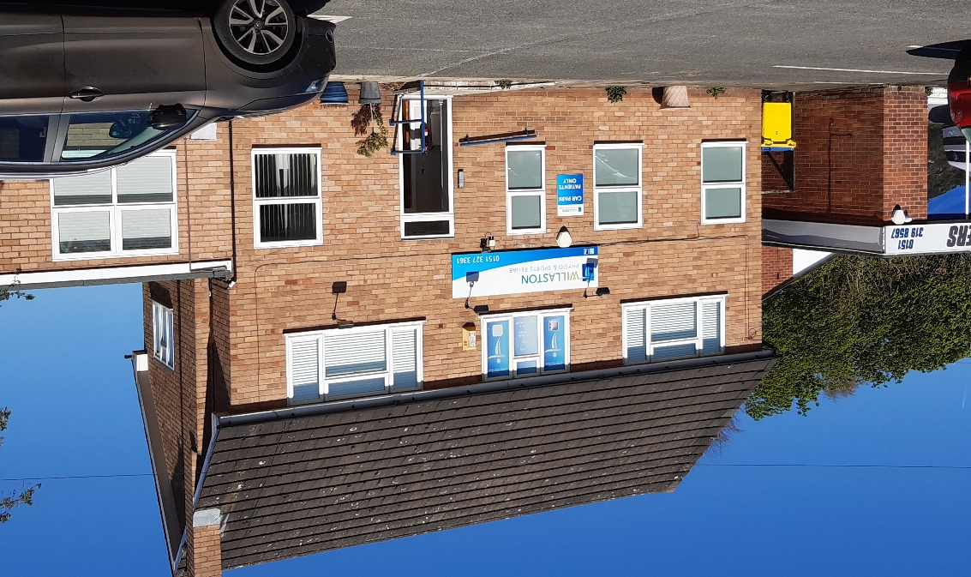

Willaston Physiotherapy in 2023

Updated January 2024

