Hooton Road Service Station / Sols Campers

There was a service station on Hooton Road, originally run by John Evans, followed by E. Thomas.
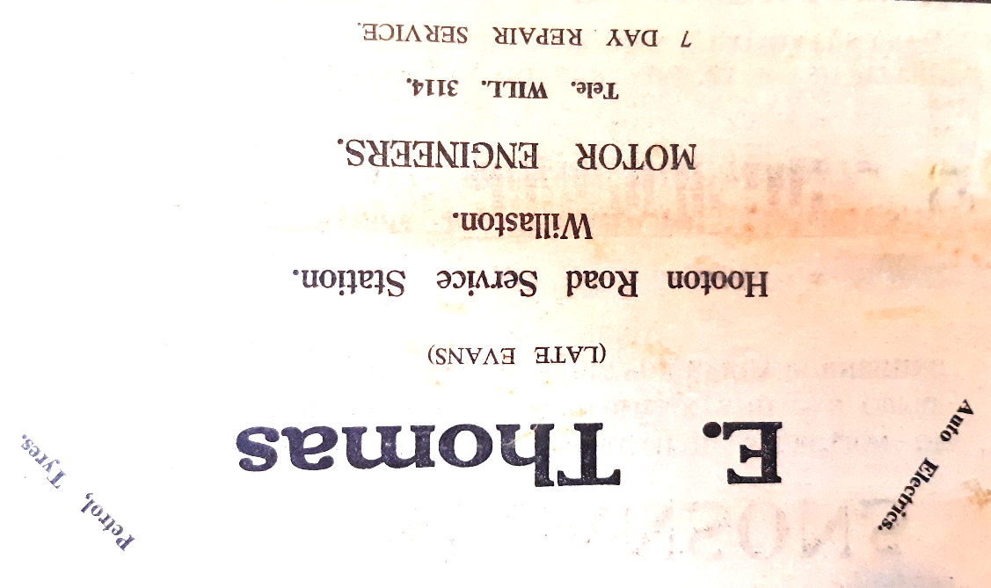

Advert from Willaston Parish News December 1962

It was then run by the Owens family (John, Brian and Joan) from 1965.

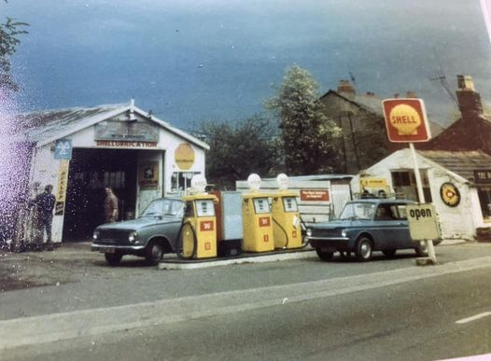

Date unknown – possibly late 1970s
Photo: Helen O’Hare

Later, in the 1990s the petrol was supplied by Spot Petrol.
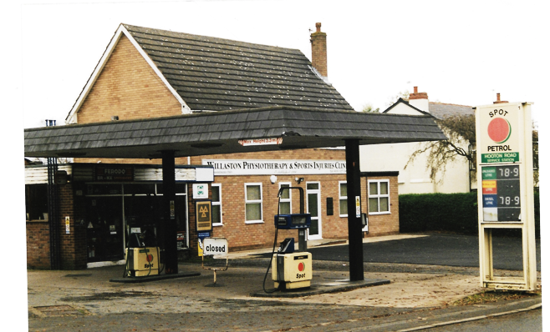

November 2002 (Photo: Bob Prince)

More recently, this became Sols Campers.

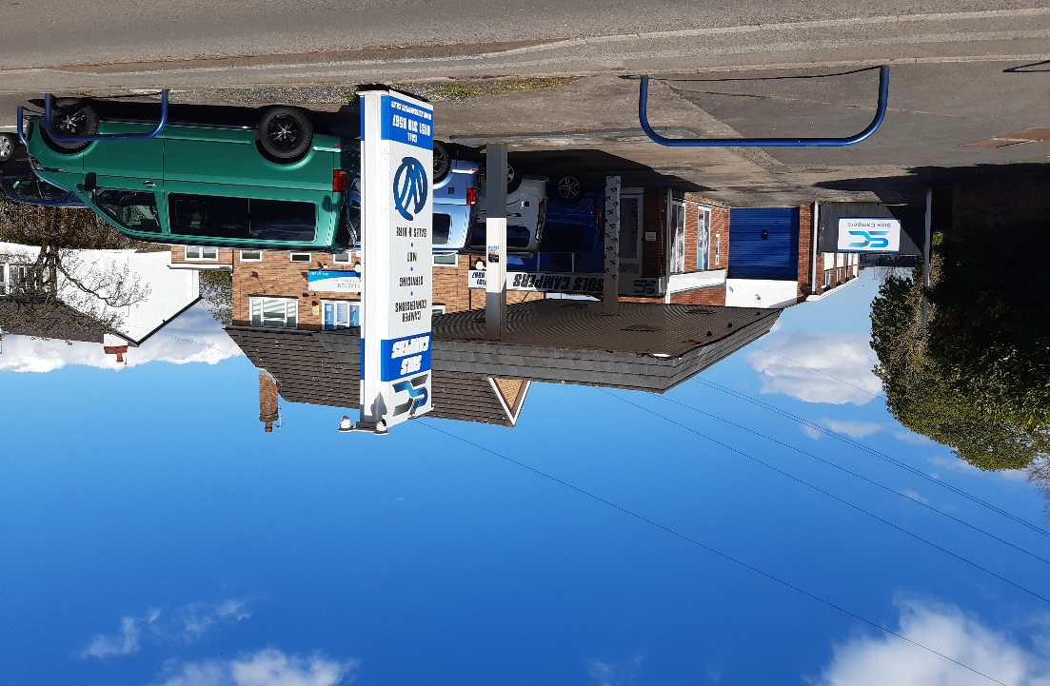

Sols Campers in 2023

Updated January 2024

