Hadlow Road Station

Hadlow Road Station was opened on 1st October 1866. It was part of the Birkenhead Railway ran a single-track branch line from Hooton to Parkgate. The extension to West Kirby was completed twenty years later.

It was named Hadlow Road Station because the name Willaston railway station had already been taken by the other Willaston in Cheshire.

The signal box was installed by the 1890s. By December 1895, there were eleven trains up and down the track on Mondays to Saturdays and four trains on Sundays.

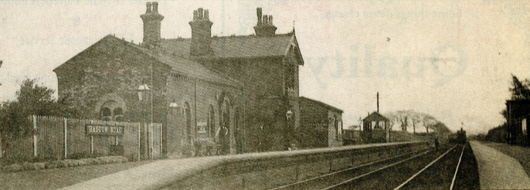

Hadlow Road Station in 1910, press cutting (paper unknown)

In 1911, Joseph Hulse was a signalman at Hadlow Road Station. He served in WW1 at the Somme and was killed in October 1016, aged 27 years, whilst working with a 180 strong party digging a new fire trench. He is remembered on the Willaston War Memorial.

By July 1922, the passenger service had increased to fifteen up and down trains, with an extra train on Saturdays and five trains on Sundays.

In 1927, Neston Colliery closed which led to a big reduction of freight train on the line but it was still popular as a passenger service. In 1932, one train ran from London Euston through to New Brighton.

Tony Whitehead remembers: I used to get the train to Neston once a week from Hadlow Road Station for woodwork lessons. The teacher was Mr Hacking who also taught my Dad. The girls from the school went to cookery classes.’

Elizabeth Hasker lived at the bottom of Smithy Lane, adjacent to the railway line. She recalls: I used to go down the embankment onto the line. If I could see a train, I knew I had to run. If not, I would walk up to the station along the line. The train driver used to slow down at my house and ring the bell. My mother knew to pick some apples. When he came back, he would pick up the apples and drop off a bag of coal in exchange. We were always alright for coal.’

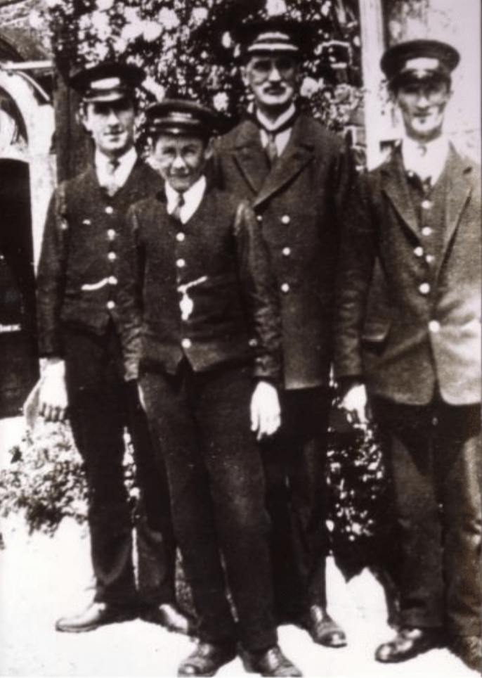

Station Master and staff 1950

By the mid-1950s, the main users of the line were children travelling to the secondary schools in West Kirby and the growth of road transport saw the number of passengers declining. The station was closed to passengers on 17th September 1956. Around 150 spectators witnessed the event, which was made more memorable by the fact that the train included a van conveying two circus elephants.

It was then closed to freight on 7th May 1962 and the tracks were lifted two years later.

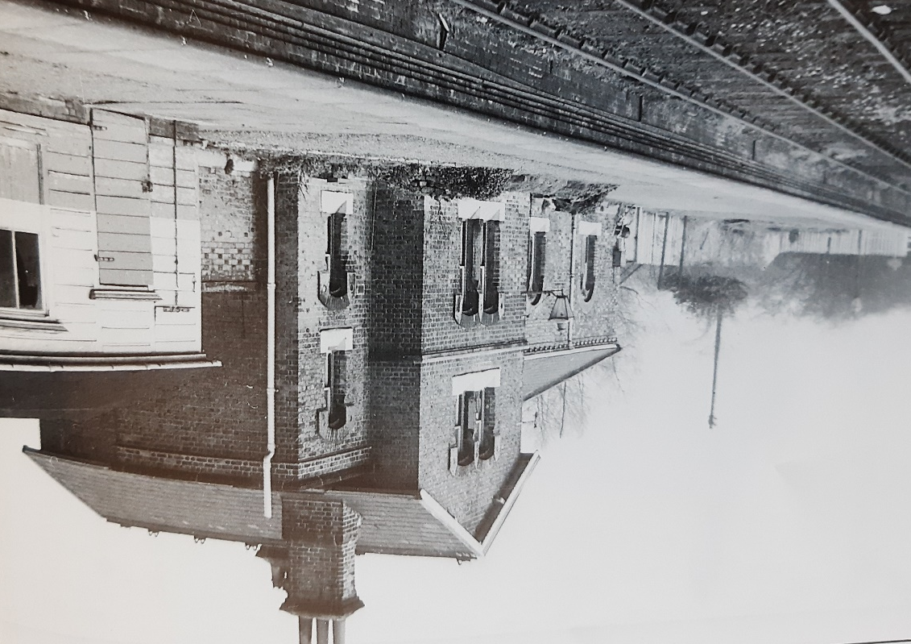

Hadlow Road Station in 1964
(Photo: HJ Leadbetter from Railway Stations of Wirral by Merseyside Railway History Group)

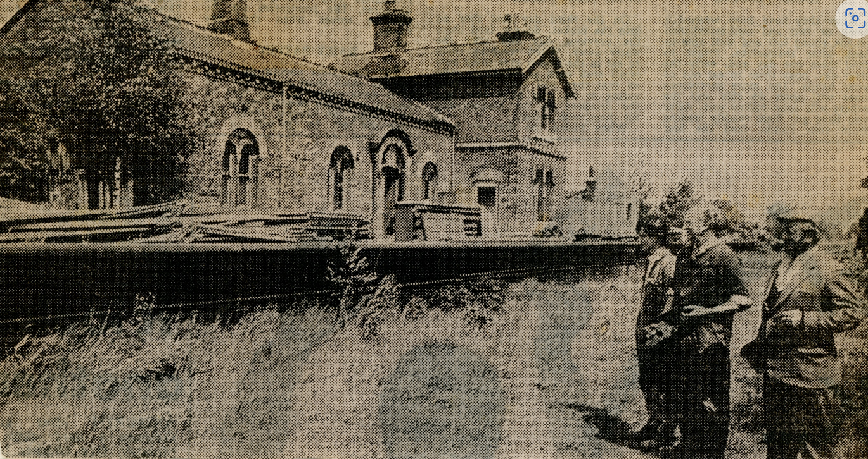

Hadlow Road Station in 1972 (newspaper cutting, paper unknown)

The Wirral Country Park was officially opened in 1973. It was the first designated Country Park in Britain. Hadlow Road Station was restored to how it looked in 1956 to become one of the main features in the Country Park. The station buildings became an information post and small museum and the former station master’s house was used by the Rangers.

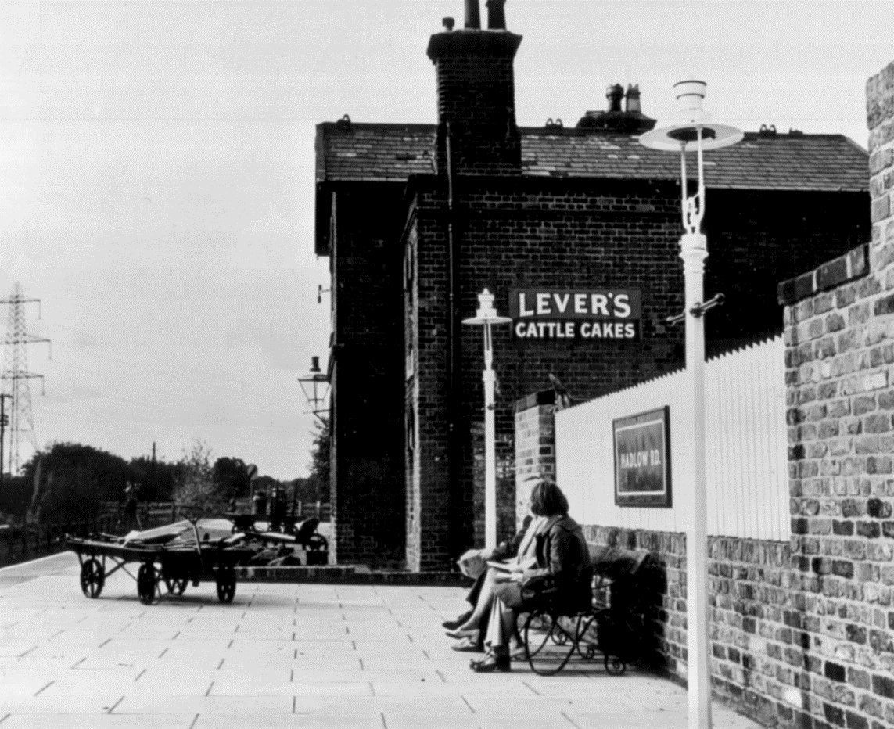

Station in 1975

In 1979, the station earned a commendation as one of the best-preserved stations in the country.

In 1983, the popular TV programme Hinge and Bracket was filmed at Hadlow Road Station.

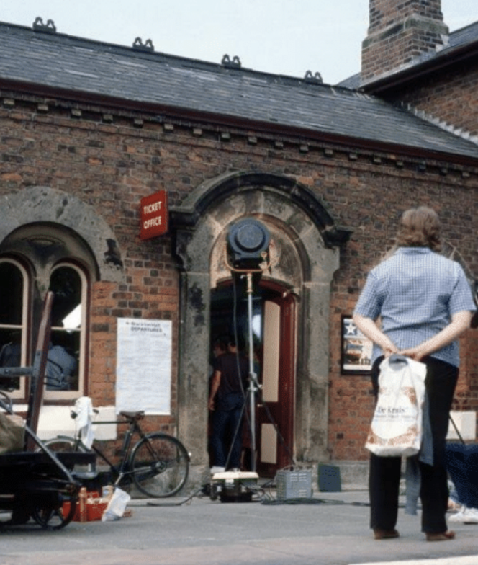

Photo: Jean Griffiths

Friends of Hadlow Road Station was set up in 2014 to restore the station to its 1952 theme. They run regular community cafés and gardening groups. They also have special events, including a Santa’s Grotto in the signal box at Christmas.
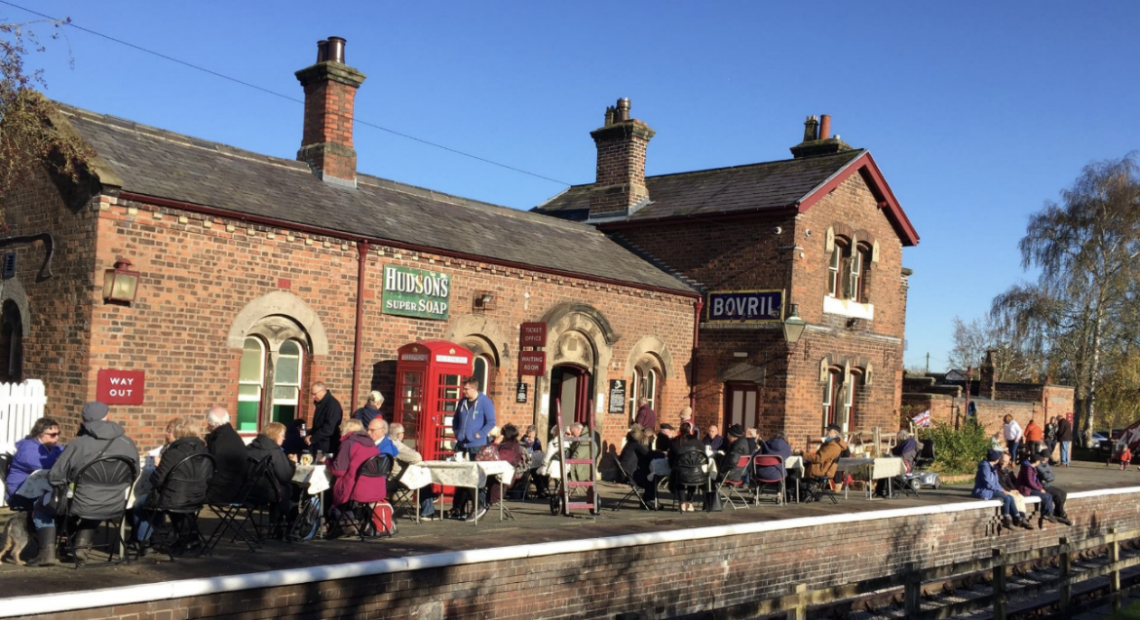
Friends of Hadlow Road Station community café in 2019

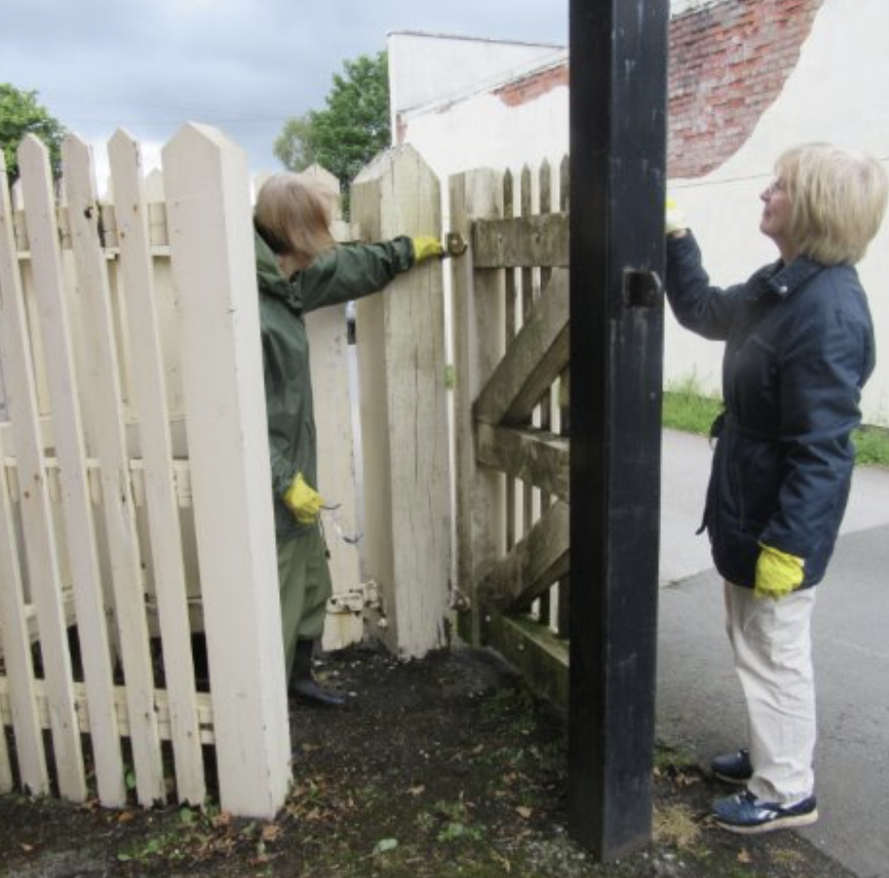

Volunteers help paint the gates

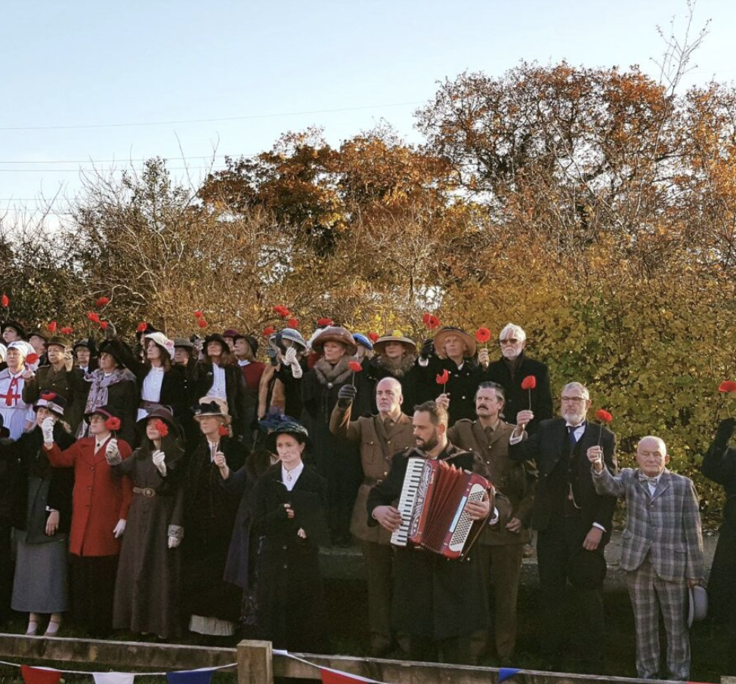
Celebrations of the 100th anniversary of the end of WW1 in November 2018

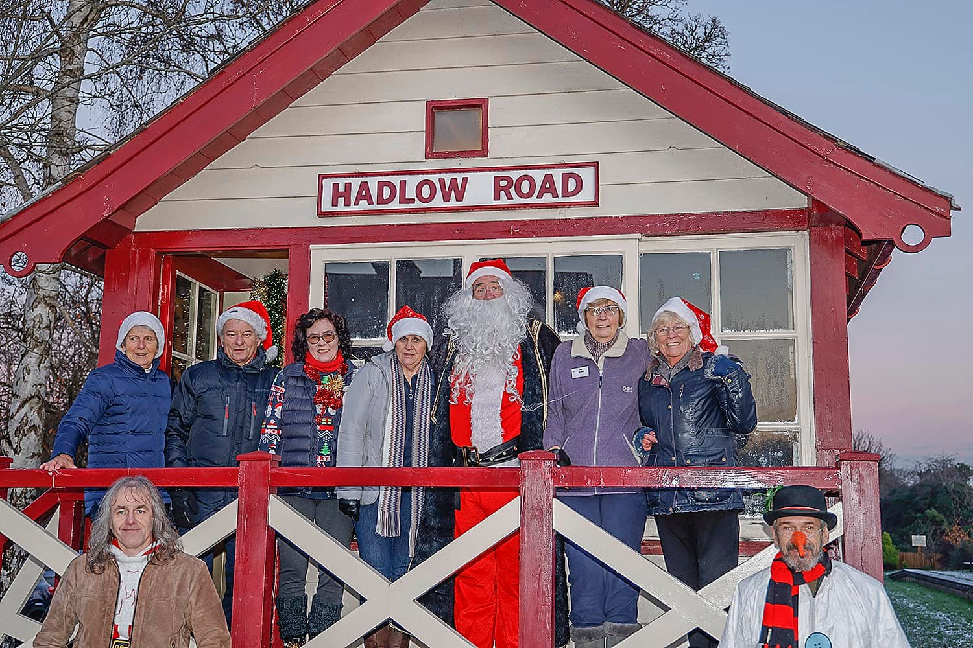

Santa and Friends of Hadlow Road Station in 2022

In 2021, Station Master’s House coffee shop opened, based in the old station master’s house.

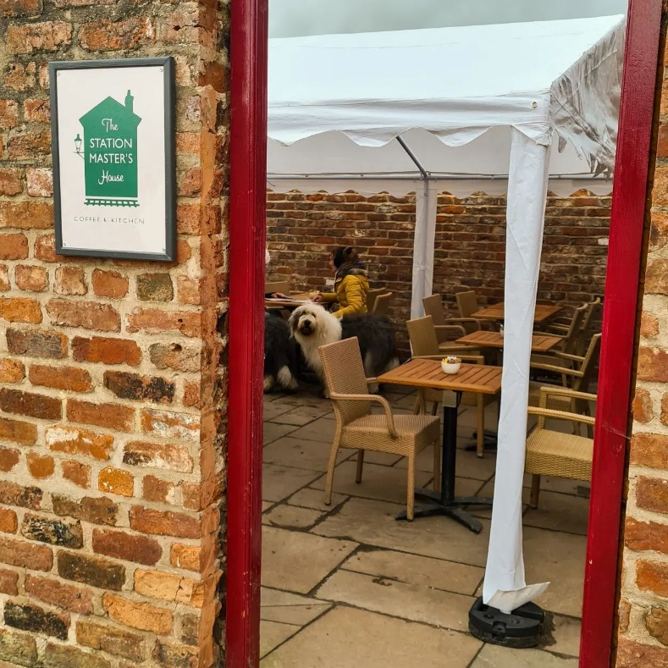

Updated January 2024

