Collier’s Joinery Works/Timber Yard

This was first run by Mr Dodson and known as Dodson’s. It was then run by Mr Collier.

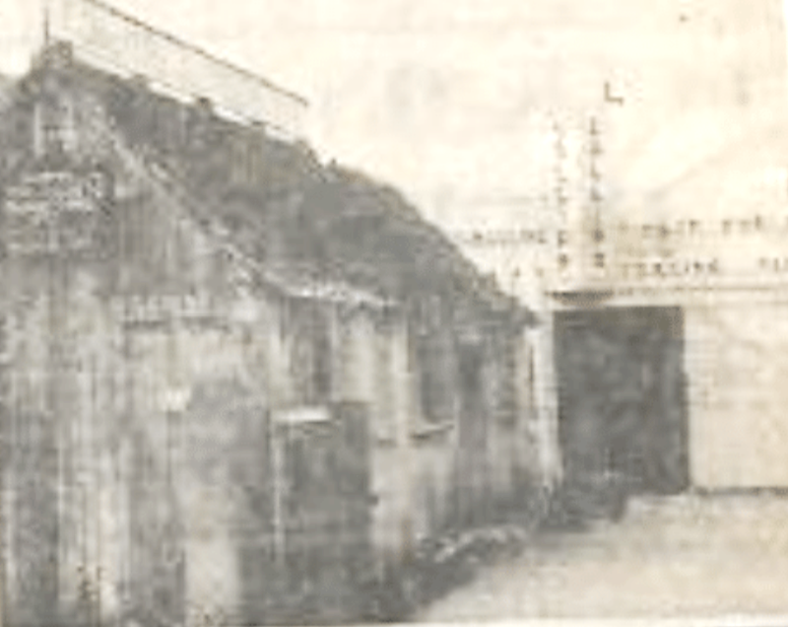

From an unknown paper dated May 1972
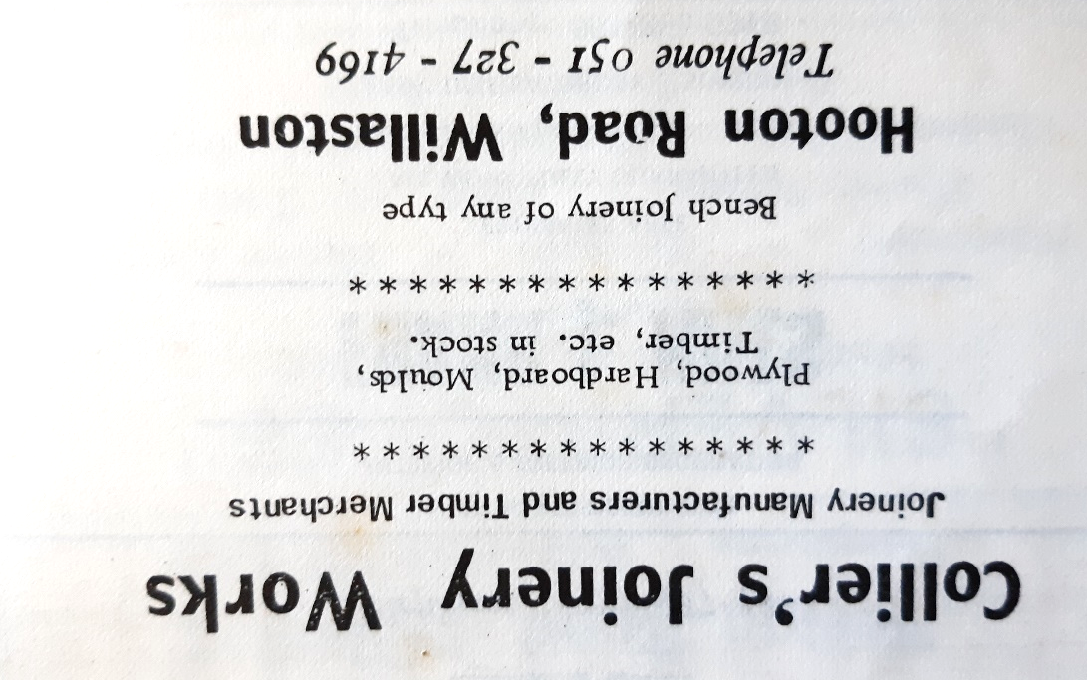

Advertisement in Christ Church Parish News September 1975

When the scout hut was built this was constructed at the joinery works and the scouts helps to lay out the wooden joists.

In the yard, there was also F. Thornton who serviced lawnmowers.

In 1998, houses were built in the colliery area, which is now Keel Hey. The road is called this after the ship building that took place at Colliers.
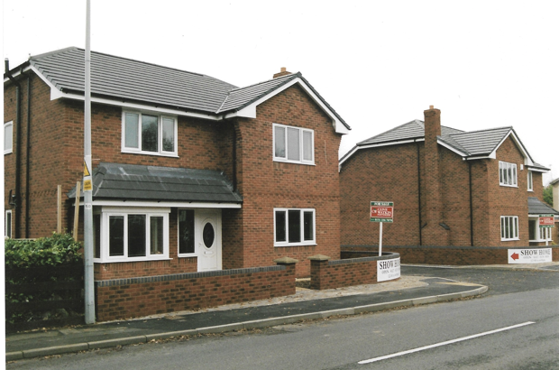

New houses at Keel Hey are open for viewing

On the edge of the timber yard was a house which later became Shop Planning and then Life Pilates.

Updated January 2024

