Christ Church

Willaston had no Anglican church until 1855 and it was not until 1865 that it became a separate parish. Before that it was in the ancient parish of Neston and people would travel to Neston on foot, horseback or farm carts to attend the church services. A few people went to other churches, including Eastham and Burton.

When the Rev. Robert Yarker became vicar of Neston in 1864, Willaston had a population of 600 and he decided it should have its own church and parsonage house. However, he died in 1853 when the fund he had started for the purpose had only reached £700. His widow wrote to the new vicar of Neston that the list of subscribers was only short as the general appeal had yet to be launched as he had intended to start the appeal once the building had started. Mrs Yarker said his ‘main object was to build a church at Willaston that should be an architectural beauty and design worthy to be the House of God.’

The architects were Robert Fulljames and F.S.Walker. It is not known why they were chosen as most of their work was done in Gloucestershire and this appears to be their only commission in Cheshire.

The carved stone font is a memorial to Robert Yarker and the east window to his wife, Frances Yarker.

His successor, Rev. Richard Gleadowe, launched a more general appeal which raised the total to £2000 and the foundation stone for the church was laid in part of Bedson Croft on 5th July 1854. The building was built of stone taken from a quarry in the middle of the village that belonged to the Pollard family.

The building consecrated on 21st June 1855. Duncan Grahame came to live at the Lydiate and gave an endowment of £1,500. He became the first patron of the living. The new building only had the cancel and nave.

This photo is thought to be from the early 20th Century (from Willaston’s Heritage by E.C. Bryan)

From 1855 to 1865, Willaston Church was used as a chapel of ease for Neston and no burial, baptism or marriage registers were kept here. Registers were first issued in May 1965 and the first entry in the burial register is for ‘Charity Taylor (gypsy girl) aged 15 years. She died whist camping in Hallwood Lane. For many years afterwards, the gypsies visited her grave every time they passed through the village.

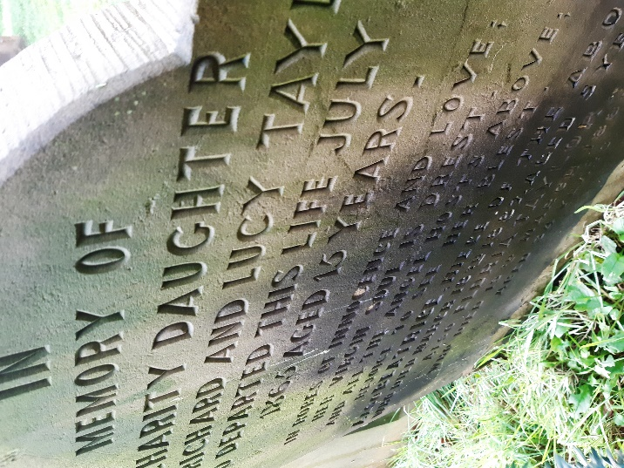

The registers show that in 1895, 14 children under the age of 11 died either from measles or complications following measles. In 1870, there were 14 deaths from diptheria. There were several Coronor’s Inquests for men killed on the railway at Hadlow Road or Ledsham and one was for a man who fell from his trap returning from Chester Fair at Christmas 1889.

Several of the church windows were given to the church as memorials.
- The West window was given in memory of Walter Grahame, the 27-year-old son of Duncan Grahame from the Lydiate.
- A window on the south side, depicting Noah and Abraham was given by friends and parishioners as a memorial to Duncan Grahame who died in 1901, aged 75.
- In 1918, a window showing St Dorothy and the Virgin Mary was given in memory of Dorothy Evelyn Todd, aged 17, by her parents.
- On the north side, a window ‘Suffer little children to come unto Me’ was given in memory of Philip Charles Eaton, aged 5 by his parents who lived at Raby House.
- Another window on the north side, showing Mary Magdalene and the Risen Lord, was in memory of Walter Glynne of the Lydiate, who died in 1925.

In 1925, the north aisle was added and new vestries were built. Some of the windows originally on the north aisle were moved into the side aisle. The foundation stone of this section was laid by Mr W.R. Glazebrook.

The organ was given by Mrs Johnston of Raby House as a memorial to her husband who died in 1926.

An oak pulpit replaced a white stone one and was a memorial to Doris Rhona Hodges who died in 1929 and the carved oak altar was given by Mrs Cato’s family in 1935. Then Mrs Johnston gave the reredos and panelling of oak in the chancel and the two chairs in the sanctuary. The oak furnishing was completed by oak choir stalls which were a memorial to Mr Matthew Clover of Roselea and the communion rails given by Canon Wilkinson and his wife.

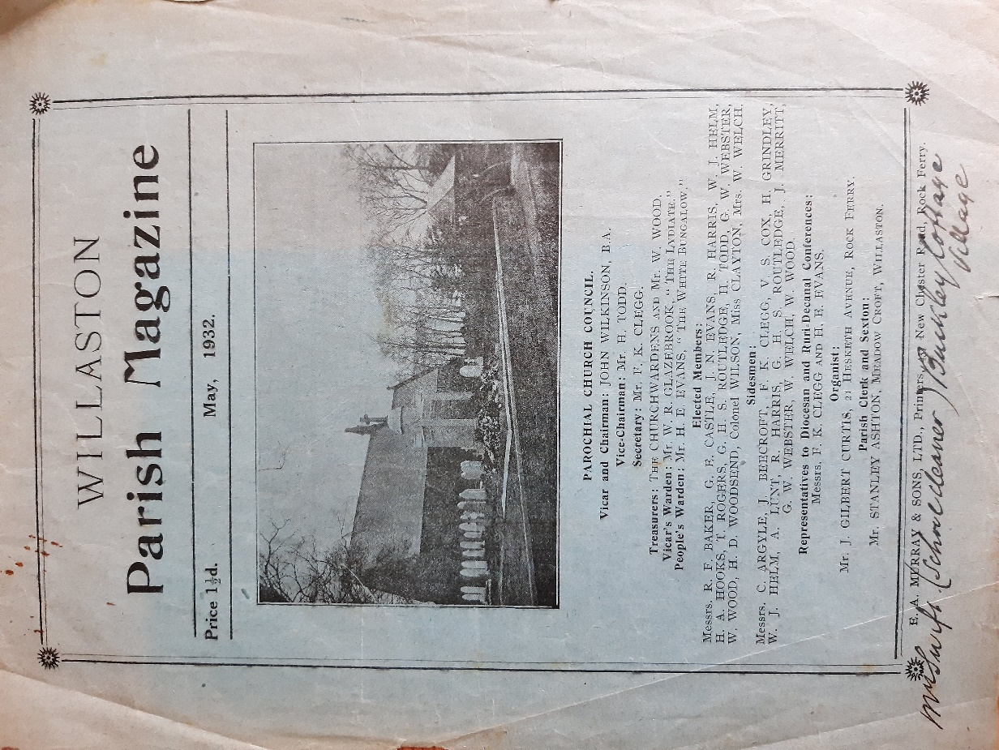

This front page of the Parish Magazine from 1932 shows that the vicar was Rev John Wilkinson and the Church Warden was Mr W.R. Glazebrook from The Lydiate.

The Church choir in approximately 1940
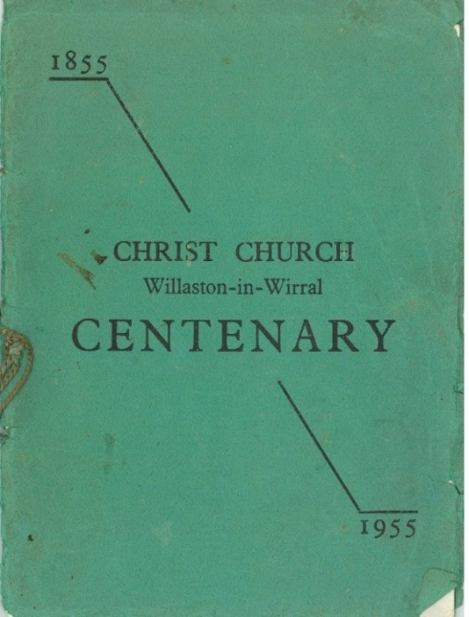

1955, Christ Church celebrated its centenary and published a book about its activities.

At the time, there were four services on Sundays:
- 8am – Holy Communion
- 10am – Children’s Service
- 11am – Matins, followed by Holy Communion on the 1st and 3rd Sundays of the month
- 6.30pm – Evensong
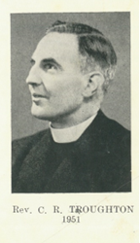
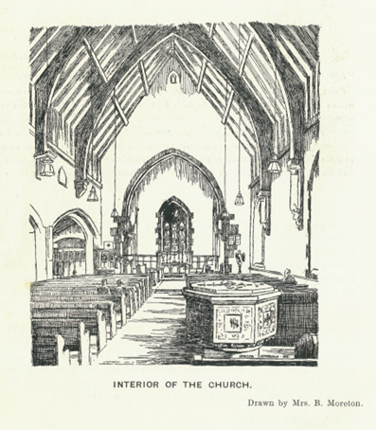

The book mentions several recent gifts to the Church, including beautifully embroidered pulpit falls and makers for the lectern which were given by Mrs Todd, Mr Peers, Mrs Burns and Miss Clayton.

During the centenary year (1955): ‘Miss Duncan has given churchwardens’ staves, the Mothers’ Union have provided new robes for the choir, a new section of panelling has been given by Mrs Roy Leach and another section promised by Mr J Adams to complete the chancel. Mrs Oakshott has very generously contributed to the refurbishing of the church.’

‘It is hoped that during the year an oak board showing the names of all the vicars of the parish will be placed over the doorway as a memorial to Canon Wilkinson.’

‘To mark the Coronation of Queen Elizabeth, a wooden seat was given to be placed in the churchyard.’

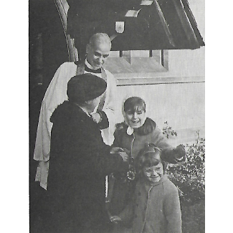
In 1971, the vicar was Fred Strachan and the main activities in the parish, other than services were:
- Mothers’ Union
- Youth Club
- Church Women’s Fellowship
- Sunday School

In 2000, the three WI’s in Willaston joined together to commission a stained-glass window in Christ Church. The window was designed by William Davies of Irby. The centre light depicts Dorcas, ‘a woman full of good works and alms deeds’ (Acts 10, xxxvi). The window was dedicated on 12th August 2000.

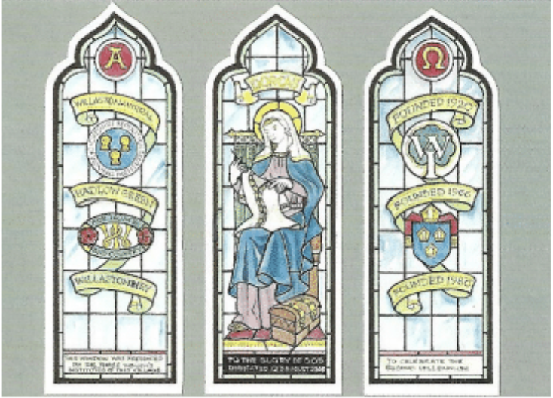

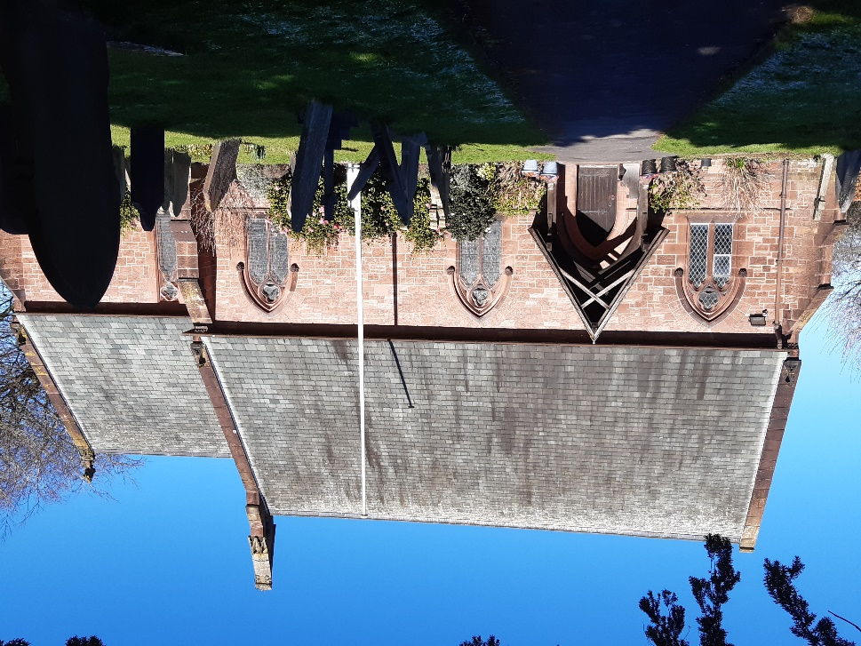
Christ Church in 2023

Updated January 2024

