Butcher / Willaston Barbers

Cecil C Barnes ran a butchers shop.

Advert in Willaston Parish Magazine in 1962

Then Archie Mowatt took this over, along with the one at Laburnum Farm.

In around 1973 it was Traditional County Caterers, as can be seen in the photo below of the Boxing Day Hunt (photo Andy Legg).

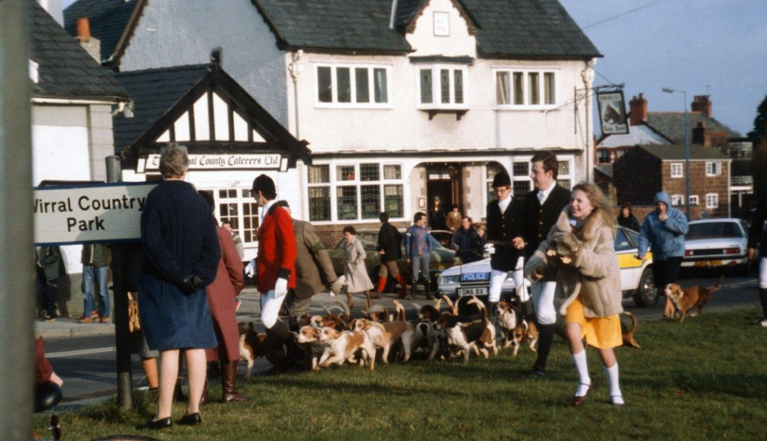

Janet Dundas recalls that her husband, who worked in the builders yard behind the shops would be a ‘tester’ for the cakes, trying them out and telling them if he didn’t like them. They catered for a lot of corporate events. Once they forgot to take the cake out of the freezer, Dave took it behind the shop, cleaned his circular saw and cut it up whilst still frozen!

It then became Willaston Antiques.

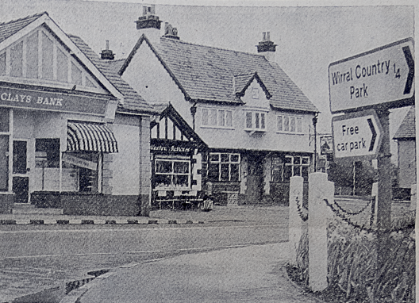

Picture from The News 1975 when it was Willaston Antiques.

It then became Dundas and Dear estate agency, which included the agency for the Halifax Building Society (Barbara Shelbourne) and then Village Properties estate agents (Eric Murch).

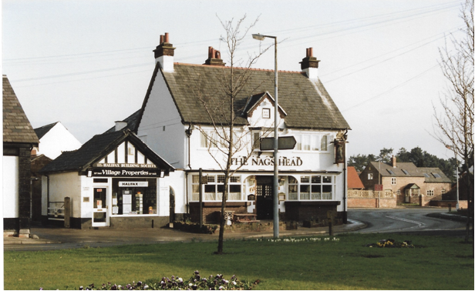

In this photo, thought to be taken in the early 1990s, Village Properties operated as an estate agent and the agency for Halifax Building Society. Later the agency changed to Yorkshire Building Society.

In 2003, it became Willaston Barbers (Beverly Rowe and Simon Worthington).

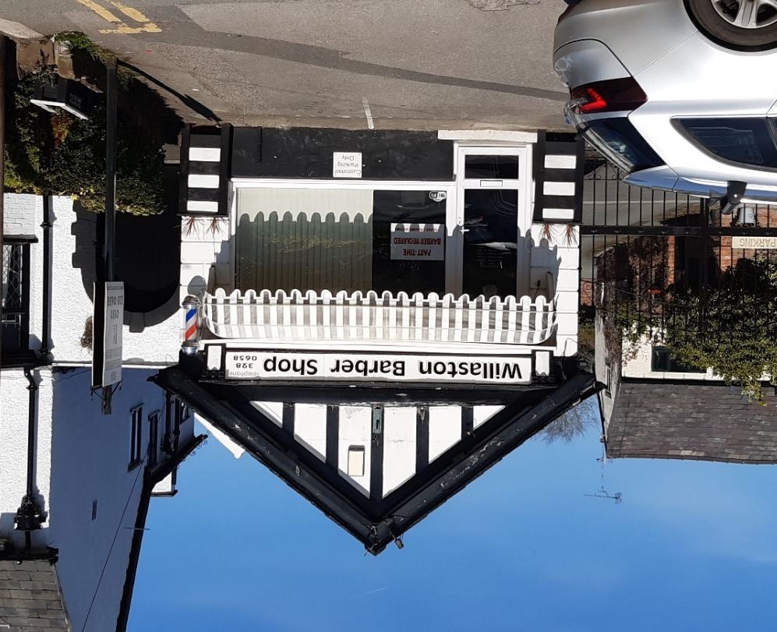

Willaston Barber Shop in 2023

To celebrate 20 years in Willaston, the shop handed out loyalty vouchers to regular customers in 2023:

Updated January 2024

