Willaston Mill

It is thought that Willaston has had a mill since 1321. In the Chester Plea roll, there is a record of an enquiry held that year to decide whether the erection of a mill by Oliver de Bordeaux at a place called ‘Trymelowe’ could go ahead without harm to the Black Prince’s Forest of Wirral. Trymelowe has been identified as being in Willaston, not far from the present mill. The jury at the end of the enquiry decided that a mill would not be harmful.

In 1640, a peg mill was built about 30m west of the current mill.

The present Mill was built in 1800 by William Lightbound, whose father-in-law had owned the previous mill for about 50 years. The mill is 110 feet high, the largest of the Wirral windmills.

The mill provided substantial employment for the village. It was claimed that it was possible to cut and thresh corn in the early morning, grind it, make it into bread and have it delivered in London the same night! However, it was never a financial success. The original owner had to take out several mortgages before selling up.

In 1860, the mill was sold for £3,500 to the Radford family. James Radford tried to improve efficiency by installing steam power and increasing the number of millstones to nine and additional buildings - being said to have spent around £30,000. This was one of the first mills to use steam power and required a 60 foot high chimney to take away the excess steam and smoke. This enabled the mill to work continuously and not just when the wind was blowing. However, this was only partially successful in helping it compete against more modern mills in Birkenhead and Liverpool.
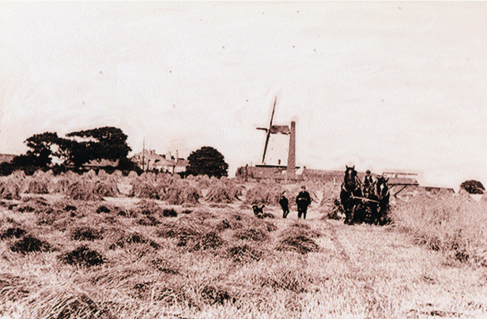

Harvest time with the mill in the background, about 1900.
Photo from Willaston of Yesteryear by Bob Prince
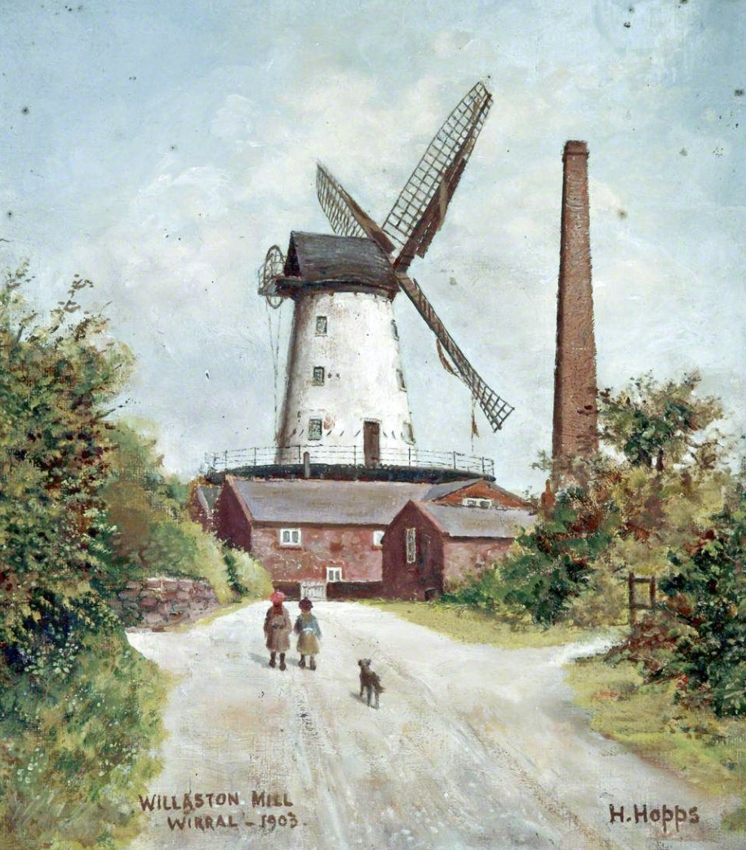

This picture of Willaston Mill is from 1903 (Credit: Williamson Art Gallery) and the chimney stack can be seen clearly.

Mr Brodbelt said in a book (title unknown):
‘The grains were hoisted up by chain and, after grinding, round their way down by chutes and into bags. On the ground floor, there were four sets of large grinding stones for making wheat into flour. The rotive power was a steam engine in an adjoining building, erected later, together with other outbuildings, mainly of stone construction, in which cleaning and separating processes were carried out.’

The grinding of wheat into flour ceased in 1885 and the mill was kept working for making cattle food with oats and maize for neighbouring farmers until 1930 when the sails were damaged in a storm and sawn off.

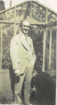
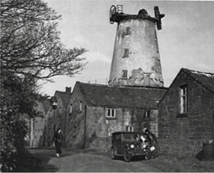

The last miller, Charles Hale Willaston Mill in 1937

In 1933, the mill was sold to Charles Townsend for £530. He had intended to preserve it but then appeared to give up on the project. In 1936, the Wirral Society bought the mill with the intention of repairing the building but their resources could not stretch to the costs.

During the Second World War, the local Home Guard detachment used the tower as a lookout post. They worked in shifts throughout the dark hours, seeing as far as Runcorn Bridge, Liverpool and the Welsh hills. They also used it in manoeuvres, along with regular units. However, by 1946 some of the mill buildings had become dangerous and were demolished.

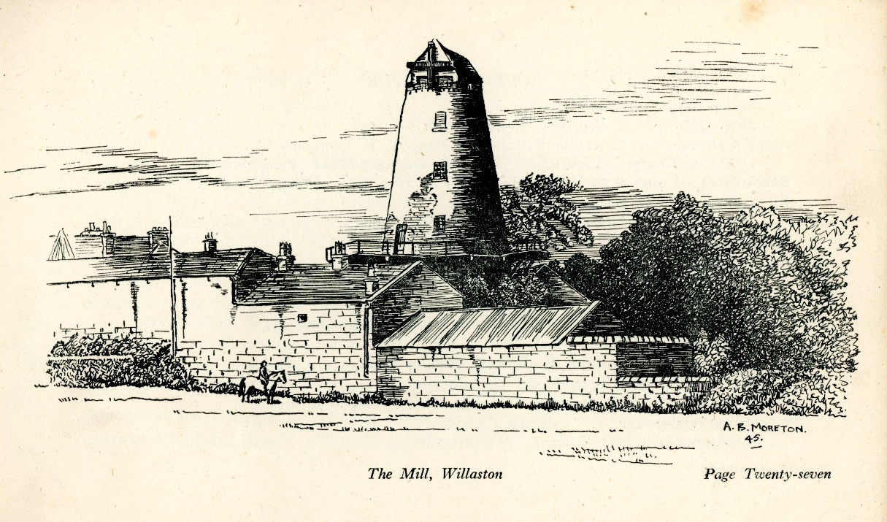

Drawing of the Mill in 1945, taken from All About Willaston by the Royal British Legion
Keith Edwards remembers playing at the mill in the early 1950s. There was a platform half way up that they were allowed to go to but sometimes they went right to the top and sat on the stumps where the sails used to be. He still has a scar where he fell. He also remembers that Nurse Lloyd lived in one of the grey mill cottages which was bought for her so that the village would have a nurse full time.

Despite plans to use the mill as a youth hostel or by the air observer corps, the mill was unused and became increasingly damaged. Eventually, the Wirral Society said they would sell the mill to anyone prepared to pay a reasonable price and maintain it. If this was not successful, it would be destroyed. Mrs Theresa Morris from Heswall and her sons put in an offer and in 1958, the mill tower was made into a private family residence. Later the bakery, stables and cart shed around the mill were also converted to houses.

The local Brownie pack was run by Elspeth Catto, daughter of James Catto who lived at the mill (dates unclear). The pack would meet on the ground floor of the mill.

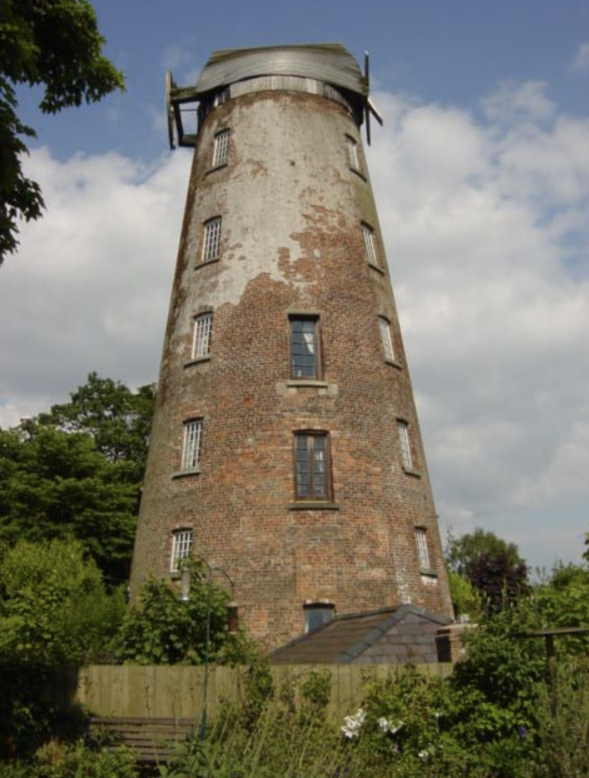

Brothers Hugh and Arthur Morris in front of the mill
Photo: The News July 1989

Willaston Mill 2004
(photo: Sue Adair)

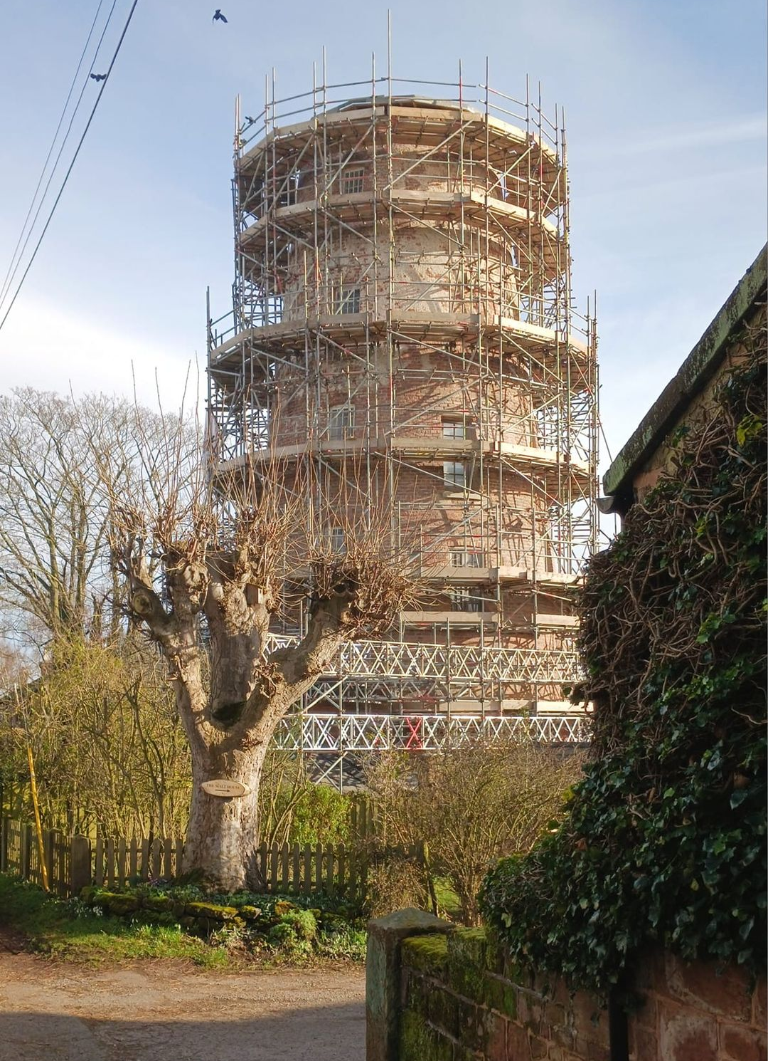

In 2023, the mill, now in the ownership of the Seedhouse family, had its roof removed and transported to Suffolk for specialised renovation. At the same time, other improvements were made including installation of new windows.
(Photo: Kevin Walford)

