Willaston Engineering Works

Based on Neston Road from 1947, run by Ron Higgins, it made various things including caravans.

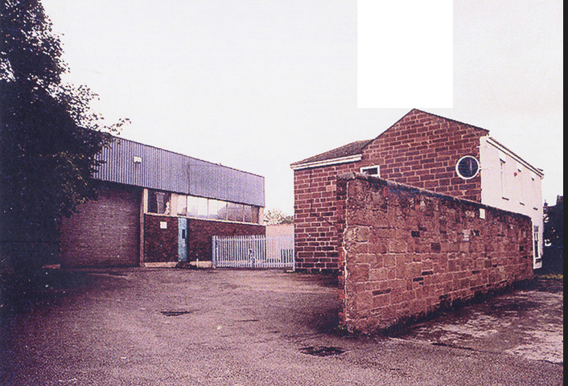

Date unknown (Photo: Bob Prince)

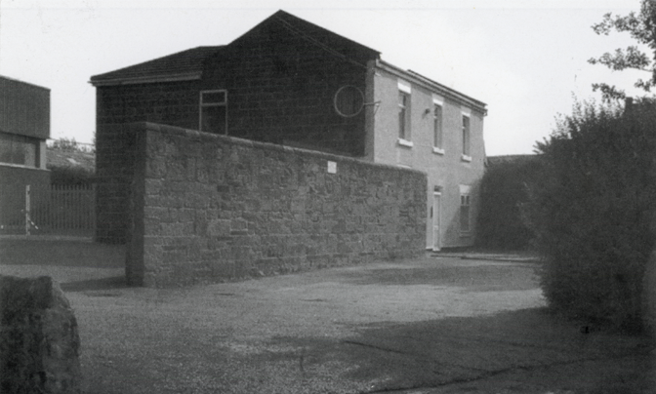

Date unknown
Photo from Willaston – Centre of Wirral by Bob Prince

In 1971, it was noted that ‘The access to the Engineering Works beside the Nag’s Head is most unsatisfactory as it involves a difficult manoeuvre at a blind corner on the main road.’ (Conservation Stage II report, June 1971: Willaston, Neston Urban District, Cheshire County Council). At that time, the exit was between the Nag’s Head and what is now White Feather Home.

It was demolished and ‘The Courtyard’ housing built in 2004.

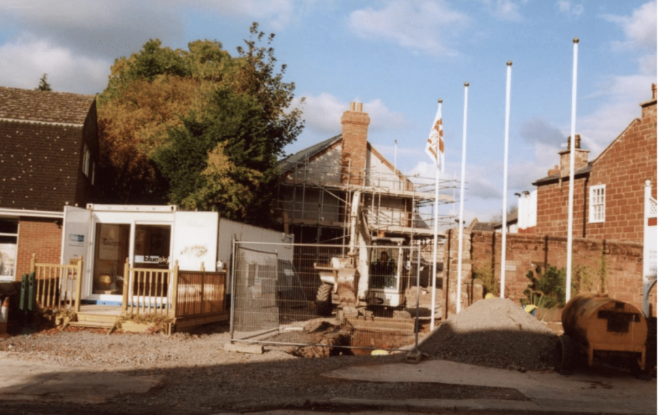

The Courtyard under construction (Photo: Jean Griffiths)
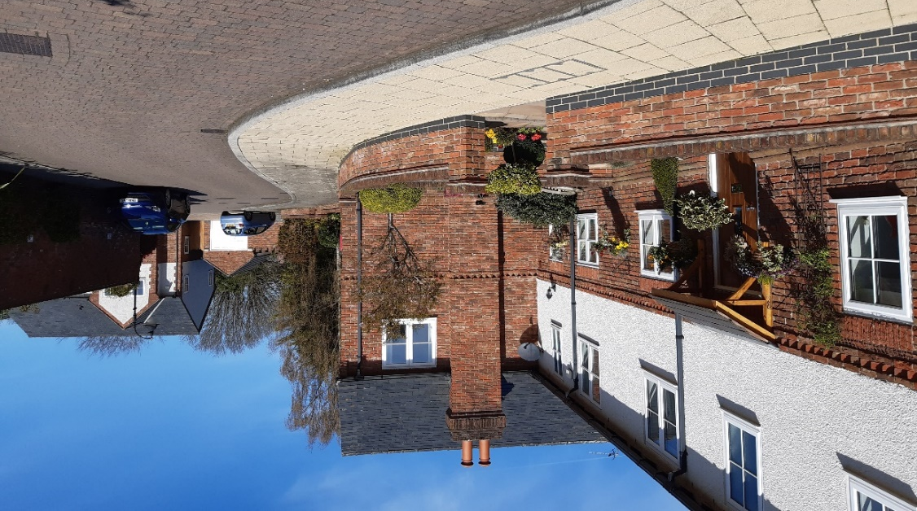

The Courtyard in 2023

