The Lydiate

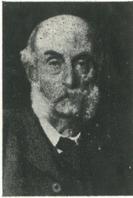
Lydiate Farm came onto the market around 1856 and was bought by Duncan Graham, a wealthy merchant. Mr Graham also bought some adjoining land and built Lydiate House in an estate of 28 acres.

Mr Graham was a benefactor to the village, supporting the church, the new school building and the original Willaston Institute. He also paid for the first piped supply of water to Duncan Graham
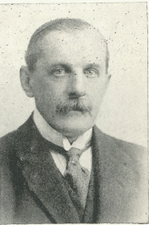
be laid for the village.

Several private owners, Walter Glynn, Walter Midwood, Edwin Beazley and W.R. Glazebrook also lived in the Lydiate. Mr and Mrs Glazebrook lived in the Lydiate from 1922 and were also benefactors to the village.

W.R. Glazebrook

The Lydiate was then used by J. Bibby and Sons of Liverpool as a training centre.
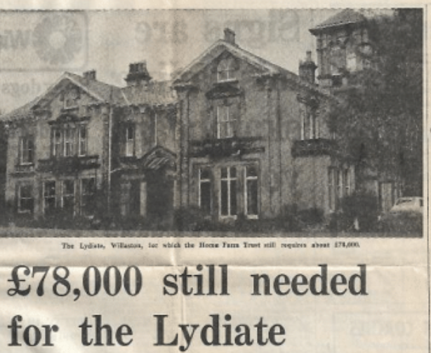

The News, week ending January 14th 1978

In 1974, Mrs Pamela Sinclair set up a support group in Wirral for Home Farm Trust, with the aim of setting up a home for people with learning difficulties. In May 1977 the building was bought by Home Farm Trust to house thirty residents with learning difficulties. The cost was £65,000. An additional £142,000 was needed to be raised to cover structural alterations, furniture, equipment and a sum to cover the deficit in the first two years.

The Lydiate was later sold and converted into several flats.

