Station Garage, Hadlow Road

In 1945, the garage was run by W Bebb. In 1951, it was run by JC Wivell and CH Kidger. By 1955, Mr Wivell was no longer involved.

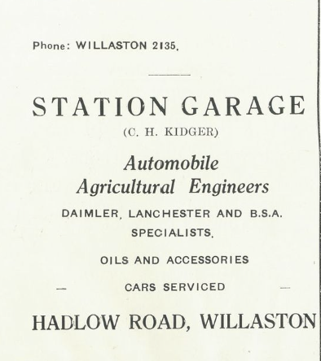

Advert in Christ Church Centenary 1955

In 1962 it became Clarke’s Garage.
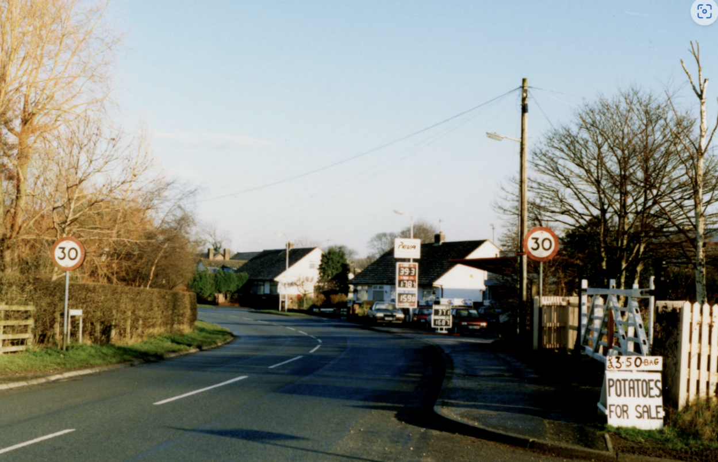
Photo: Jean Griffiths, date unknown

Later, it became Willaston Car Sales.

