Mill View

Mill View was used for many businesses:

Sigley Brothers, Building Contractors

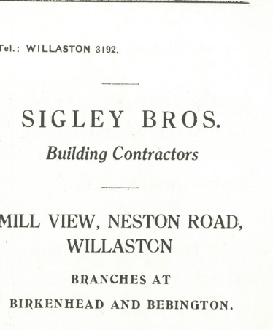

Advert in Christ Church Centenary 1955
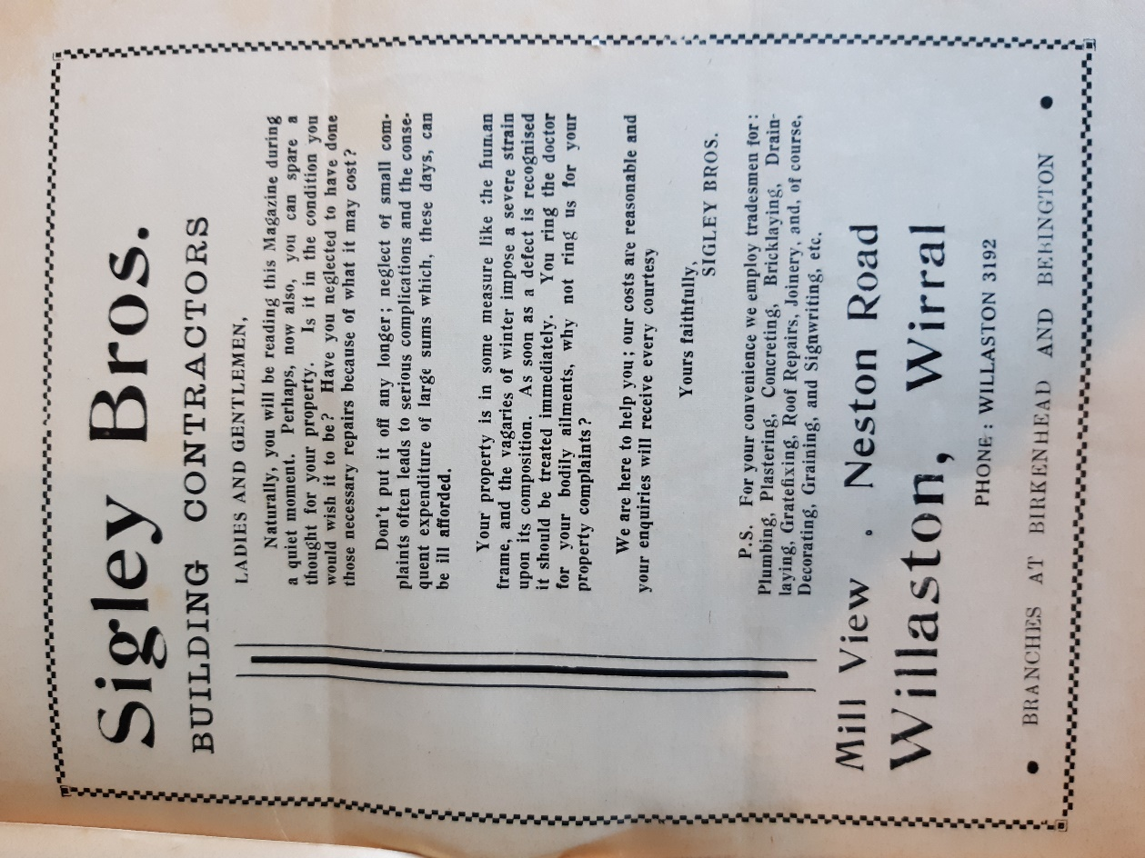

Advert in Willaston Parish News in December 1962

Irene Hairstylist, with Irene Harrison, Sue Oxton and Gladys Thomas

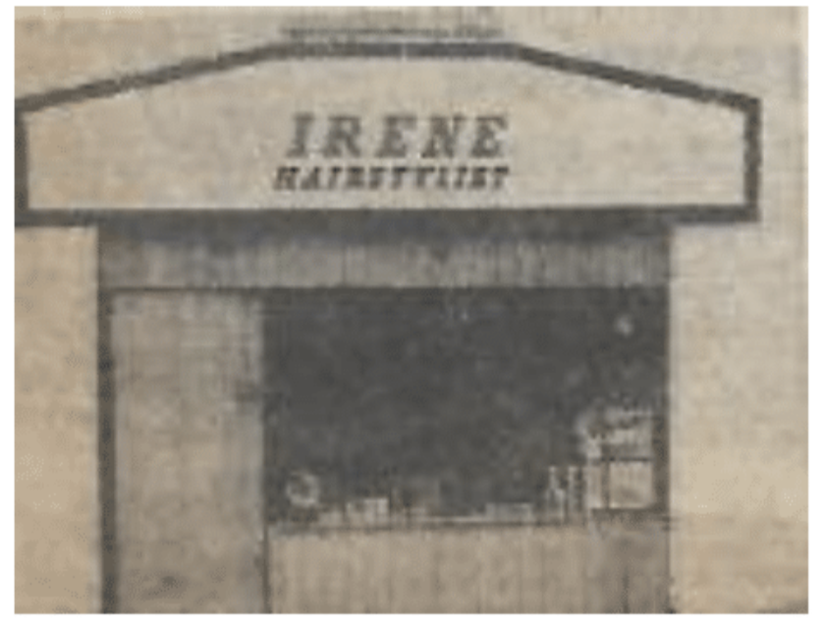

Press cutting May 1972, paper unknown

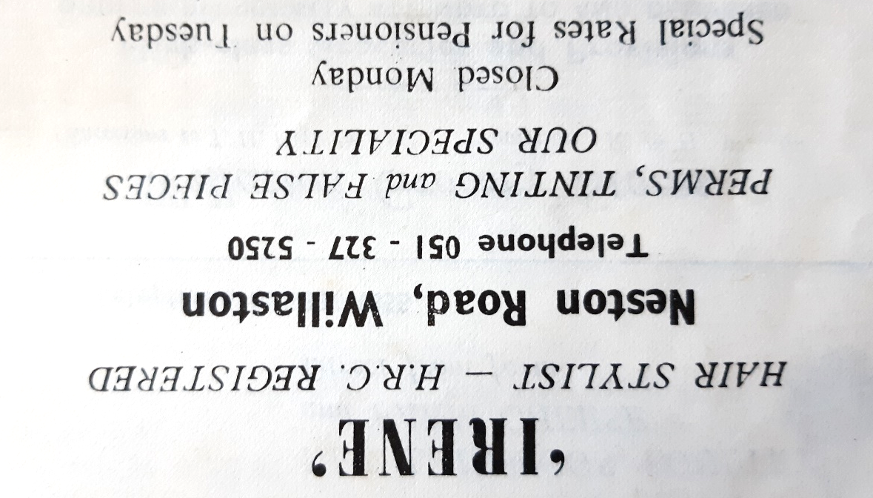

Advertisement in Christ Church Parish Magazine September 1975

Her Way – Hairdressers with Pauline Marsden (wife of Gerry Marsden) and Joyce Ryan

Millview Studio: Hair, Beauty and Aromatherapy. Run by Kate Colombo from 1996.

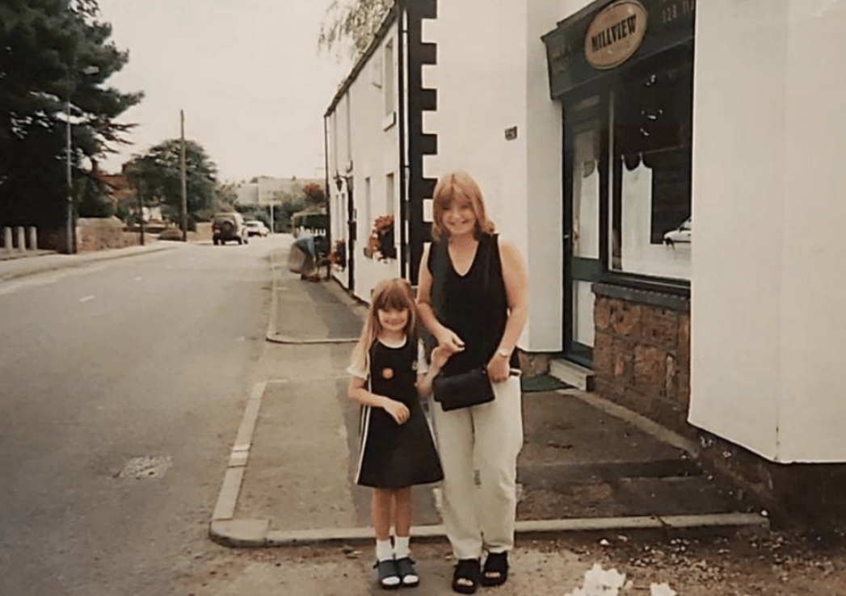

Millview studio in 1996.

It was converted to a house in 1999.

At the rear of Mill View and neighbouring cottages was Fairclough’s Builders Yard, which is now converted into stables.

