Methodist Chapel

The first Methodist chapel was built in Willaston in 1838, near to Corner House Farm (now Pollard’s Inn) on the site now occupied by Weint Cottage. The building was about 46ft x 23ft, split into the chapel 28ft x 23ft and the schoolroom 18ft x 23ft. It cost £90. The chapel seated about 150, but some change in 1868 reduced this to 100.

In 1842 the Sunday School had 54 children (about equal numbers of boys and girls) and eleven teachers (eight male and three female); over the next twenty-five years, the School averaged 67.
From 1875 onwards, Chapel activities were frequently reported in the Cheshire Observer including a Band of Hope meeting, a tea party, Chapel Anniversary Service, Harvest Thanksgiving Service, a Temperance meeting, and the annual sermon of behalf of Home and Foreign Missions.
In the 1878 Neston Petty Sessions, two young men were summonsed for ‘disturbing a congregation’ during a Willaston Chapel service by singing songs from a comic book and rattling the chapel’s shutters. The Chairman said ‘it was a most disgraceful offence’, and they were each fined 20s [about 3 days’ wages for a skilled tradesman] and costs.’
By the 1880s, the Chapel Temperance Society had 300 members. The chapel had become too small and was described as dilapidated. It took five years to find a suitable site for a new chapel. Building began in 1889 and the new chapel opened in 1890.
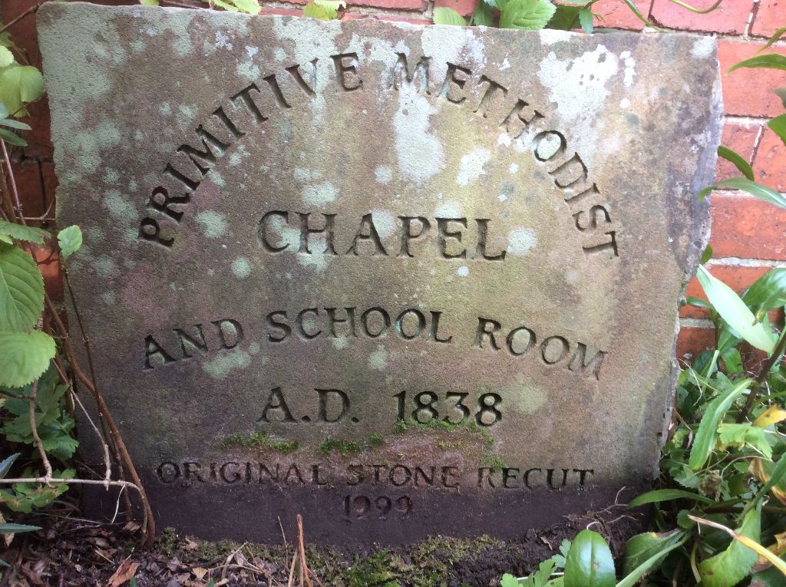
The old chapel was sold off by auction and later demolished. All that survives of it is an engraved stone (see above) which now stands in the garden of the 1889 chapel.

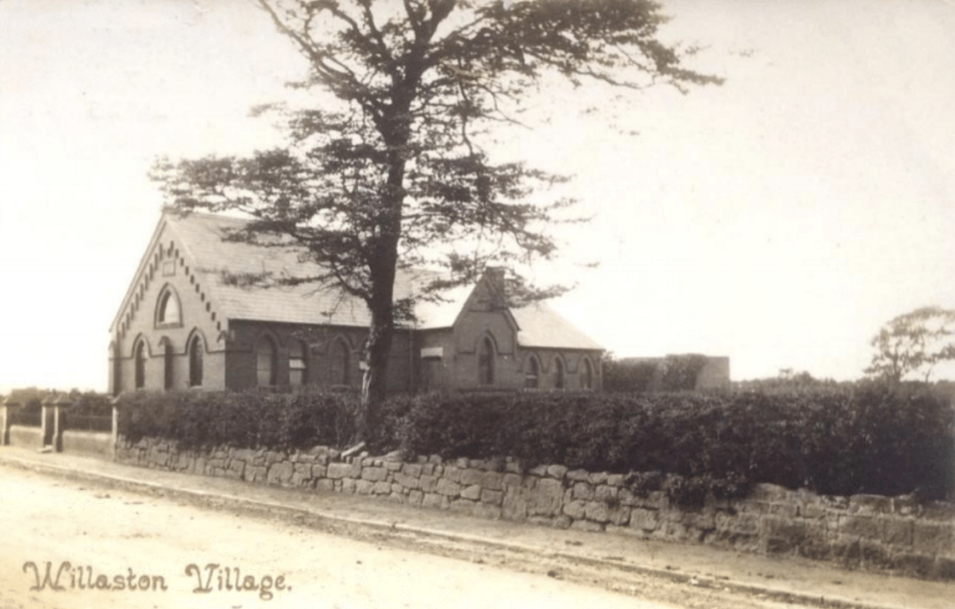
The new building was built of Ruabon brick and cost £700. There were services on Sundays at 10.45am and 6pm led by local preachers and a Tuesday evening service at 7pm every three or four weeks.

Postcard postmarked 1906
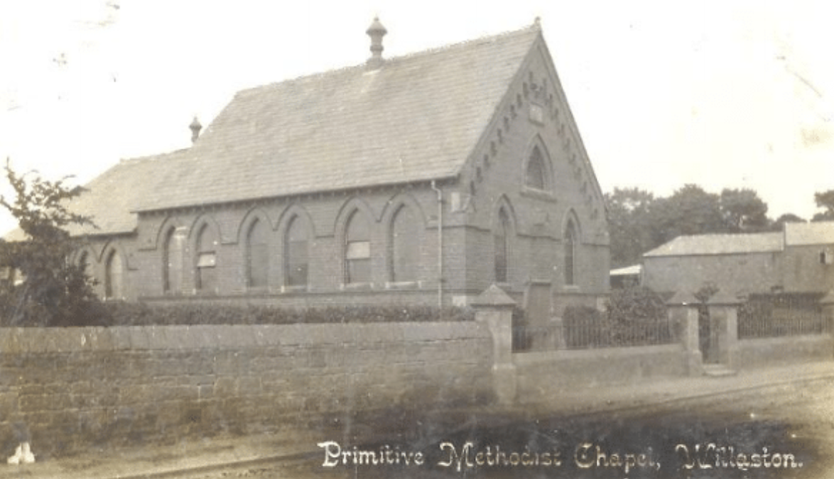

Postcard postmarked 1908

By 1910, the Sunday School register listed 75 boys and girls. They ran Band of Hope classes at which they played games, had talks on the Christian life and the evils of drink, signed the pledge and sang ‘Dare to be a Daniel’.

During the Second World War, volunteers ran a canteen from the chapel for service men and women. For six nights a week from the Autumn 1940 until the end of the war, a hot meal was served for 80-100 people. For 1s 6d they got a fried egg, chips, peas, bread and butter, cake and tea.

In 1945, All About Willaston by the Royal British Legion noted that there was a Child Welfare Clinic open from 2pm to 4pm on Thursdays.

In 1972 the Methodist School room housed the library service in Willaston and Saturday mornings, Monday afternoons and Thursday evenings. The library was run by Gill Niblock until 1994 when she had to retire. She used to sit at a huge table, usually with her German Shepherd dog at her side. The room housed three large bookcases and a precarious children’s folding bookcase.

Congregations dwindled but in the 1980s a Sunday School was set up again and chapel numbers revived. Extensions were built in the 1990s to accommodate the enlarged Sunday School and Youth Club. The group had trips out and club nights.

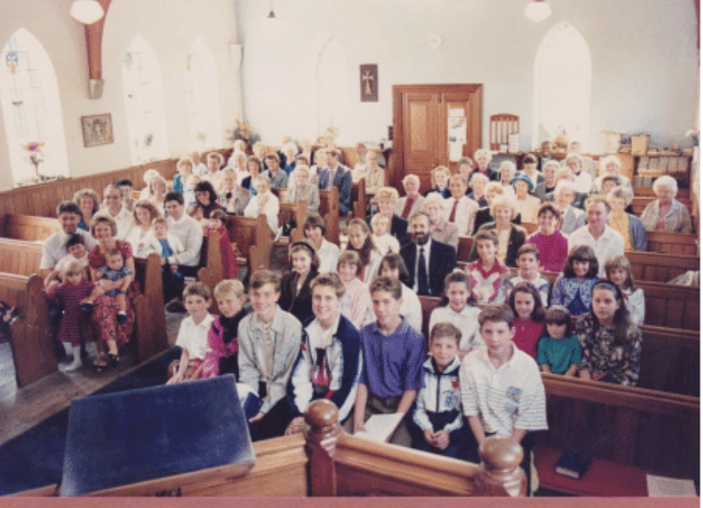

Harvest Festival in 1991

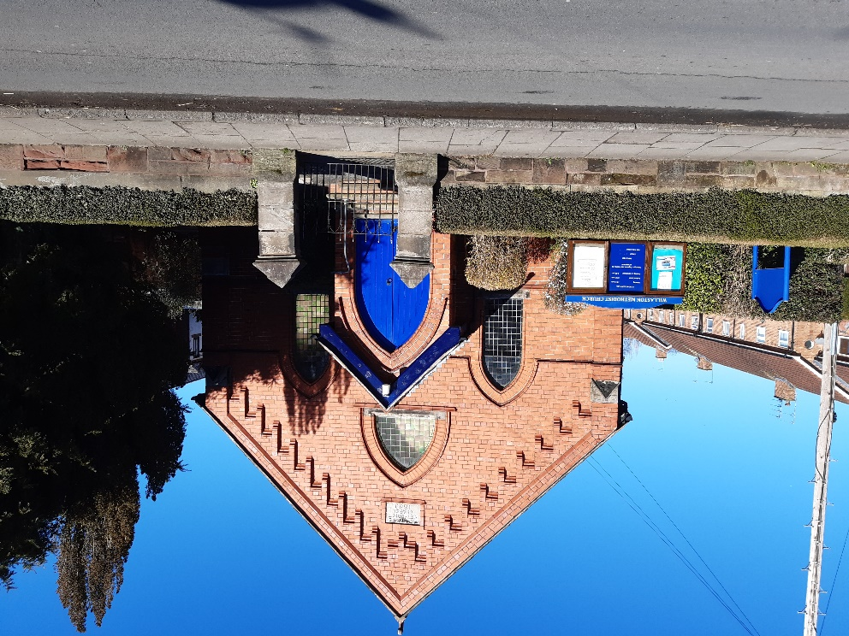

Methodist Chapel in 2023

