Lloyds Garage

Lloyds Garage was started in 1921. It was initially based in buildings on Neston Road, with workshops in barns behind which originally belonged to Laburnum Farm. The business was started by Sam Lloyd and later run by his sons Fred and Steve Lloyd. Steve Lloyd came to Willaston just before the First World War to deliver Willaston’s first motorcar – a Lanchester – to Mr Hatton Todd of The Grange and stayed for a month to teach him how to drive it. Steve returned after demob and took up permanent residence in the village.
Advert in Willaston Parish Magazine December 1962

The garage sold petrol and cars would pull to the side of the road and fill up with booms that would swing out. The left side of the frontage was sales and parts and the right side was the office. This was where you paid for petrol.

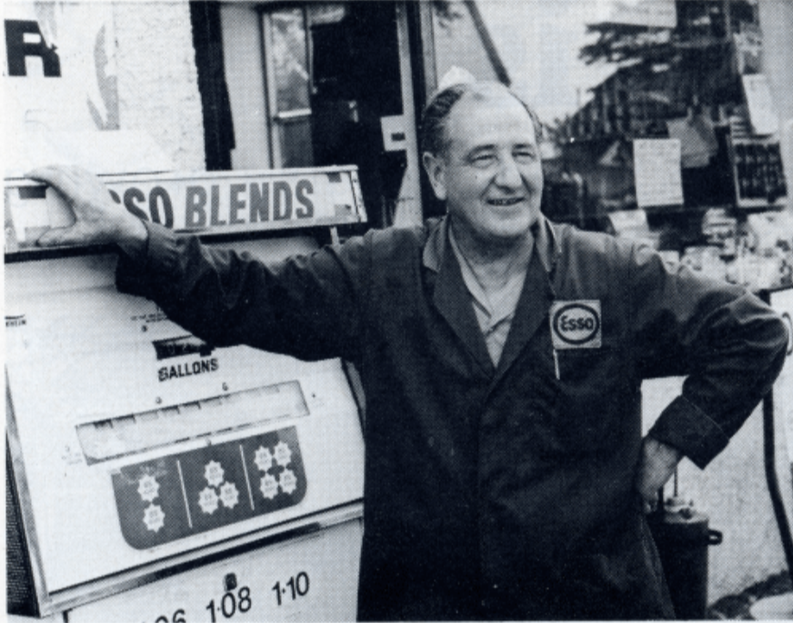

Steve Lloyd by the petrol pump
(Photo: Cheshire Life September 1979)

Julie Prowse remembers going into the garage to put £3 petrol in her car for the week.

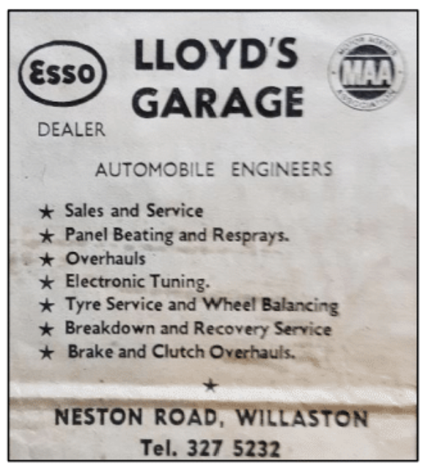

Advertisement from The News, April 18th 1975

The garage now is owned by Nigel and Ronnie Lloyd (Steve’s sons) and no longer has the frontage. The frontage became a Post Office (right side) and Style and Beauty on the left.

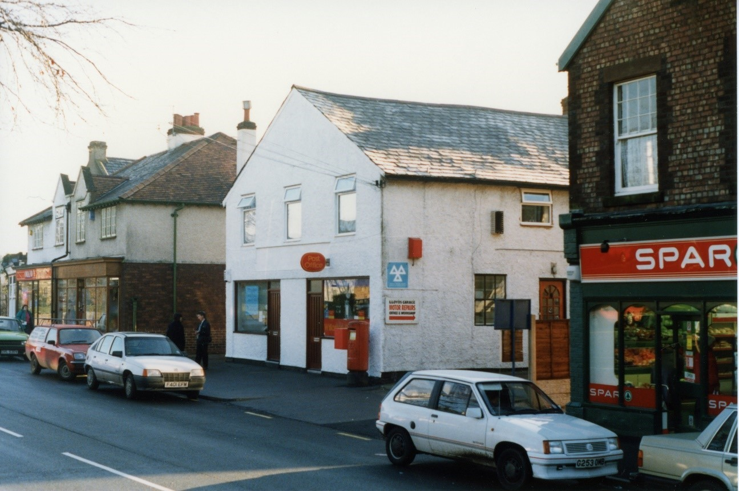

The building in the early 1990s with the Post Office on the right and Style and Beauty on the left (Photo: Jean Griffiths)

Style and Beauty was opened by Heather Murray in 1989.

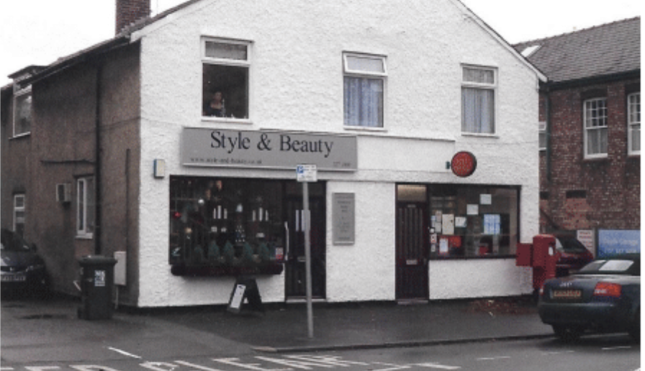

Photo thought to be taken in 2009

In 2018, the Post Office closed and the whole unit was converted to Style and Beauty.

