Leech’s Farm / Pear Tree Farm

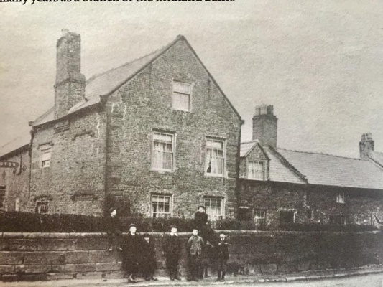

Leech’s Farm was built in the early 18th Century as a farm house. The ground floor has a cellar which was used to store cheese and milk. The farm was generally known as Pear Tree Farm and had a tree in the back that was taller than the house and grew into the actual walls of the house, into the bedroom.

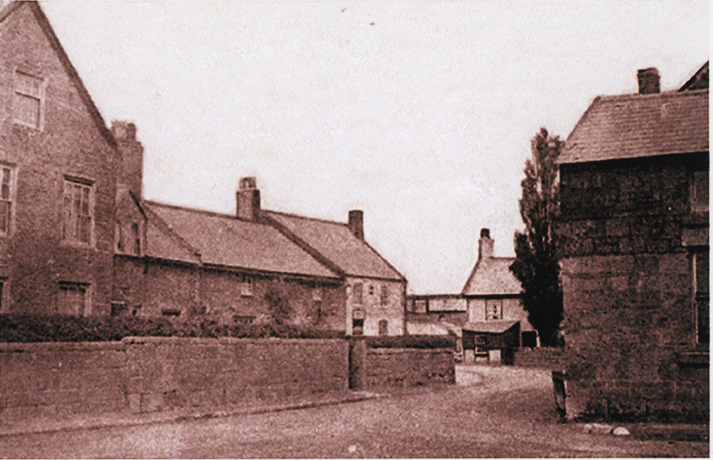

Leeches Farm on the left, with the Nags Head and Colls barn on the right (date unknown)

The building was acquired by Midlands Bank and it was run as a bank from at least the 1950s, later becoming HSBC. In 1945, the bank was only open on Tuesday and Friday mornings.

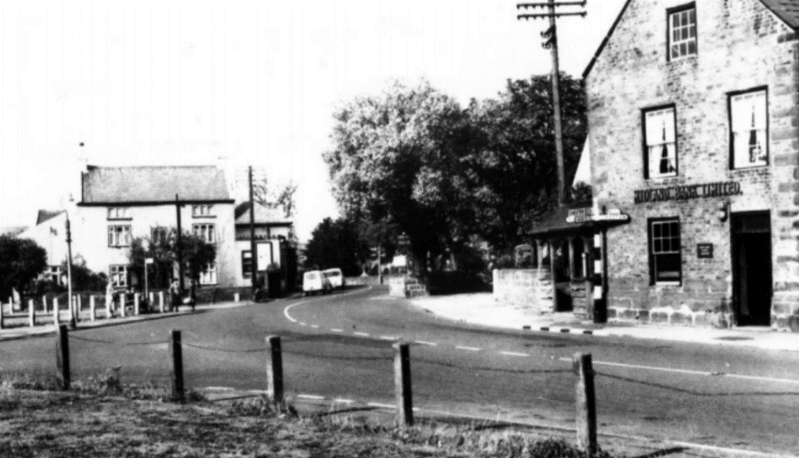

Midland Bank in the 1950s
Photo from Yesterday’s East Wirral 1860-1960 by Ian Boumphrey

This photo, taken in 1970 was in Cheshire Life magazine.

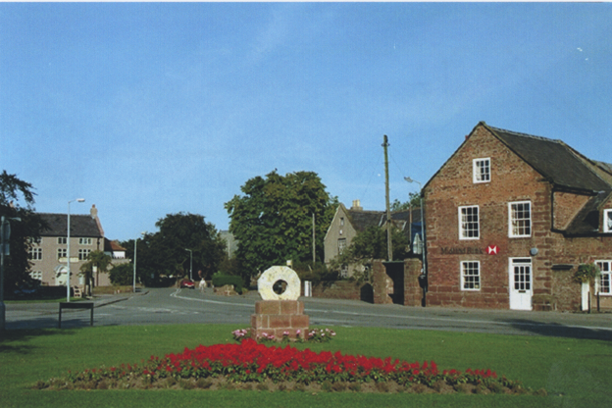
Midland Bank (taken over by HSBC) in 2001
Photo from Willaston in Photographs by Bob Prince

The premises then became a gift shop, called The Gift House, run by Cathy Plant and Anne Shepherd between November 2005 and September 2013, followed by Miss Gill from Ness who continued under the same trading name.

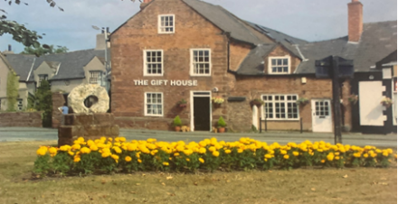

In 2015 it was sold to twins Jilly Parker and Jayney and became part of White Feather Home and Gifts. The name was in memory of Jilly’s husband who died whilst rowing on the River Dee in 2012 and the owner believed that the feather was still watching over her. It became known as Bank House and for a time was run as a luxury rental cottage after it was completely renovated, with many a bride staying the night before going to Christ Church to get married.

It became part of the White Feather Home shop.

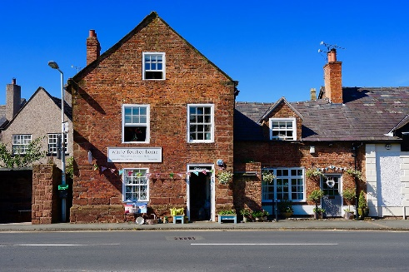

In 2021 to 2022, Victoria’s Sandwich used the premises as a pop-up cake shop, before they moved into permanent premises.

In 2022, it was converted back into accommodation.
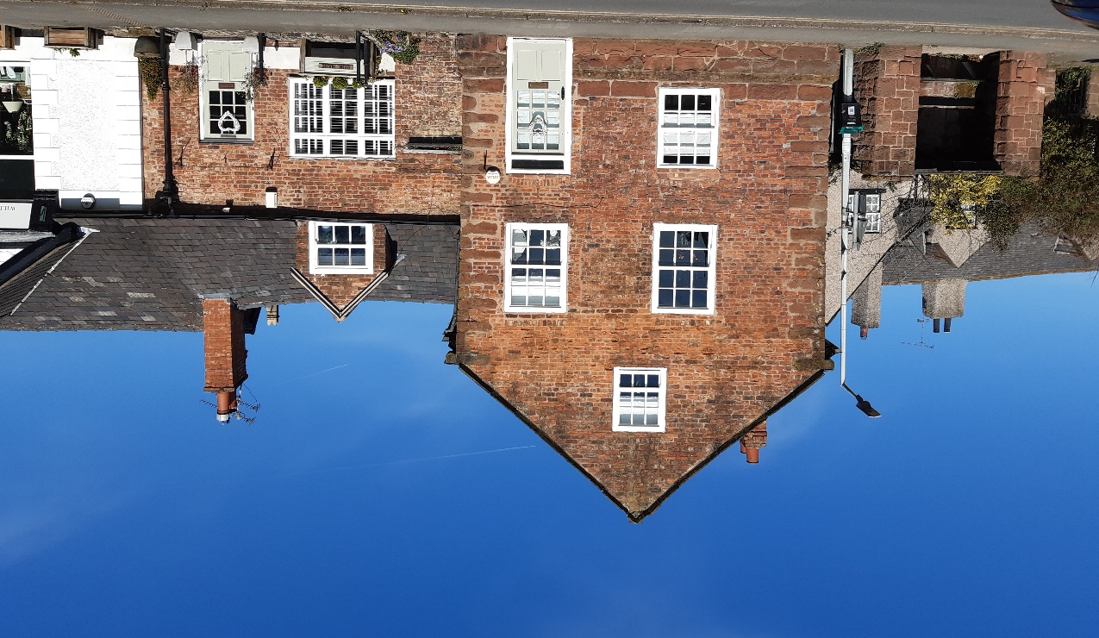
2023

