Pre-School at Hadlow Road

A pre-school was run at Willaston Grange by Lady Christine Bibby.

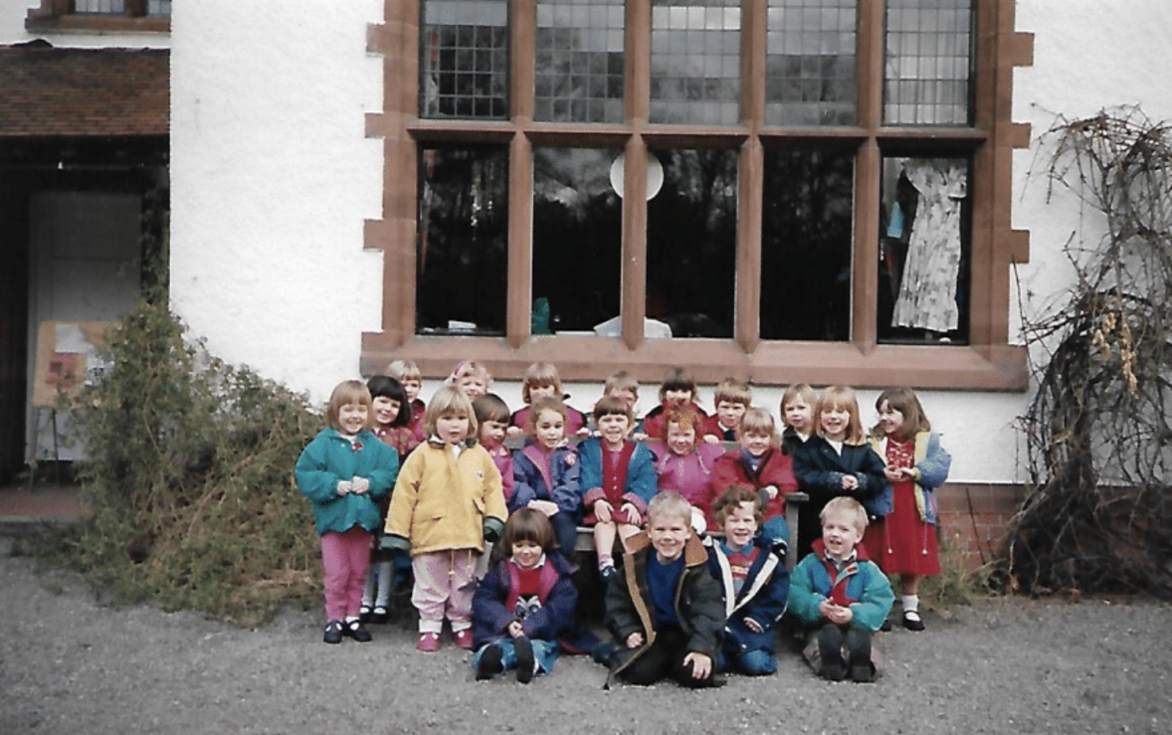

Children from the playgroup in 1993 (Photo: Annette Troake)

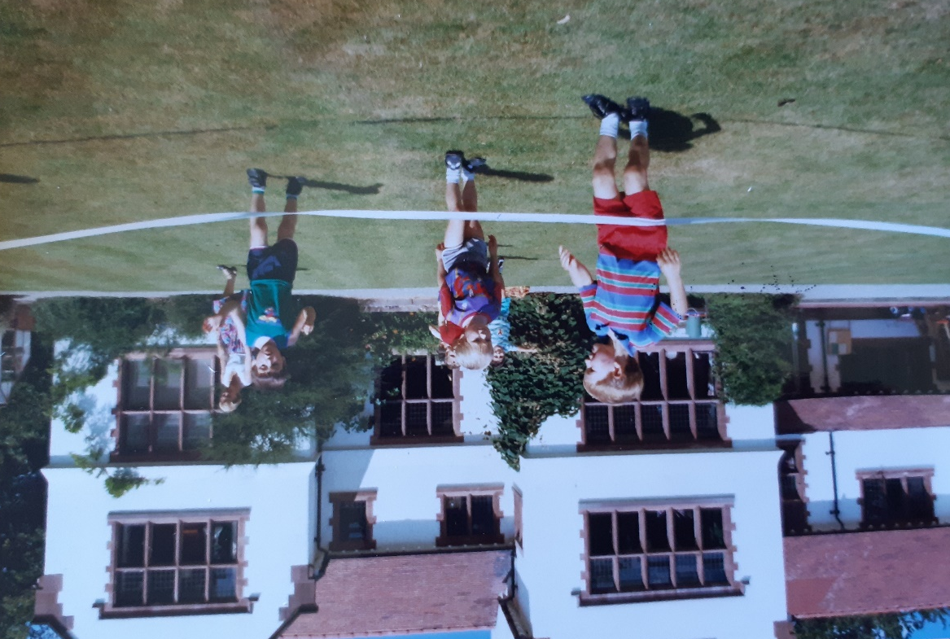

Sports Day 1990 (Photo: Jane Townsend)

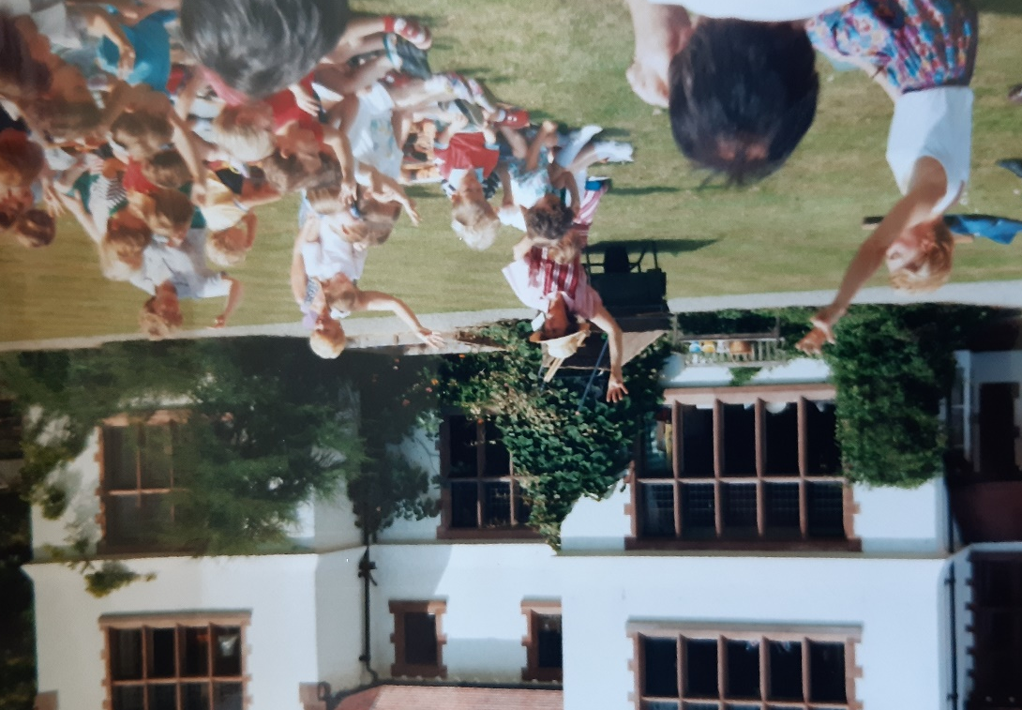

Show 1990 (Photo: Jane Townsend)

Marc Moss-Jones remembers: I was there from the late 1970s to the very early 1980’s. I remember playing in the playroom, milk and biscuits around the table im the big kitchen and Taggles, the black Labrador.’

Andrew Jones remembers: I remember Santa coming out of the woods at Christmas. I don’t have a great memory but in my head there were reindeer as well (but they may have been ponies or something).

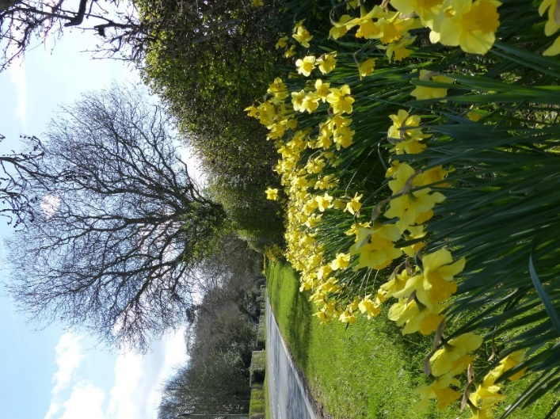
The daffodils opposite Willaston Grange were mainly planted by groups of children from the playgroup.

Daffodils in March 2023
(Photo: Ruth Hampshire)

