Johnston Recreation Ground

The Johnston Recreation Ground was given to the Willaston Parish Council in 10 February 1930 by Isabel Johnston of Raby House, Willaston, for the purpose of ‘a public recreation ground and children’s playing field for the parish of Willaston.’ She stipulated that the management of the ground should be nine parishioners and initially Isabel Johnston, the Vicar and Churchwardens would be ex-officio members of the committee.

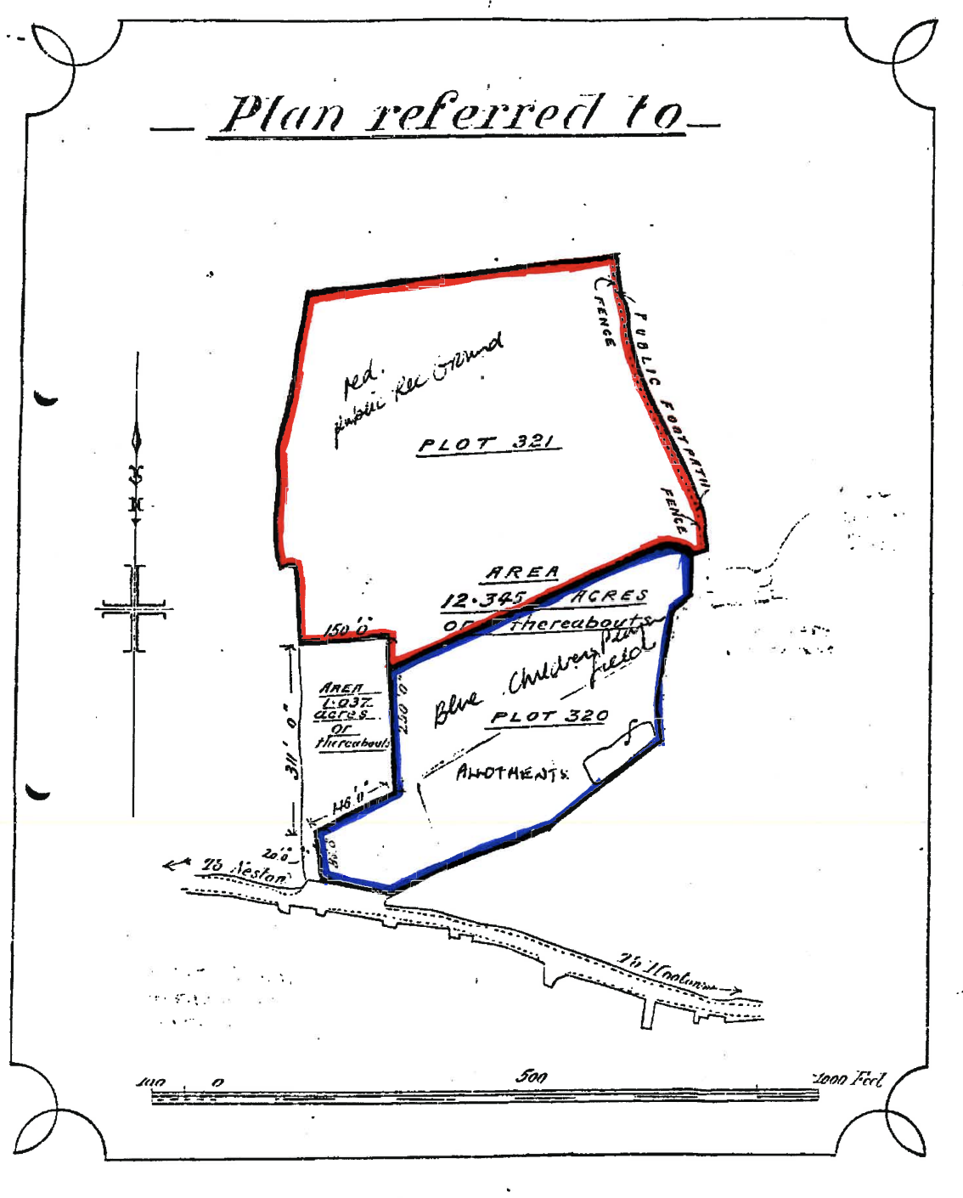
Taken from the conveyancing document

There were some stipulations:
- ‘Under no circumstances are games or sports to be allowed on the land on Sundays and Good Fridays’
- ‘The land shall not be used for political or other meetings of a like nature not shall it be used for public fairs or club days nor shall the land be used for any other purpose without the consent of the Executive Committee who shall be entitled to sanction a charge being made for admission on not exceeding eight days in any one year. The Parish Church and Chapel shall each be entitled to have if so desired at least two of such days in any year for their purpose.’

The responsibility for the upkeep of the Recreation Ground was transferred to Neston Urban District council in 1933 when the Willaston Parish Council was dissolved. Allotments were provided, which cost 1/- per plot per year in 1945.

In the 1950s there were hockey and cricket pitches on the Recreation Ground.

Ruth Hampshire remembers the play area in the 1970s:
‘I recall the old rocking horse and Witches Hat roundabout which was quite dangerous really especially since it was set above concrete! On 5th November for many years there was an organised big bonfire and fireworks on the Rec including soup and jacket potatoes. Brian Sambrooke would be on the flat roof of the school to ensure that none of the fireworks landed on the roof and caused a fire.’

In 1979, a new governing document was agreed and ownership was transferred to the Council, with it becoming the sole trustee.

A new pavilion was built in 1979. Cheshire Life takes up the story:
‘It seems that the Council demanded a rent from the local football club for its use but it was such that the club could not afford it without raising some money. So they asked for permission to install a licensed bar. And then it was discovered that under the original deed of gift by Miss Isabel Johnston such an activity was not condoned and, moreover, it is questionable whether the pavilion should have been built at all!’

In 2013, Willaston Residents’ and Countryside Society formed a sub-group to improve the play area. In three stages and having raised £119,500 the new play area was completed in December 2020.

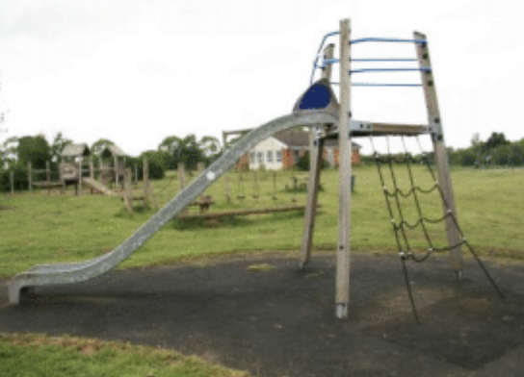

Play area in 2013

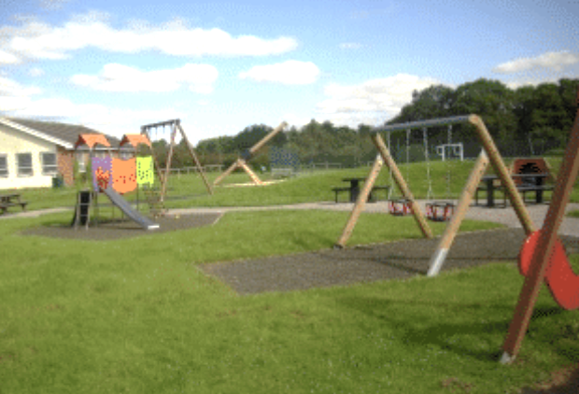

Play area in December 2020

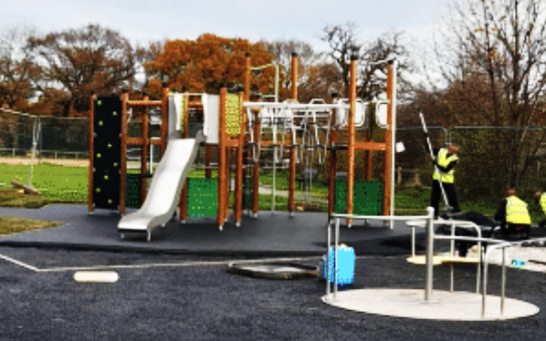

Left to Right: Sue Unsworth, Cllr Myles Hogg, Andy James from Cheshire West and Chester Council, Lesley Booth and Hilary Booth

In 2023, two trees were planted at the entrance to the Recreation Ground in memory of HM Queen Elizabeth II and HRH Prince Philip.

