Home Farm

Home Farm is thought to have been built in 1616. It was a farmhouse until 1912, then became a private residence.
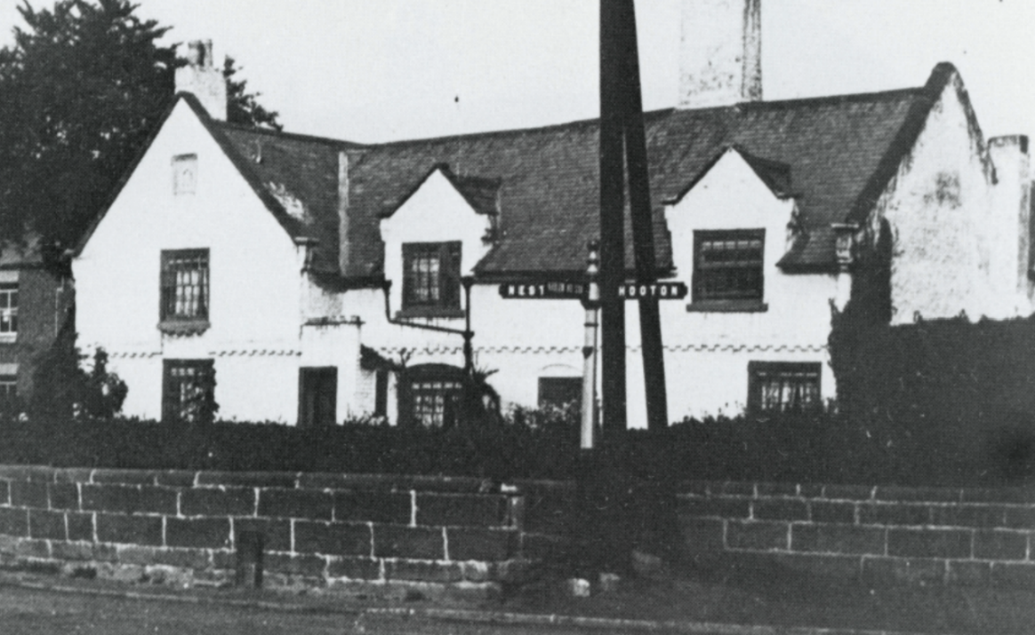

Photo from: Pictures from the Past. Collection No 3 by Derek and Marian Young
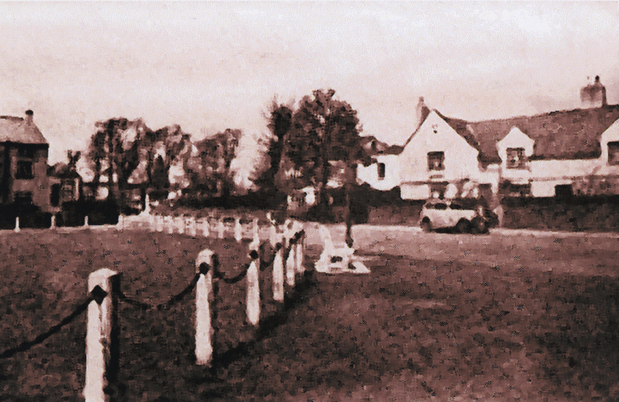

Date unknown (1950’s?)

From 1944 to 1997, an extension to the east side was Jackson’s - a Greengrocer, Fishmonger and Game shop run by Kelly and Lil Jackson and their son Eddie.

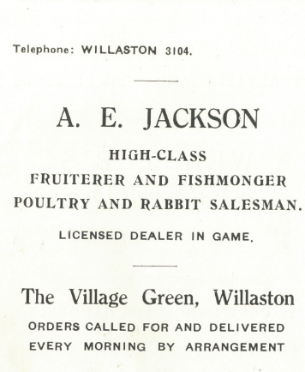

Advert in Christ Church Centenary 1955

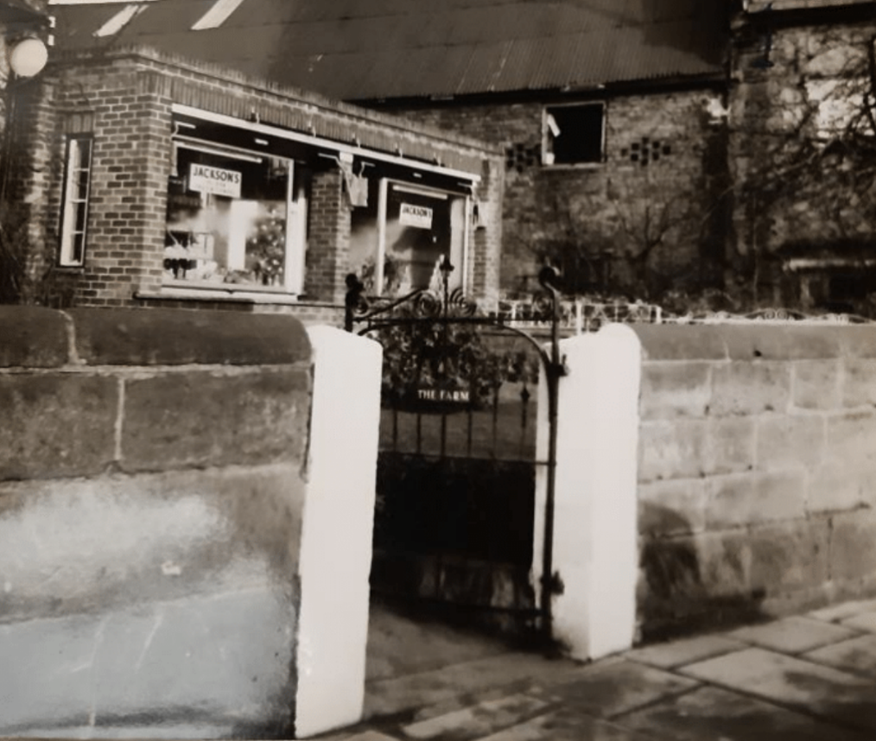

Date unclear

Ruth Hampshire remembers: ‘My Mum regularly shopped at Jacksons from when they first moved into the village in 1963. It was a fabulous shop that was a hive of activity and even had a huge marble fish counter. Kelly Jackson wrote the bill on a brown paper bag with a big thick pencil. I loved visiting and used to be invited to go into the farmhouse to see Aunty Doll (Kelly’s sister) who would be sitting by the farmhouse fireplace – it was a dark room because the windows were so small. I also went out to the barns to see the turkeys which enthralled me.’
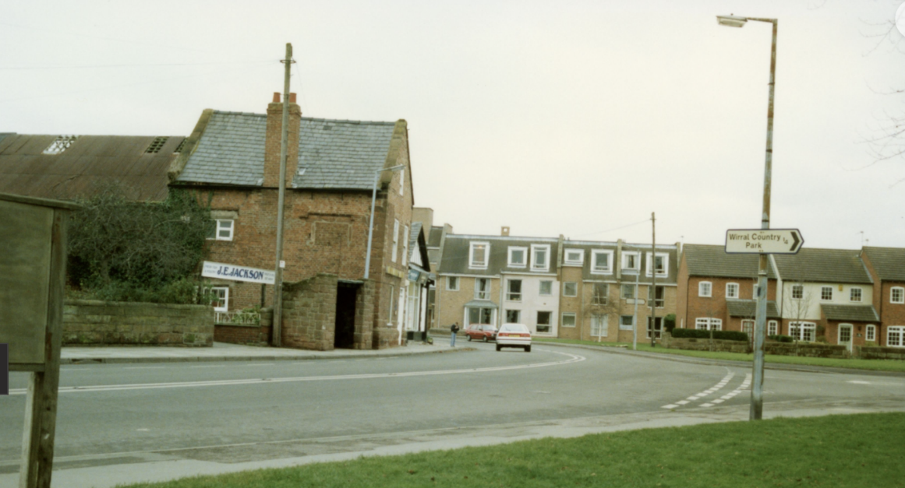

Date unclear, probably 1990s
Photo: Jean Griffiths

Joanne Doherty remembers:
‘I worked there as a child, filling bags of potatoes. I could always touch my toes afterwards! Lovely shop, great times.’

The National Westminster Bank was also part of the farmhouse until 1995.

In 1998, the farm and barns were converted to houses, now known as Willaston Farm.

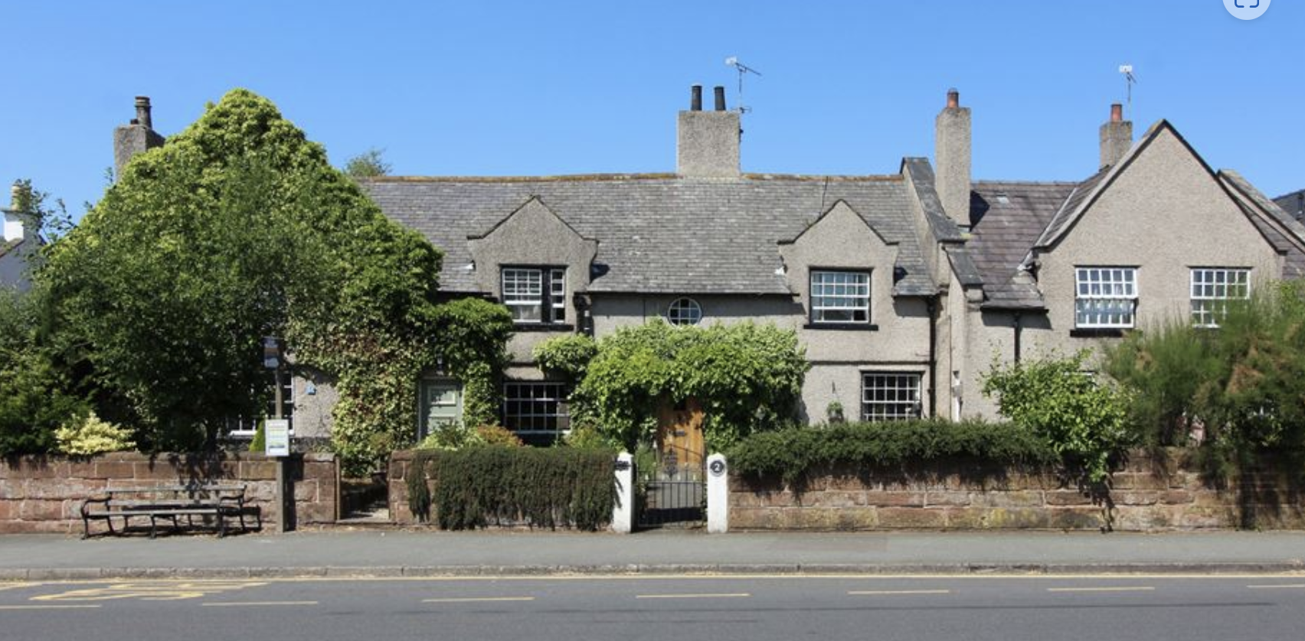

Willaston Farm in 2018 (Photo: Phil Nash)

Stables and Farmyard

The stables and farmyard were converted into houses in 1998.

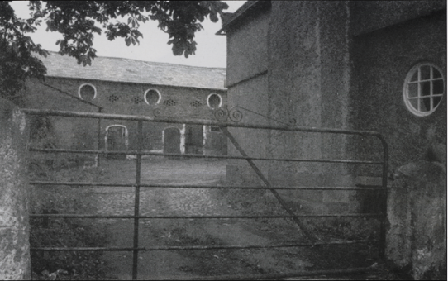

Before and after conversion
(Photos from Willaston – Centre of Wirral by Bob Prince)

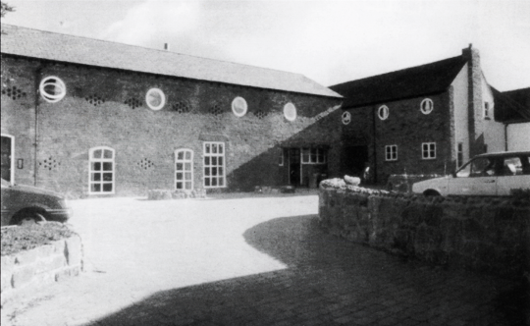

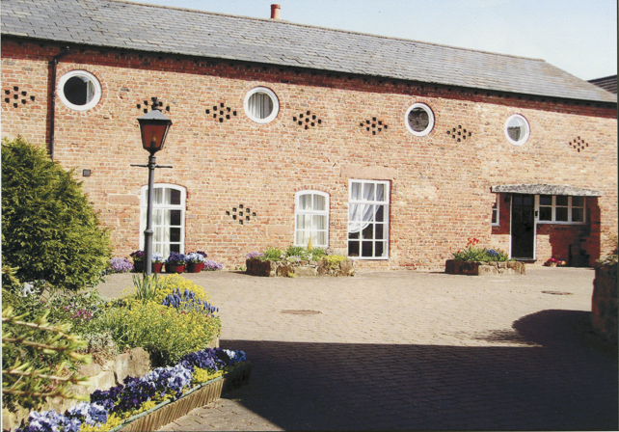

2010
Photo from Willaston in Pictures by Bob Prince

