Hawthorne School

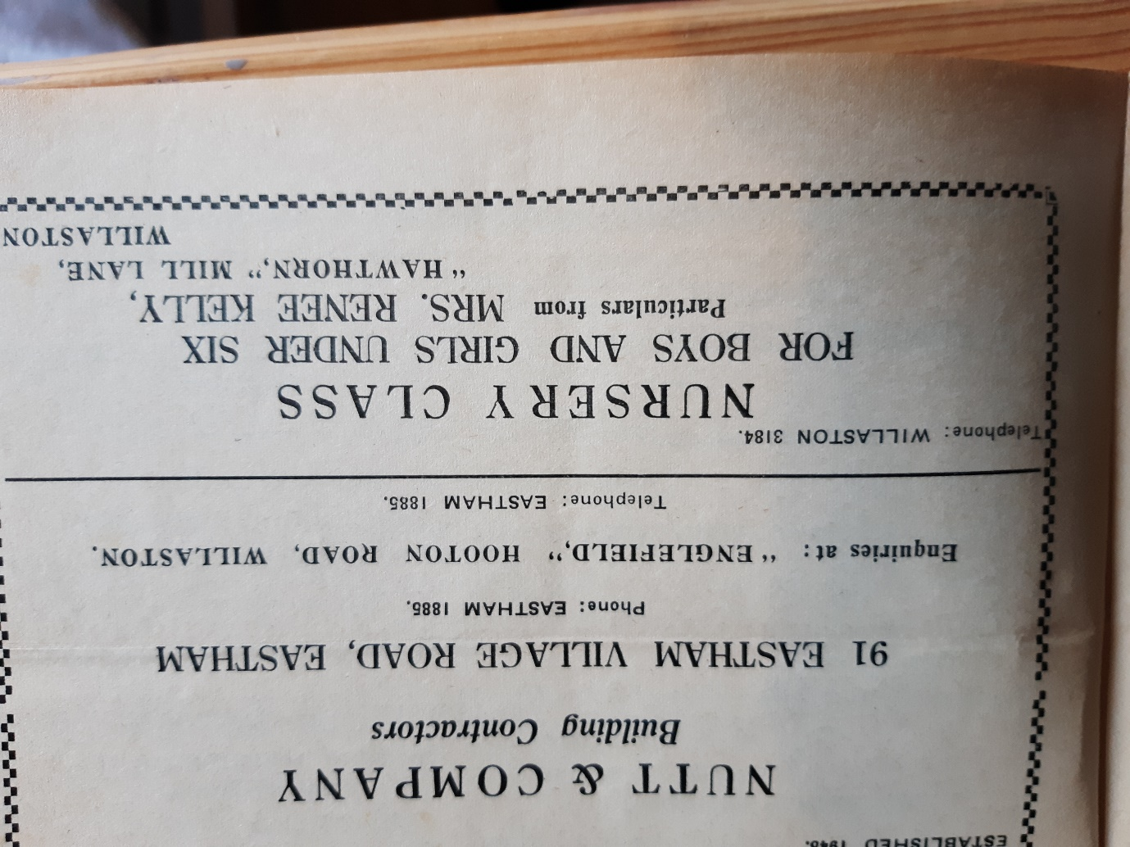'Hawthorn' is a bungalow in Mill Lane and when Mrs Kelly gave up teaching to raise her family in 1950, she soon started to run a pre-school.  It ran for 30 years. Mrs Kelly was said to be quite a disciplinarian; the children all wore uniforms.  They arrived with an apple, which they placed in a bowl for later, and greeted Mrs Kelly with 'Bonjour Madame!'.

Advertisement in *Willaston Parish News* December 1962

Children attending the school in 1979 (Photo: Chris Wells)



The Hawthorne School Badge

In a newspaper article (paper unknown) John Kelly wrote a tribute to his wife and the school she had run:

*In an area where children’s activities were of necessity organised, within their own households, she [Mrs Kelly] quickly discovered neighbour’s children found their way to our house where they could play in ample space under her watchful eye. Fine – while the sun shines. But what when the weather is cold and wet? Send the kiddies home? Or keep them amused with games and sing-songs?*

*If you love children of course you certainly don’t send them home, you play with them, and from playing with them to teaching them is a very short step indeed for those with the necessary skills.*

*So the nucleus of a nursery school was formed, almost, as it were, by spontaneous generation. It was soon obvious we could not allow our house and my wife’s time to be monopolised so casually, and the little group of children had either to be disbanded or organised on a regular basis. Who could have the heart to tell the kiddies not to come any more? Not Mrs Kelly.*

*So the children continued to come – no longer to ‘Hawthorn’ but not to Hawthorn School. That was nearly 30 years ago and our house has been full of children’s laughter from that day to this.*

*Even an enterprise as modest as this cannot avoid the problems which have to be faced by the teaching profession … So the questions were debated and settled one by one in the quiet of our own home, free from the stress of committees and with the benefit – or hindrance – of directives from authorities of any kind…*

*‘I have to confess the fuss about uniforms puzzles me’ my wife mused ‘The uniforms of the soccer and rugger teams, not to mention the show jumpers in Horse of the Year and even symphony orchestras seem popular enough. I imagine if they all turned out in jeans for a change, there would be a considerable outcry, though no doubt they would all play or perform equally well. After all, jeans and anoraks are just as much uniform as any combination of school cap and blazer. You could say children in trousers or skirt and blazer are uniformally neat and tidy. I like it that way. So apparently do the parents. In addition, it is practical, saves mum the worry of choice, costs no more than any other form of dress and puts no child at a disadvantage. So we’ll keep to uniform.’*

*Discipline? There was never any doubt about discipline. As discipline and learning are inseparable, it is impossible to have one with the other. ‘If children are to learn’ Mrs Kelly summed up, ‘they must be told what to do and how to do it.’*

*‘I daren’t say,’ she confided ‘children must do what they are told – I’d be branded a reactionary Victorian schoolmarm. But if parents don’t want their children to learn, which of course does mean, doing what they are told, they must send their children elsewhere. They would waste my time, and other children’s time. And time is too precious to waste.’*

*‘But’, I queried ‘isn’t it true to say that present opinion is firmly opposed to teaching very young children?’ My wife nodded agreement but added: ‘In my experience, it is as harmful to deprive children of any age who clearly want to learn, as it is to force lessons on a child who doesn’t. Children have to learn to learn. The art of teaching is to foster the desire to learn and then satisfy it. And a very difficult art it is.’*

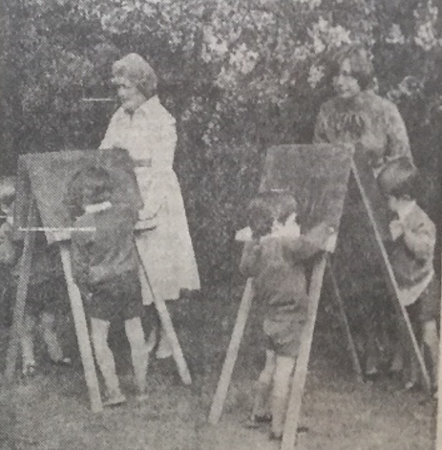

Rene Kelly (left) and fellow teacher Mrs Sue Reads make the most of the sunshine with an outdoor lesson.

The Kelly’s have a grave in the churchyard: