Hanns Hall Farm

Information below comes from ‘The Bibby Story’, printed in 1950 and held by Cheshire Archives and Local Studies Service and is reproduced with permission of Cheshire Shared Services and Lady Christine Bibby.
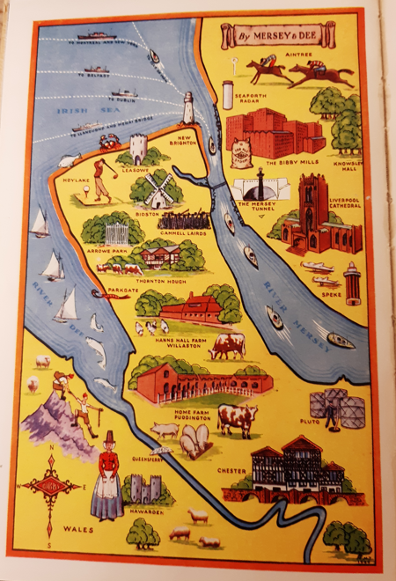
The Bibby family ran two experimental farms – one in Puddington and one at Hanns Hall, Willaston. At Willaston, experiments were carried out in the nutrition, health and rearing of poultry and pigs and a technical advisory service was run in connection with them.

The farm was about 270 acres, of which 110 acres were arable and 60 poultry (with approx. 1,600 laying hens, rising to 7000 birds during the breeding season). The rest was pastureland.
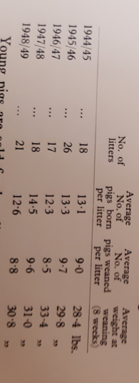
The farm also bred pigs and they were proud of their breeding record, as the table below shows:
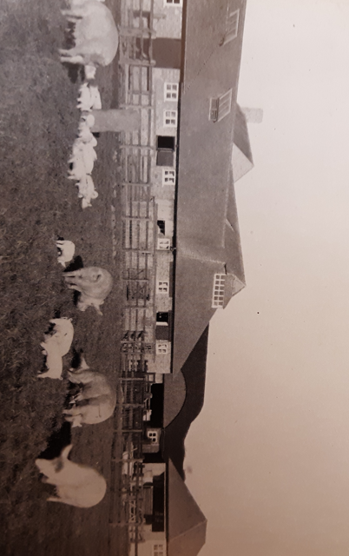

Aerial view of Hanns Hall Farm, showing the lay-out of the experimental poultry runs

Aerial view of the building, barns and dairy

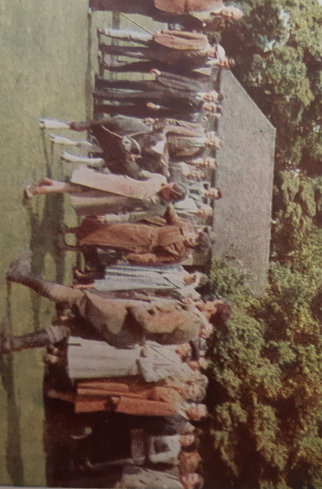
A party of visiting farmers watch whilst a younger member of the family walks a
young bull.

In 1945, All About Willaston, produced by the British Legion, comments on ‘the very successful Wirral Farmers Show in aid of the Red Cross [which] have been held at the Hanns Hall Farm which has attained importance as a Research Station.’

Advertisement in Willaston Parish News December 1962

