Grocery Store

The site of the Spar grocery shop has been a grocery store for a long time.

Willaston Grocery Stores – run by Fred Moss

AH Gardener, Groceries and Provisions

Advertisement in Willaston Parish Magazine in June 1951

Mr Brooks and Miss Pass
Advertisement in Willaston Parish Magazine in December 1962, when it appears Mr Brookes had recently taken over

Keith Edwards remembers that a steam wagon used to come to deliver big bags of items such as sugar. These would be divided into smaller bags to be sold. On the back of the wagon was an advertisement for lemonade featuring a black boy with a pineapple hat.

Spar Grocers with various owners:
- Jack and Dorothy Wignall
- Ken and Marjorie Downham in 1971

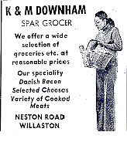
Advertisement in The News April 1975

- Phil Davies

Cheshire Life reported in November 2006:
Phil Davies who owns the local Spar has been there for 20 odd years. ‘We have a very different Spar from what you would expect,’ says Phil. ‘This shop is attuned to the Willaston clientele and I still class myself as a grocer. The range we carry is suited to the area. We have everything from quail eggs and handmade biscuits to 35 different kinds of marmalade and 40 odd varieties of Baxter’s soup. I source as much stuff locally as I can. The vast majority of vegetables come from near Willaston and Burton. We bake our own break, and we have a fine array of different cheeses. There is still a market for quality and personal service.’ In fact, not only do they deliver orders says Phil but they sometimes even put the food away in the fridge for the customers. You can’t get much better service than that.’

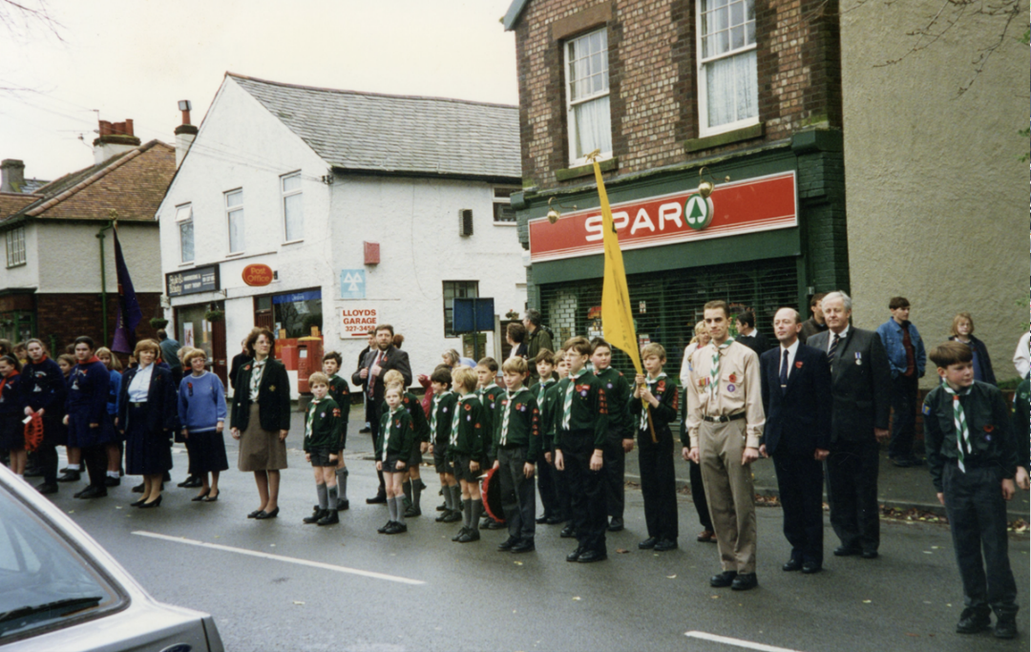

The Remembrance Parade lines up outside Spar in 1994

- G&E Murgatroid

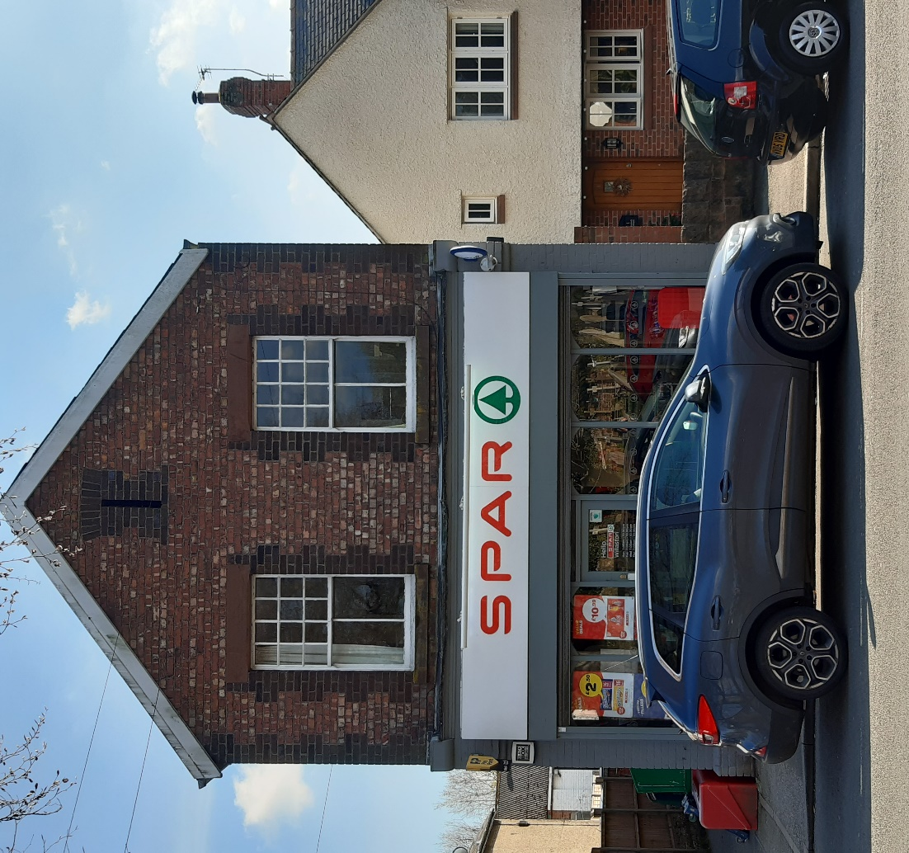

Spar in 2023

