Griffin and Legg Landscape Gardeners

Andrew Legg and Peter Griffin met at the Flintshire Horticultural College in 1961 and served as trainee landscape gardeners in the south of England. After a time, they decided to start their own business in Upton. After Andrew married, they purchased Heathfield on Hooton Road and turned the redundant smallholding into their office and yard for their business.

The business expanded and permission to run a nursery from the site was given. This then developed into a small garden centre – Deescape Nursery.
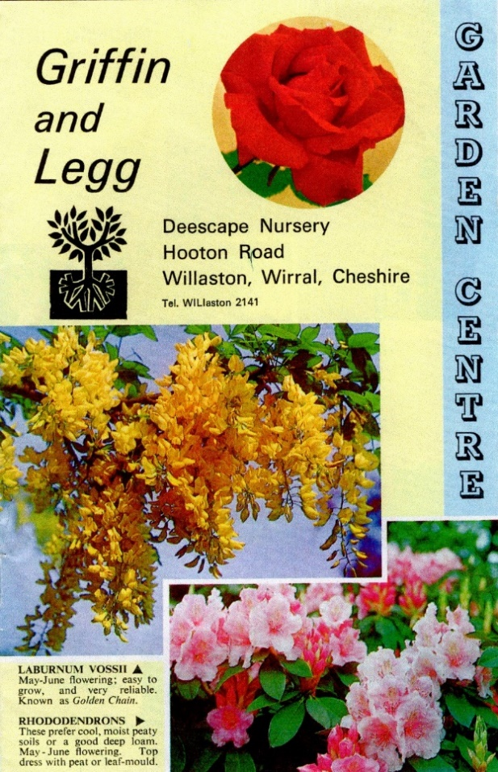
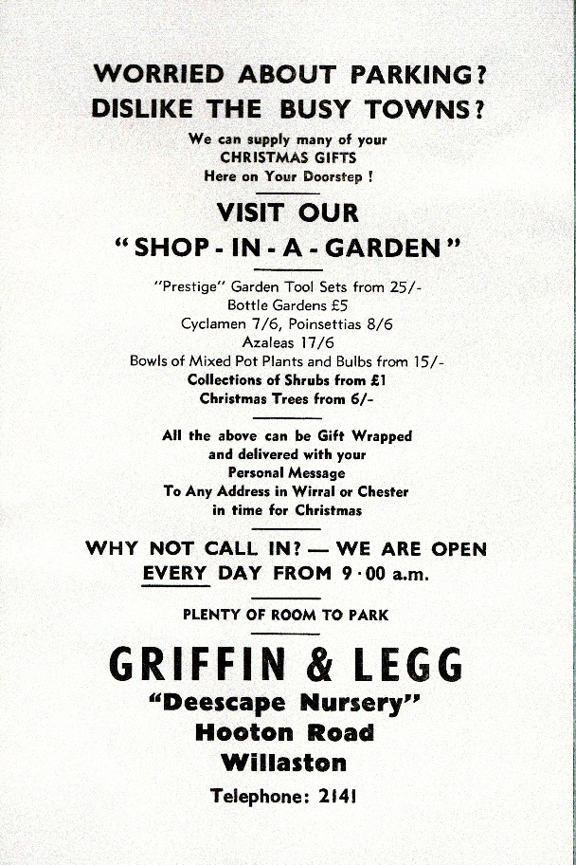
Christmas 1965

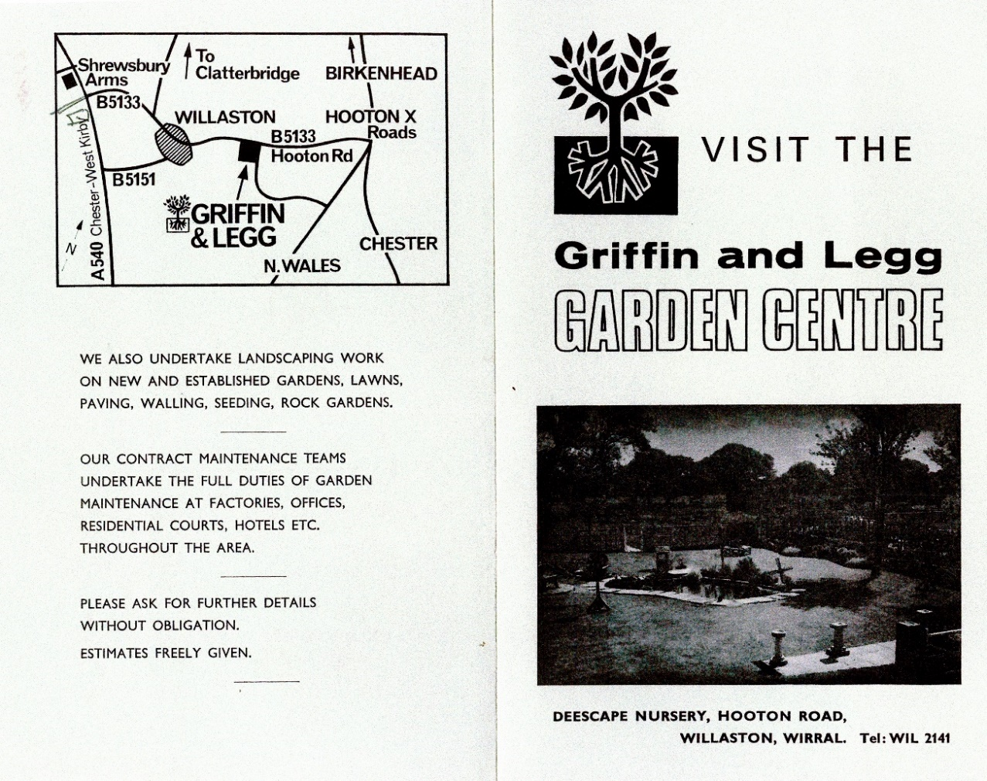

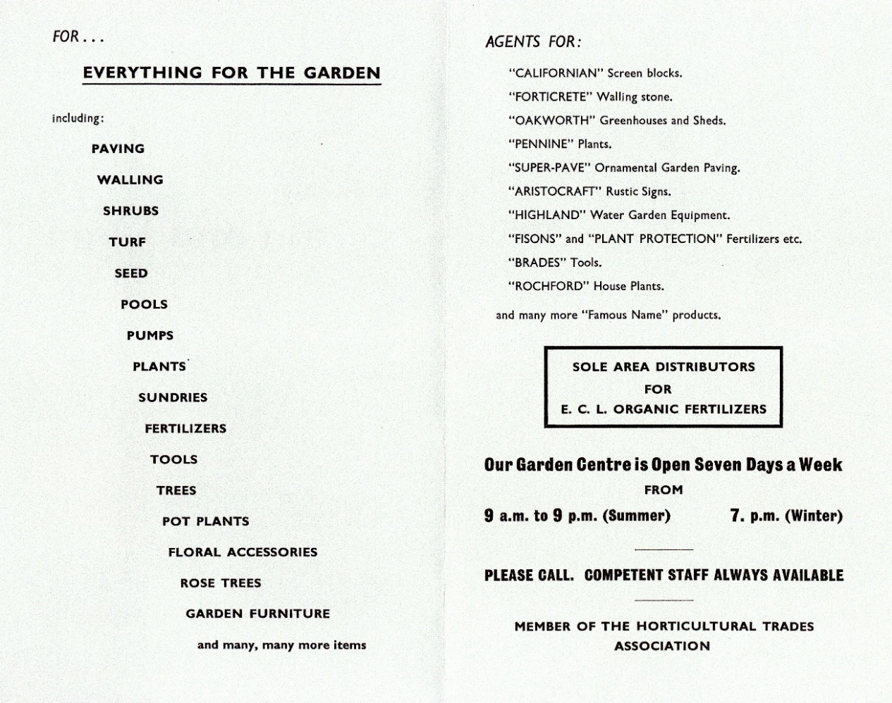

However, the garden centre had not received planning approval from Neston Council and in September 1967, they were forced to close the centre. Other activities continued however and an office, show garden and the selling of logs continued on the site.
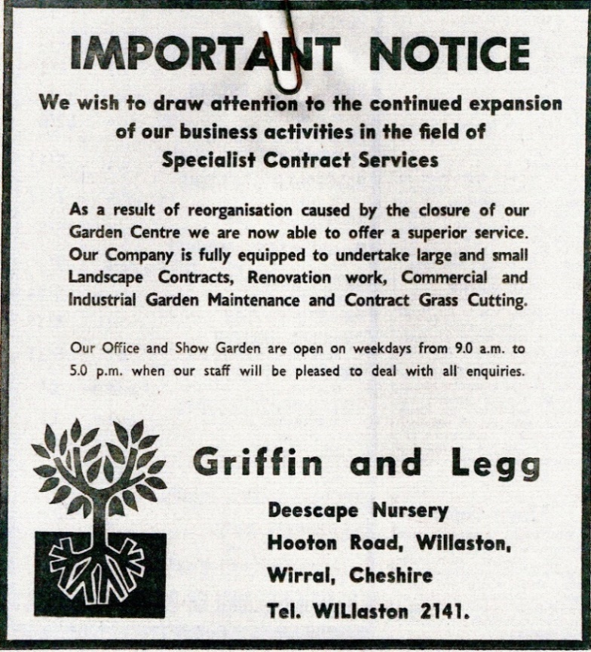

Derek Bibby from Willaston Grange then invested in the company and after several more years of trading he sold the company to EH Williams of Liverpool and the business transferred to Gateacre in 1979.

Andrew remained with the company and was a senior Project Manager at the International Garden Festival in Liverpool in 1984.

The house and land at Heathfield was sold in 1987 and the current houses built on the site.

