The Green Lantern Café

This café was owned and run by Mrs Wilkinson and her daughter Brenda from the 1930’s.

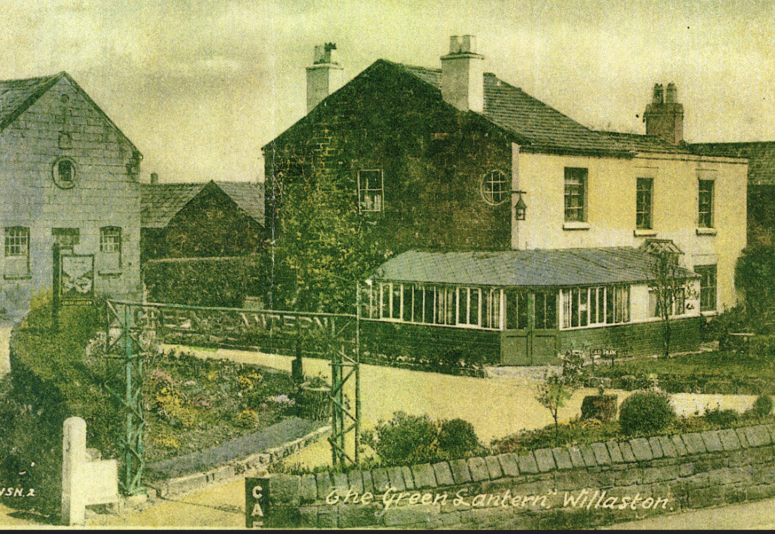

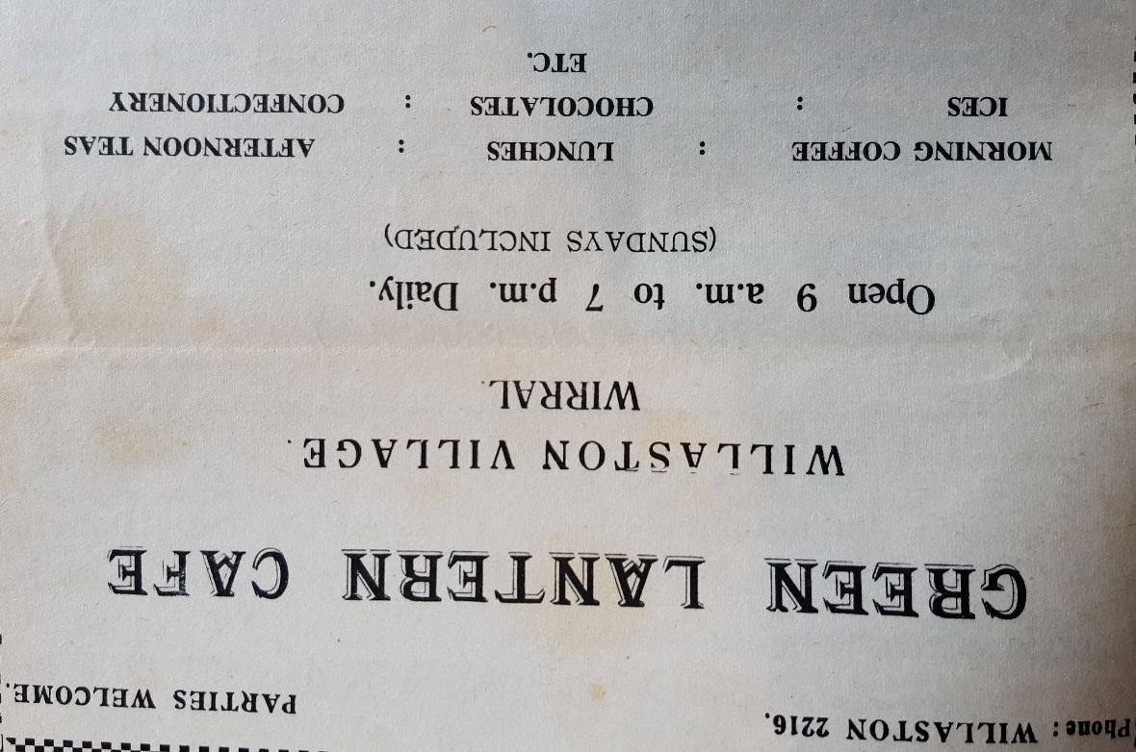

Advertisement in Willaston Parish News December 1962

Brenda was well-known in her later life for going around in a small blue disability scooter/car with her dog and fundraising for Guide Dogs for the Blind.

By 1969, the building was vacant.

In 2004 the building was renovated and is now The Lantern House, 2 The Courtyard.

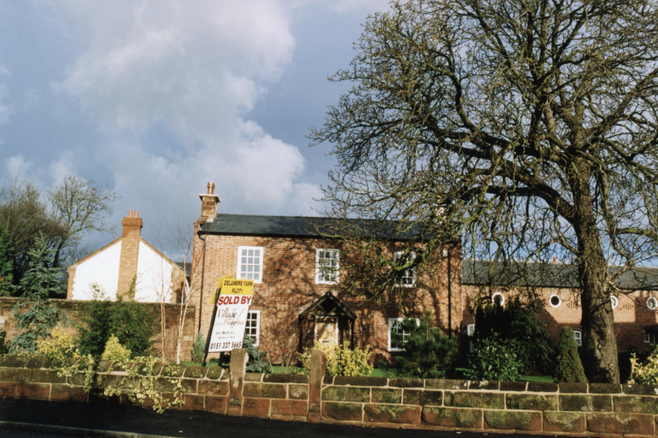

Lantern House for sale in 2004

Photo: Jean Griffiths

