Elm Road

The houses in Elm Road were built during the Second World War to house people working at the Royal Ordnance Factory No 10 by Hooton Station. Skilled men came to work there from all over the country. The Ministry of Supply commissioned the architect Arthur W Kenyon to create a series of small housing estates for ‘married factory workers’ employed in essential industries connected to the war effort.

The parlours were constructed with a strengthened ceiling and walls so that they could be converted into an air raid shelter by blocking the window. As a further precaution, asbestos was used liberally on the roofs of the bay-windows, the entrance door surrounds and the downpipes. The staircase was cast in concrete.

After the war, the properties were sold off to the tenants.

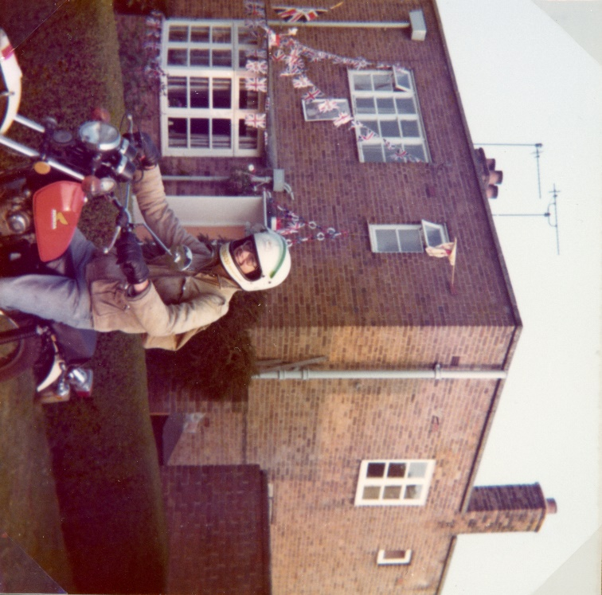

1977 – houses on Elm Green decorated for the Queen’s Silver Jubilee (photo: Tony Whitehead)

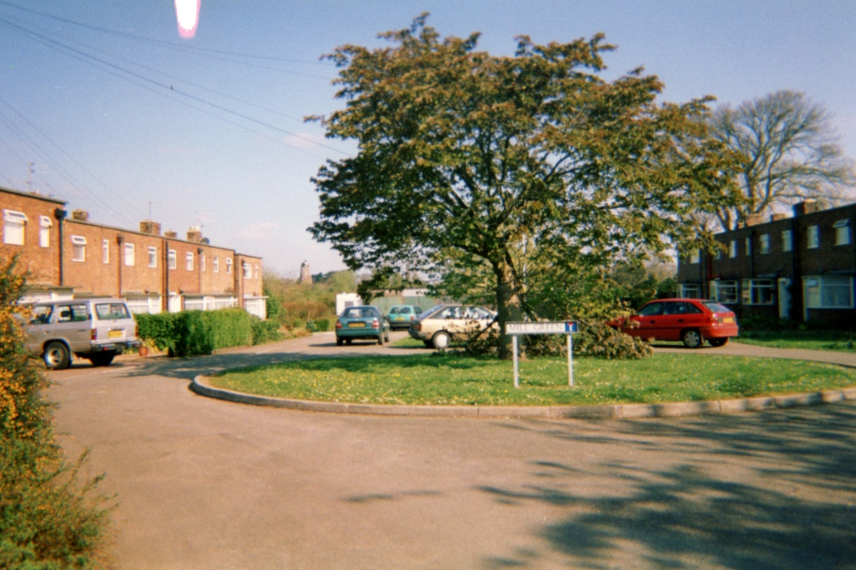

Mill Green in 1997 (Photo: Jane Townsend)

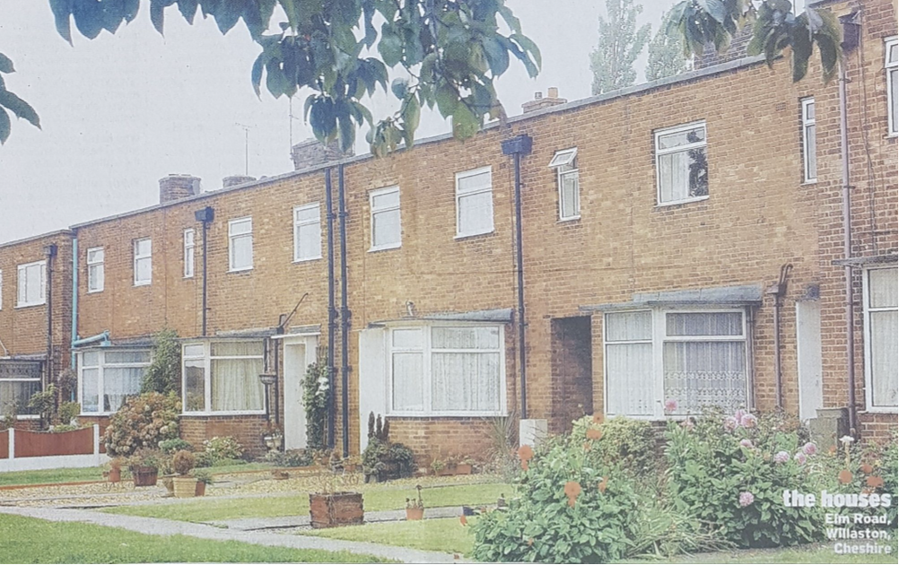

Elm Road in 2003 (Photo: Property Telegraph)

Later the residents replaced the flat roofs. These were funded either by the Council or privately, depending on their income.

