Coal Merchants

J&C Pollard had a coal merchants in the sidings at Hadlow Road Station.
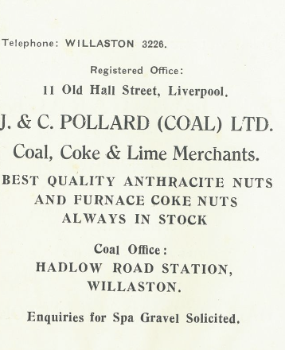

Advert in Christ Church Centenary 1955

Keith Edwards remembers that there was a green wooden hut where people paid for their coal and the lady in the office was Mrs Williamson.

There was a separate coal merchants run by J. W. Crabb and then A. and S. Pugh off Hadlow Road.

Advert in Willaston Parish Magazine December 1962

Entry from 1945 business directory

