Elizabeth’s Cottages / Church Hall

The church hall was built in 1927 by Isabel Johnston and gave it to the church in 1937 with an endowment of £1600. Originally there was a flat at the rear for a resident caretaker.

From April 1927, it became the permanent home of the Women’s Institute.

Cherry trees were planted next to the hall to commemorate the Coronation in 1937 of King George VI and Queen Elizabeth and a bronze tablet indicated this.

In 1951, activities included the Women’s Institute, meetings of the Horticultural Society, three badminton clubs and drama club.

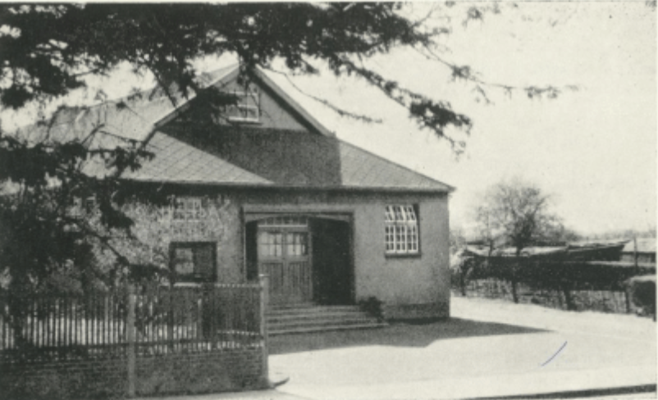

Church Hall in 1955
(From Christ Church Centenary 1955)

In 1955, the hall had a stage, dressing rooms, kitchen, a large hall and cloakrooms. According to Christ Church Centenary, the Church Council had ‘spent a great deal of money on re-laying the floor and decorating the interior and exterior.’ It was described as ‘suitable for dramatics, concerts, dances, meetings and shows.’ The book noted that the local Women’s Institute used the hall a great deal and had ‘presented to it an electric clock and heavy velvet state curtains’.

In July 1962, the first bulletin of the new Willaston Countryside Society gave information about booking fees and regular lettings as follows:
Concerts and plays £5 5s 0d
Dance – 7pm to midnight £5 5s 0d
Dance – 7pm to 1am £6 5s 0d
Full day booking £6 10s 0d
Half day booking £3 10s 0d
Political meeting £4 0s 0d
Whist drive – afternoon £2 2s 0d
Whist drive – evening £2 10s 0d
Wedding reception to 5pm £4 0s 0d
Afternoon meeting £1 10s 0d
Children’s tea party £2 10s 0d

Regular lettings were:
- Women’s Institute – First Wednesday afternoon in each month
- Mothers’ Union – Second Wednesday afternoon in each month
- Dancing Classes – Thursday afternoons in term time
- Youth Club – Thursday evenings in winter
- Country Dancing – Alternate Monday evenings in winter

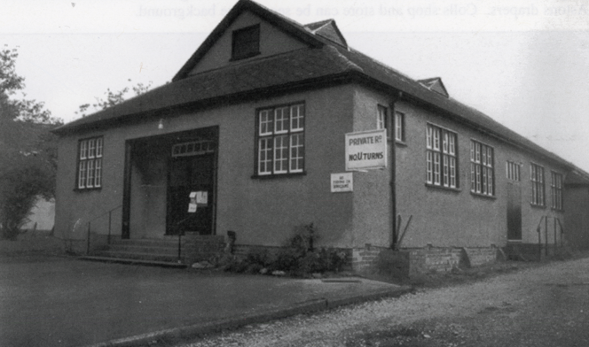

Church Hall, date unknown

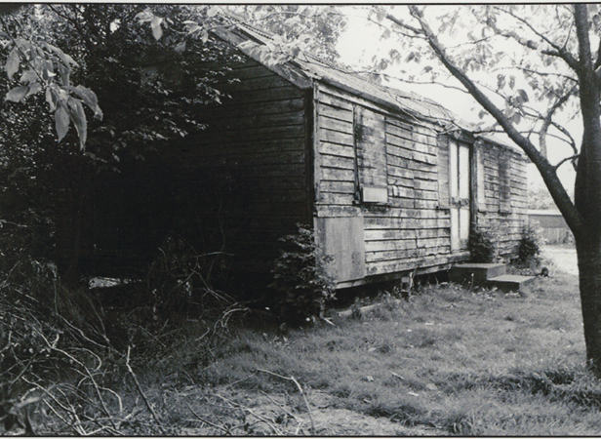

Hut at back of church hall used for storage (date unknown)
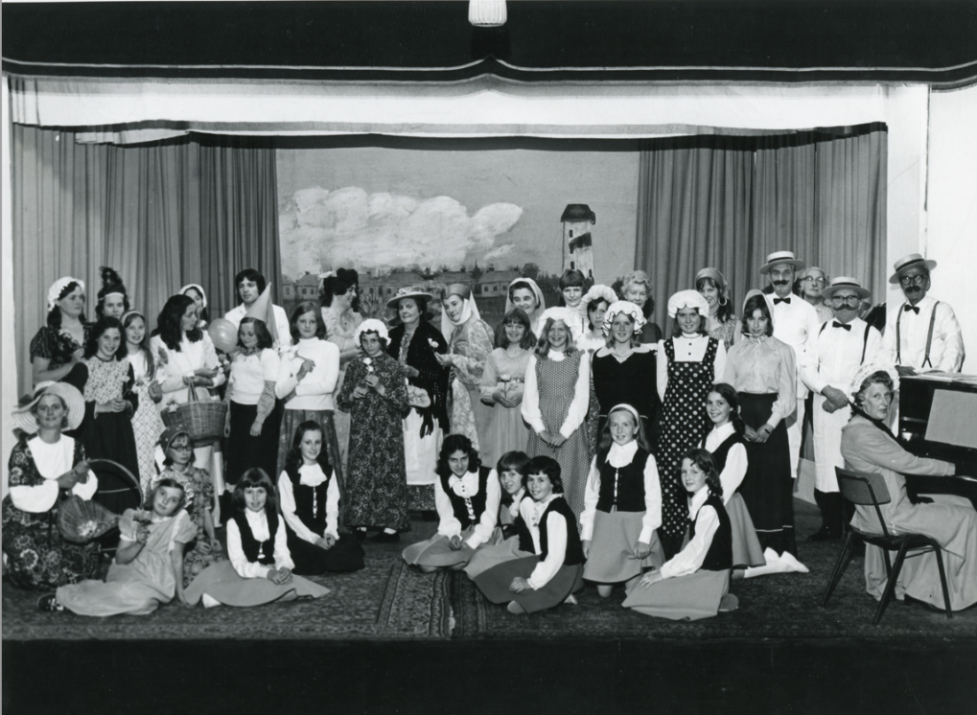
Willaston Heritage Festival 1975

In the late 1970’s, Alan Niblock and Bill Faull set up The Help Group. Local teenagers took coffee and biscuits and helped with any small jobs needed for older widows and widowers in the village every Sunday morning after church.
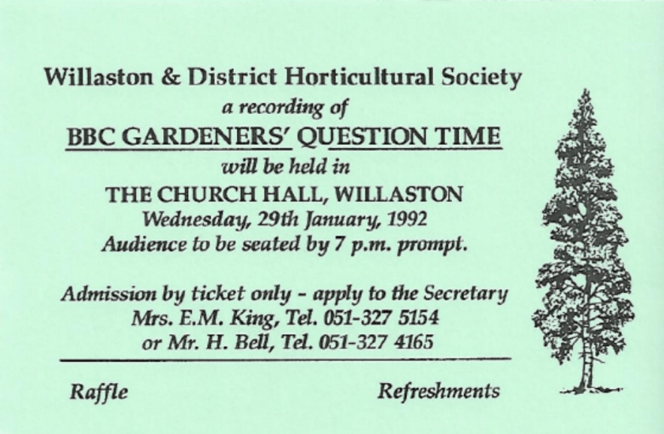

In 1992, the Horticultural Society hosted a recording of BBC Gardener’s Question time in the Church Hall

Brian Preston remembers jumble sales at the Church Hall in the 1960’s and 1970’s, which were organised by the Scouts. They were advertised in the Birkenhead News and the village was packed out when the Birkenhead bus arrived.

Eddie Townsend remembers joining the Mersey Morris Men when they practised in the hall

Tony Whitehead recalls being the bingo caller for Friday Night bingo in the 1980’s.

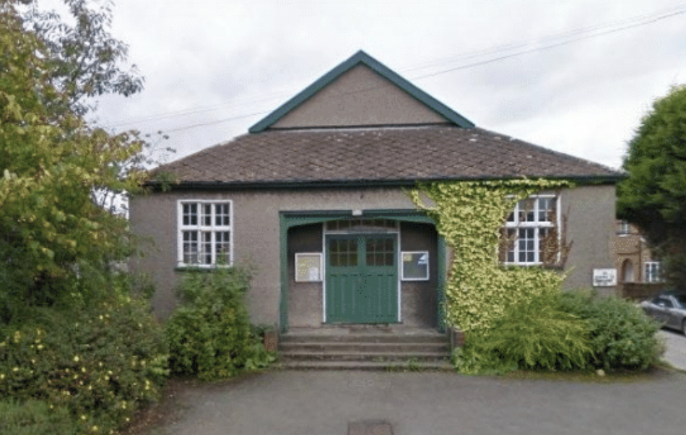

Hall in 2011 (Photo: Marc Jones)

However, the condition of the hall deteriorated and in 2011 it was demolished.

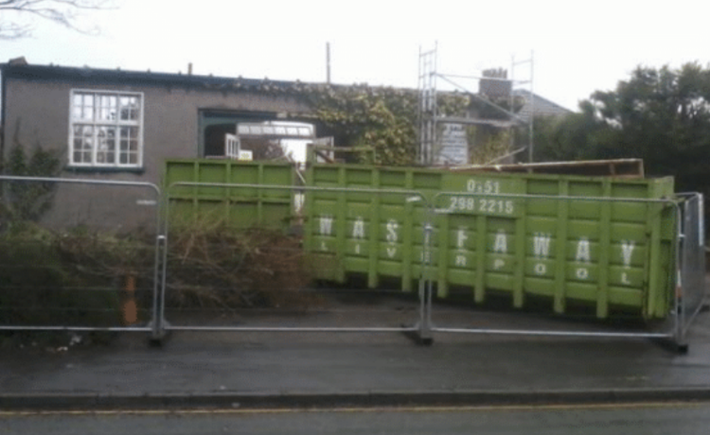

Photos: Marc Jones

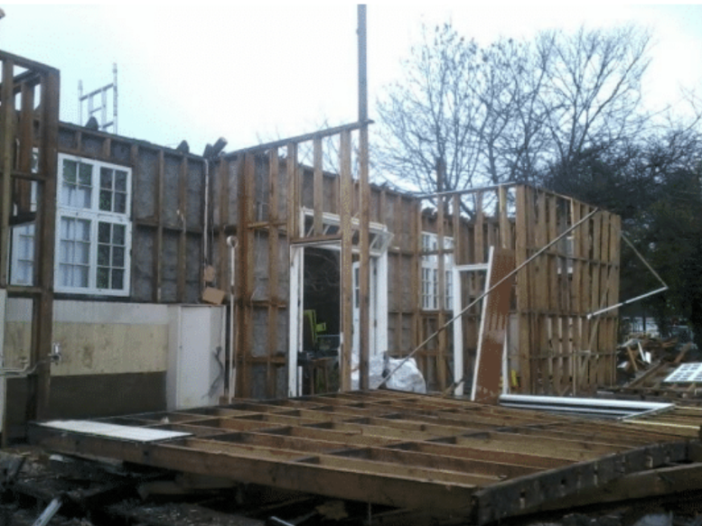

In 2013, five cottages, known as Elizabeth’s Cottages were built on the site, designed by Willaston resident Bill Hardman.

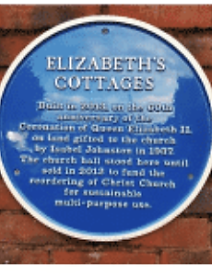

There is a plaque on the cottages to acknowledge the generosity of Isobel Johnston.

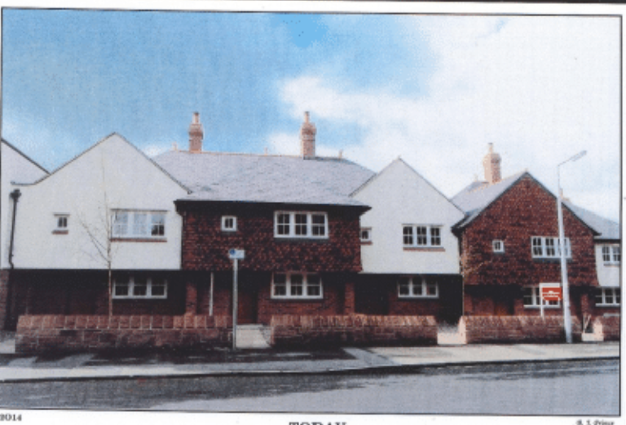

Elizabeth’s Cottages in 2014. (Photo: Bob Prince)

