Church Farm

Church Farm

Church Farm was originally known as Charity Farm.

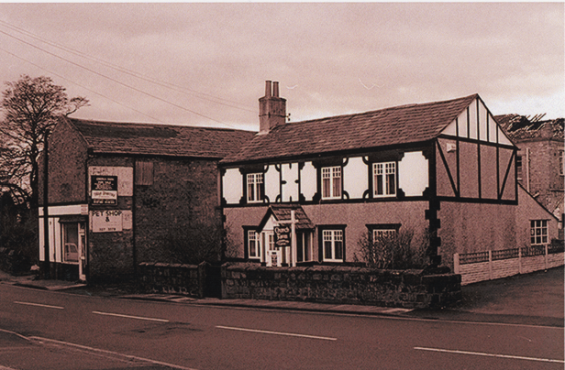

Date unknown
Photo from Willaston of Yesteryear by Bob Prince

It then became an antique shop, run by Larry Baker in 1978.

Then became a Veterinary Practice run by G. Skerritt from 1992 to 2011.

In 2011 it was converted to a house.

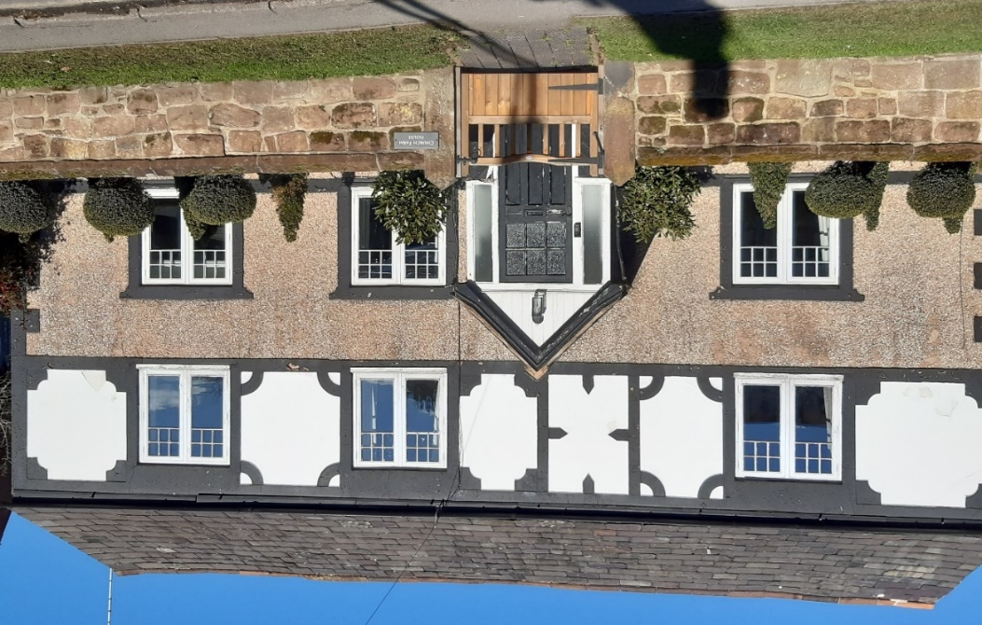

Church Farm House in 2023

Barns

The associated barns were also used by various businesses:

Hales Corn Stores
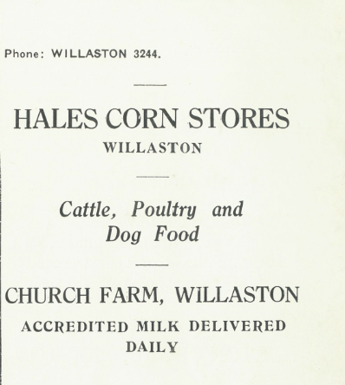

Advert in Christ Church Centenary 1955

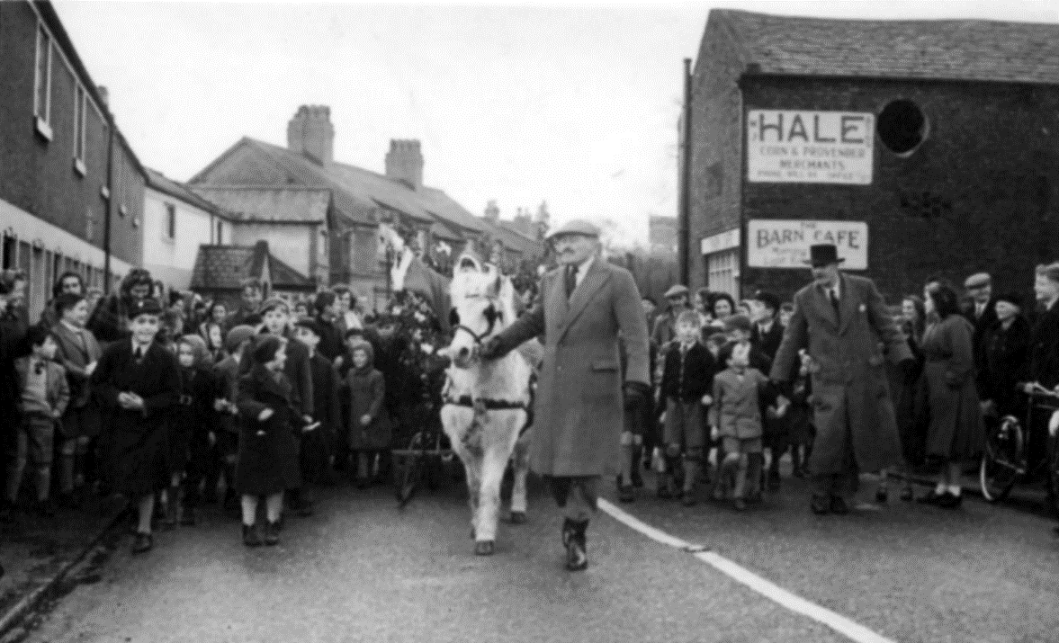

A white horse is pulling Father Christmas on a sleigh
along Neston Road in the early 1950s
(Photo from Yesterday’s East Wirral by Ian Boumphrey)

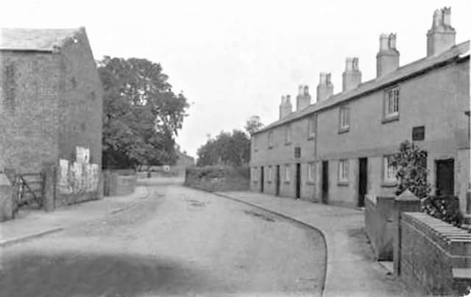

View towards the village with Hales Barns on the left
(date and origin of photo unknown)

Advertisement in Christ Church Parish News September 1975

Electrician – Mr Clapperton
He also had premises in Bromborough
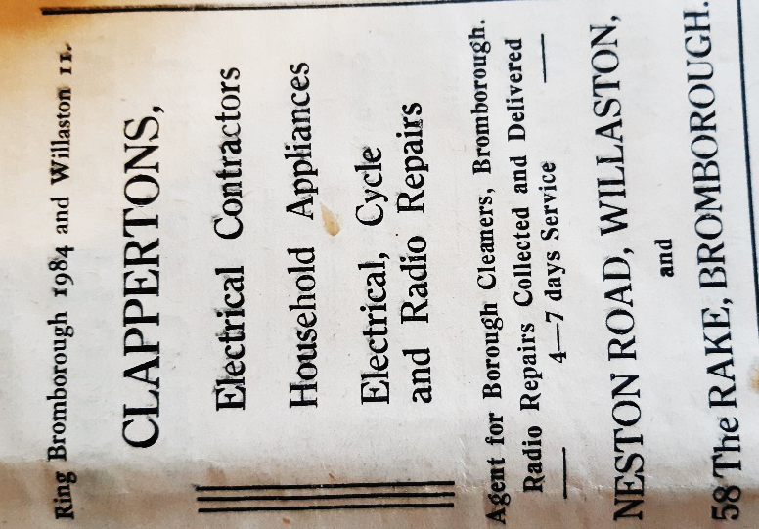

Advertisement in
Willaston Parish News June 1951

Gent’s Outfitters – Dave Lloyd

Barn Café – Mrs Coupe

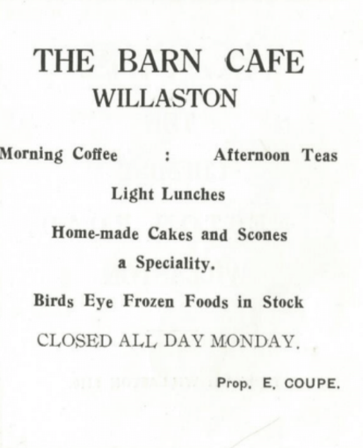

Advert in Christ Church Centenary 1955

Cakes – Miss Broster

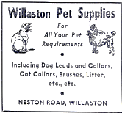
Willaston Pet Supplies – Libby Harker and Lorna Cheetham

Advertisement in The News 1975

In 1971, a report (Conservation Stage II report, June 1971: Willaston, Neston Urban District, Cheshire County Council) noted that ‘Several buildings detract from the view at this point, particularly the large buildings at the rear of Church Farm which are in need of screening…’
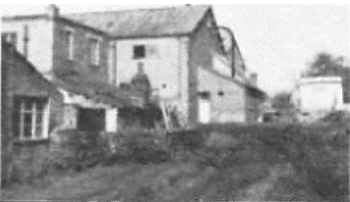

Photo from the 1971 report

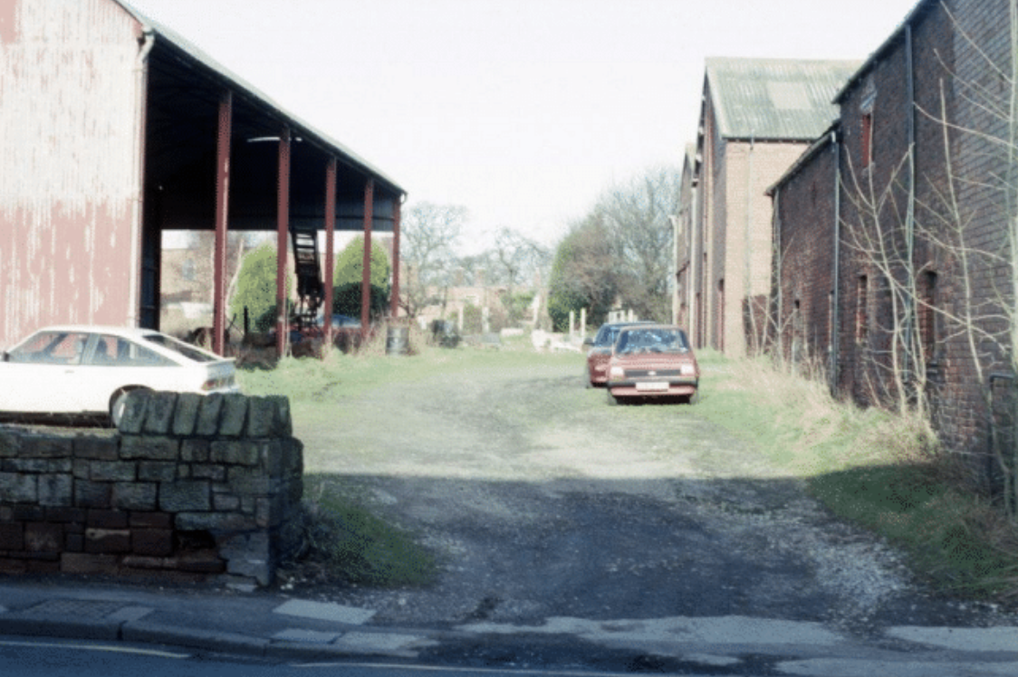

The barns before demolition
(Photo: Jean Griffiths)
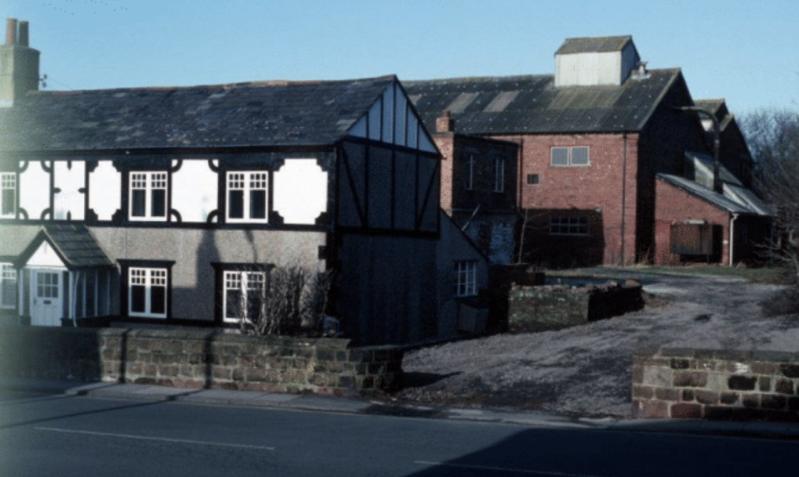

Church Farm and the Barns before they were demolished
(Photo: Jean Griffiths)

In 1995 the barns were demolished and Church Farm Court was built.
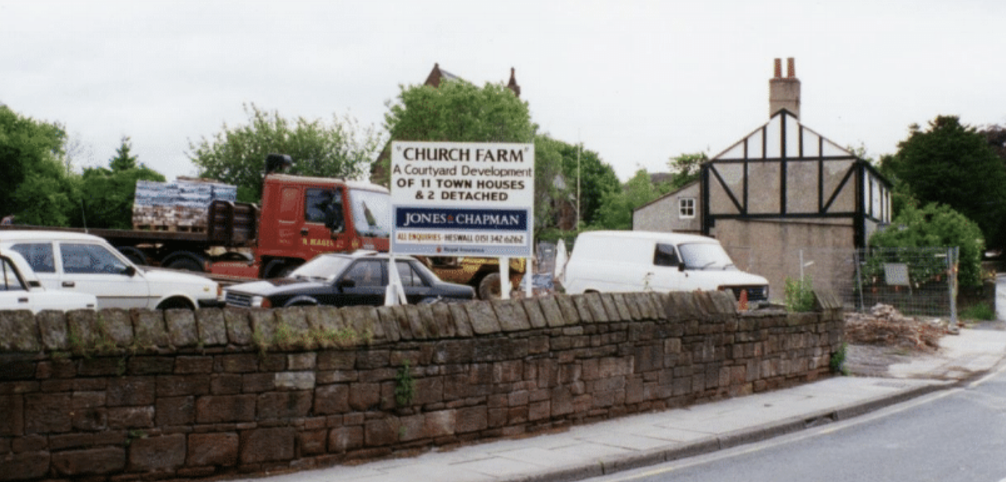
Photo: Jean Griffiths

