Cherry Brow Terrace – Newsagent and Butcher Shop

Taylors newsagent and tobacconist was at the end of a small terrace row on Hadlow Road.
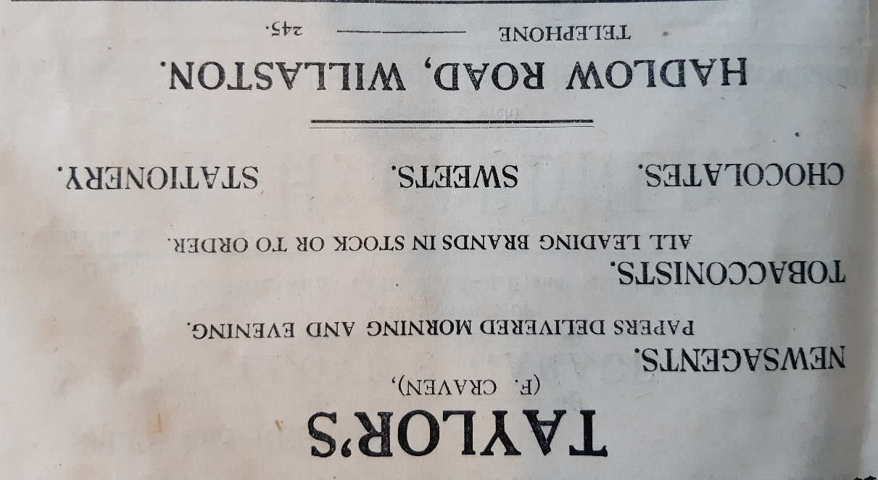

Advert in Willaston Parish Magazine June 1951

Later it became Mattingly and Craven Newsagent, ran by Frank and Fred and then EA and JB Fyfe, who also ran newsagents on Neston Road.

Advert in Willaston Parish Magazine in September 1975

In late 1975, it was converted to a butcher shop, run by Tudor Davidson.

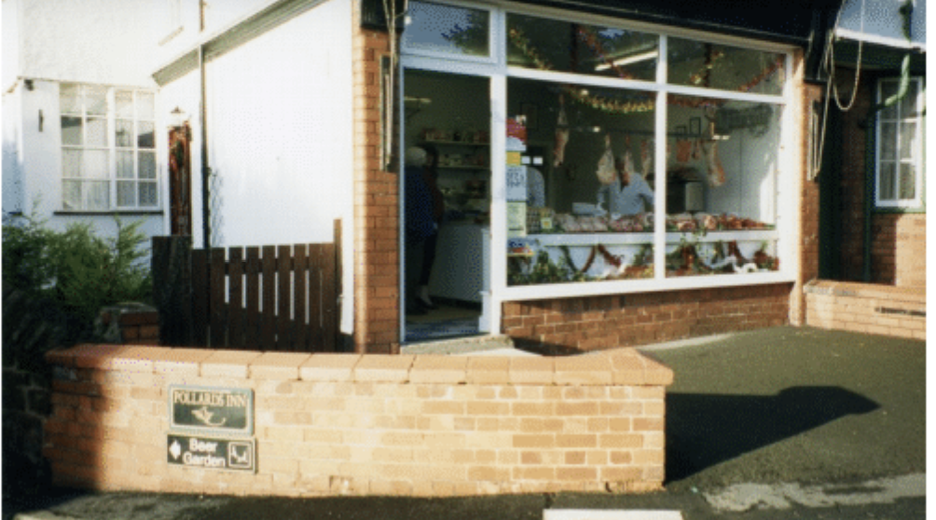

Photos: Jean Griffiths

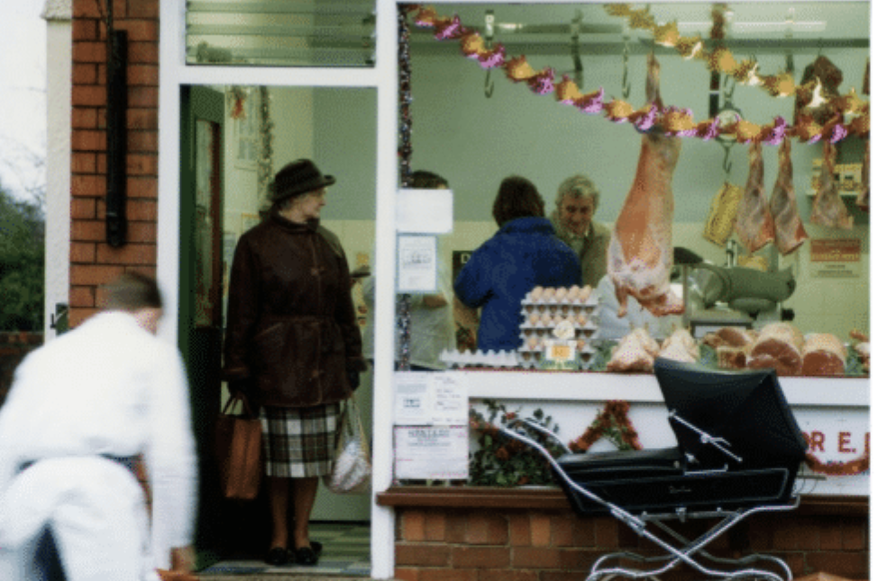

In 2004, it was converted to a house.

