Cherry Brow Farm

Cherry Brow Farm was built in 1739 by Ambrose Green and his wife Mary. Ambrose Green was a sailor. It was originally was on the edge of the Green but now housing is between the building and the Green.

In 1945, Mrs Frances from Cherry Brow Farm sold milk.

In 1971, Cherry Brow Farm was noted as being empty and surrounded by ruined outbuildings, with gaps where old cottages and farm buildings have disappeared. Trees had grown up to surround the house, almost hiding it from view, although it was very close to the road.

In 1974, the farm was listed as Grade II.

Around this time, the farmhouse was owned by Mr A Gee, who lived in Heswall and took it over as his share of a business partnership that broke up. He came under pressure from the council to restore the house. The newspaper article (unknown paper) states: Many people in the Willaston area are not even aware of the house’s existence because it has become so obscured by trees and overgrowth in the last few years.’

In 1979, it was bought by John and Sheila Saunders for £12,000. Mr Saunders described the house as ‘An eyesore – it was in a state of complete dereliction. The roof and floors had collapsed and the drainage had gone.’

The farm before restoration work began
Photo: Pioneer, June 1988

Mr and Mrs Saunders spent eight years and an estimated £20,000 renovating the building. For four years, the house was uninhabitable and they lived in a caravan.

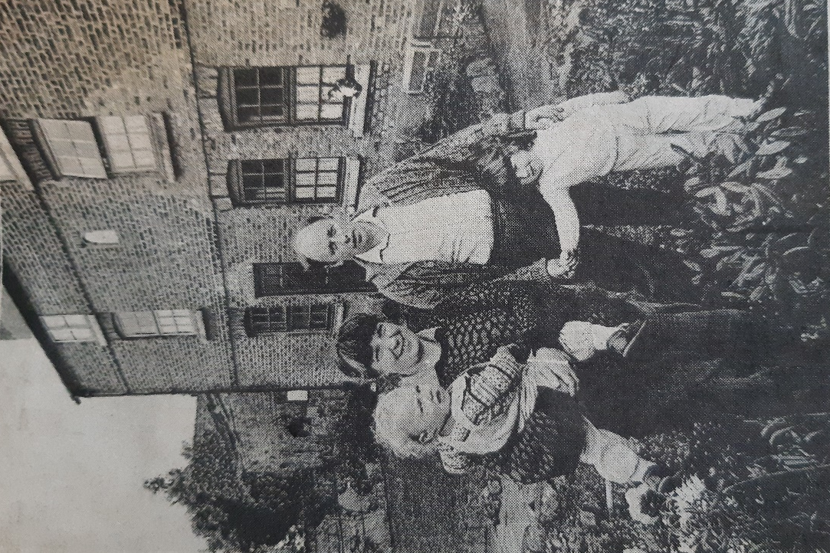

John and Sheila Saunders outside the restored farmhouse with daughters Helen and Kathryn in 1988
Photo: Pioneer, June 1988

