Broadlake Farm

Broadlake was a originally a farm house but had become a private dwelling by 1951.
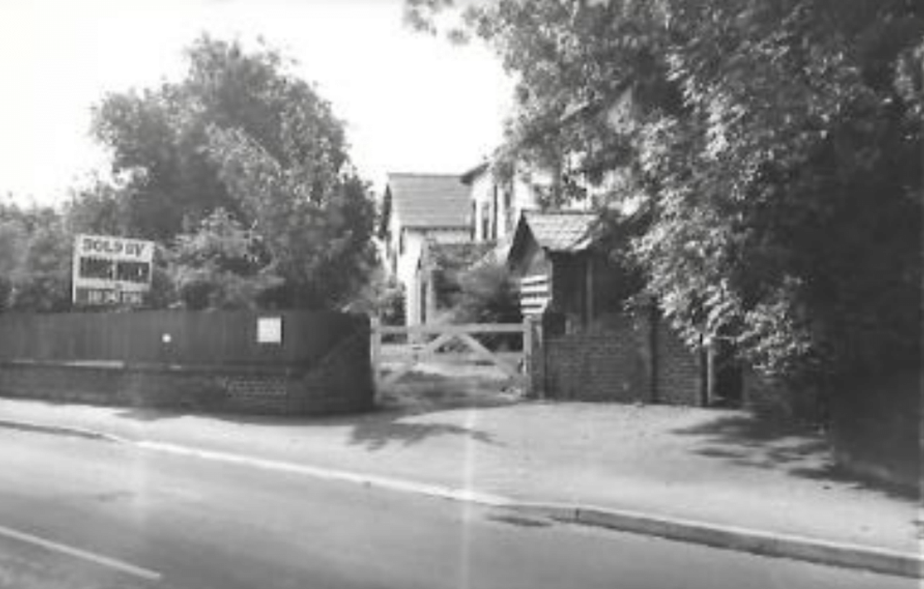
Broadlake in 1977

Broadlake was pulled down in 1978, with the developer taking swift action before local opposition to its removal could be properly organised. Broadlake Cottage still remains.

The new estate was developed and the Willaston Residents’ Committee was consulted on the names for the estate. They responded as follows:
We did feel it was a bit confusing to have three Broadlakes. No one fancied Broadlake Mews. Mews simply is not a local use. Johnston Close was suggested – Mrs Johnston being a past beneficiary to the village who gave the recreation ground and Church Hall to Willaston. Other names associated with Broadlake itself are Oakshott and Stern. What about Broadlake as the generic name, Broadlake Way and Johnston or Oackshott Close?

