Atworth House

There was a grocer’s store at Atworth House for many years, established in 1870. The store also included a post office and public phone in the shop.

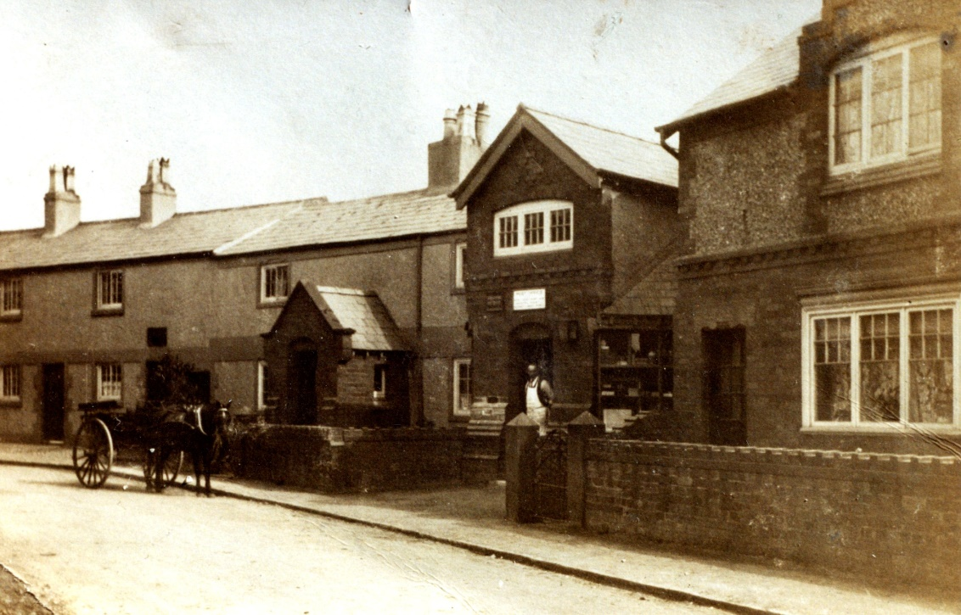

Photo from Willaston of Yesteryear by Bob Prince
Date unknown

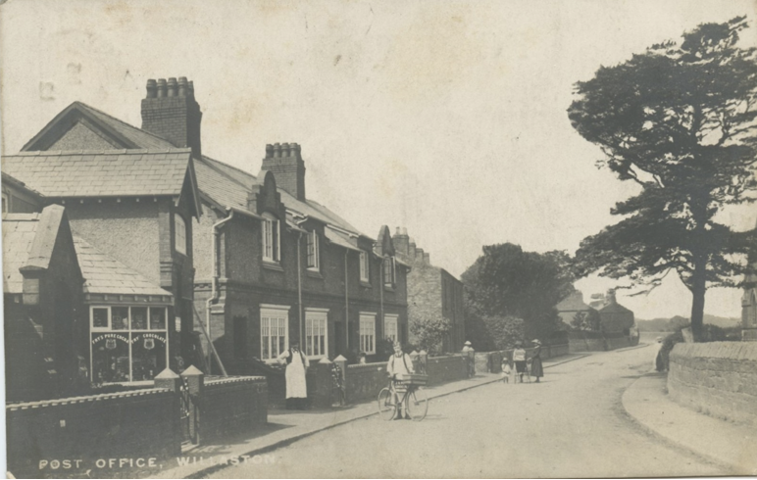
Postcard, date unknown

The shop was a family business run by John and Alice Pugh, from at least 1901.

After the first world war, Wilf Pugh joined them in running the shop, after serving. Wilf’s brother, Horace Pugh, had been wounded on the first day at the Battle of Passchendaele and had passed his brother when being carried from the front line on a stretcher. They spoke briefly before Horace died.

In 1945, All About Willaston published by the British Legion noted that the shop was open on weekdays, apart from Wednesday afternoons. The Post Office business included Money Order, Postal Order, Savings Bank, Licences, Telegraph and Telephone etc.

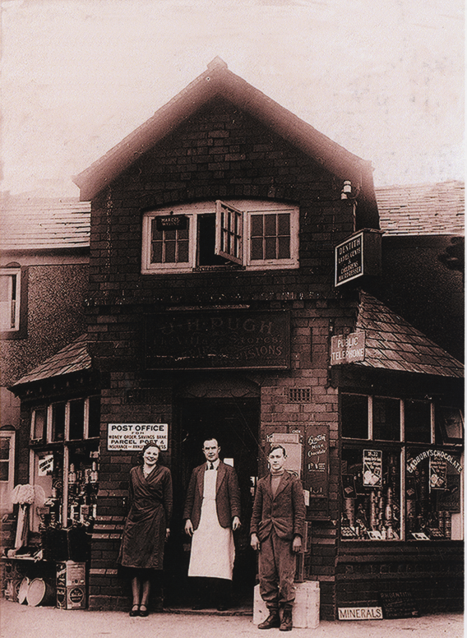
This photo shows the Post Office and General Store owned by Mr J.H. Pugh around 1940. The picture shows, left to right, Miss Wright, Mr Pugh and Mr Higgins. Picture from Willaston of Yesteryear by Bob Prince.

Advertisement from Willaston Parish Magazine June 1951

Above the shop there was a men’s and ladies’ hairdressers, run by Bob Dentith and Betty Hampson respectively. Betty is said to have specialised in Marcel Waving.

Advert in Willaston Parish Magazine in December 1962
An identical advert was in the Parish Magazine of June 1951.

It was then a grocer shop run by Roy and Hilda Wheeler.

It then became a delicatessen run by Peter and Thelma Watt.

In 1991, the shop became a florist – Jillian Dawn Floral Designs. The shop is currently run by three generations of the same family: Irene and Haydn, daughter Tracey and granddaughter, Emily. Initially, they grew flowers in Two Oaks Farm to supply the shop, selling excess stock in Liverpool and buying worldwide flowers to sell in Willaston.

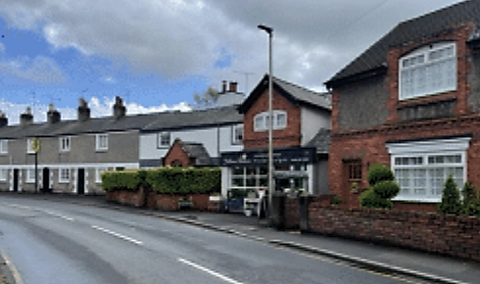

The shop in May 2022

