Astons / Peppers Café

A ladies’ and children outfitting and haberdashery shop was run by Selma and Muriel Aston for over 50 years. They gave up the shop when Selma reached the age of 80 in 1993.

In 1945, the shop included a library service.

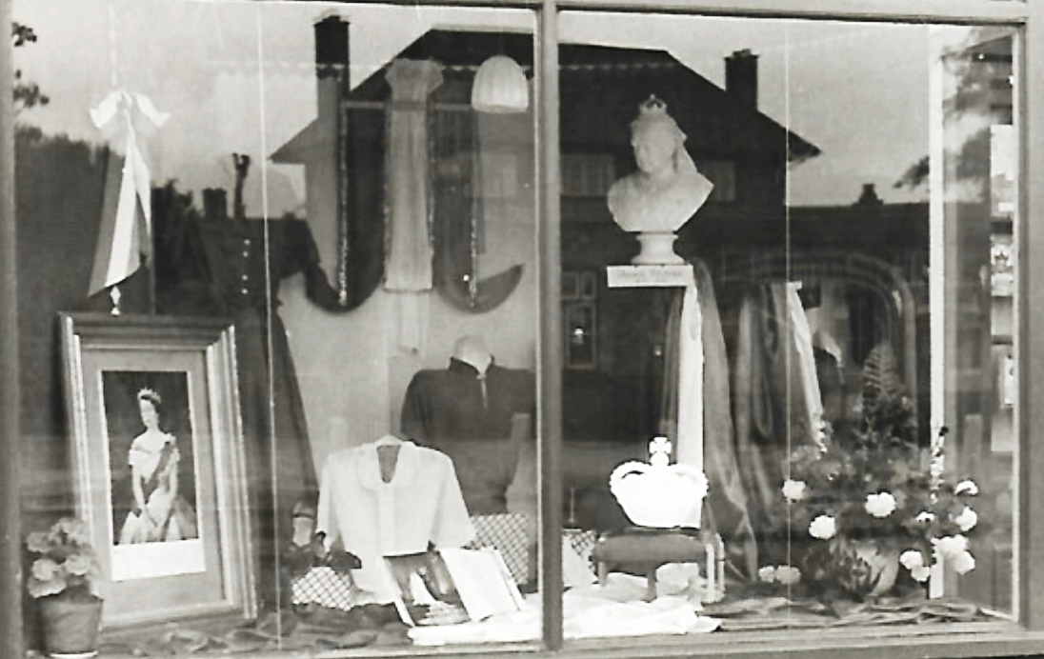

Coronation window in Astons in 1952

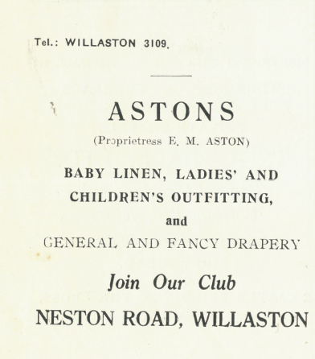

Advert in Christ Church Centenary 1955

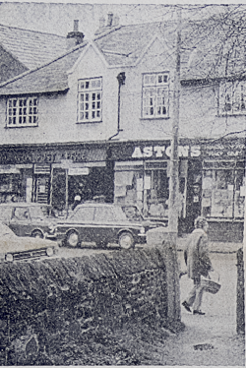

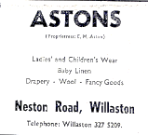

Photo and advert in
The News in 1975

Ruth Hampshire remembers: Aston’s was certainly an Aladdin’s cave. I remember the glass and polished wood counters with drawers in them. The shelving went up to the ceiling so they used ladders to reach items form way up high. The Miss Aston’s lived above the shop. Mum used to buy wool from Aston’s – she would order the wool and they would keep it for her until she needed it. They would scurry off into the back room for orders or something new that they thought would be of interest.’

Sheila Smith remembers: ‘Brilliant shop and ladies. [They] sold everything and if it wasn’t what you went in for, you felt obliged to buy as they went to so much trouble, disappearing to the ‘store room’ – garage down the garden!’

Sue McKinnon remembers: ‘We used to go there to buy the elastic banding to play ‘elastics’ at school.’

Kath Edwards remembers: ‘If you liked a dress, you could take it home to try it on. One time, I wanted a wedding dress and was given a box with eight different dresses to choose from. I tried them all, chose one and took the others back. You could get anything that you wanted.’

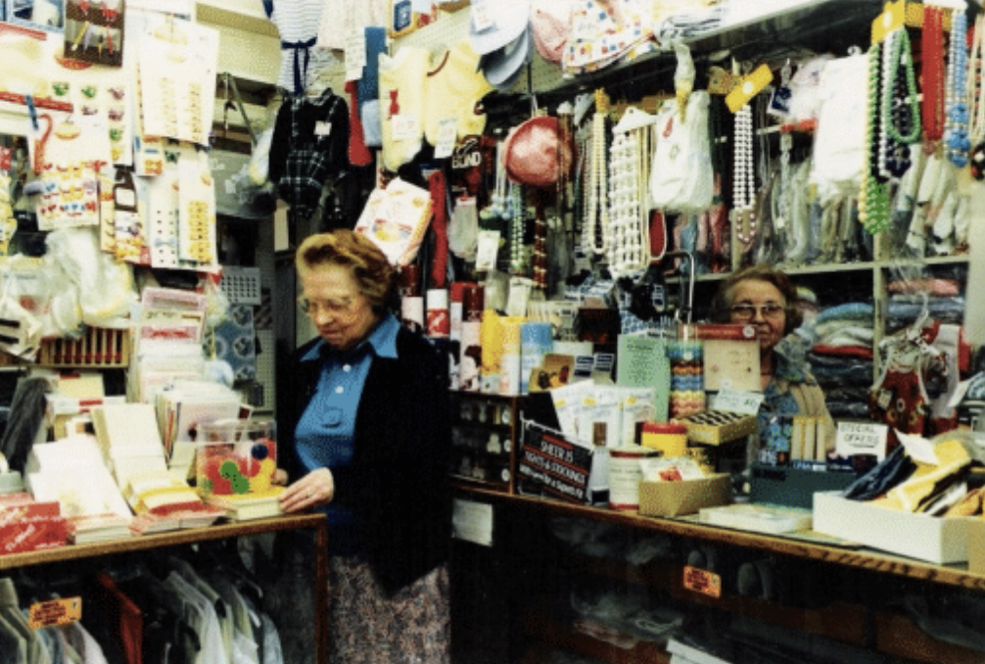

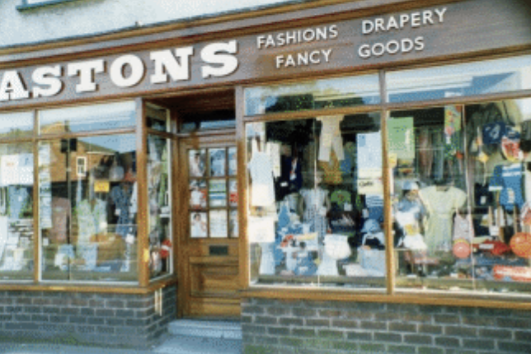
Photos: Jean Griffiths

The shop then became Barbara’s shop – a drapery run by Barbara Fyfe

Photo: Bob Prince, from Willaston – Centre of Wirral

Michael Phillips hardware and electrical store from 1994 to 1997.

It then became Aston’s Café, run by Vicky Patton

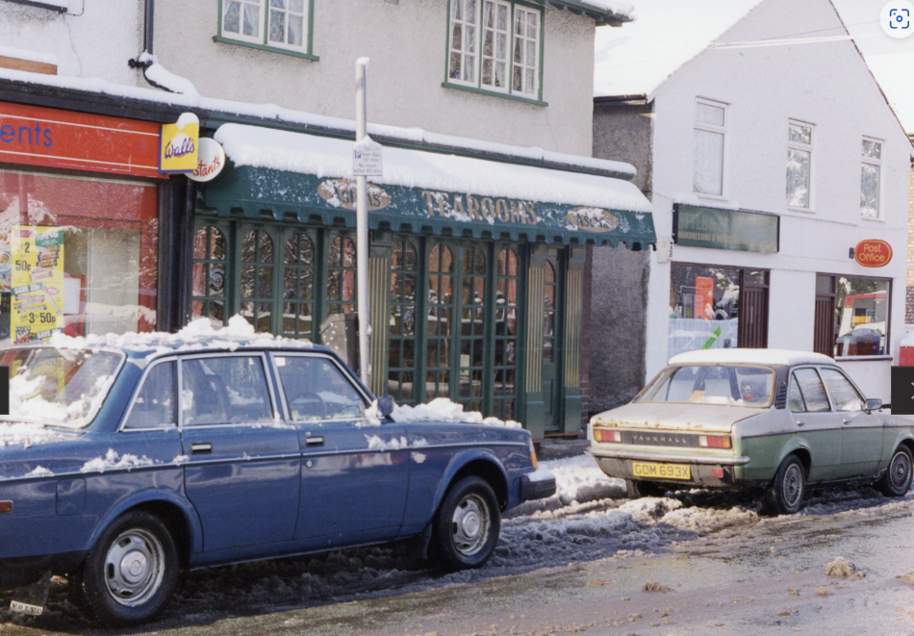

Photo: Jean Griffiths

From 2021, it became Peppers Café.

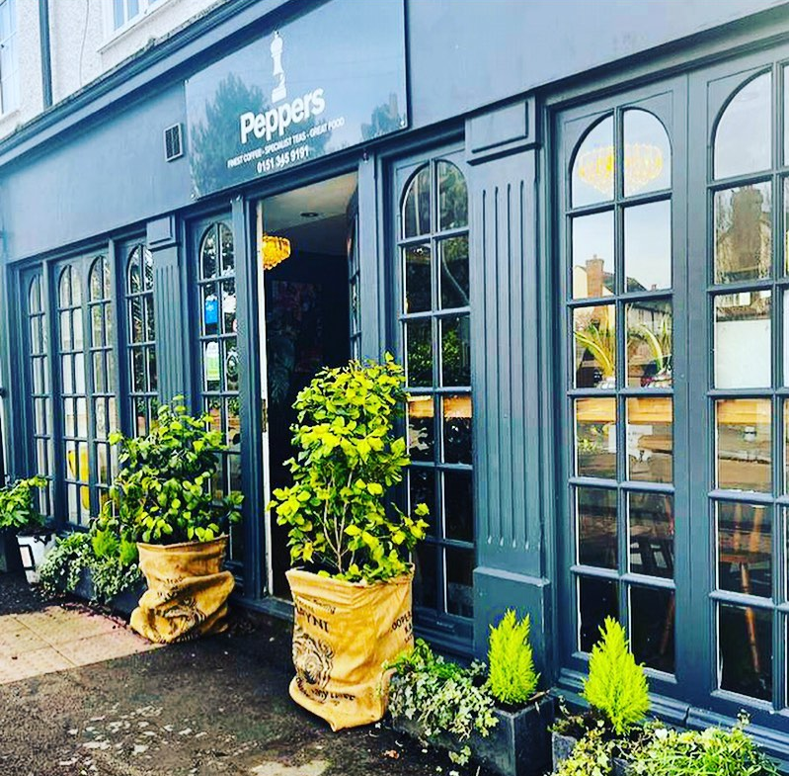

Peppers Café in 2023

