Ash Tree Farm

Ash Tree Farm, on Hadlow Road originally was a single room on the ground floor and one above. Later extensions were built to the south and later still, wings on the north and east sides. The original house was built of wattle and daub in a timber frame and may date from the 15th century or earlier. It is probably Willaston’s oldest house. The construction of the chimney indicates that the roof was originally thatched.

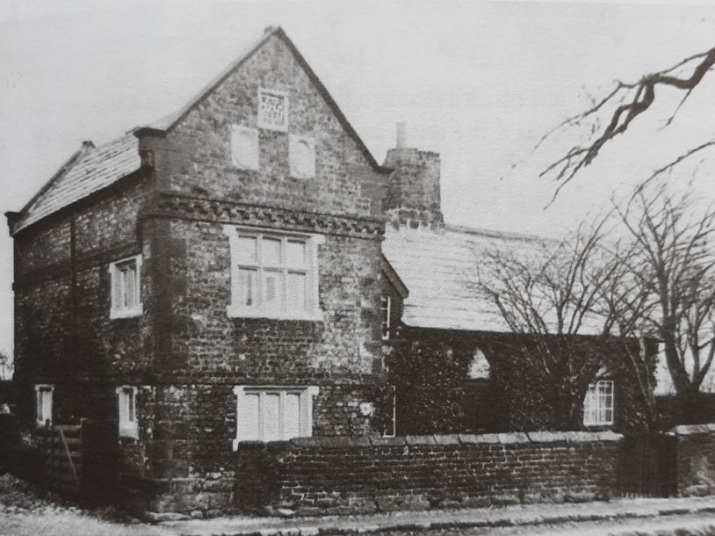

Ash Tree Farm in 1908
Photo: Willaston’s Heritage by E.C. Bryan

Miss Ethel Wood, who lived at Ash Tree Farm for 80 years (probably until the late 1960s) said that the house owes its name to two ash trees which formerly stood between the timber-framed part and the road but were cut down in the early 20th century.

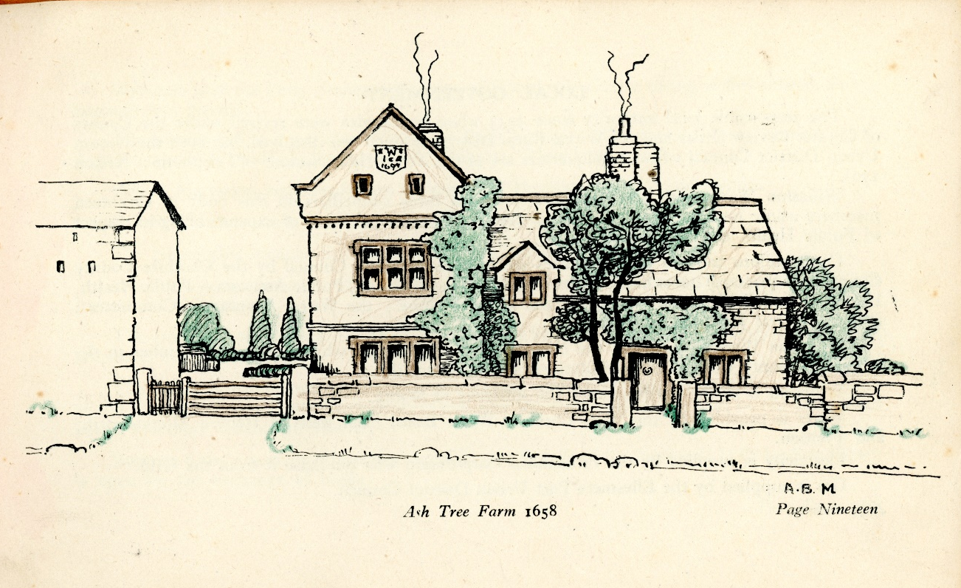
Drawing of Ash Tree Farm in 1945, taken from All About Willaston by the British Legion

In 1962, the building was listed at Grade II and later the buildings that were originally cowsheds and a barn were also listed.

Greame Sambrook remembers:
‘As young children in the 1960s we had a lot of freedom to roam the village and fields. I remember there being so little traffic that the sisters who used to own Ashtree Farm let their chickens roam free on Hadlow Road. We often used to see them pecking in the dirt outside the farm on Hadlow Road.’

In 1967 an application was made to develop the site for housing which would have involved the demolition of the farm buildings which were in a poor state of repair. After discussion with the county planning department, the developers were persuaded to offer the farmhouse for sale and Bill Hardman became the owner. Unfortunately, the building by then had been left empty and was described in Cheshire Life in 1970 as:
‘This crook-framed cottage … for some years has lain empty, neglected and a target for vandals … Its windows are broken, the interior is ankle-deep in rubble and rubbish but, for all that, it still remains a building of architectural and historical importance. Happily, a young couple from Neston – Bill Hardman and his wife Diana – have bought the place and intend to restore it and live in it. They ought to be granted the freedom of the village for their courage.’

Mr Hardman applied to the County Council for a grant under the Local Authorities (Historic Buildings) Act 1962 and a grant of 25% of the estimated cost of restoration was agreed. He preserved its external appearance and all the internal historical features.

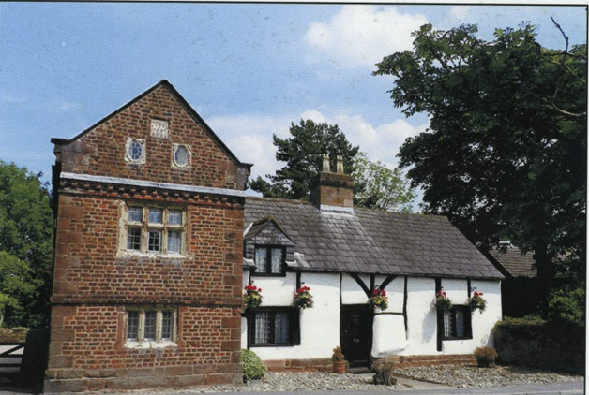

Ash Tree Farm in 2012
Photo from Photographs of Willaston by Bob Prince

