Acres Farm

Joe Dutton Dairies operated from Acres Farm.

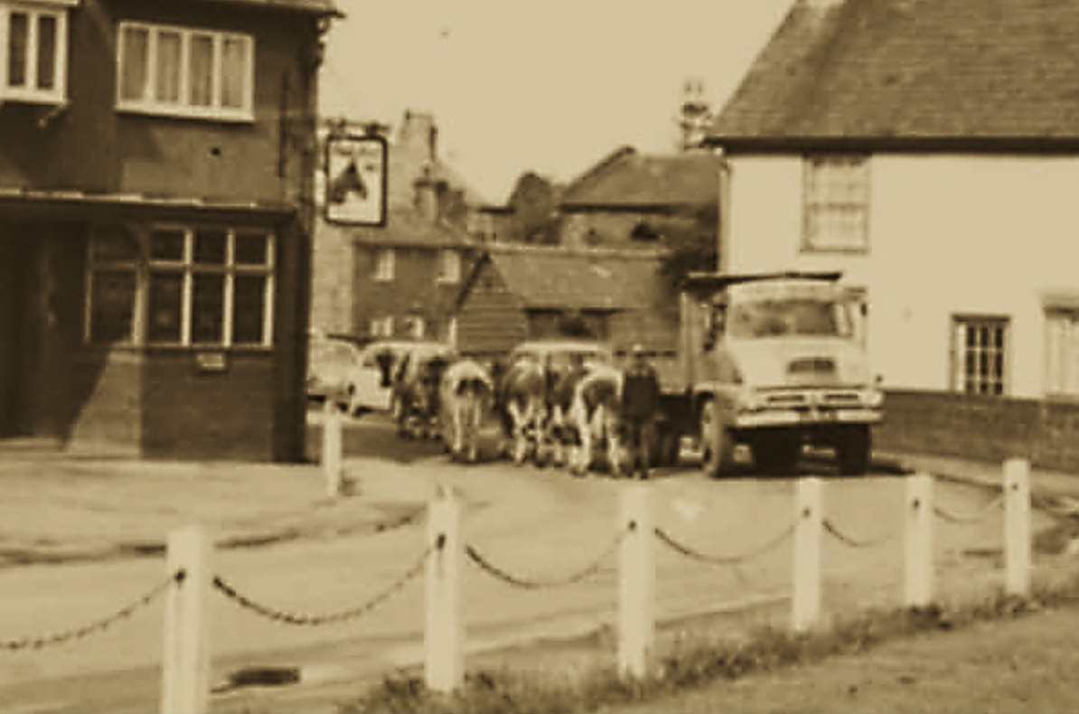
Date unknown
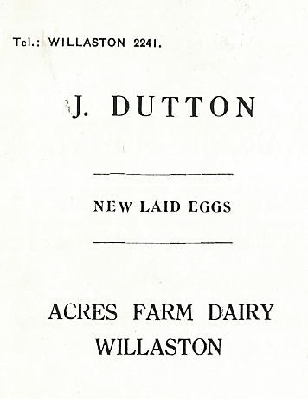

Advert in Christ Church Centenary 1955

Advert in Willaston Parish News December 1962

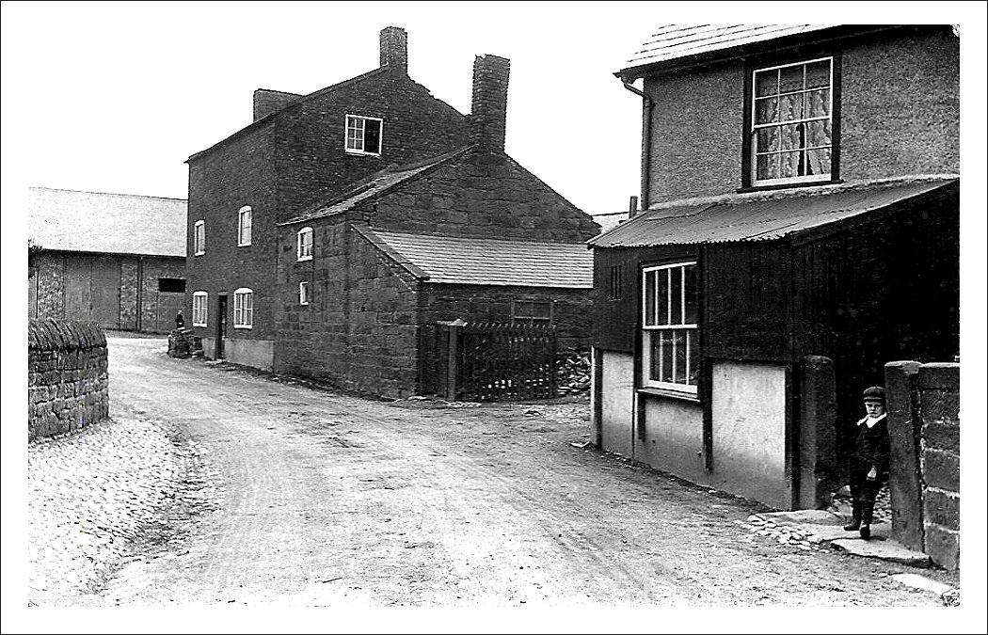
Old Hall Farm in front and barns of Acres Farm in rear.
View from another angle

Many of the buildings have disappeared and been replaced by Cannel Court.

Joyce Ryan remembers: ‘Mrs Dutton delivered milk in wellies and a tweedy skirt – she lived in her wellies. The milk bottles had cardboard tops.’

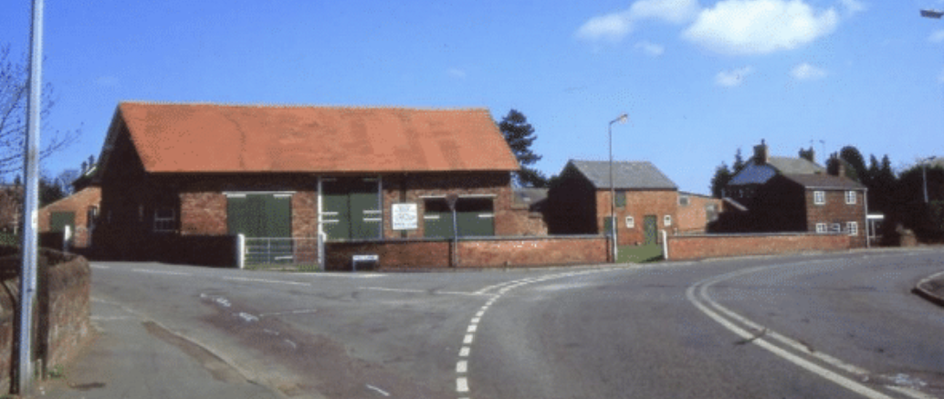

Acres Farm in the late 1980’s (Photos above and below: Janet Leece)

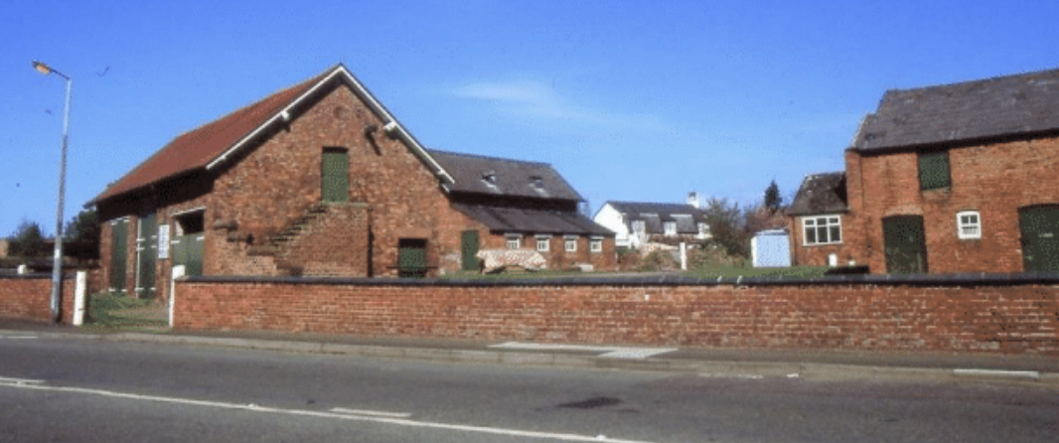

Ruth Watson says ‘Joe Dutton provided and delivered milk to our estate and horse manure. One Winter he got flu and it is said he neglected to get any treatment. Unfortunately, it killed him.’ The farm was then closed, the contents auctioned and the buildings converted into housing.

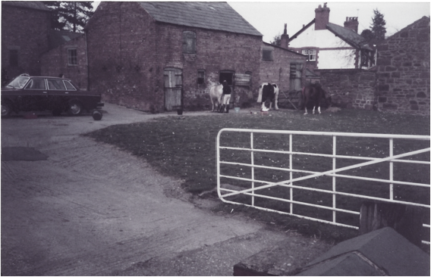

The farm in 1989 (photo Ruth Watson)
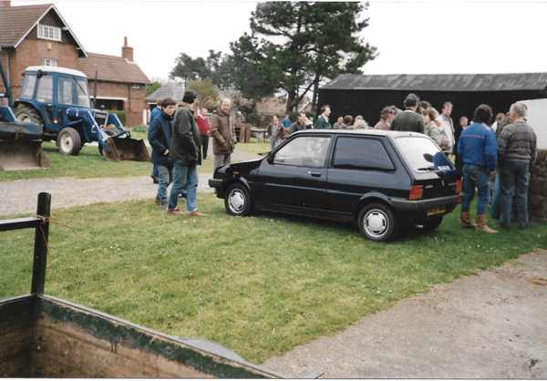

Photos above and below of the sale of deadstock (the farm machinery) in 1989 – the auctioneer came from Chester and has a light cap on in the picture below. (Photos: Ruth Watson)

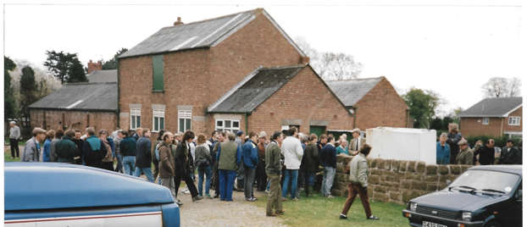

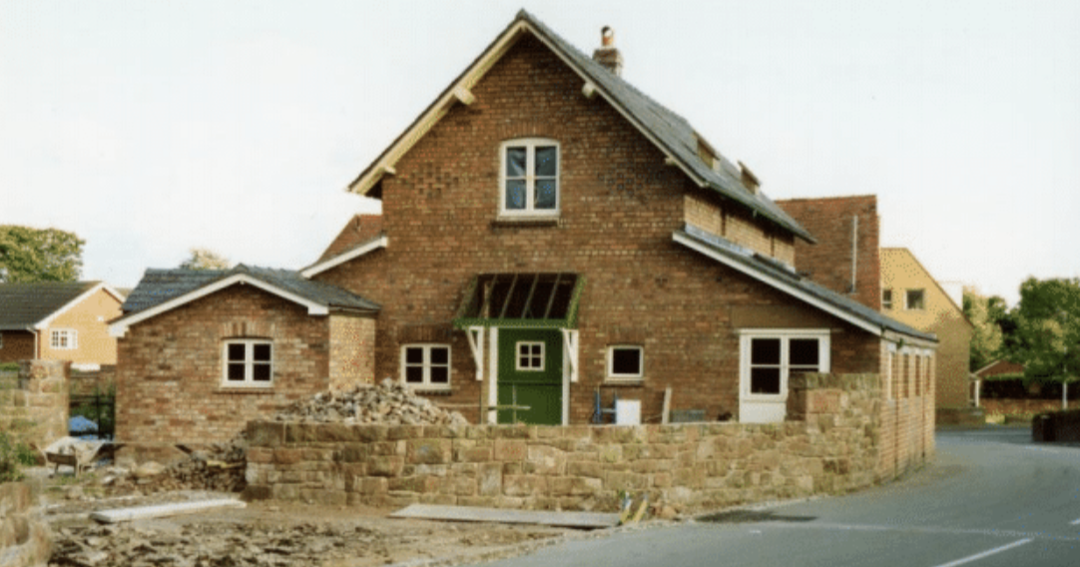

Building work begins (Photo: Jean Griffiths)

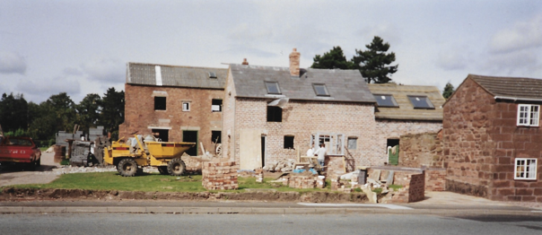

Photo: Ruth Watson
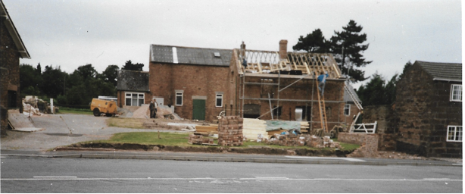

Photos above and below: Ruth Watson

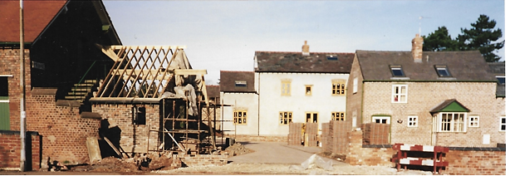

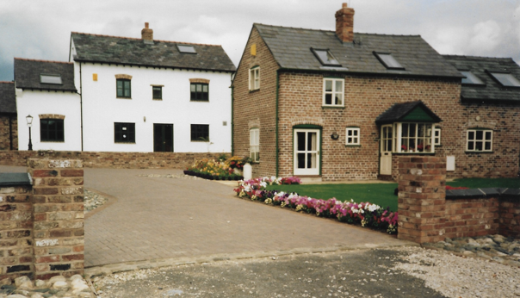

Completed houses in August 1990 (photo: Ruth Watson)

